Configure an EC2 instance and access instance using RDP

OBJECTIVES: 1: Amazon EC2 is used to launch as many servers as you want.

2: To develop and deploy application faster.

3: To configure security and networking, and manage storage.

4: To enables you to scale up or down to handle changes in requirements or spikes in popularity, reducing your need to forecast traffic.

5: Using RDP to remotely connect to another computer over a network, giving you full access to and control over the computer's software, data and resources.

**HOW TO CREATE AN INSTANCE**

Open an AWS console

Go to search coloum, type EC2 and Enter

Click on Launch instances

Choose an instance name, create a key pair

Enter a key pair name. Choose a private key file format, then click create.

Allow RDP traffic from anywhere

NOTE: This will help you connect to your instance.

Click on create instances.

Go back to instances, click on the instance you created and connect.

Go to RDP client

Click on Get password, browse to download key pair browse and decrypt.

Click on Remote Desktop Connection , paste the password that was decrypted and click ok.

On remote Desktop Connect, click Yes

The server will be launched.

START THE PROCESS WITH SCREENSHOT

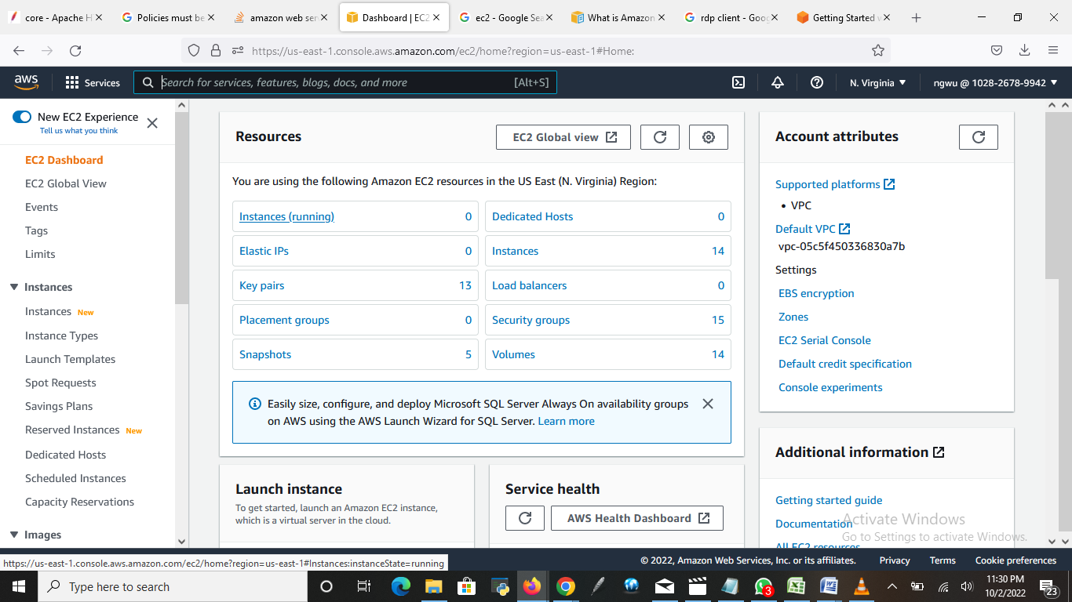

Open an EC2 dashboard, click on instances

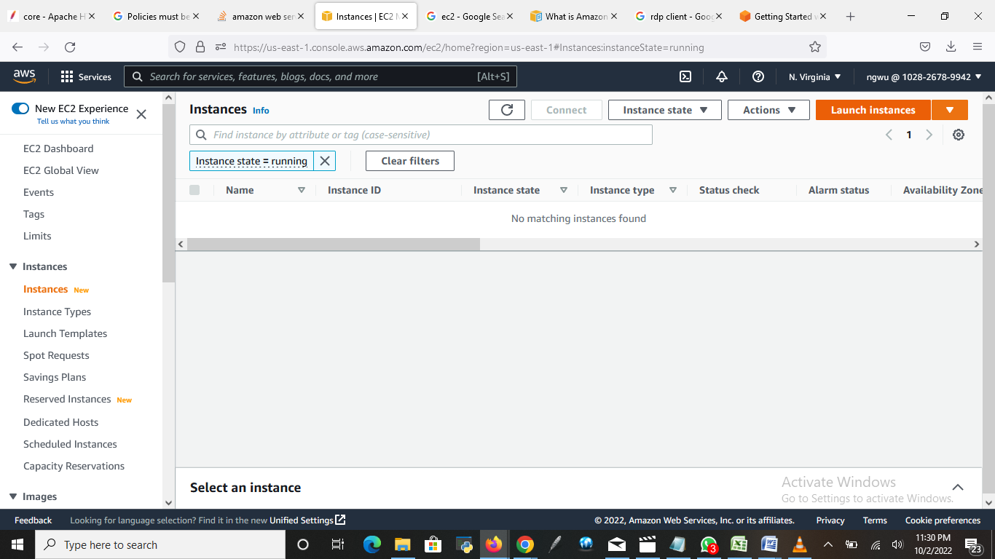

Click on launch instances

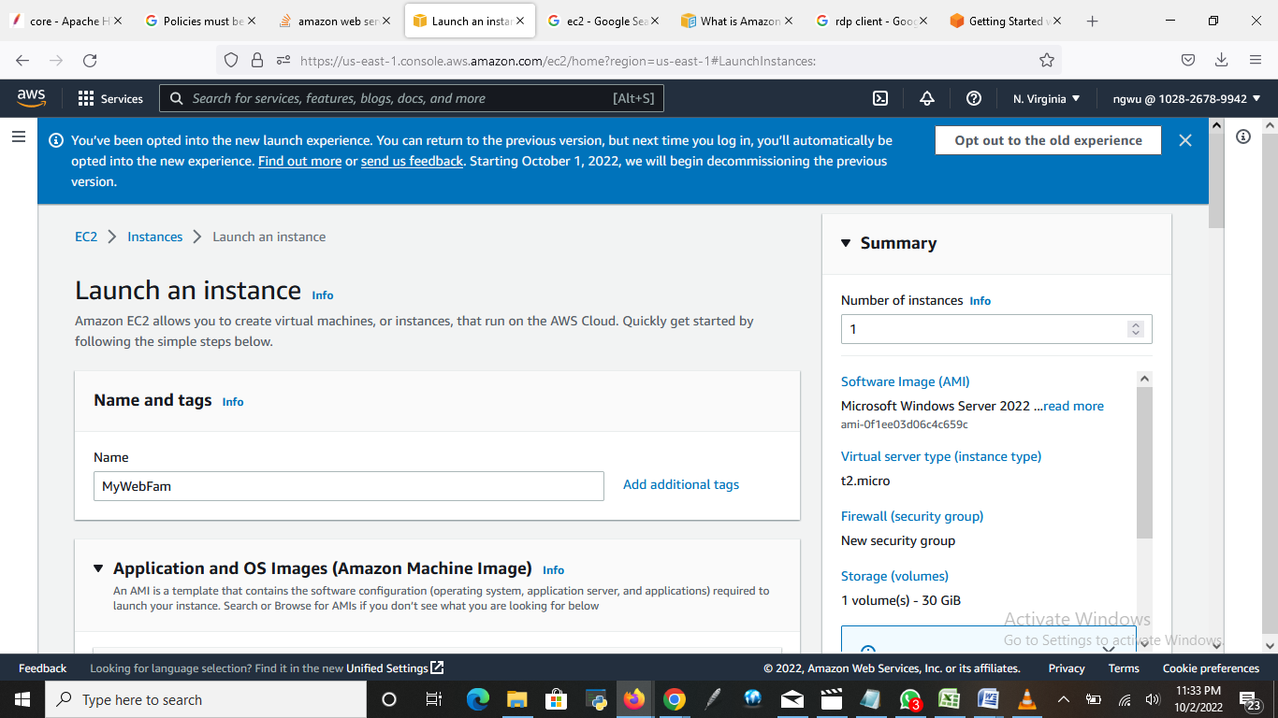

Enter the name of the server. Eg “MyWebFam”

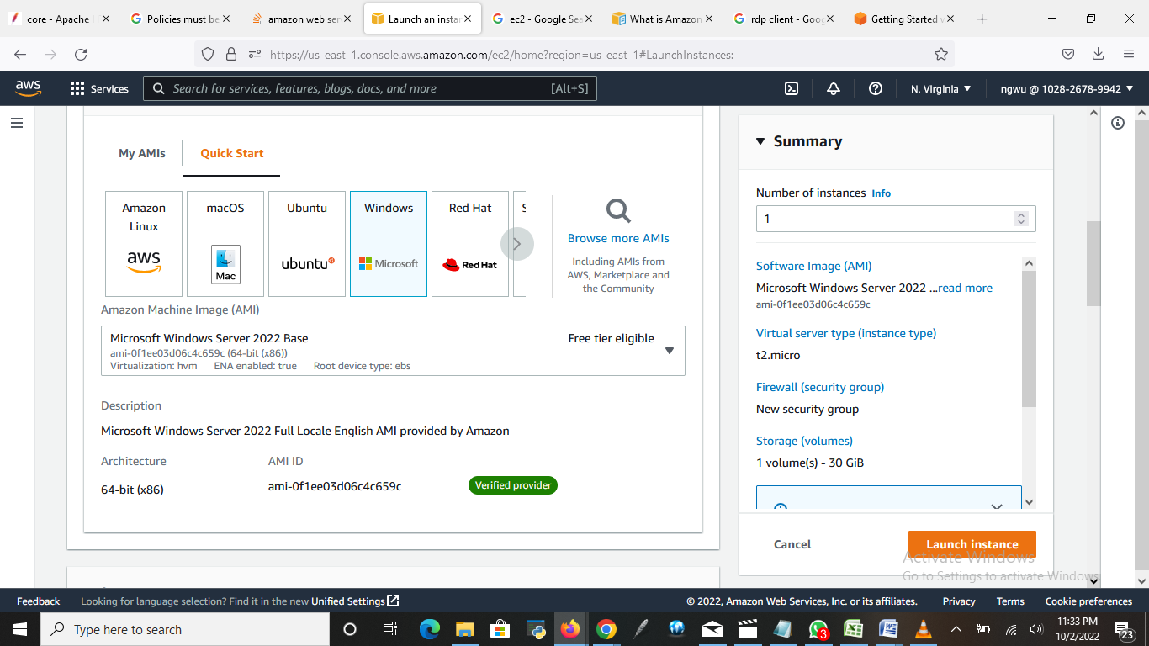

Under “Quick Start” choose Windows

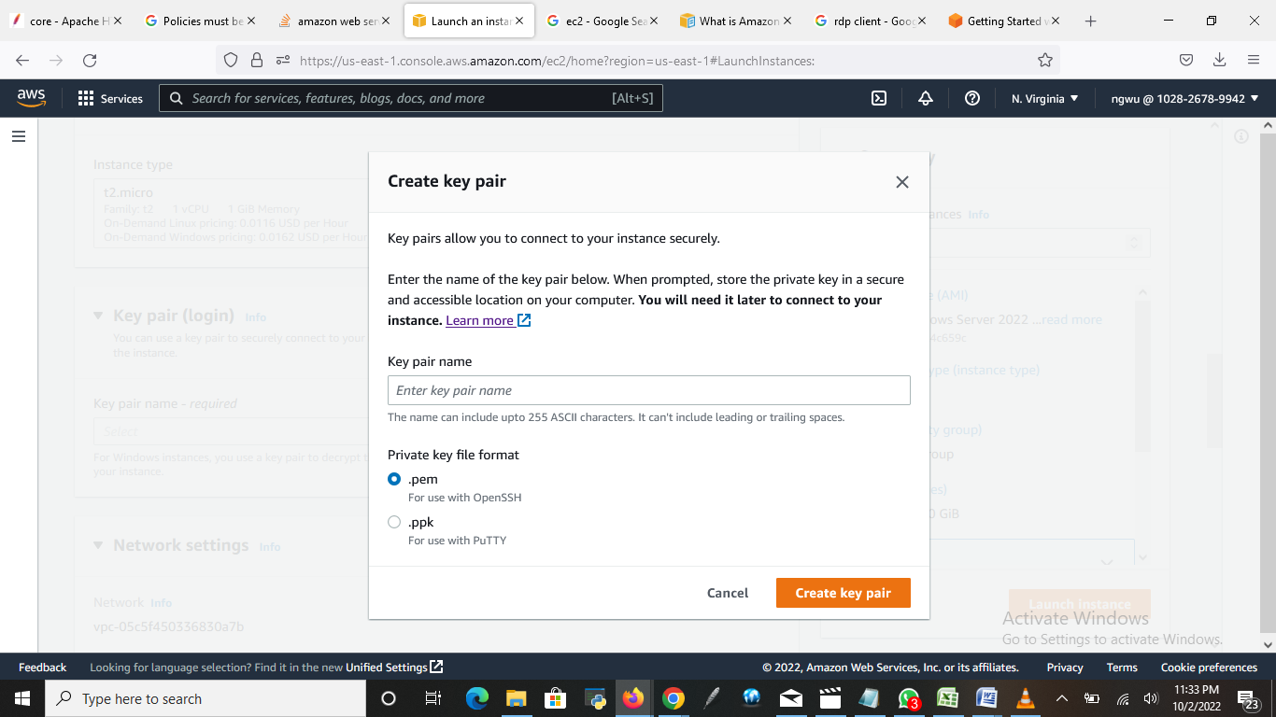

Create a key pair by entering a key pair name. Eg: ngwu, then click on create

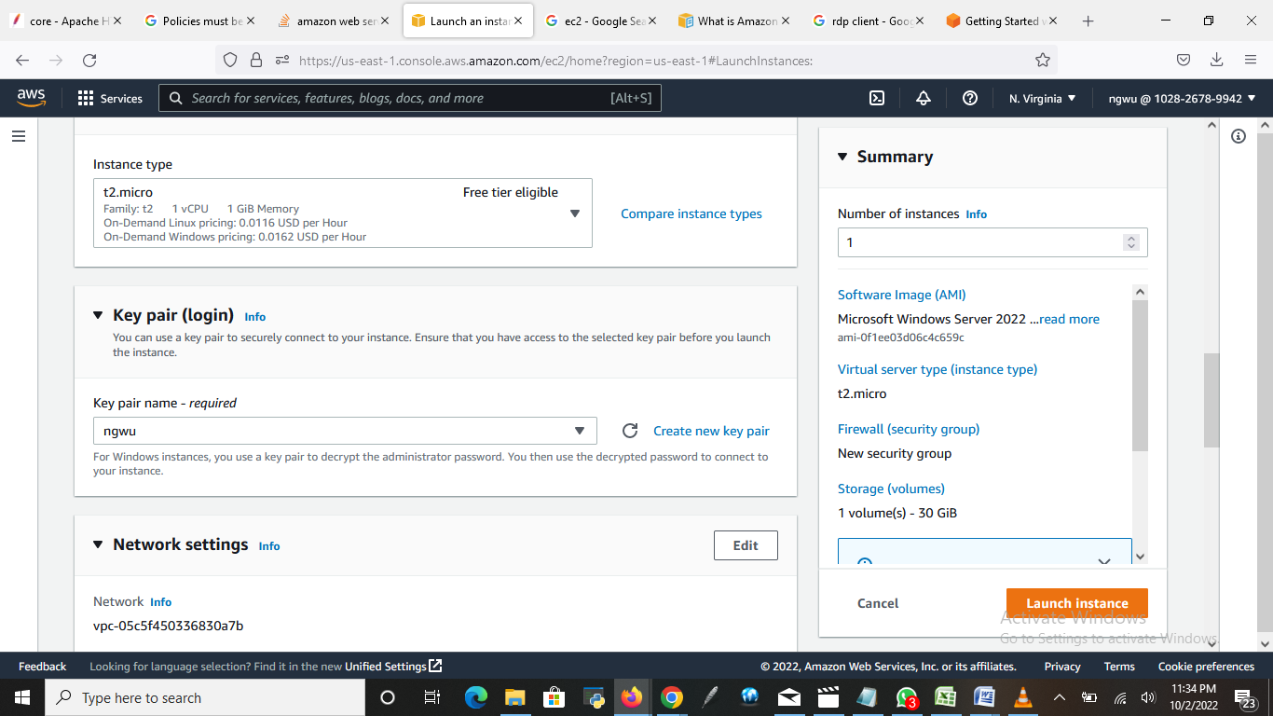

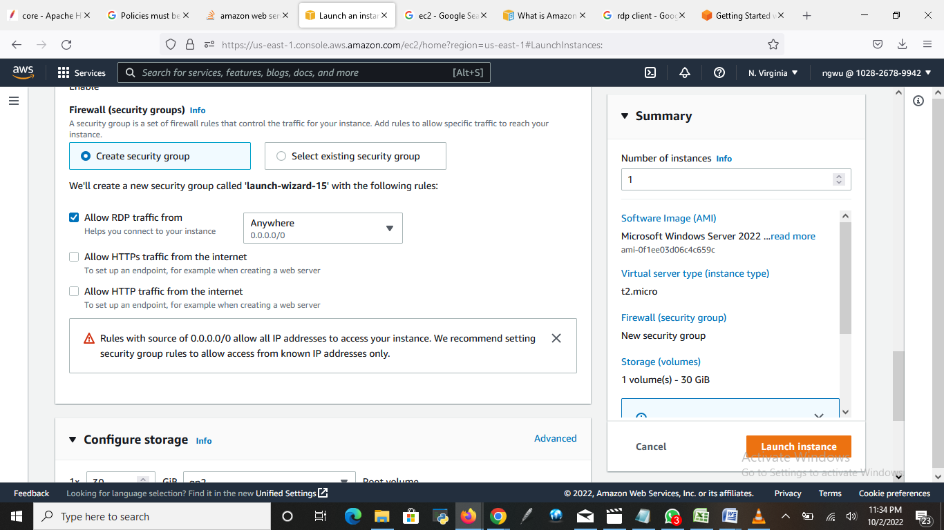

Allow RDP traffic from “Anywhere”

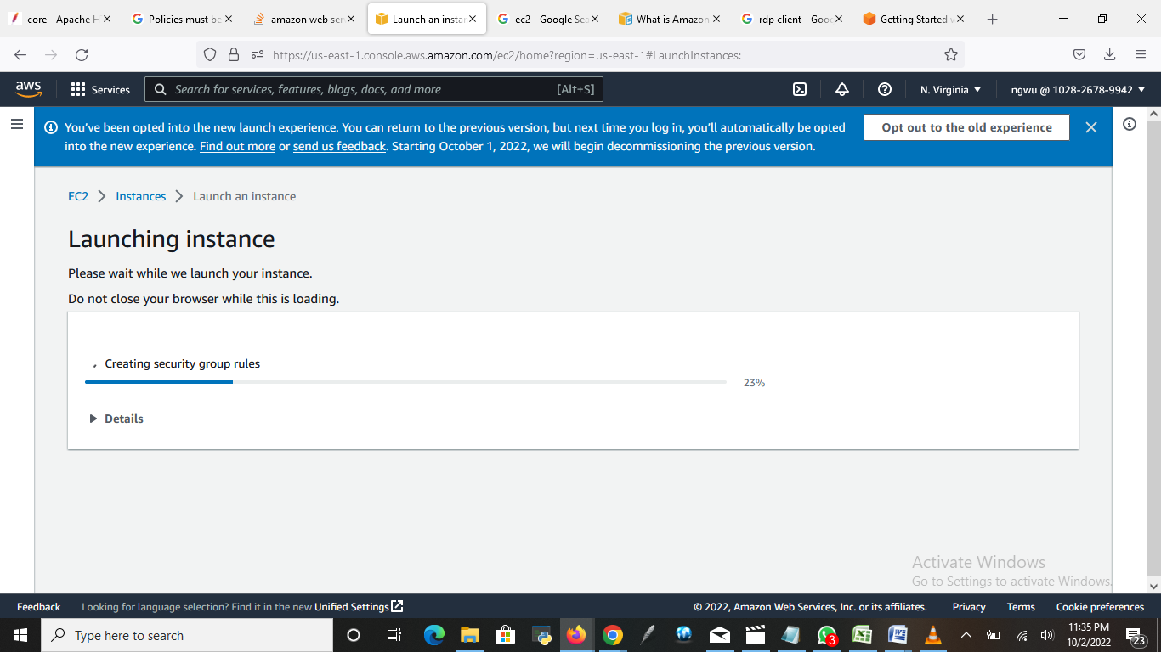

Click on Launch instances.

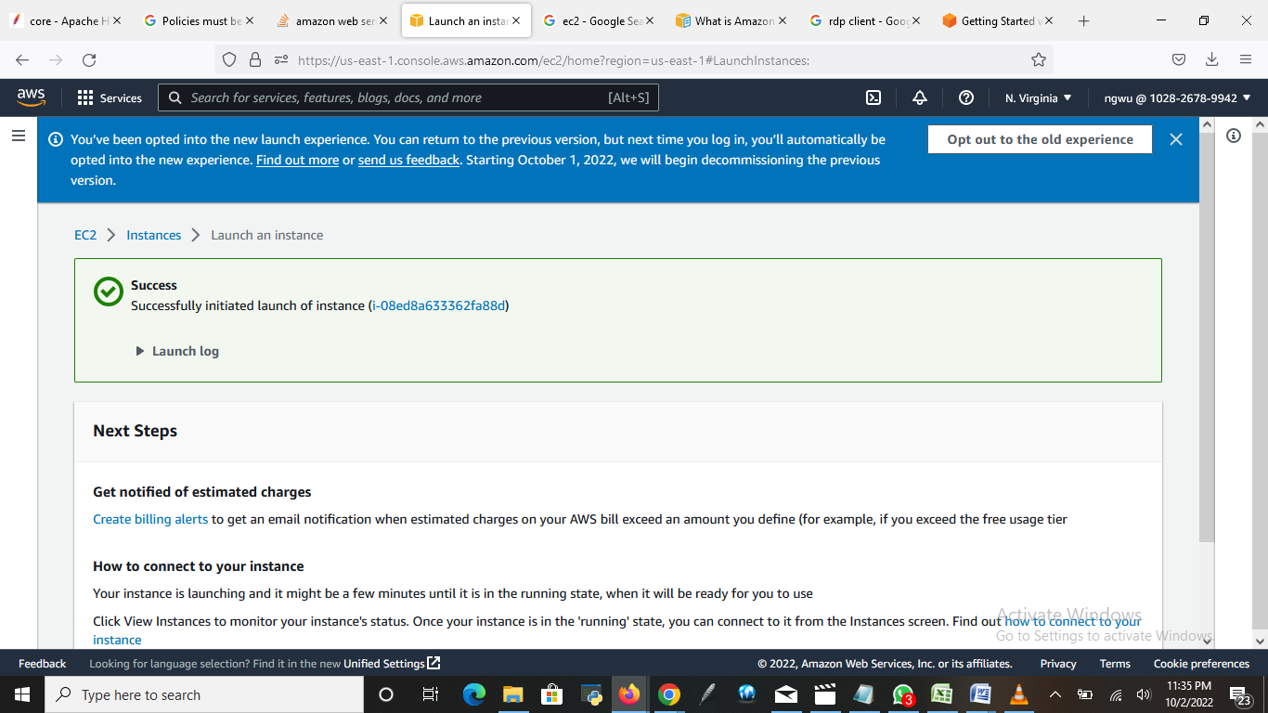

The instance has successfully launched.

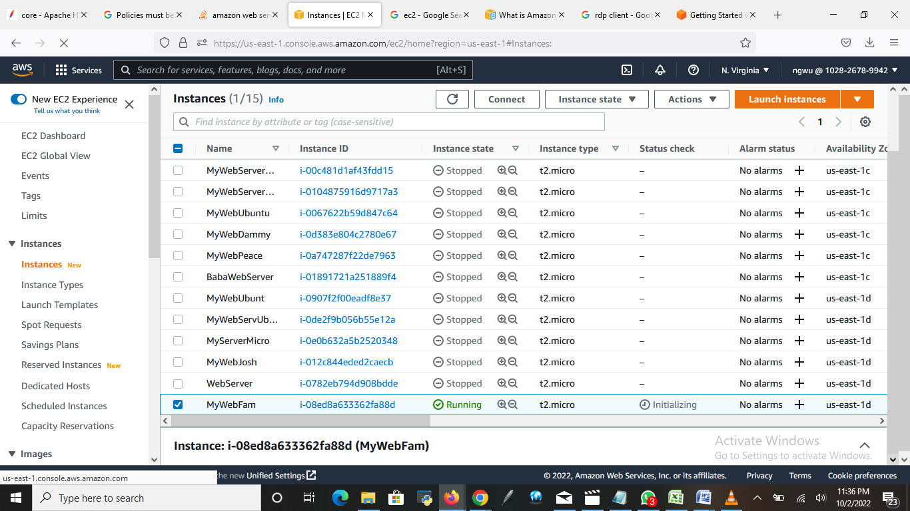

Go to instance you created, select it and click “connect”

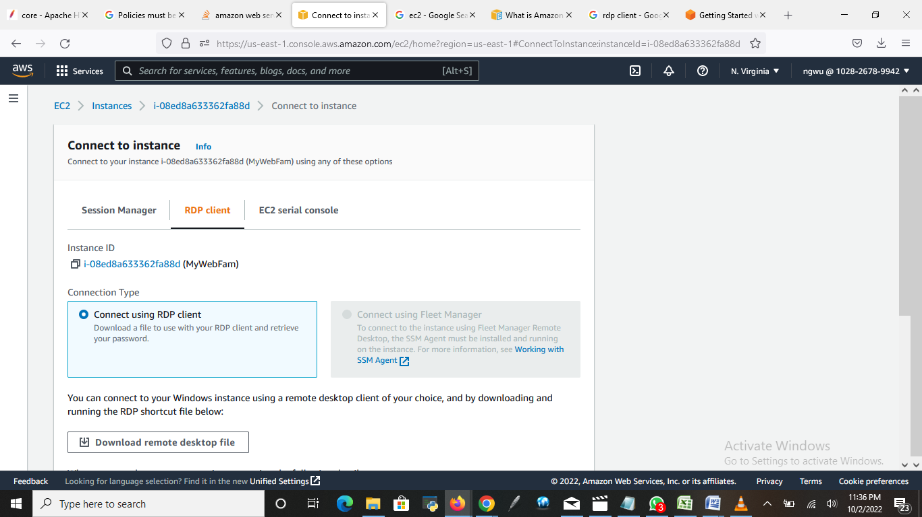

Go to RDP client, choose “connect using RDP client”

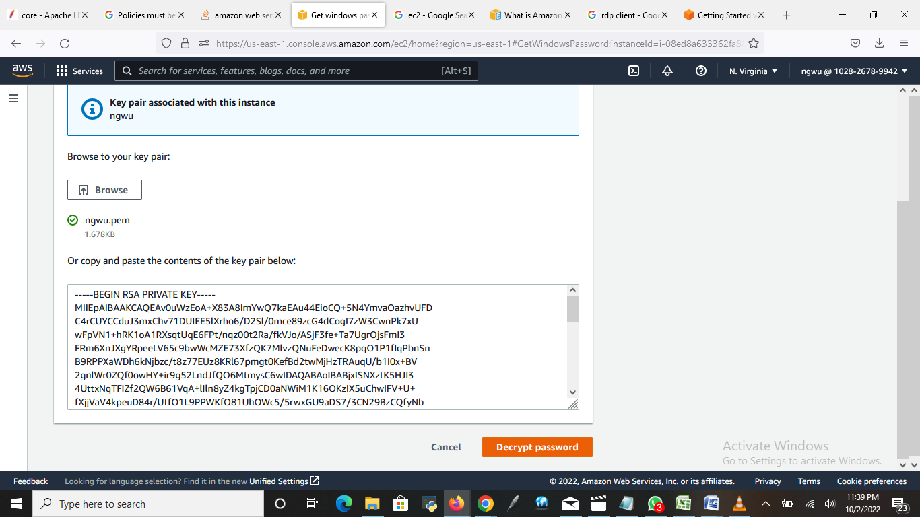

Click on “Browse” to get the key pair you created to decrypt the password, and then click on “Decrypt password”

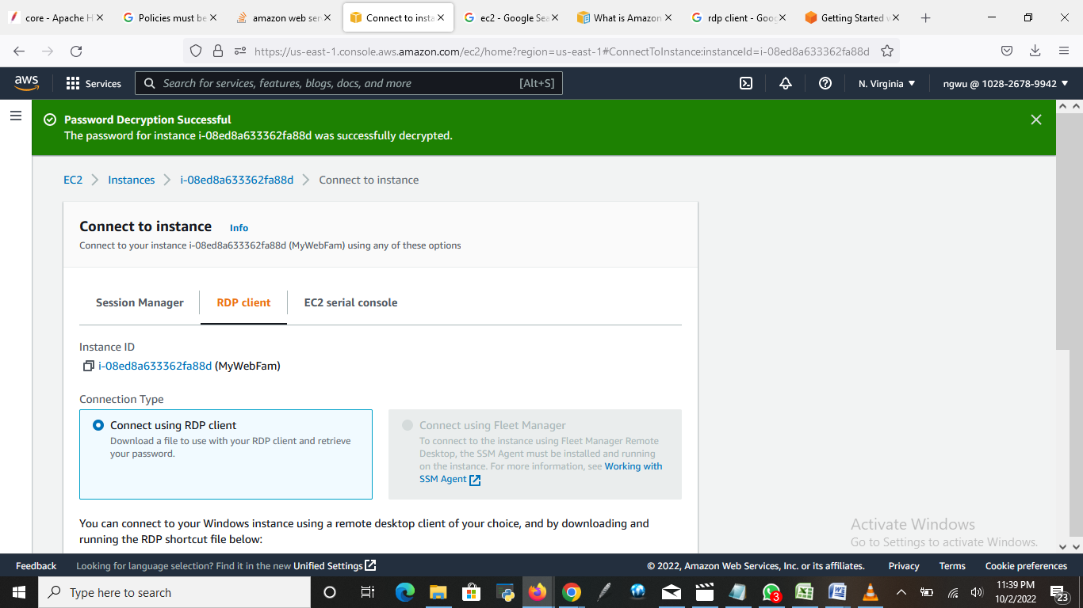

You will see “Password Decryption Successful”

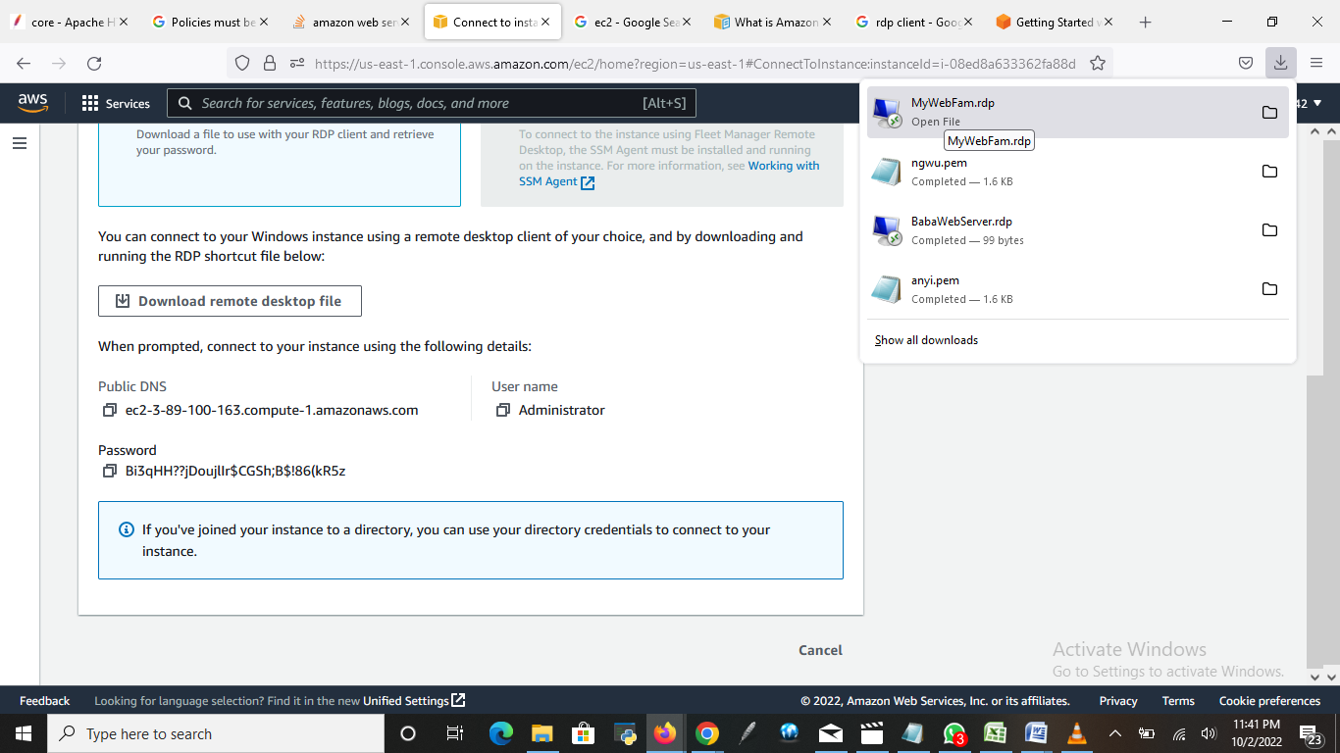

Click on “Download remote desktop file”. At the top right side, you will see the web name “MyWebName.rdp” click on it.

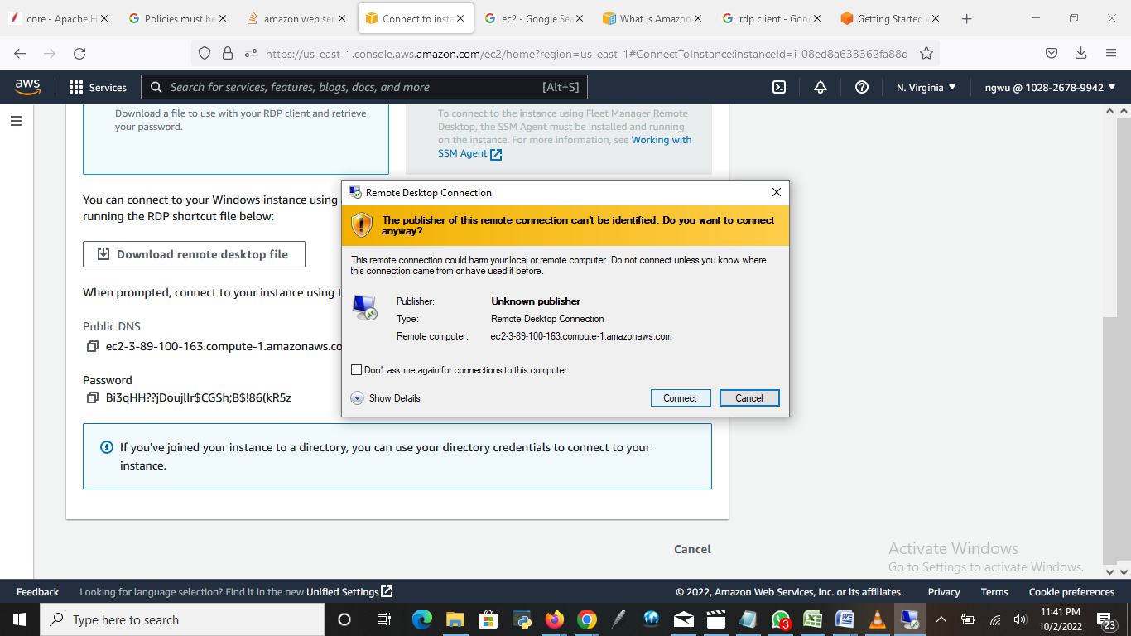

Click on Connect

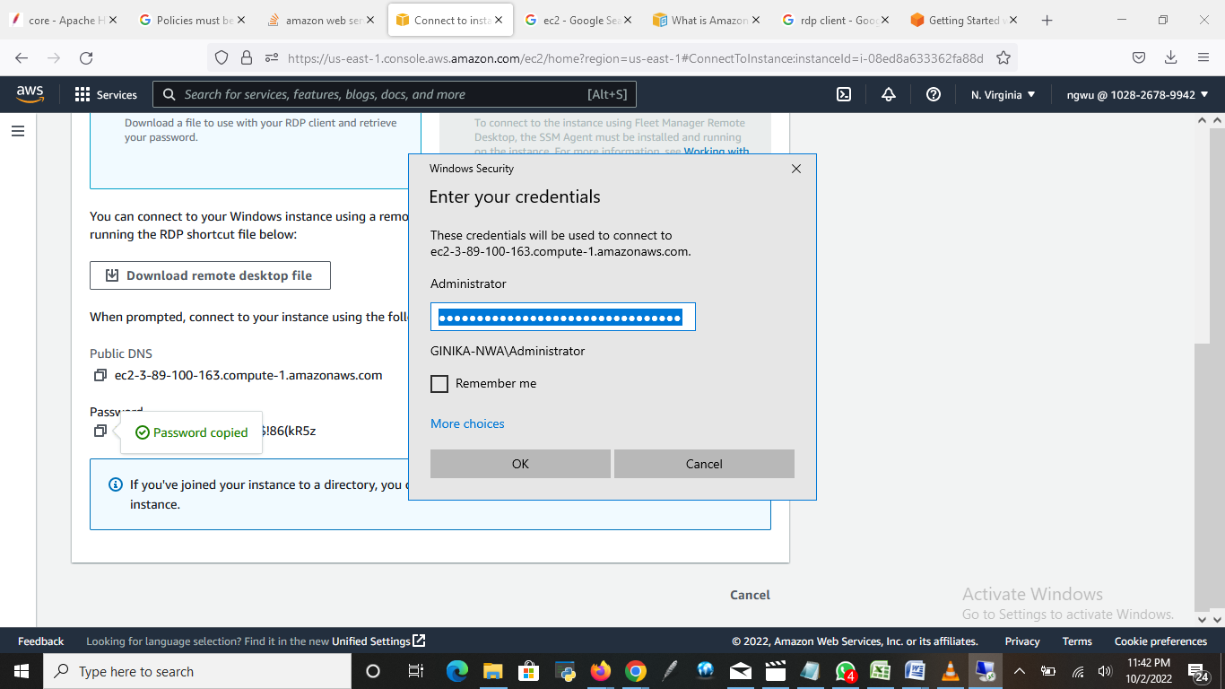

Enter the password you decrypted and click “ok”

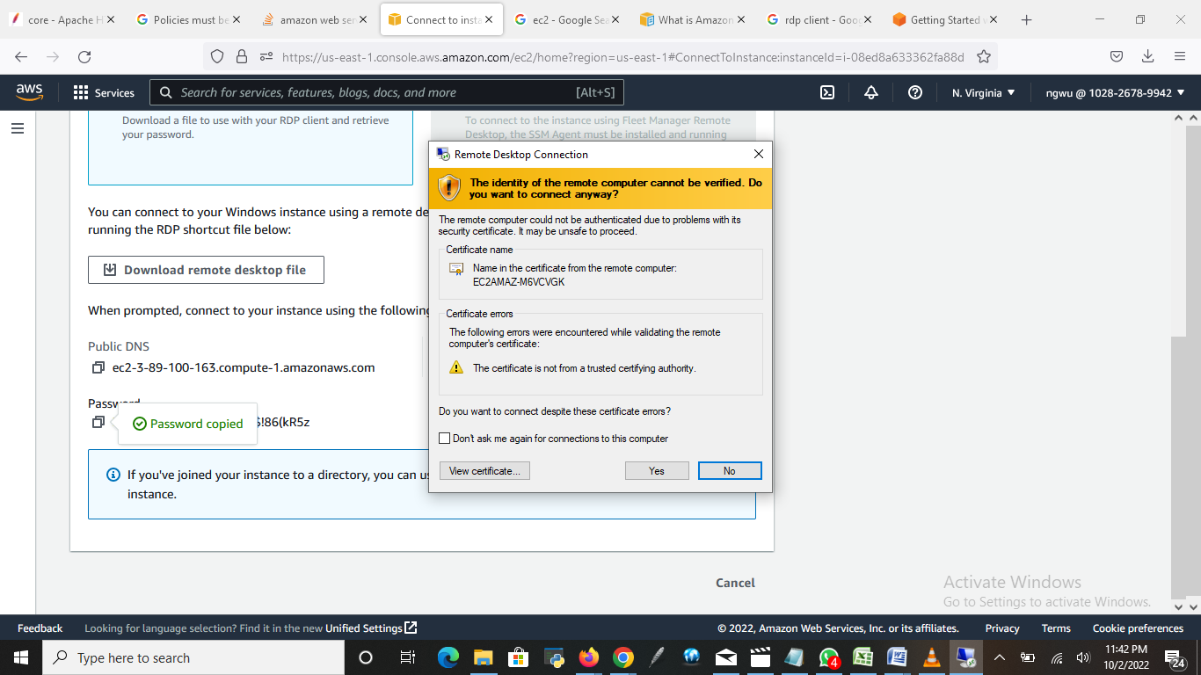

Click “Yes”

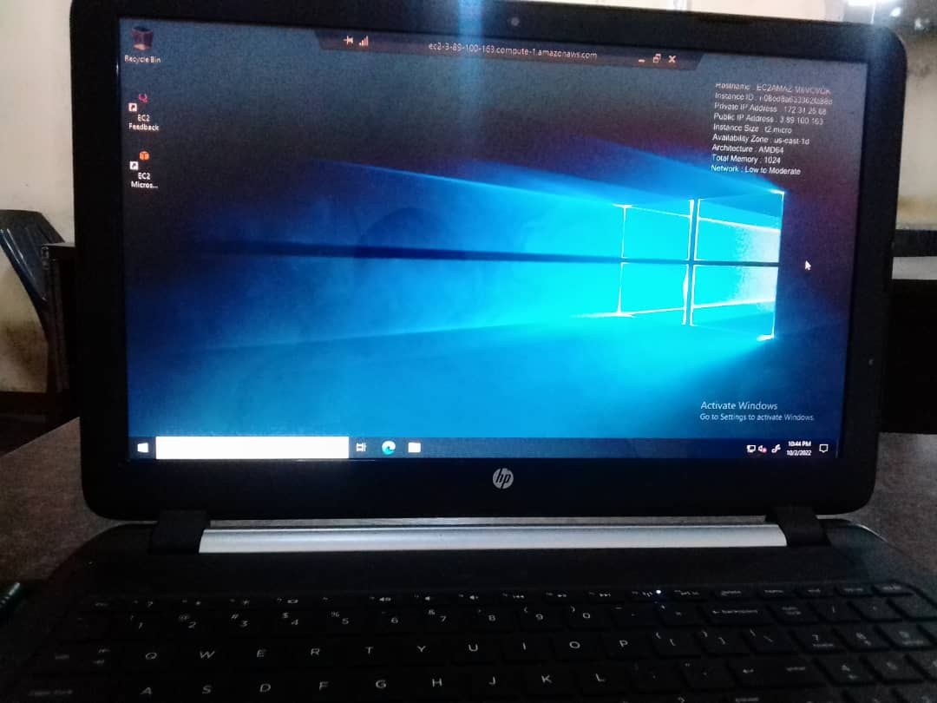

Instance successfully launched using RDP client.