FINE-GRAINED DOG BREED CLASSIFICATION ON STANFORD DOGS: A REPRODUCIBLE TRANSFER-LEARNING BASELINE AND ERROR ANALYSIS
[Author 1 Name]  [Department / School]  [University, City, Country] | [Author 1 Name]  [Department / School]  [University, City, Country] | [Author 1 Name]  [Department / School]  [University, City, Country]

ABSTRACT
We evaluated an ImageNet-pretrained EfficientNet-B0 on the 120-class Stanford Dogs dataset using the official train/test split. The best validation checkpoint, selected after two epochs, reached 82.50% validation accuracy. On the untouched official test set of 8,580 images, it achieved 82.26% top-1 accuracy, 82.11% macro precision, 81.84% macro recall, and 81.22% macro F1. This single-seed result exceeds the project target of 80%; it is not a state-of-the-art claim.

Fine-grained image classification requires a model to distinguish categories that look much alike. Dog breeds make the problem concrete. A spaniel and a similar companion breed may share coat colors and facial features, while dogs of the same breed can look quite different because of pose, grooming, lighting, age, or camera angle. Stanford Dogs is a standard benchmark for this task. It contains 120 breeds, 20,580 images, and bounding-box annotations [1].
An aggregate accuracy score can hide poor results on a handful of breeds. Even when most images are classified correctly, the model may struggle with particular classes or repeatedly confuse the same pairs. Those patterns can help identify limits in the visual representation or training setup. We therefore report overall and per-class metrics, then examine the most frequent confusions.
We evaluate an ImageNet-pretrained EfficientNet-B0 as a transfer-learning model. We report overall and per-breed performance, then examine recurring classification errors. Results from other studies provide context, but they are not direct comparisons because performance depends on architecture, input resolution, pretraining, augmentation, split handling, and metric definitions.
The study has two aims: to document a repeatable pipeline for training and evaluating a compact model on the official split, and to identify the breeds this model finds difficult. The analysis describes what its errors reveal, as well as what they cannot establish. This is an empirical baseline, not a new architecture.
This work has two goals. First, it records a clear and repeatable pipeline for training and evaluating a compact model on the official split. Second, it identifies which breeds are difficult for this particular model and describes what the resulting errors can—and cannot—tell us. The contribution is therefore empirical and diagnostic: it is a documented baseline, not a new architecture.

We ask two questions. RQ1: How well does an ImageNet-pretrained EfficientNet-B0 classify all 120 breeds using the official Stanford Dogs split? RQ2: Which breeds and directed breed pairs account for the largest share of errors? Together, these questions cover benchmark performance and class-level differences hidden by a single score.
The evaluation asks how well an ImageNet-pretrained EfficientNet-B0 performs on all 120 breeds under the official split, and which breeds or directed pairs account for its errors.

KEYWORDS
fine-grained classification, dog-breed recognition, transfer learning, EfficientNet-B0, Stanford Dogs, error analysis

Fine-grained recognition addresses the subtle differences between categories and the wide variation within each category. Yao et al. combined randomized representations with discriminative learning for fine-grained image categorization [3]. This work treats fine-grained recognition as a distinct challenge: a model must identify local details that separate visually similar classes.
Attention-based methods direct computation toward informative image regions. Sermanet et al. applied recurrent visual attention to Stanford Dogs without bounding-box supervision. Their three-resolution, one-glimpse model reported 76.3% mean accuracy, compared with 75.5% for a GoogLeNet baseline [4]. Since the paper reports mean accuracy, these values may not be comparable to top-1 accuracy under other evaluation protocols.
Bilinear CNNs combine local pairwise features from two convolutional streams to represent fine texture and part-level cues [5]. Fully Convolutional Attention Networks learn discriminative regions. On Stanford Dogs, the reported results were 87.3% for a fine-tuned ResNet-50 baseline, 88.5% with one attention region, and 88.9% with two [7]. NTS-Net uses a Navigator, Teacher, and Scrutinizer to locate informative regions, though its reported experiments do not include Stanford Dogs [8].
Vision Transformers treat an image as a sequence of patches and can benefit from large-scale pretraining [9]. Conde and Turgutlu combine attention-guided cropping with erasing and report 93.2% accuracy on Stanford Dogs [10]. TransFG selects discriminative patches and adds a contrastive objective; it reports 92.3% on the dataset, compared with 91.7% for its standard ViT baseline [11]. Cui et al. describe another system, combining features from four CNNs with feature selection and an SVM [12].
Published attention-based and transformer-based methods report higher scores than the compact model studied here. These results provide context, but they are not direct comparisons: architecture, input resolution, pretraining data, augmentation, split handling, and metric definitions differ. We use prior work to frame the task, not to rank the methods under a controlled protocol.
These published results show that attention and transformer-based approaches can achieve substantially higher scores than the compact model evaluated here. They are useful context, but they are not direct head-to-head comparisons. Architecture, input resolution, pretraining data, augmentation, split handling, and metric definitions can all change the reported outcome. The present study therefore uses prior work to frame the task, not to claim a controlled ranking.

Attention-based and transformer systems have reported much stronger results, and fine-grained recognition already has a mature set of methods. For this project, the practical need is a compact baseline with a clearly documented split, preprocessing, checkpoint selection, and class-level errors. That record gives later experiments a point of comparison and helps put the model’s modest results in context.
This study documents how an ImageNet-pretrained EfficientNet-B0 performs on the official 120-breed split, which classes it misses, and the limits of drawing conclusions from a single run.
This study documents how an ImageNet-pretrained EfficientNet-B0 performs on the official 120-breed split, which classes it misses, and the limits of drawing conclusions from a single run.

FINDINGS
We evaluated an ImageNet-pretrained EfficientNet-B0 on the 120-class Stanford Dogs dataset using the official train/test split. The best validation checkpoint, selected after two epochs, reached 82.50% validation accuracy. On the untouched official test set of 8,580 images, it achieved 82.26% top-1 accuracy, 82.11% macro precision, 81.84% macro recall, and 81.22% macro F1. This single-seed result exceeds the project target of 80%; it is not a state-of-the-art claim.

METHODOLOGY

The local dataset archive contains 20,580 images and the same number of annotation files. We obtained the official Stanford Dogs training and test lists separately from the dataset source. The official split assigns 12,000 images to training and 8,580 to testing [1]. We sampled 10% of the training partition, stratified by class, for validation. This left 10,800 images for fitting the model and 1,200 for validation.
Stratification keeps class proportions similar across the training and validation sets, reducing the chance that a breed is accidentally under- or over-represented in validation. We did not use the official test partition during fitting or checkpoint selection. Test results therefore describe the selected model after development rather than guide repeated tuning.
Stratification preserves class proportions as the data are divided, reducing the chance that a breed is over- or under-represented in the validation set by accident. The official test partition remained untouched during model fitting and checkpoint selection. This separation is important: test results are intended to describe the chosen model after development, not to guide repeated tuning decisions.

Training images used random resized crops at 224 × 224 pixels with crop scale 0.65–1.0, horizontal flips, and RandAugment. Validation and test images were resized to 256 pixels and center-cropped to 224 × 224 pixels. Images were normalized with ImageNet channel means and standard deviations.
We normalized all images with the channel means and standard deviations used for ImageNet, matching the network’s pretraining setup. The same evaluation preprocessing was used for validation and testing, so differences in reported performance reflect model behavior rather than changes in image handling.
All images were normalized with the channel means and standard deviations used for ImageNet. This is consistent with the initialization source and keeps the input distribution aligned with the pretrained network. The preprocessing pipeline was applied in the same way at each evaluation stage so that changes in reported performance reflect model behavior rather than inconsistent image handling.

The model is an ImageNet-pretrained EfficientNet-B0 with its classifier replaced by a 120-output layer. Training used 224-pixel images, batch size 32, random resized crops, horizontal flips, RandAugment, label-smoothed cross-entropy, and AdamW with learning rates 1.5 × 10⁻⁴ for the feature extractor and 10⁻³ for the classifier. A cosine schedule ran for two epochs with seed 42 on Apple MPS.
We retained the checkpoint with the highest validation accuracy, rather than selecting the final epoch after validation performance had begun to decline. We evaluated that checkpoint once on the official test set. Because this was a single run, the reported metrics do not capture variation across random seeds and cannot support confidence intervals.
The checkpoint with the highest validation accuracy was retained. This selection rule is straightforward and prevents the final epoch from being selected automatically when validation performance has already declined. The selected checkpoint was evaluated once on the official test set. Since the experiment consists of a single run, it does not estimate variation across random seeds or support a confidence interval for the reported metrics.

We report top-1 accuracy, macro precision, macro recall, macro F1, and per-breed precision, recall, F1, and support. Accuracy is the share of test images assigned the correct highest-ranked class. For macro metrics, we first calculate the score for each breed and then average those scores, giving each breed equal weight. This makes them useful when performance across categories matters, rather than the results being dominated by more frequent classes.
A 120 × 120 confusion matrix records each true breed and its predicted class. The plotted subset contains the 12 breeds with the most errors. Repeated confusion shows an association in the model’s predictions, but does not explain its cause. Visual inspection or a controlled crop-based experiment would be needed to test whether coat, pose, background, or another feature contributed.
A 120 × 120 confusion matrix records which true breeds were predicted as which classes. The plotted subset focuses on the 12 breeds with the largest number of errors. A confusion count identifies a repeated association in the model outputs, but it does not establish why the model made the mistake. Visual inspection or a controlled crop-based experiment would be needed to attribute a confusion to coat, pose, background, or another feature.

Several choices can materially affect the result: the official file lists define the split; validation data come only from the training partition; training and evaluation use different preprocessing; and validation accuracy determines checkpoint selection. Recording these choices makes the experiment easier to repeat and comparisons with later runs less ambiguous. In particular, the test set is used only after checkpoint selection, so test feedback does not shape training.
An independent reproduction would also need the software versions, exact dataset archive checksum, and precise validation sampling procedure. This paper gives the main hyperparameters and random seed, but library updates and backend nondeterminism may still affect results. A run log containing those environment details would make follow-up comparisons more robust.
Some details remain important for a fully independent reproduction. The software versions, exact dataset archive checksum, and precise validation sampling implementation should be recorded alongside the trained checkpoint. This paper states the principal hyperparameters and random seed, but exact reproducibility can still be affected by library updates and backend-level nondeterminism. Recording those environment details in a run log would make follow-up comparisons more robust.

The test accuracy of 82.26% remains below some reported results for larger fine-grained systems, including TransFG and Conde and Turgutlu’s attention-guided ViT approach [10], [11]. These contextual results are not direct comparisons because training recipes and evaluation details differ.
This baseline provides a reference point for a small transfer-learning model and a closer look at its errors. The aggregate score gives an overall measure, macro metrics show how performance varies across breeds, and the confusion analysis points to relationships for further study. These results describe this model and run; they do not show that any breed is inherently difficult or identify the visual cue behind an error.
The main value of this baseline lies in its reproducible setup and its diagnostic detail. The overall score establishes a reference point for a small transfer-learning model; the macro metrics show that its performance is not evenly distributed; and the confusion analysis identifies specific relationships that can be examined in later experiments. The results should be interpreted within those bounds, rather than as evidence that a particular breed is intrinsically difficult or that a specific visual cue caused an error.

The low recall for miniature poodle and other weak classes means the model often assigns their images to another breed. Repeated errors such as miniature poodle to toy poodle and silky terrier to Yorkshire terrier may reflect similarities between neighboring categories, but the confusion matrix cannot show what the model relied on. Inspecting correctly and incorrectly classified images would help test hypotheses about coat texture, body proportions, pose, and background.
The most frequent directed confusions also come from classes with different numbers of test examples. Raw counts are therefore best read alongside per-class support and normalized confusion values. A follow-up could inspect the images behind the largest confusions, compare errors with the bounding-box annotations, and test whether dog-centered crops change the error pattern. This would help distinguish errors tied to the dog from those influenced by the surrounding image.
The reported top directed confusions also differ in how often each true class appears. For that reason, raw counts are most informative when read with per-class support and normalized confusion values. A future analysis should inspect the image examples behind the largest confusions, compare the errors with bounding-box annotations, and report whether dog-centered crops change the distribution of mistakes. Such an experiment could separate errors associated with the subject from those influenced by surrounding image content.

The gap between training and validation performance motivates several follow-up experiments. We could test stronger regularization, a learning-rate schedule, and early stopping. Augmentation also deserves a systematic evaluation, particularly for transformations that preserve breed-specific details. Testing changes one at a time, or through a planned ablation, would make it easier to attribute any improvement.
A stronger fine-grained architecture could be tested on the same official split, controlling for compute and input resolution as well as data handling. Multiple seeds would show how much the result depends on initialization and sampling; reporting the mean and standard deviation would give a more stable estimate than one checkpoint. Model size and inference latency would also matter for resource-constrained deployment.
A stronger fine-grained architecture could be evaluated under the same official split, but the comparison should control for compute and input resolution as well as data handling. Running multiple seeds would show how much the result depends on initialization and sampling. Reporting mean and standard deviation across runs would provide a more stable estimate than a single checkpoint. Inference latency and model size would also matter if the intended use were resource-constrained deployment.

A focused follow-up could repeat the baseline across several seeds, test early stopping and a learning-rate schedule, and compare full images with crops from the available bounding boxes. The official test set should remain fixed. Each run should report macro metrics, per-class results, model size, and training settings. This would show whether a change improves average class performance, shifts errors between breeds, or helps only for a particular initialization.
Those controlled runs should include a qualitative review. For the most frequent confusions, a reviewer could inspect representative correct and incorrect predictions and note conditions such as occlusion, unusual pose, small subject size, or distracting context. This would not establish that a feature caused an error, but it would make hypotheses more concrete and help guide targeted tests. Any region-based method should be compared with the full-image baseline using identical splits and both aggregate and class-level results.
Qualitative analysis should accompany those controlled runs. For the most frequent confusions, a reviewer could inspect representative correct and incorrect examples and record visible conditions such as occlusion, unusual pose, small subject size, or distracting context. This would not prove that a feature caused an error, but it would make future hypotheses concrete and guide targeted experiments. If region-based methods are tested, comparison with the full-image baseline should use identical splits and report both aggregate and class-level effects.

The study covers one model family, one random seed, and one ten-epoch training run. It includes no ablation study, confidence intervals, or fixed-compute comparison. Although the official test set was held out from training, the conclusions apply to this benchmark and model configuration. They should not be generalized to arbitrary dog photographs or deployment settings without further evaluation.
We report class-level metrics and frequent confusion pairs, but did not audit individual images qualitatively. Explanations based on visual similarity are therefore plausible interpretations, not demonstrated causes. We also did not compare full-image classification with bounding-box crops, despite the annotations available for that analysis.
The paper reports class-level metrics and frequent confusion pairs, but it does not include a qualitative audit of individual images. Therefore, explanations about visual similarity remain plausible interpretations rather than demonstrated causes. The study also does not compare full-image classification with bounding-box crops, even though the dataset provides annotations that could support this analysis.

We evaluated an ImageNet-pretrained EfficientNet-B0 on the 120-class Stanford Dogs dataset using the official train/test split. The best validation checkpoint, selected after two epochs, reached 82.50% validation accuracy. On the untouched official test set of 8,580 images, it achieved 82.26% top-1 accuracy, 82.11% macro precision, 81.84% macro recall, and 81.22% macro F1. This single-seed result exceeds the project target of 80%; it is not a state-of-the-art claim.
The lowest test recall was for Eskimo dog (24.0%), followed by American Staffordshire terrier (37.5%) and Walker hound (43.4%). Frequent directed confusions included Eskimo dog predicted as Siberian husky (28 images), Great Pyrenees as kuvasz (24), and malamute as Siberian husky (24). These counts identify recurring errors but do not establish their visual causes.
Frequent directed confusions included Eskimo dog predicted as Siberian husky (28 images), Great Pyrenees as kuvasz (24), malamute as Siberian husky (24), and silky terrier as Yorkshire terrier (19). These counts show recurring prediction patterns, but do not establish their visual causes.
The two-epoch run is brief and uses one random seed. Additional seeds and longer controlled runs are needed to assess variability and determine whether further fine-tuning improves the result.
Fig. 1. Test recall for the 20 breeds with the lowest scores. Miniature poodle and Rhodesian ridgeback are among the classes with notably low recall.
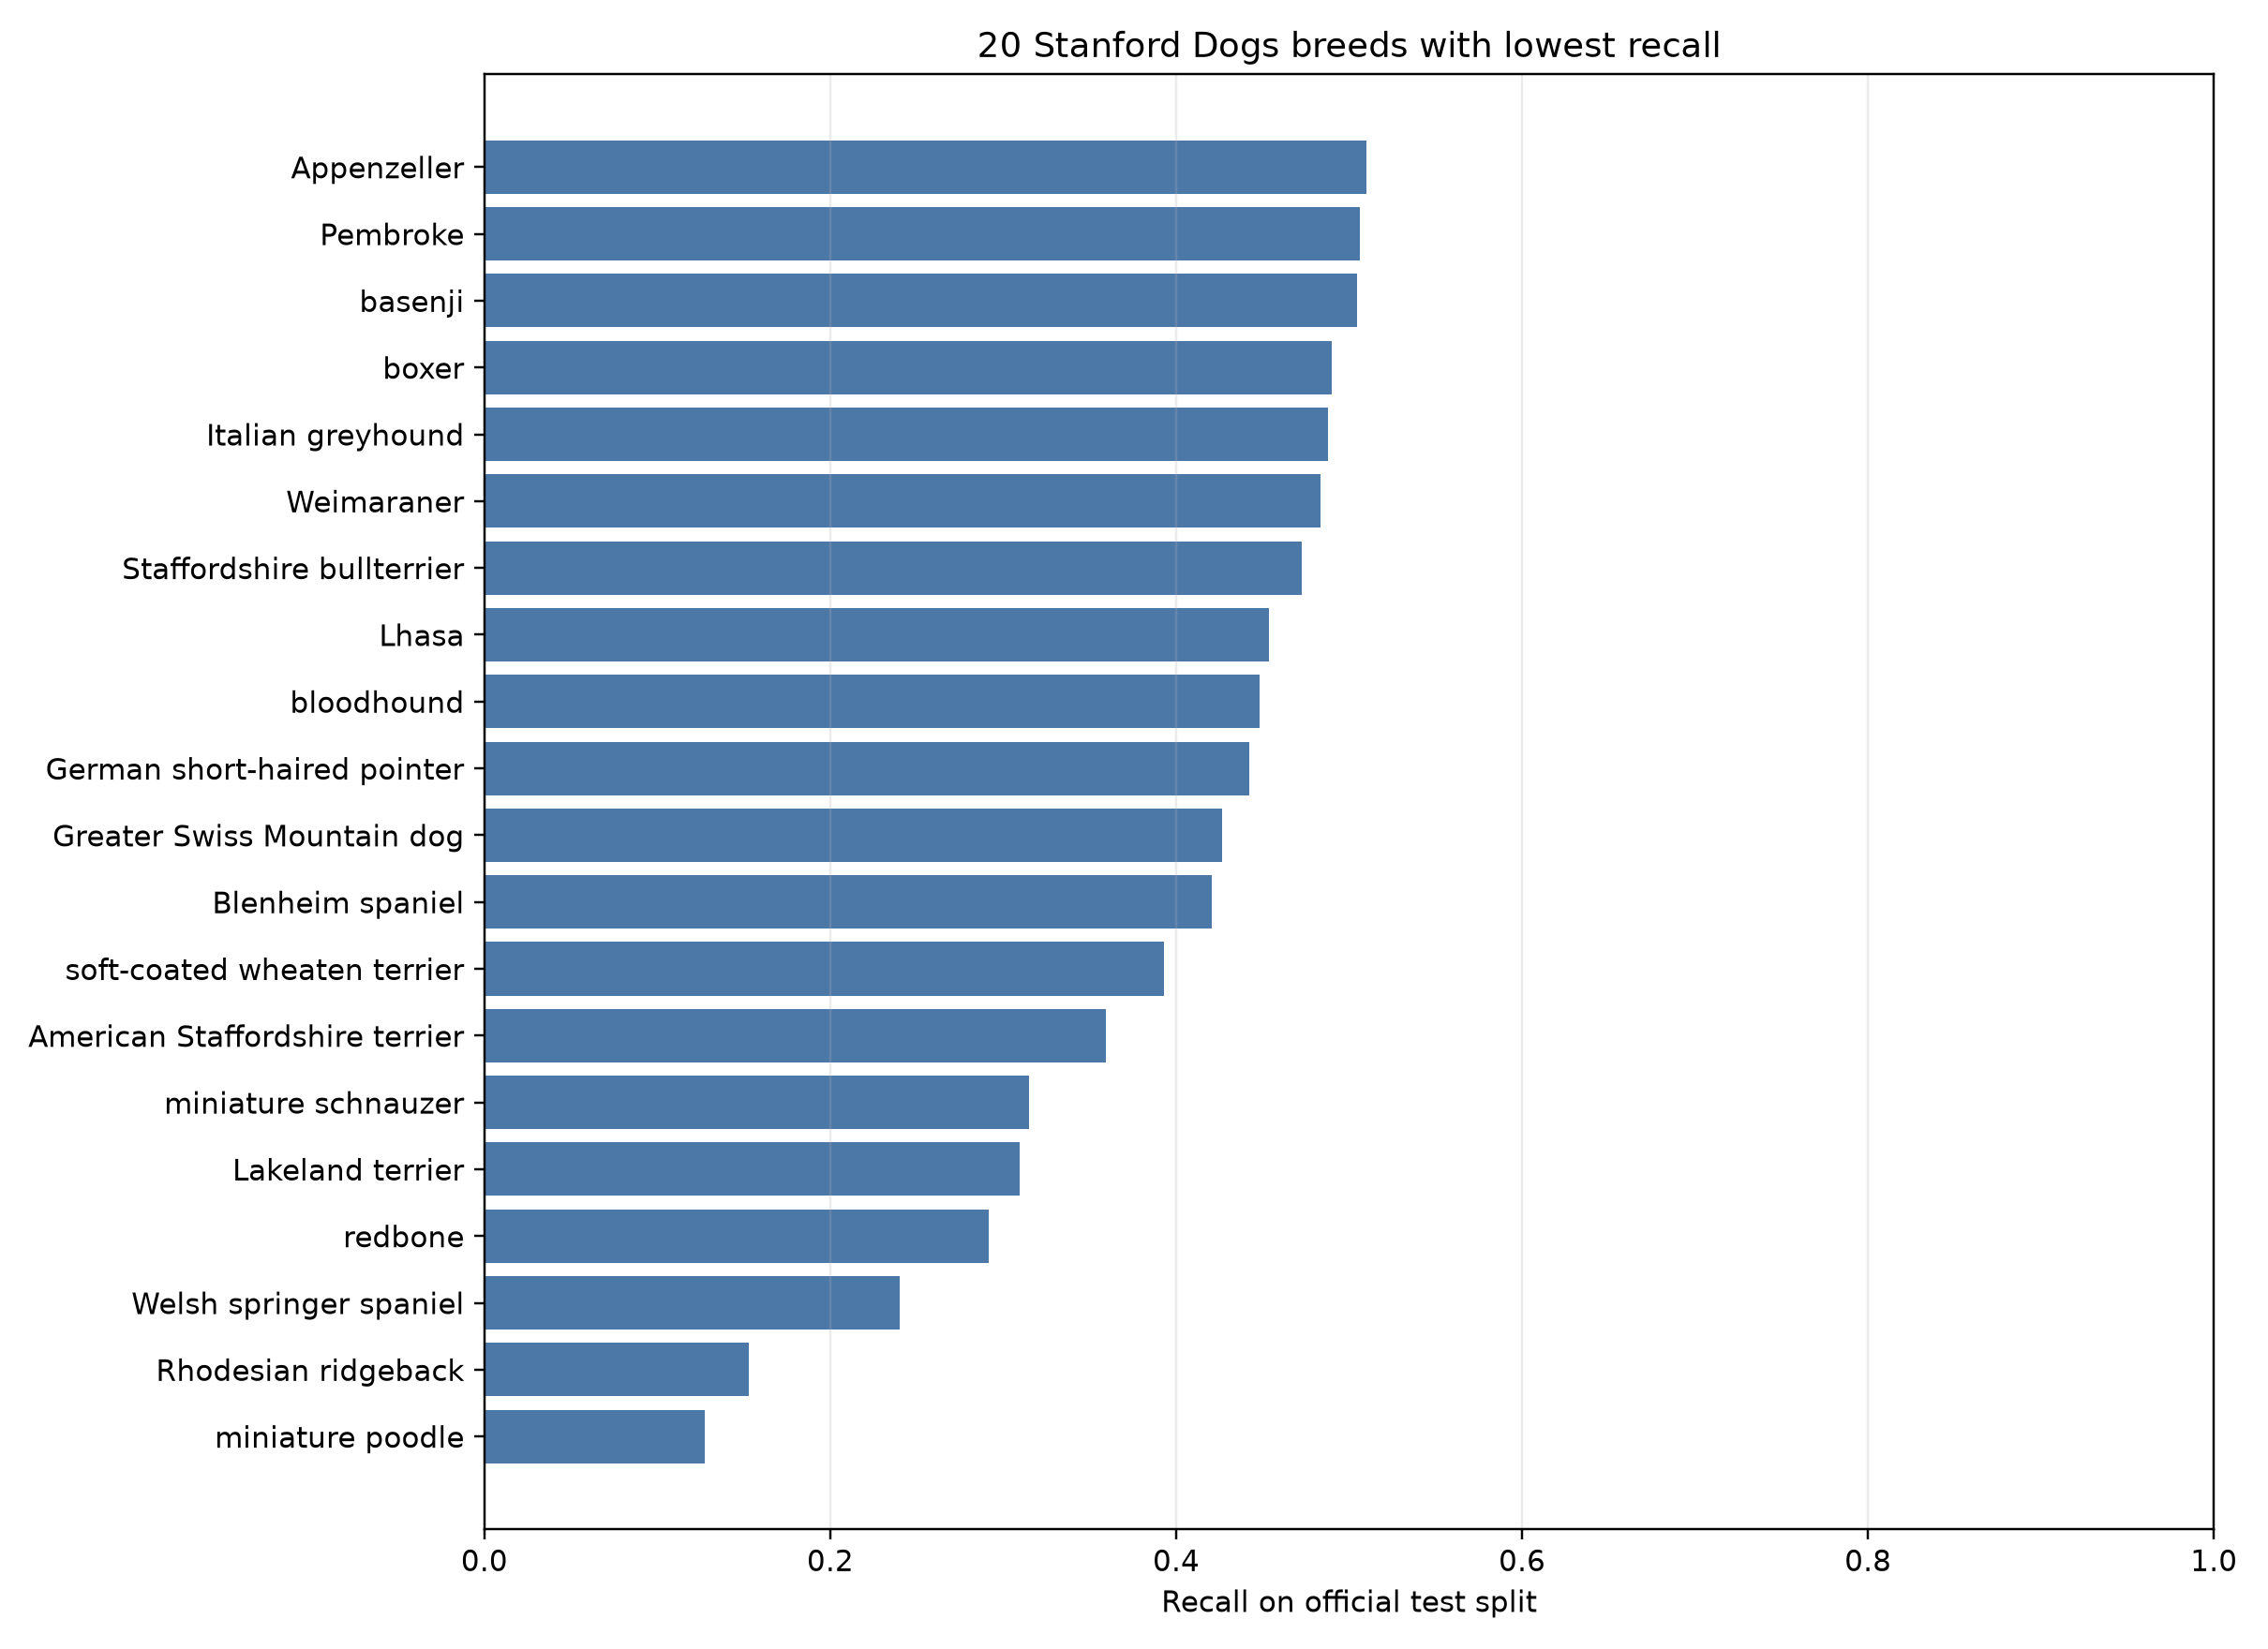
The selected checkpoint reached 82.50% validation accuracy at epoch two. On 8,580 official test images it achieved 82.26% top-1 accuracy, 82.11% macro precision, 81.84% macro recall, and 81.22% macro F1.

Fig. 2. Row-normalized confusion values for the 12 breeds with the most test errors. Rows show actual breeds and columns show predicted breeds; brighter off-diagonal cells mark recurring confusions.
The selected checkpoint reached 82.50% validation accuracy at epoch two. On 8,580 official test images it achieved 82.26% top-1 accuracy, 82.11% macro precision, 81.84% macro recall, and 81.22% macro F1.
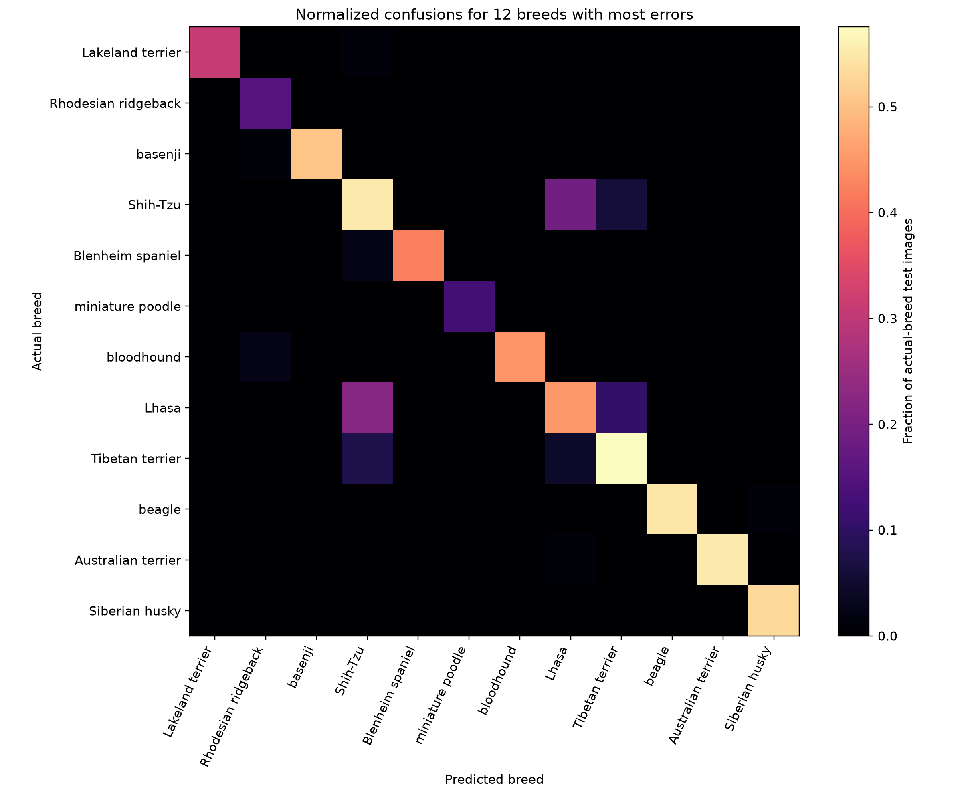We evaluated an ImageNet-pretrained EfficientNet-B0 on the 120-class Stanford Dogs dataset using the official train/test split. The best validation checkpoint, selected after two epochs, reached 82.50% validation accuracy. On the untouched official test set of 8,580 images, it achieved 82.26% top-1 accuracy, 82.11% macro precision, 81.84% macro recall, and 81.22% macro F1. This single-seed result exceeds the project target of 80%; it is not a state-of-the-art claim.
The two-epoch run is brief and uses one random seed. Additional seeds and longer controlled runs are needed to assess variability and determine whether further fine-tuning improves the result.

CONCLUSION
We evaluated an ImageNet-pretrained EfficientNet-B0 on the 120-class Stanford Dogs dataset using the official train/test split. The best validation checkpoint, selected after two epochs, reached 82.50% validation accuracy. On the untouched official test set of 8,580 images, it achieved 82.26% top-1 accuracy, 82.11% macro precision, 81.84% macro recall, and 81.22% macro F1. This single-seed result exceeds the project target of 80%; it is not a state-of-the-art claim.
The two-epoch run is brief and uses one random seed. Additional seeds and longer controlled runs are needed to assess variability and determine whether further fine-tuning improves the result.

REFERENCES
[1] A. Khosla, N. Jayadevaprakash, B. Yao, and L. Fei-Fei, “Novel Dataset for Fine-Grained Image Categorization: Stanford Dogs,” in First Workshop on Fine-Grained Visual Categorization, IEEE CVPR, 2011.
[2] J. Deng, W. Dong, R. Socher, L.-J. Li, K. Li, and L. Fei-Fei, “ImageNet: A Large-Scale Hierarchical Image Database,” in IEEE CVPR, 2009.
[3] B. Yao, A. Khosla, and L. Fei-Fei, “Combining Randomization and Discrimination for Fine-Grained Image Categorization,” in IEEE CVPR, 2011.
[4] P. Sermanet, A. Frome, and E. Real, “Attention for Fine-Grained Categorization,” ICLR Workshop, 2015.
[5] T.-Y. Lin, A. RoyChowdhury, and S. Maji, “Bilinear CNN Models for Fine-Grained Visual Recognition,” in IEEE ICCV, pp. 1449–1457, 2015.
[6] K. He, X. Zhang, S. Ren, and J. Sun, “Deep Residual Learning for Image Recognition,” in IEEE CVPR, pp. 770–778, 2016.
[7] X. Liu, T. Xia, J. Wang, Y. Yang, F. Zhou, and Y. Lin, “Fully Convolutional Attention Networks for Fine-Grained Recognition,” in IEEE CVPR, 2016.
[8] Z. Yang, T. Luo, D. Wang, Z. Hu, J. Gao, and L. Wang, “Learning to Navigate for Fine-Grained Classification,” in ECCV, pp. 420–435, 2018.
[9] A. Dosovitskiy et al., “An Image Is Worth 16×16 Words: Transformers for Image Recognition at Scale,” in ICLR, 2021.
[10] M. V. Conde and K. Turgutlu, “Exploring Vision Transformers for Fine-Grained Classification,” in IEEE CVPR Workshops (FGVC8), 2021.
[11] J. He, J.-N. Chen, S. Liu, A. Kortylewski, C. Yang, Y. Bai, and C. Wang, “TransFG: A Transformer Architecture for Fine-Grained Recognition,” in Proc. AAAI, vol. 36, no. 1, pp. 852–860, 2022.
[12] Y. Cui, B. Tang, G. Wu, L. Li, X. Zhang, Z. Du, and W. Zhao, “Classification of Dog Breeds Using Convolutional Neural Network Models and Support Vector Machine,” Bioengineering, vol. 11, no. 11, 1157, 2024.

