FINE-GRAINED DOG BREED CLASSIFICATION ON STANFORD DOGS: A REPRODUCIBLE TRANSFER-LEARNING BASELINE AND ERROR ANALYSIS
[Author 1 Name]  [Department / School]  [University, City, Country] | [Author 1 Name]  [Department / School]  [University, City, Country] | [Author 1 Name]  [Department / School]  [University, City, Country]

ABSTRACT
Fine-grained dog-breed recognition is difficult because many breeds share visible traits, while individuals within one breed can differ in pose, coat, age, and background. This paper reports a reproducible transfer-learning baseline using an ImageNet-pretrained ResNet-18 on the 120-class Stanford Dogs dataset. The experiment follows the official train/test partition, reserves a stratified portion of the training data for validation, and selects a checkpoint using validation accuracy. On the untouched test set of 8,580 images, the selected model reaches 66.08% top-1 accuracy and 64.92% macro F1. Errors are unevenly distributed: miniature poodle recall is 12.7%, and several frequent mistakes occur between visually related breeds. Training accuracy rises while validation performance falls after epoch five, indicating overfitting in this run. The study documents a practical baseline and class-level error patterns rather than proposing a new architecture or claiming state-of-the-art performance.

INTRODUCTION
Fine-grained image classification asks a model to distinguish categories that are visually close. Dog breeds make this challenge easy to see: a spaniel and a similar-looking companion breed may share coat colors and facial shape, while two dogs from the same breed can appear quite different because of pose, grooming, lighting, age, or camera angle. The Stanford Dogs dataset provides a common benchmark for this task, with 120 breeds, 20,580 images, and bounding-box annotations [1].
A single aggregate accuracy score does not tell the whole story in a 120-class problem. A model may correctly classify most examples yet perform poorly on a small number of breeds. It may also make errors in consistent pairs, which can point to limits in the visual representation or the available training procedure. For that reason, this study reports both overall metrics and class-level results, and it examines the most frequent confusions alongside the overall score.
The experiment uses an ImageNet-pretrained ResNet-18 as a transfer-learning baseline. Residual networks provide a well-established convolutional architecture [6], and pretrained weights offer a practical starting point when training data are limited. The final classification layer is adapted to the 120 Stanford Dogs classes and the network is fine-tuned on the official training partition.
This work has two goals. First, it records a clear and repeatable pipeline for training and evaluating a compact model on the official split. Second, it identifies which breeds are difficult for this particular model and describes what the resulting errors can—and cannot—tell us. The contribution is therefore empirical and diagnostic: it is a documented baseline, not a new architecture.

A. Research Questions
The evaluation is organized around two questions. RQ1 asks how well an ImageNet-pretrained ResNet-18 performs on all 120 breeds when trained with the official Stanford Dogs split. RQ2 asks which breeds and directed breed pairs account for the largest share of its errors. These questions focus the analysis on both benchmark-level performance and the uneven behavior hidden by a single score.

KEYWORDS
fine-grained classification, dog-breed recognition, transfer learning, ResNet-18, Stanford Dogs, error analysis

LITERATURE REVIEW
Fine-grained recognition has long addressed the gap between subtle differences across categories and broad appearance variation within a category. Yao et al. explored combining randomized representations with discriminative learning for fine-grained image categorization [3]. This line of work treats the task as more than ordinary object recognition: the model needs to discover which local details separate neighboring classes.
Attention-based methods attempt to direct computation toward informative regions. Sermanet et al. applied recurrent visual attention to Stanford Dogs without relying on bounding-box supervision. Their three-resolution, one-glimpse model reported 76.3% mean accuracy, compared with 75.5% for a GoogLeNet baseline [4]. Because the paper reports mean accuracy, these figures should not be assumed to match top-1 accuracy under every evaluation protocol.
Bilinear CNNs capture local pairwise feature interactions by combining information from two convolutional streams, an approach designed to represent fine visual texture and part-level cues [5]. Fully Convolutional Attention Networks learn discriminative regions; their reported Stanford Dogs results include 87.3% for a fine-tuned ResNet-50 baseline, 88.5% with one attention region, and 88.9% with two regions [7]. NTS-Net uses a Navigator, Teacher, and Scrutinizer to find informative regions, although its reported experiments do not include Stanford Dogs [8].
Vision Transformers represent an image as a sequence of patches and can benefit from large-scale pretraining [9]. Conde and Turgutlu combine attention-guided cropping and erasing and report 93.2% accuracy on Stanford Dogs [10]. TransFG selects discriminative patches and adds a contrastive objective; it reports 92.3% on Stanford Dogs against 91.7% for its standard ViT baseline [11]. Cui et al. describe a separate system that combines features from four CNNs, feature selection, and an SVM [12].
These published results show that attention and transformer-based approaches can achieve substantially higher scores than the compact model evaluated here. They are useful context, but they are not direct head-to-head comparisons. Architecture, input resolution, pretraining data, augmentation, split handling, and metric definitions can all change the reported outcome. The present study therefore uses prior work to frame the task, not to claim a controlled ranking.

GAP ANALYSIS
Prior work has reported substantially stronger results with attention-based and transformer-based systems, and the benchmark already has a mature set of fine-grained methods. The remaining practical need for this project is a transparent, compact baseline whose split, preprocessing, checkpoint selection, and class-level errors are documented together. This makes it possible to interpret a modest model in context and gives later experiments a reproducible point of comparison.
The study does not claim a new architecture or a direct comparison with published systems. Its specific gap is empirical: documenting how a commonly available ImageNet-pretrained ResNet-18 behaves on the official 120-breed split, including the classes it misses and the limitations of a single run. The analysis addresses two questions: how well does this baseline classify the official test set, and which breeds or breed pairs account for recurring errors?

FINDINGS
The selected checkpoint achieved 66.08% top-1 accuracy and 64.92% macro F1 on 8,580 official test images. Validation accuracy peaked at 65.50% at epoch five, while training accuracy reached 93.3% and validation accuracy fell to 59.7% by epoch ten. Miniature poodle had the lowest recall (12.7%), followed by Rhodesian ridgeback (15.3%) and Welsh springer spaniel (24.0%). Frequent mistakes included Blenheim spaniel predicted as Japanese spaniel (36 images) and miniature poodle predicted as toy poodle (29 images).

METHODOLOGY

A. Dataset and Data Partitioning
The local dataset archive contains 20,580 images and 20,580 corresponding annotation files. The experiment uses the official Stanford Dogs training and test lists, obtained separately from the dataset source. The official partition assigns 12,000 images to training and 8,580 to testing [1]. A stratified 10% sample of the official training partition—1,200 images—was set aside for validation, leaving 10,800 images for fitting the model.
Stratification preserves class proportions as the data are divided, reducing the chance that a breed is over- or under-represented in the validation set by accident. The official test partition remained untouched during model fitting and checkpoint selection. This separation is important: test results are intended to describe the chosen model after development, not to guide repeated tuning decisions.

B. Image Preprocessing and Augmentation
Images were processed at 224 × 224 pixels. During training, random resized crops used a scale range of 0.7 to 1.0, horizontal flips were applied, and brightness, contrast, and saturation were varied mildly. These transformations expose the model to changes in framing and appearance while retaining the dog as the main object. Validation and test images were resized to 256 pixels and center-cropped to 224 × 224, yielding a deterministic evaluation pipeline.
All images were normalized with the channel means and standard deviations used for ImageNet. This is consistent with the initialization source and keeps the input distribution aligned with the pretrained network. The preprocessing pipeline was applied in the same way at each evaluation stage so that changes in reported performance reflect model behavior rather than inconsistent image handling.

C. Model and Optimization
The classifier is an ImageNet-pretrained ResNet-18 [6]. Its final fully connected layer was replaced with a 120-output layer, one output for each breed. All model parameters were fine-tuned using cross-entropy loss and AdamW, with a learning rate of 3 × 10⁻⁴ and weight decay of 10⁻⁴. Training used batches of 32 for ten epochs and random seed 42. The run used Apple’s MPS backend.
The checkpoint with the highest validation accuracy was retained. This selection rule is straightforward and prevents the final epoch from being selected automatically when validation performance has already declined. The selected checkpoint was evaluated once on the official test set. Since the experiment consists of a single run, it does not estimate variation across random seeds or support a confidence interval for the reported metrics.

D. Evaluation Measures
The evaluation reports top-1 accuracy, macro precision, macro recall, and macro F1, as well as per-breed precision, recall, F1, and support. Accuracy is the proportion of test images assigned the correct top-ranked class. Macro averaging first computes a metric separately for each breed and then gives each breed equal weight. This is useful when the goal is to understand performance across categories rather than letting the more frequent categories dominate the summary.
A 120 × 120 confusion matrix records which true breeds were predicted as which classes. The plotted subset focuses on the 12 breeds with the largest number of errors. A confusion count identifies a repeated association in the model outputs, but it does not establish why the model made the mistake. Visual inspection or a controlled crop-based experiment would be needed to attribute a confusion to coat, pose, background, or another feature.

E. Reproducibility Considerations
The pipeline records several choices that can materially affect the result: the official file lists define the split, validation data come only from the training partition, the preprocessing differs between training and evaluation, and the checkpoint is selected by validation accuracy. Keeping these decisions explicit makes it easier to repeat the experiment and reduces ambiguity when comparing it with later runs. In particular, using the official test set only after checkpoint selection avoids allowing test feedback to shape the training procedure.
Some details remain important for a fully independent reproduction. The software versions, exact dataset archive checksum, and precise validation sampling implementation should be recorded alongside the trained checkpoint. This paper states the principal hyperparameters and random seed, but exact reproducibility can still be affected by library updates and backend-level nondeterminism. Recording those environment details in a run log would make follow-up comparisons more robust.

FURTHER DISCUSSION
The test accuracy of 66.08% is lower than the published numbers for larger fine-grained systems such as TransFG and the attention-guided ViT approach of Conde and Turgutlu [10], [11]. This result is unsurprising given that the present experiment uses a compact ResNet-18, a 224-pixel input, and one training run. The methods also use different training recipes and potentially different evaluation details. A controlled comparison would require matching the split, image resolution, augmentation, pretraining, and metric calculation.
The main value of this baseline lies in its reproducible setup and its diagnostic detail. The overall score establishes a reference point for a small transfer-learning model; the macro metrics show that its performance is not evenly distributed; and the confusion analysis identifies specific relationships that can be examined in later experiments. The results should be interpreted within those bounds, rather than as evidence that a particular breed is intrinsically difficult or that a specific visual cue caused an error.

A. Interpreting Per-Breed Errors
The low recall for miniature poodle and other weak classes indicates that the model often assigns their images to a different class. Frequent confusions such as miniature poodle to toy poodle and silky terrier to Yorkshire terrier are plausible cases of neighboring visual categories, but a confusion matrix cannot show what the model attended to. Breed-level inspection of correctly and incorrectly classified images would be needed to test hypotheses about coat texture, body proportions, pose, or background.
The reported top directed confusions also differ in how often each true class appears. For that reason, raw counts are most informative when read with per-class support and normalized confusion values. A future analysis should inspect the image examples behind the largest confusions, compare the errors with bounding-box annotations, and report whether dog-centered crops change the distribution of mistakes. Such an experiment could separate errors associated with the subject from those influenced by surrounding image content.

B. Overfitting and Practical Improvements
The training-validation gap suggests several reasonable follow-up experiments. Stronger regularization, a learning-rate schedule, and early stopping could reduce overfitting. Data augmentation could also be evaluated more systematically, especially transformations that preserve breed-specific details. These changes should be tested one at a time or in a planned ablation so that improvements can be attributed to a particular choice.
A stronger fine-grained architecture could be evaluated under the same official split, but the comparison should control for compute and input resolution as well as data handling. Running multiple seeds would show how much the result depends on initialization and sampling. Reporting mean and standard deviation across runs would provide a more stable estimate than a single checkpoint. Inference latency and model size would also matter if the intended use were resource-constrained deployment.

C. Implications for a Follow-Up Study
A focused follow-up could begin with a small, pre-registered set of experiments: repeat the baseline across several seeds; test early stopping and a learning-rate schedule; and compare full images with images cropped using the available bounding boxes. Each run should retain the same official test set and report macro metrics, per-class results, model size, and training settings. This design would reveal whether changes improve average class performance, merely move errors between breeds, or help only under a particular random initialization.
Qualitative analysis should accompany those controlled runs. For the most frequent confusions, a reviewer could inspect representative correct and incorrect examples and record visible conditions such as occlusion, unusual pose, small subject size, or distracting context. This would not prove that a feature caused an error, but it would make future hypotheses concrete and guide targeted experiments. If region-based methods are tested, comparison with the full-image baseline should use identical splits and report both aggregate and class-level effects.

D. Limitations
This study is limited to one model family, one random seed, and a single ten-epoch training run. It includes no ablation study, confidence intervals, or fixed-compute comparison. The test set is official and was reserved from training, but all conclusions still concern one benchmark and one model configuration. They should not be generalized to arbitrary dog photographs or deployment settings without additional evaluation.
The paper reports class-level metrics and frequent confusion pairs, but it does not include a qualitative audit of individual images. Therefore, explanations about visual similarity remain plausible interpretations rather than demonstrated causes. The study also does not compare full-image classification with bounding-box crops, even though the dataset provides annotations that could support this analysis.

RESULTS
The best validation accuracy was 65.50% at epoch five. The checkpoint selected at that point achieved 66.08% top-1 accuracy on the official test set, with 68.24% macro precision, 65.57% macro recall, and 64.92% macro F1 across 8,580 images. Accuracy and macro F1 summarize different aspects of the outcome: the former measures the total share of correct predictions, while macro F1 gives equal importance to each breed’s precision and recall.
Performance varied markedly by breed. Miniature poodle had the lowest recall at 12.7%, followed by Rhodesian ridgeback at 15.3% and Welsh springer spaniel at 24.0%. These figures mean the model missed many test examples from these classes, even though the overall test accuracy was substantially higher. Such class-level variation is one reason to report macro metrics alongside overall accuracy.
Several directed confusions occurred repeatedly. Blenheim spaniel was predicted as Japanese spaniel 36 times; miniature poodle as toy poodle 29 times; silky terrier as Yorkshire terrier 25 times; and miniature schnauzer as standard schnauzer 24 times. These examples are consistent with difficulty separating related or visually similar categories. However, counts alone cannot determine whether the similarity lies in appearance, data coverage, or the learned representation.
The training and validation curves also point to overfitting in this run. By epoch ten, training accuracy had reached 93.3%, while validation accuracy had fallen to 59.7% from its epoch-five peak. The growing gap suggests that the model continued to fit the training examples without improving its generalization to held-out validation data. Early stopping at the best validation checkpoint limited the effect on the final evaluation, but the divergence indicates that the training recipe could be improved.
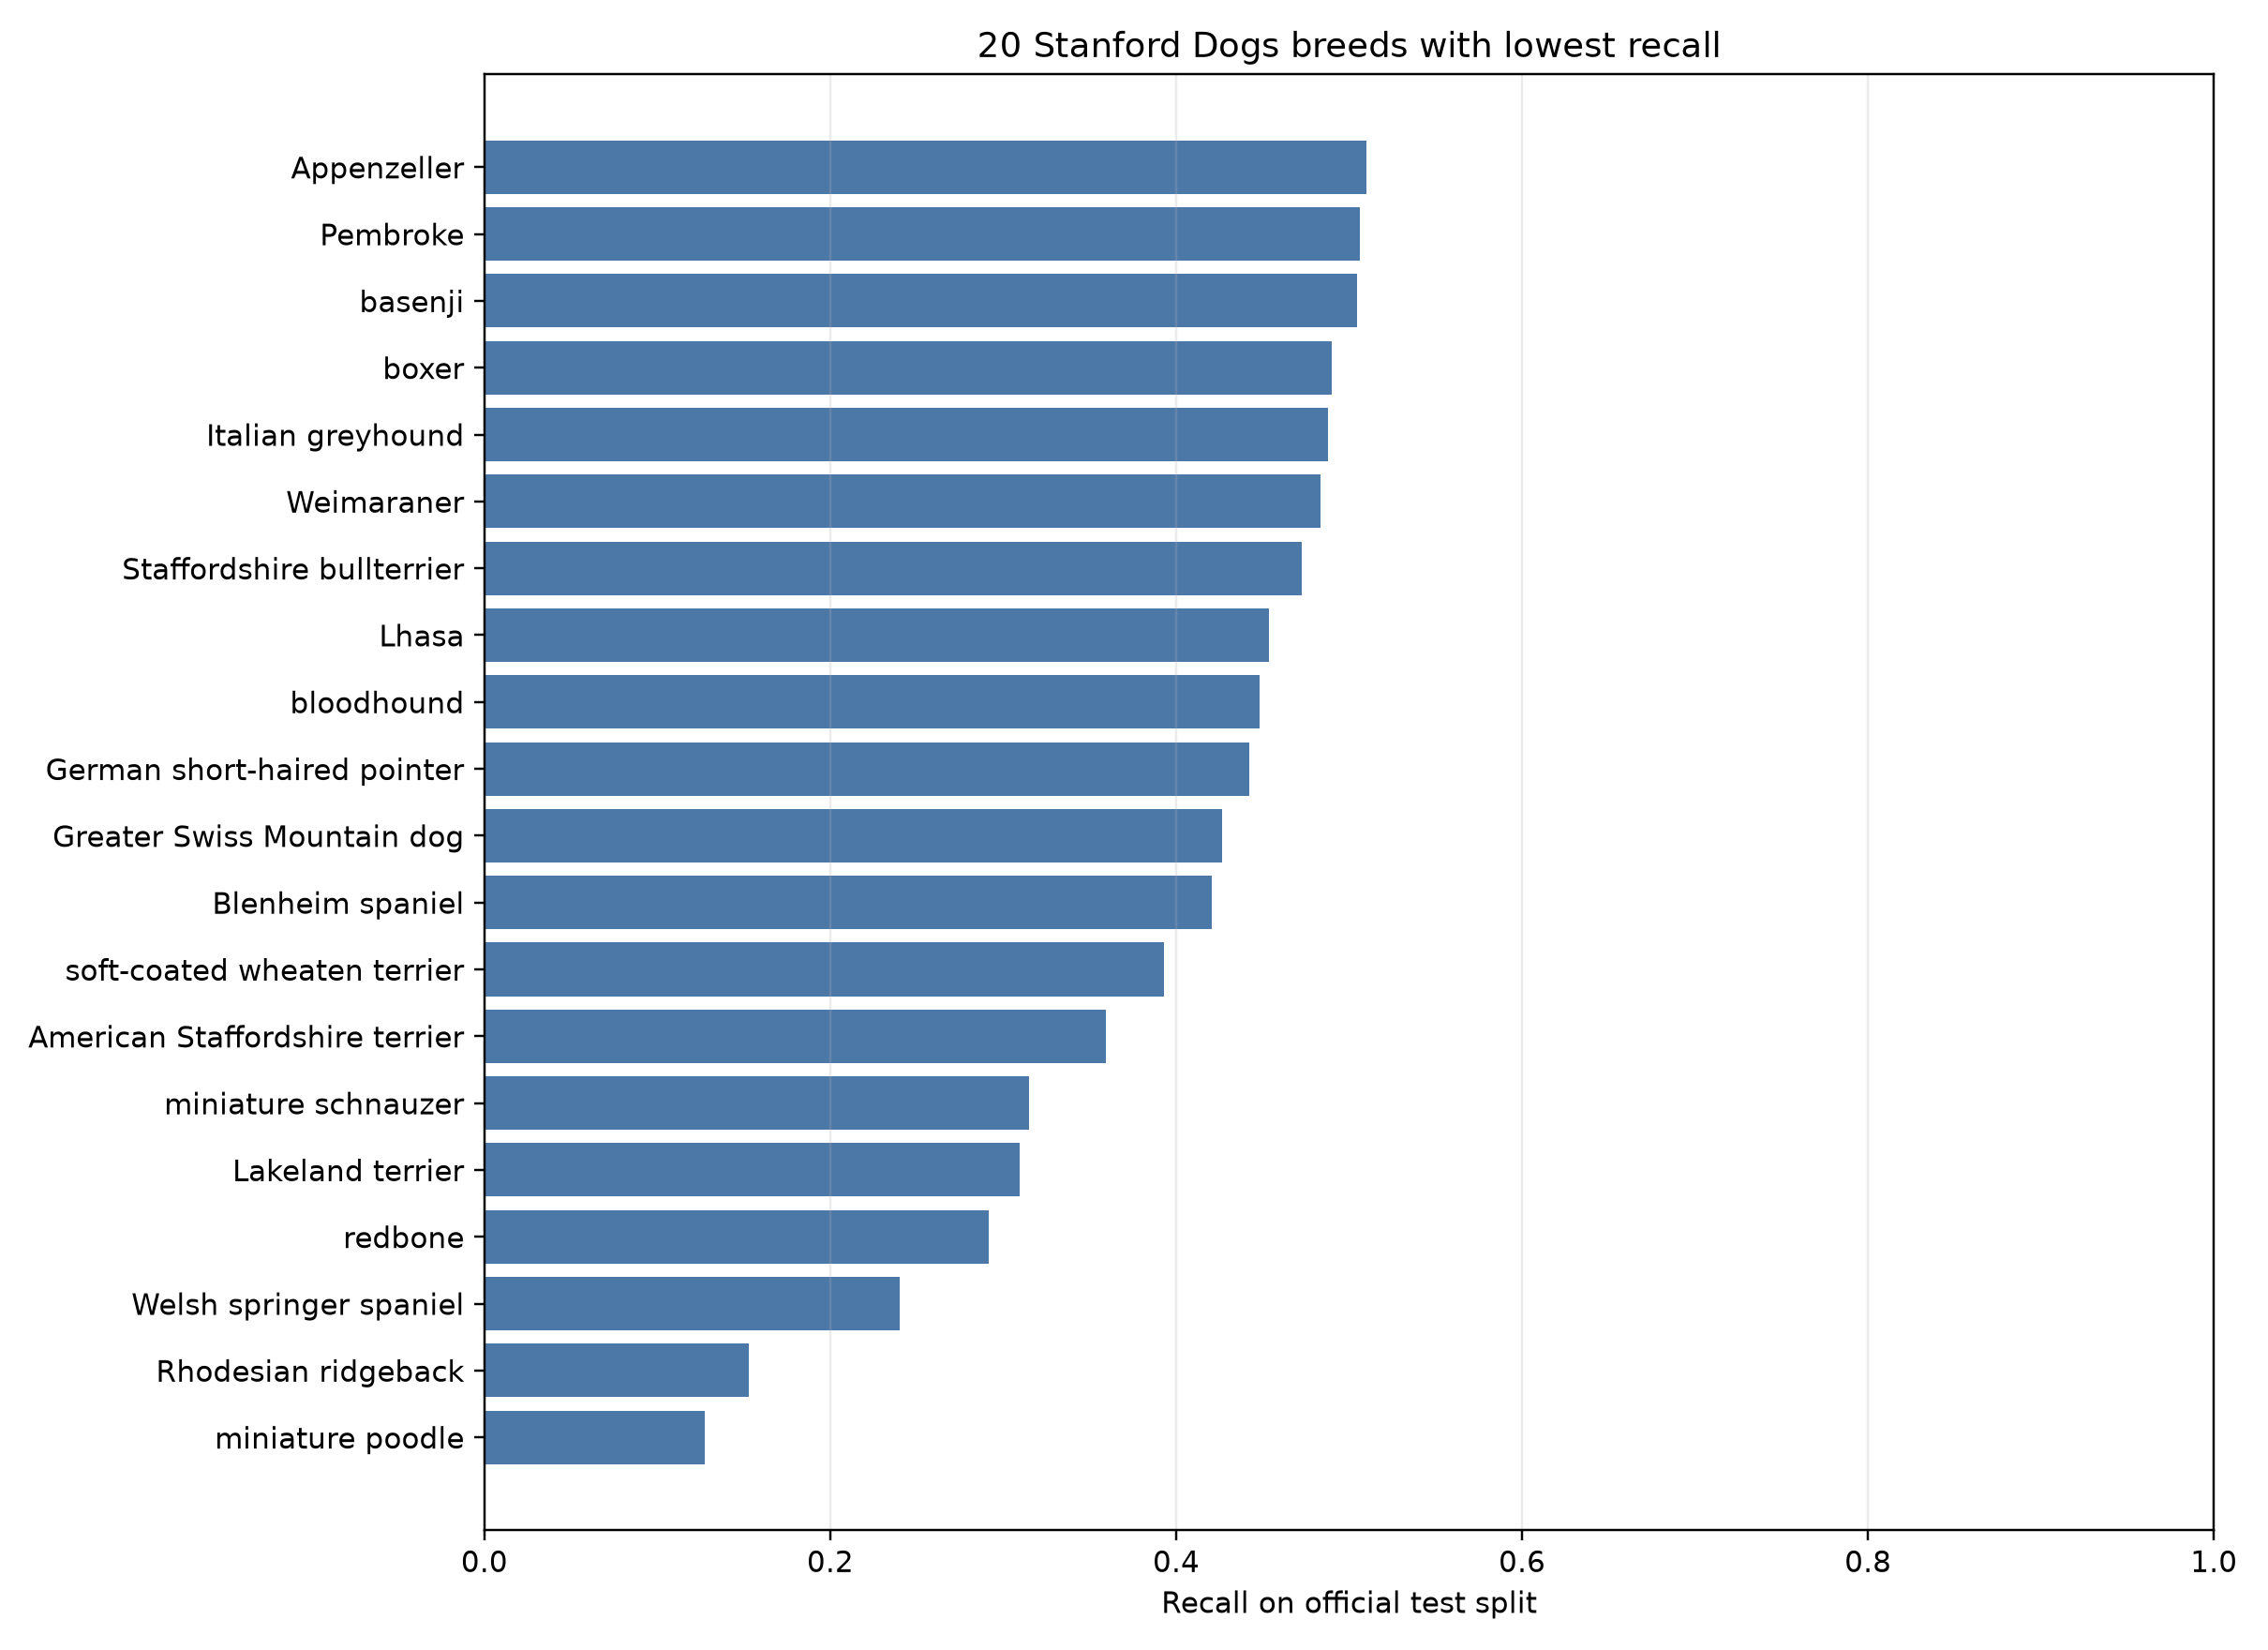
Fig. 1. Recall for the 20 breeds with the lowest test recall. The plot highlights substantial class-level variation, including the low recall for miniature poodle and Rhodesian ridgeback.

A. Reading the Aggregate Metrics
The macro precision of 68.24% is higher than the macro recall of 65.57%, while the macro F1 of 64.92% reflects the balance between the two. A higher precision than recall can occur when the model makes relatively conservative predictions for some classes, missing examples even when its predictions for that class are often correct. Here, the aggregate values should be read together with the per-breed table: they summarize a broad pattern but do not identify which labels drive the difference. Likewise, top-1 accuracy answers whether the highest-scoring label is correct, but it does not measure how useful the lower-ranked predictions might be in an assisted review workflow.
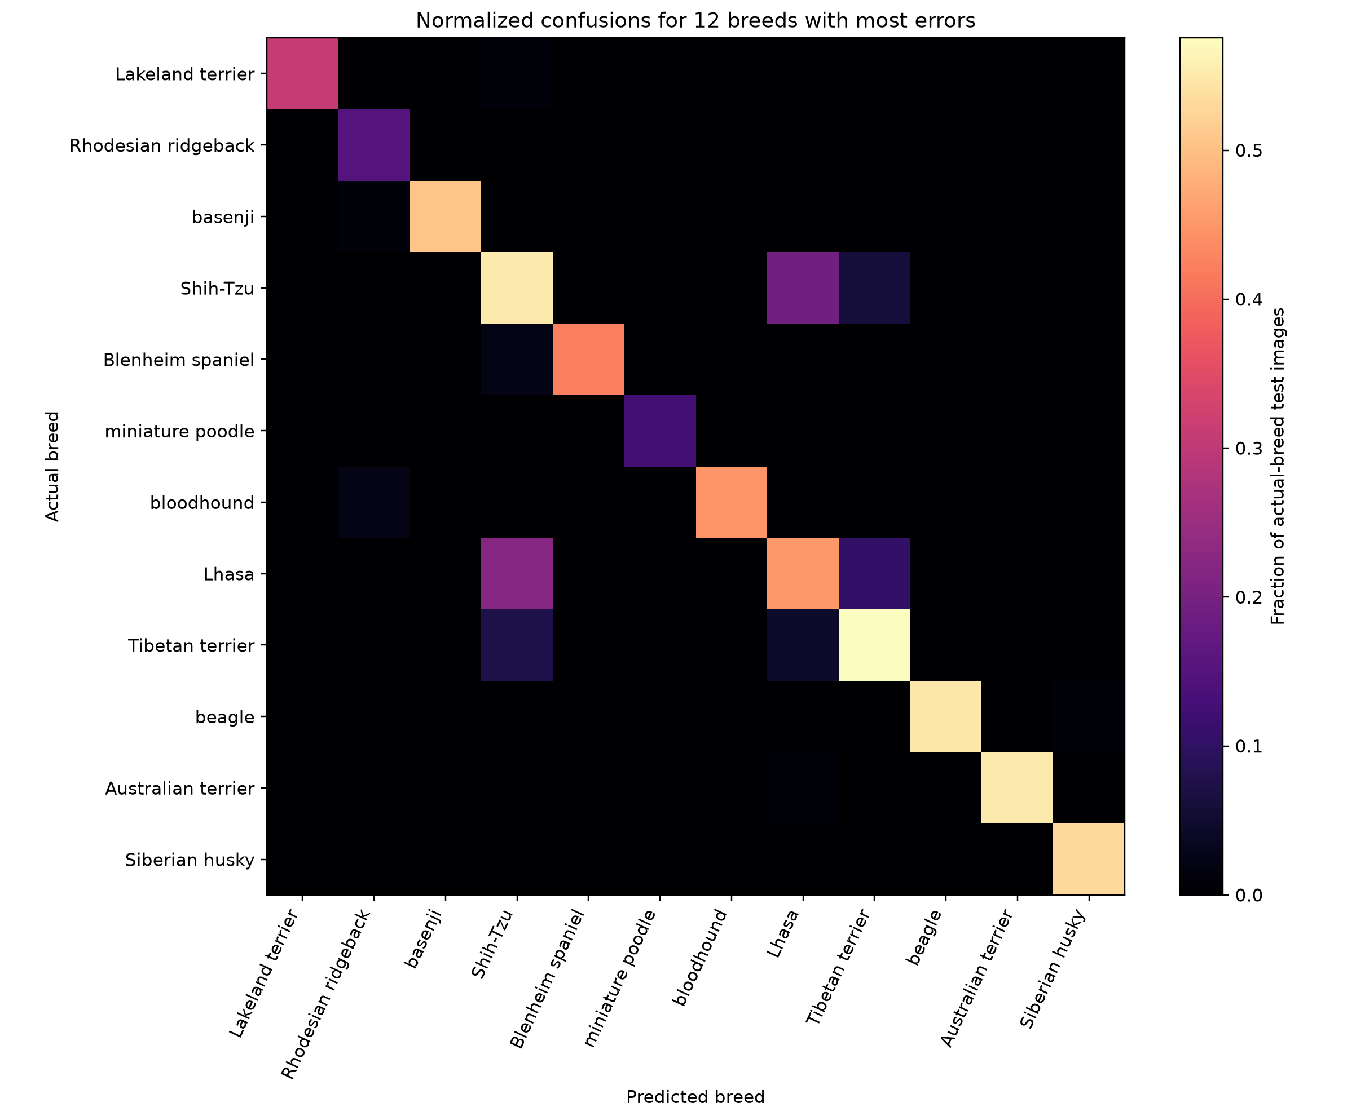
Fig. 2. Row-normalized confusion values among the 12 breeds with the most test errors. Rows show actual breeds and columns show predicted breeds; brighter off-diagonal cells indicate recurring confusions.

CONCLUSION
This paper documented an ImageNet-pretrained ResNet-18 baseline for classifying the 120 breeds in the Stanford Dogs dataset. Using the official split and a validation-selected checkpoint, the model achieved 66.08% top-1 test accuracy and 64.92% macro F1 on 8,580 test images. Class-level results showed substantial variation, including low recall for miniature poodle, while directed confusions highlighted several breed pairs that merit closer inspection.
The training run reached its best validation accuracy at epoch five and showed a widening gap between training and validation performance afterward. These findings point to overfitting under the tested configuration and motivate experiments with stronger regularization, improved scheduling, multiple seeds, and fine-grained model architectures. Future work should keep the official test partition fixed, compare methods under a matched protocol, and use bounding-box crops and qualitative review to investigate the source of breed-level errors.

REFERENCES
[1] A. Khosla, N. Jayadevaprakash, B. Yao, and L. Fei-Fei, “Novel Dataset for Fine-Grained Image Categorization: Stanford Dogs,” in First Workshop on Fine-Grained Visual Categorization, IEEE CVPR, 2011.
[2] J. Deng, W. Dong, R. Socher, L.-J. Li, K. Li, and L. Fei-Fei, “ImageNet: A Large-Scale Hierarchical Image Database,” in IEEE CVPR, 2009.
[3] B. Yao, A. Khosla, and L. Fei-Fei, “Combining Randomization and Discrimination for Fine-Grained Image Categorization,” in IEEE CVPR, 2011.
[4] P. Sermanet, A. Frome, and E. Real, “Attention for Fine-Grained Categorization,” ICLR Workshop, 2015.
[5] T.-Y. Lin, A. RoyChowdhury, and S. Maji, “Bilinear CNN Models for Fine-Grained Visual Recognition,” in IEEE ICCV, pp. 1449–1457, 2015.
[6] K. He, X. Zhang, S. Ren, and J. Sun, “Deep Residual Learning for Image Recognition,” in IEEE CVPR, pp. 770–778, 2016.
[7] X. Liu, T. Xia, J. Wang, Y. Yang, F. Zhou, and Y. Lin, “Fully Convolutional Attention Networks for Fine-Grained Recognition,” in IEEE CVPR, 2016.
[8] Z. Yang, T. Luo, D. Wang, Z. Hu, J. Gao, and L. Wang, “Learning to Navigate for Fine-Grained Classification,” in ECCV, pp. 420–435, 2018.
[9] A. Dosovitskiy et al., “An Image Is Worth 16×16 Words: Transformers for Image Recognition at Scale,” in ICLR, 2021.
[10] M. V. Conde and K. Turgutlu, “Exploring Vision Transformers for Fine-Grained Classification,” in IEEE CVPR Workshops (FGVC8), 2021.
[11] J. He, J.-N. Chen, S. Liu, A. Kortylewski, C. Yang, Y. Bai, and C. Wang, “TransFG: A Transformer Architecture for Fine-Grained Recognition,” in Proc. AAAI, vol. 36, no. 1, pp. 852–860, 2022.
[12] Y. Cui, B. Tang, G. Wu, L. Li, X. Zhang, Z. Du, and W. Zhao, “Classification of Dog Breeds Using Convolutional Neural Network Models and Support Vector Machine,” Bioengineering, vol. 11, no. 11, 1157, 2024.

