**📌 Introduction**

Welcome to the **Citizen Complaints and Engagement System** — a fully responsive, multilingual web application designed to empower citizens to voice their concerns, report issues, and engage with local authorities more effectively. This MVP (Minimum Viable Product) is built to streamline communication between citizens and governing bodies, enhancing transparency and service delivery.

🌍 **Key Features**:

* Fully responsive design for mobile, tablet, and desktop devices.
* Multilanguage support: **Kinyarwanda (default)**, English, and French.
* Intuitive interface for submitting, tracking, and managing complaints.
* Admin and staff dashboards for issue review and response.
* **Real-time notifications** via **SMS** and **email** to keep users informed on the status of their complaints.
* Real-time feedback and status updates to users.

This system is especially built with **Rwandan communities** in mind, making it accessible, user-friendly, and inclusive across language preferences.  
  
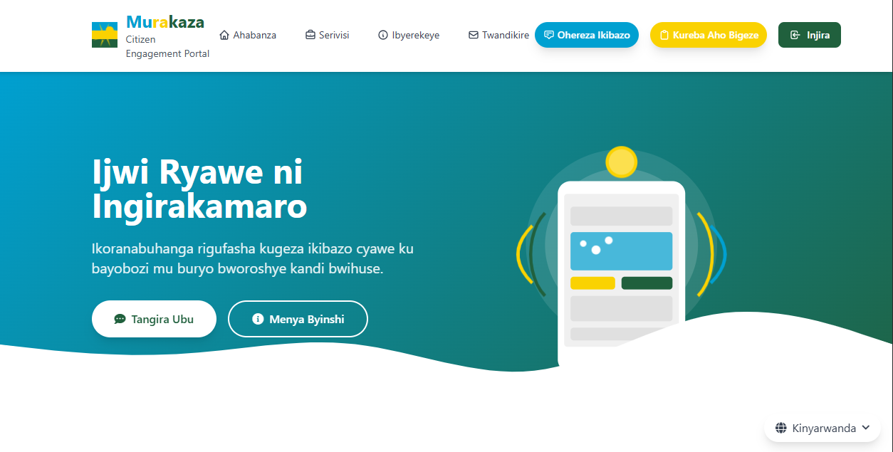

Figure web-kinyarwanda

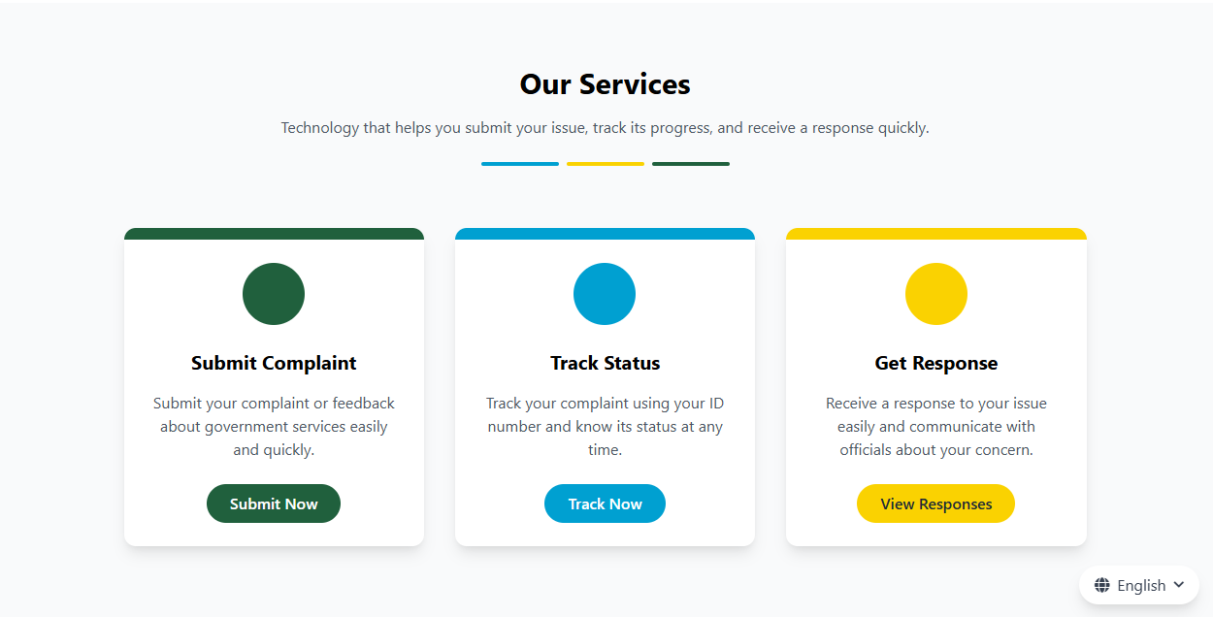

Figure web-english

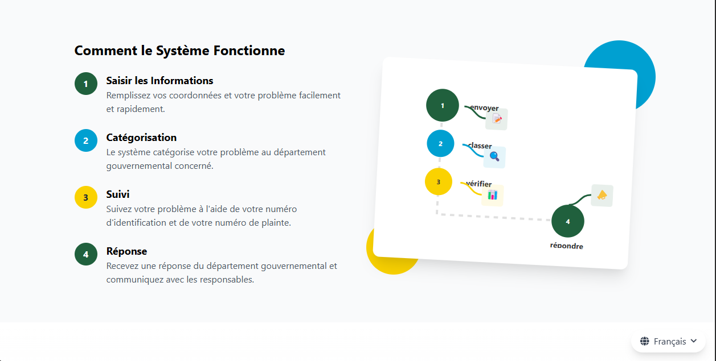

Figure web-fr

**🔐 Admin Account Creation & User Invitation System**

To ensure security and proper access control, the **Citizen Complaints and Engagement System** uses a **restricted account creation workflow**:

* 💼 **Initial Admin Setup**: During the first-time setup, a **primary admin account** is created manually. This account has full privileges and is responsible for managing the system.  
  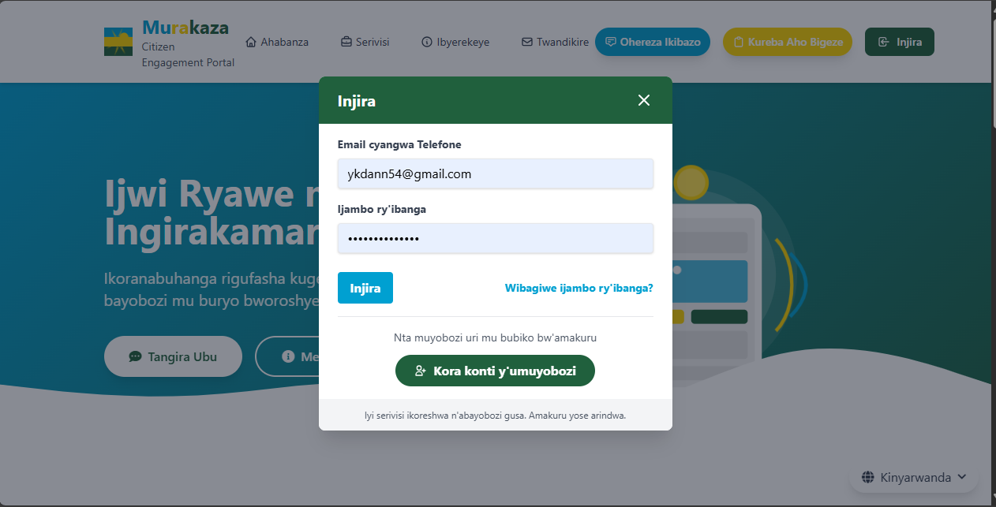  
    
  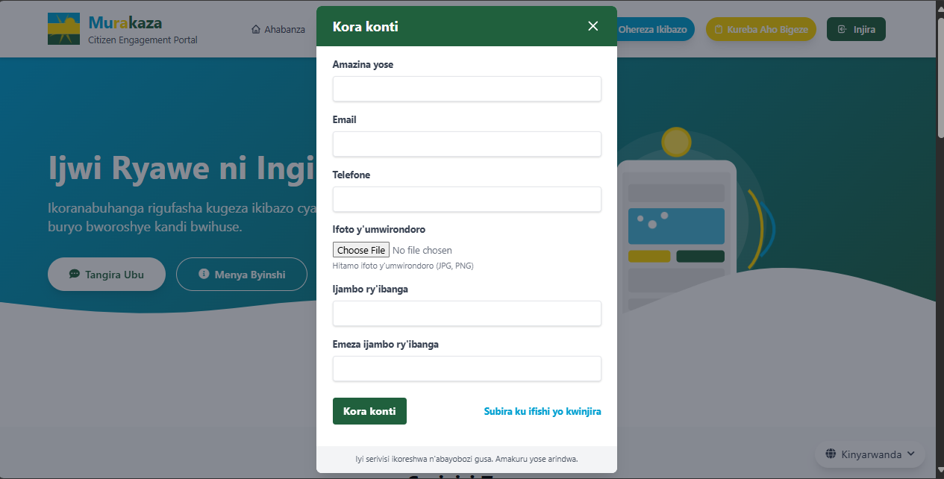  
    
    
  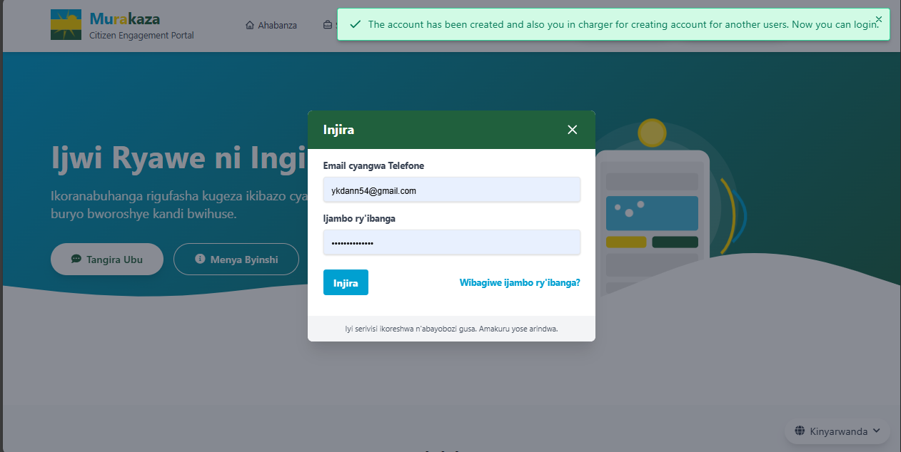
* ✉ **Invitation-Based Registration**: After initial setup, the admin can **send invitation links** to staff members or authorized users who need access to the system. These invitations allow them to create their own accounts through a secure process.  
    
  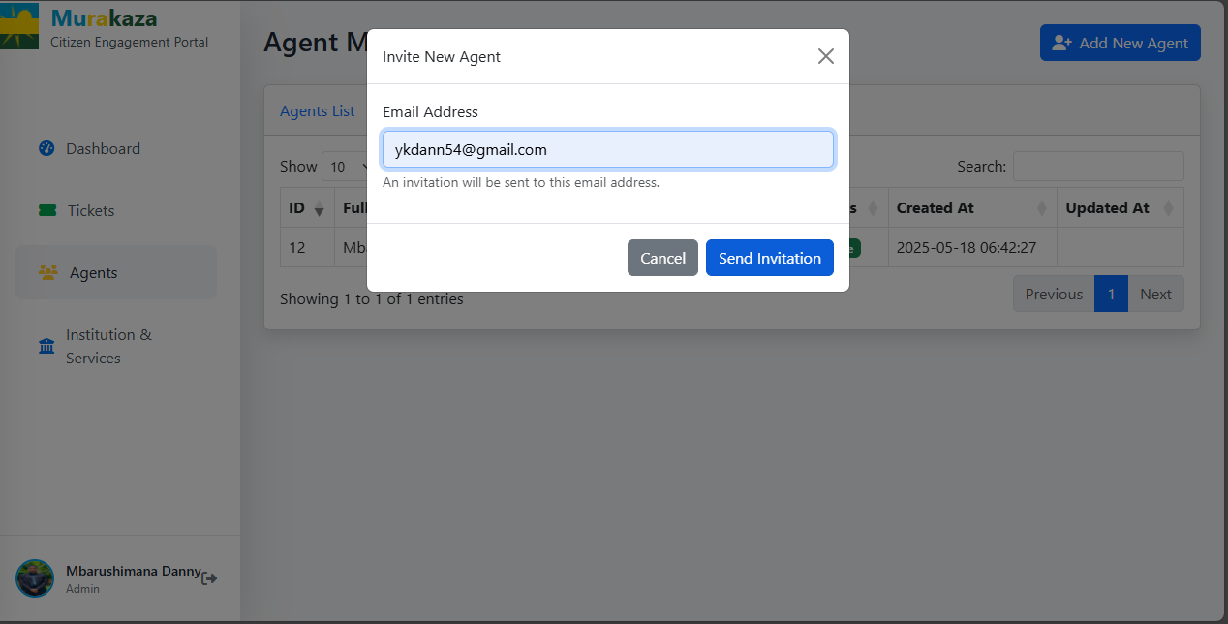  
    
  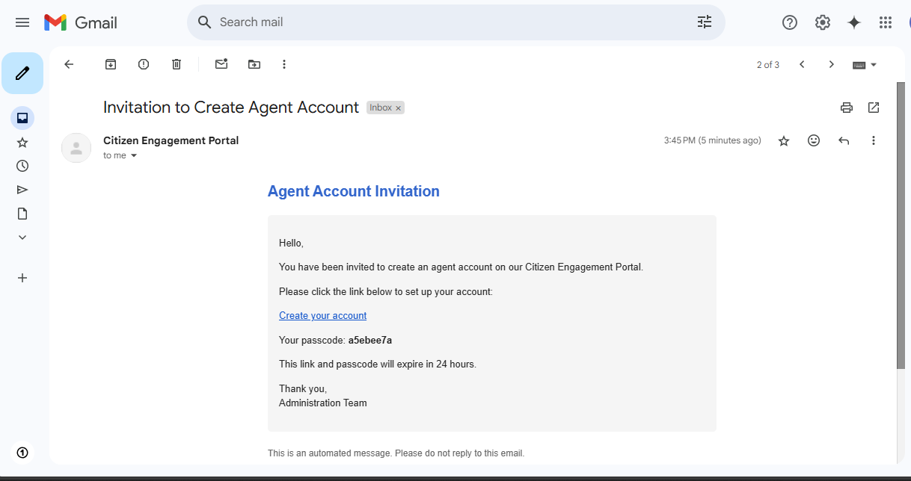
* 🚫 **No Public Signup**: For security and integrity, the system does **not allow open or public registration**. Only users who receive invitations from the admin can create accounts.

## This controlled approach helps maintain a secure environment and ensures that only trusted personnel have access to sensitive complaint data and system features. 🖥Dashboard & Interfaces

As part of this MVP, the **Citizen Complaints and Engagement System** provides **four main operational interfaces**, designed with simplicity and functionality in mind to deliver core features effectively:

### 1. 📊 Dashboard (Landing Page)

* After login, users are directed to a **minimal but functional dashboard**.
* Displays basic **analytics** such as:
  + Number of registered citizens.
  + Number of complaints submitted.
  + Complaint resolution statistics.
* Designed as a foundation for future scalability while providing immediate insight into system usage.  
  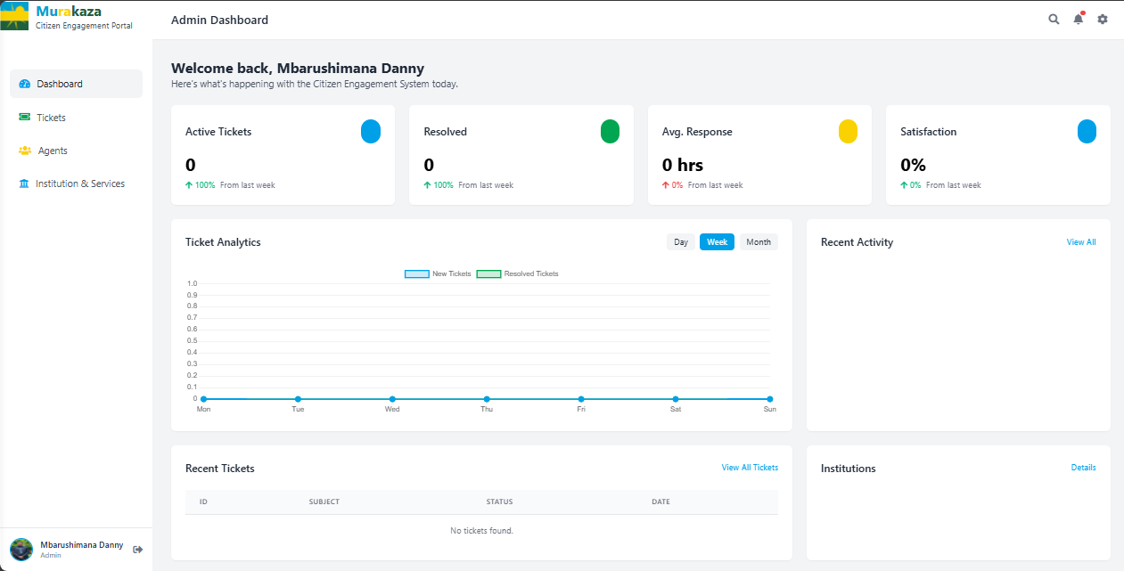

### 2. 💼 Agents Interface

* Shows a **list of all agents** registered in the system.
* Admins can **view and manage agent profiles**.
* Helps track who is responsible for handling citizen complaints.  
  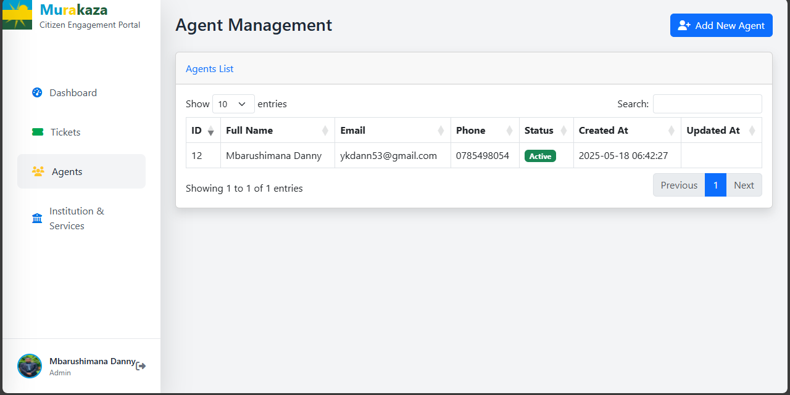

### 3. 📨 Ticket Management System

The core functionality of the system, divided into **three dynamic tabs**:

* **New Tickets**:
  + Displays all newly submitted tickets that have not yet been assigned.  
    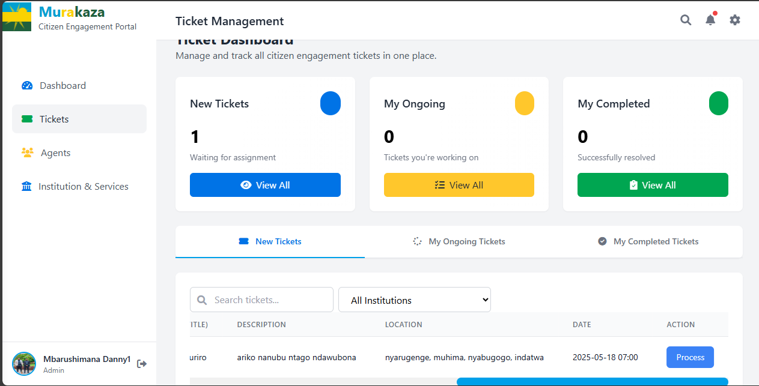
  + Agents can view ticket details and **click "Proceed"** to accept the ticket.

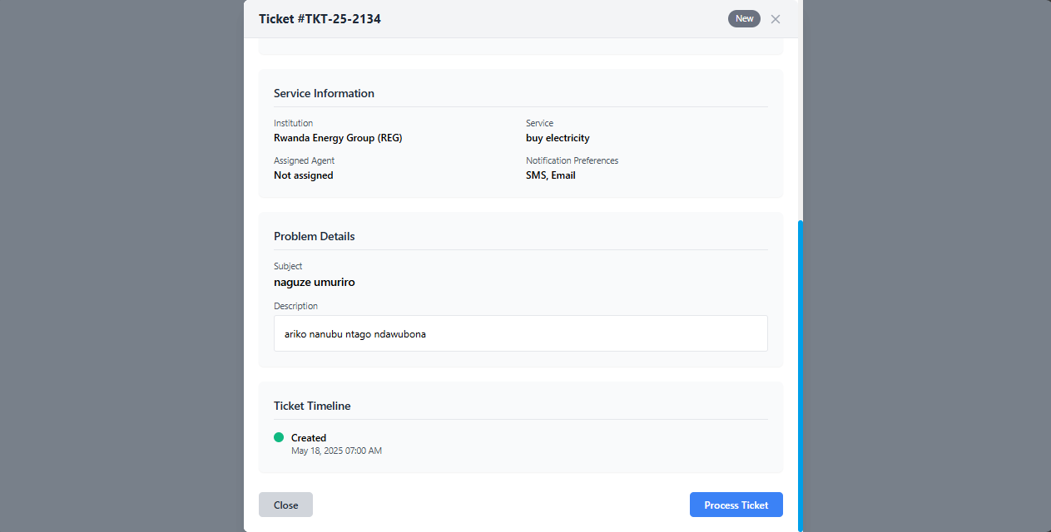

* + Upon acceptance, the system **notifies the citizen** that their case has been received.  
    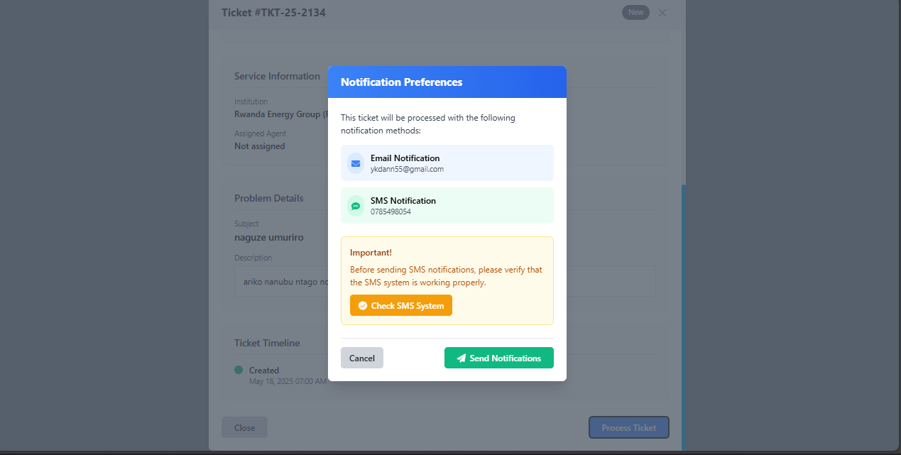
* **Ongoing Tickets**:
  + Displays tickets currently **assigned to the logged-in agent only**.  
    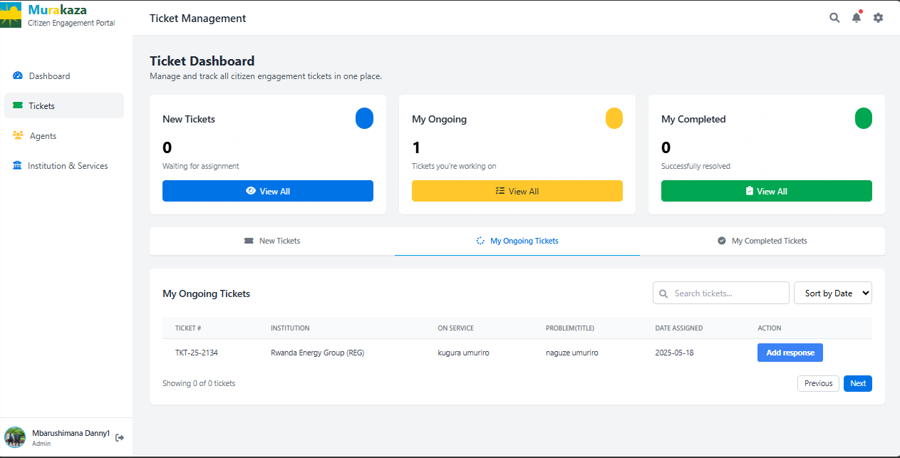
  + Agents can **add responses**, updating the case and optionally **notifying the citizen** with each response.  
      
    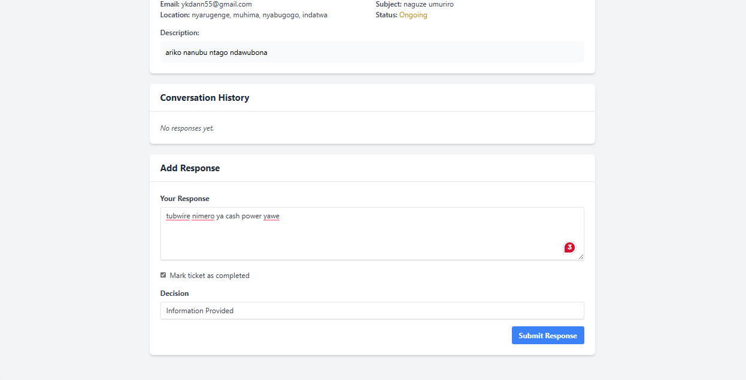  
    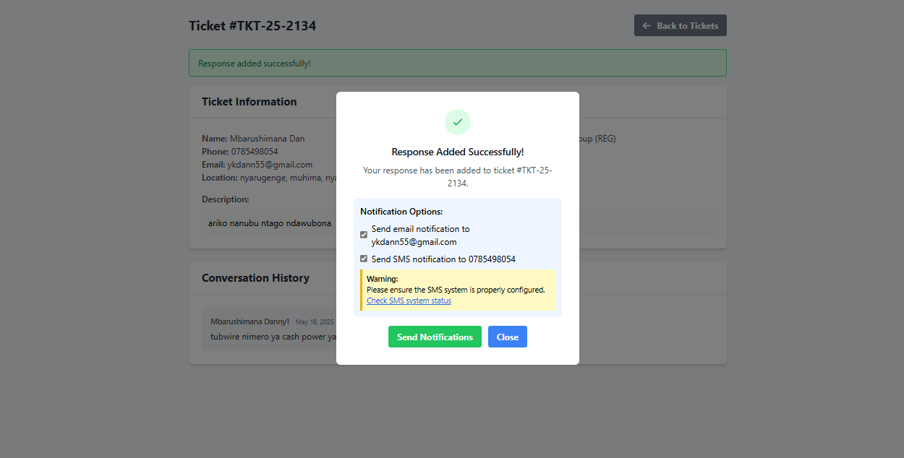
* **Completed Tickets**:
  + Displays tickets that the agent has marked as resolved.
  + Keeps a record for transparency and future reference.

### 4. 🏢 Institutions & Services

* Admins can **add and manage institutions** (e.g., police, health, water board, etc.) and their respective **services**.  
  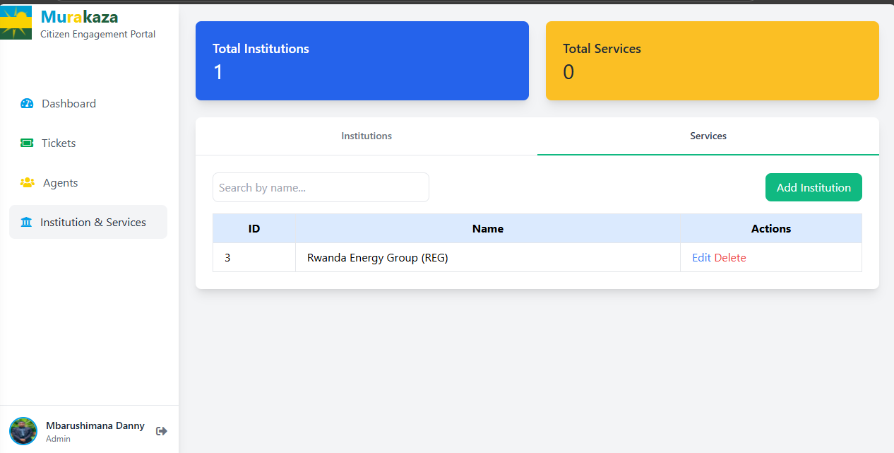
* Citizens can then **choose an institution and specific service** when submitting their complaint or question, ensuring it reaches the right department.  
  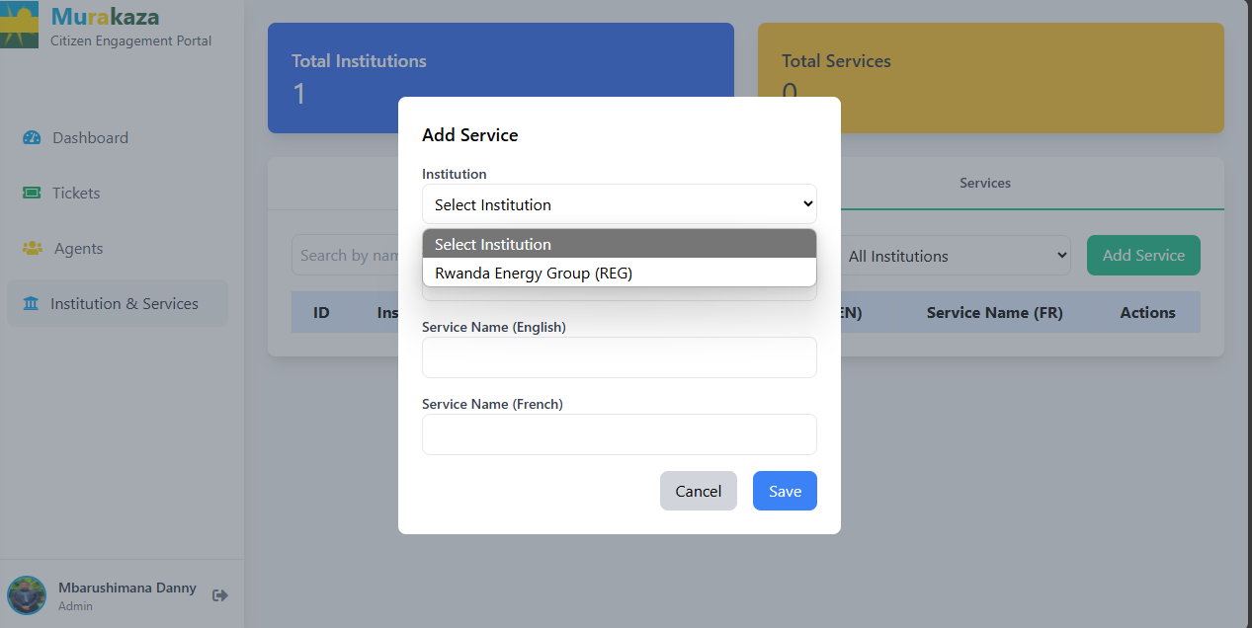

## 🙋 Citizen Actions & Engagement Flow

The **Citizen Complaints and Engagement System** is built to ensure an easy and transparent process for citizens to report issues and receive updates. Here's how citizens interact with the platform:

### 📝 1. Submit a Complaint (**"Ohereza Ikibazo"**)

* Citizens click on the **“Ohereza Ikibazo”** (Submit Complaint) button on the platform.
* A **modal form** opens where they fill out required details  
  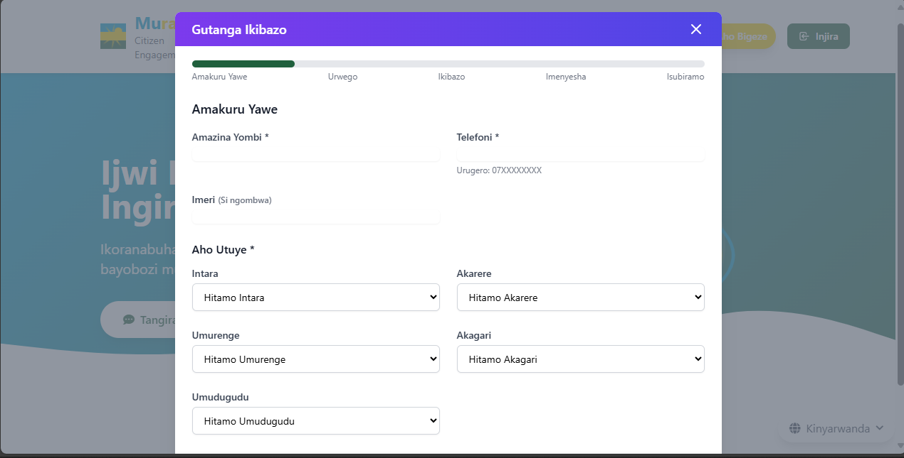  
    
  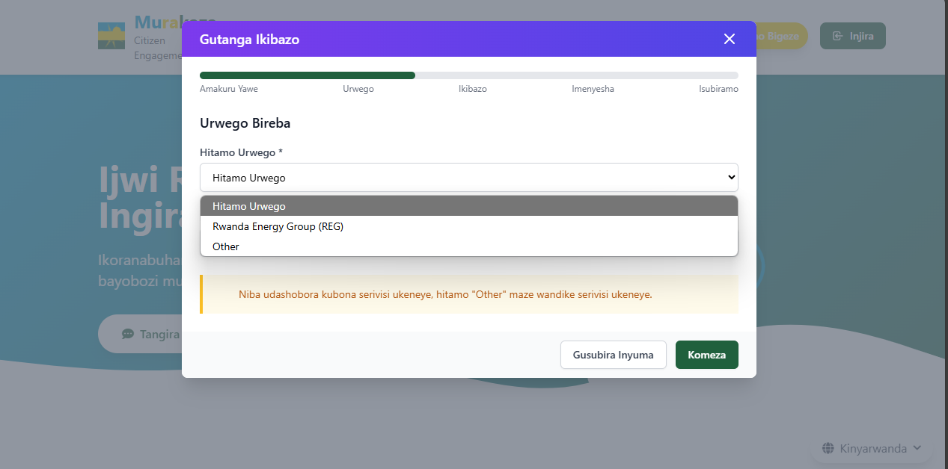  
  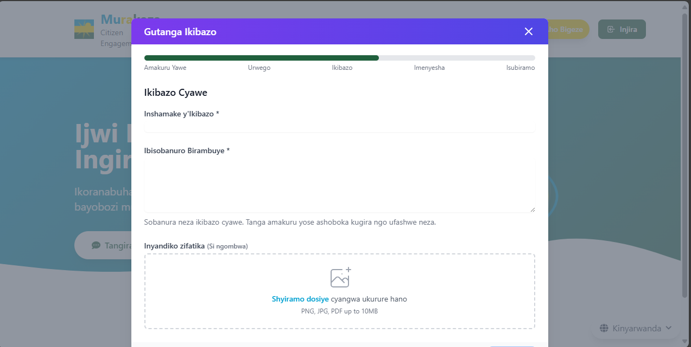  
  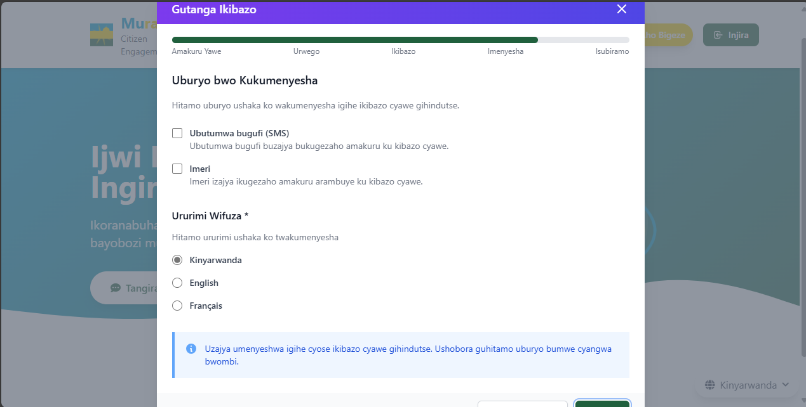  
  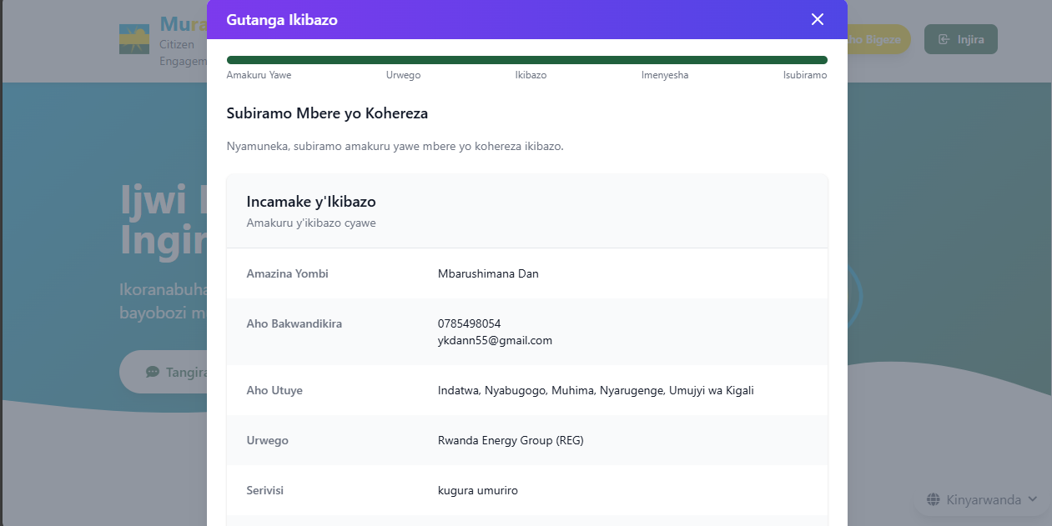
* Once submitted, the ticket is created and routed to the relevant agent.  
  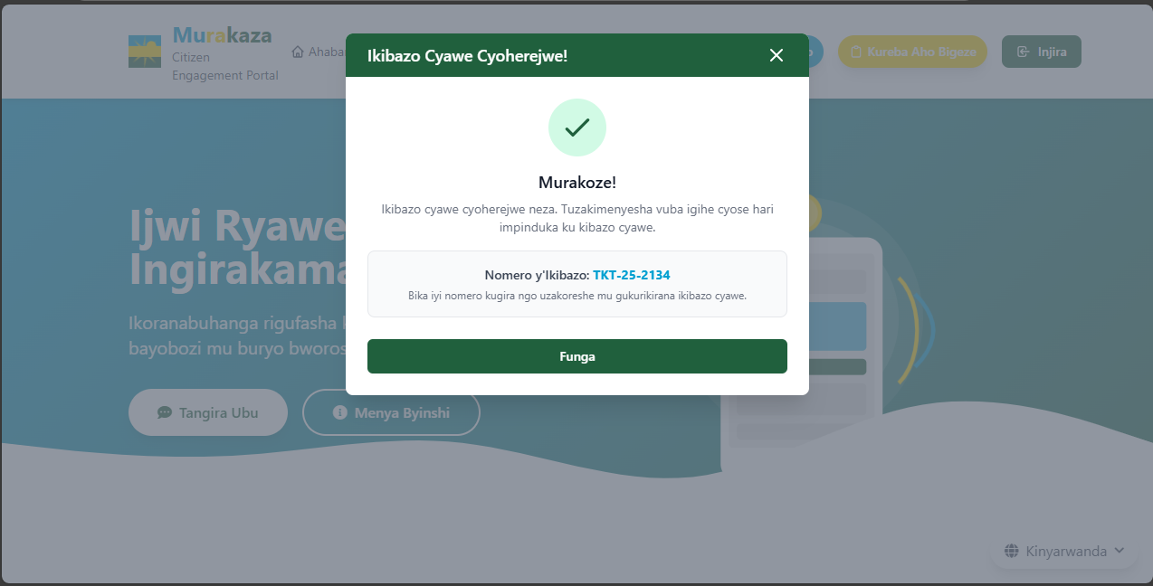

### 🔔 2. Notification System

* Citizens receive **real-time notifications** through their **selected delivery method** (SMS or email):
  + When the ticket is received and assigned to an agent.  
      
    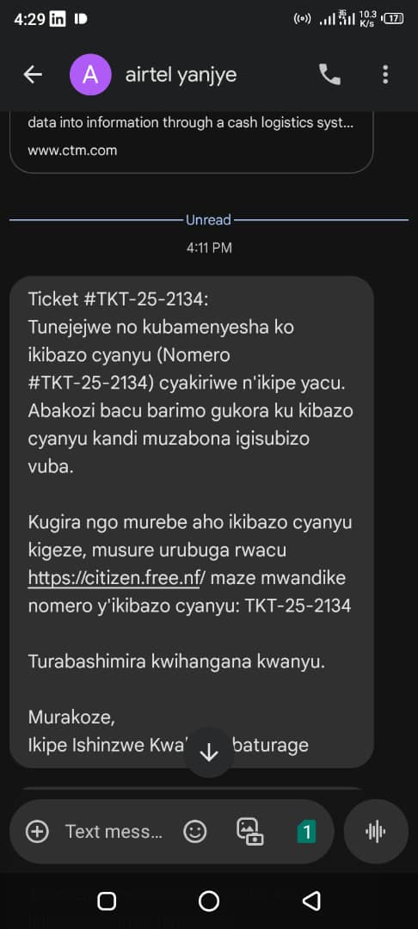
  + Every time a response is added to their ticket by an agent.  
    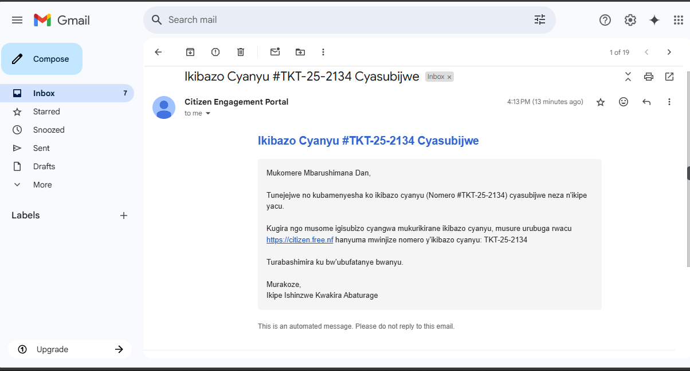

### 🔍 3. Track Complaint Status (**"Kureba Aho Bigeze"**)

* Citizens can check the progress of their complaint by:
  + Clicking on the **"Kureba Aho Bigeze"** (Track Status) button.  
      
    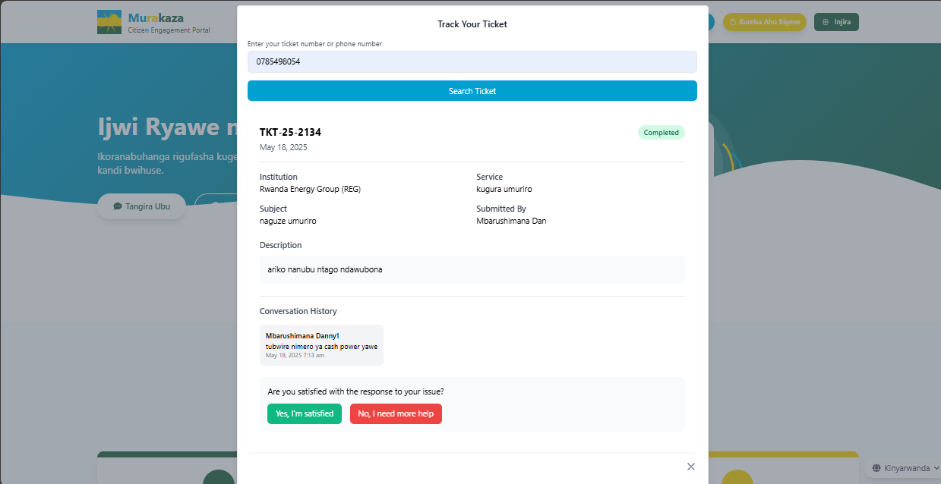
  + Entering their **ticket number** or **phone number**.
* The system shows:
  + Ticket details
  + Current status (New, Ongoing, or Completed)
  + All responses from agents

### ✅ 4. Feedback & Follow-Up

* Once the ticket is marked as resolved, citizens are asked:
  + **“Are you satisfied?”** (Options: Yes / No)
* If **“No”** is selected:
  + A **chat interface** is opened, allowing the citizen to continue the conversation or ask further questions.  
    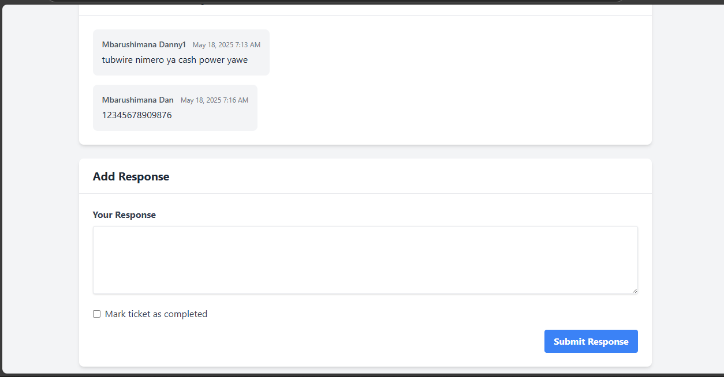
  + The assigned agent is **notified immediately** and can respond accordingly.  
    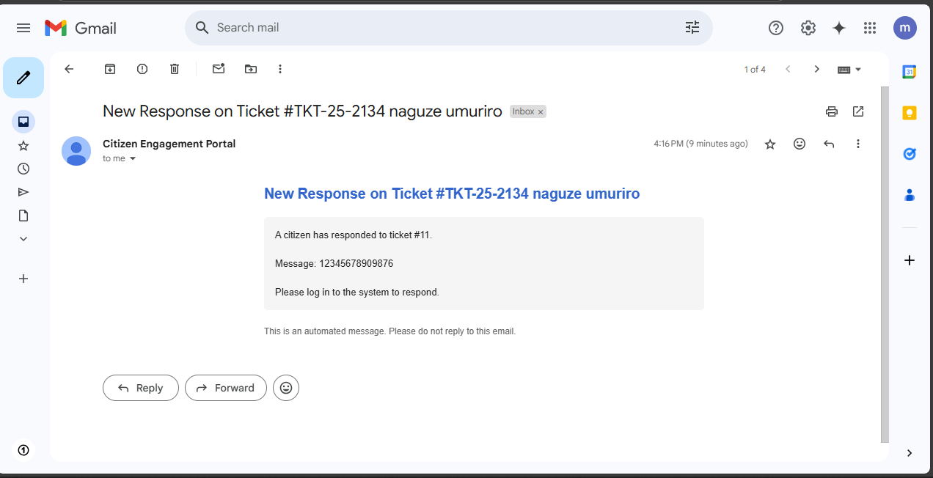

This interactive flow ensures that citizens feel **heard, supported, and continuously engaged** throughout the resolution process.

* If **“Yes”** is selected:  
  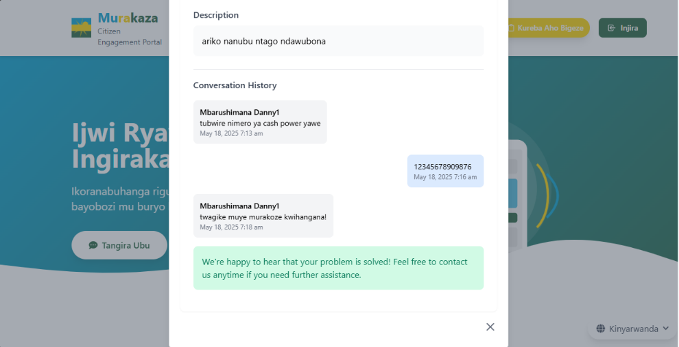

## 🔧 Additional Communication & Future Enhancements

To ensure maximum accessibility and reliability, the system integrates current best practices and plans for future development, including:

### ✅ SMS Delivery Assurance

* A **test mechanism** has been implemented to **verify that SMS notifications are successfully delivered** to citizens.
* This ensures that citizens receive critical updates even without active internet connections.
* Helps in identifying and resolving delivery issues proactively.  
  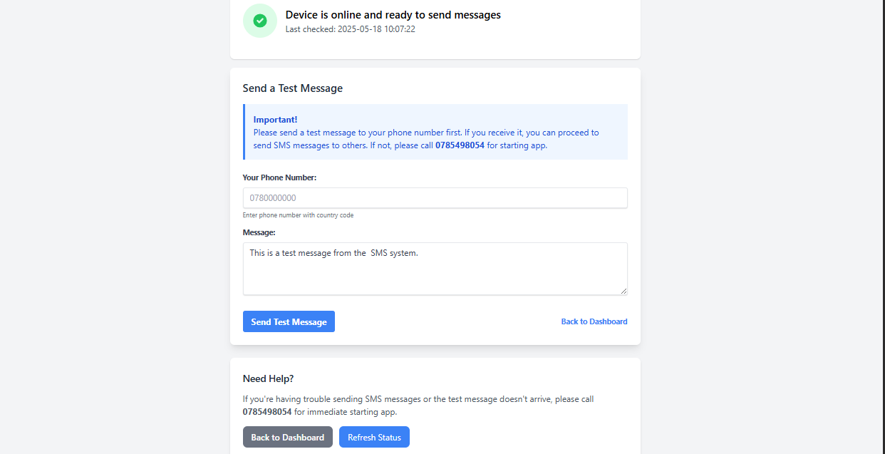

### 📱 Planned USSD Integration (Future Enhancement)

* Recognizing that many citizens may lack consistent internet access, we plan to integrate **USSD support**.
* This feature will allow users to **submit complaints**, **track tickets**, and **receive updates via simple USSD codes** on any mobile device — no smartphone or internet required.
* It will further expand the system’s reach to **rural and underserved areas**.

### 🎥 Scheduled Video Communication (Future Enhancement)

* We aim to add a feature that allows **citizens to schedule video calls** with agents or institution representatives when needed.
* This will enable more personalized support, especially for complex or sensitive issues.

These enhancements ensure the system remains **inclusive, scalable, and adaptable** to the evolving needs of both citizens and institutions.