**INDIVIDUAL REPORT FORMAT**

# Subject Code

# Subject Title

# Group Name

# Student Name and UOG Id

# Submission Date

# Table of Contents

1.0 Credentials, Links and Roles

1.1 Group credentials and related links 1

1.2 Group members and roles 2

2.0 Evaluation of Product and Process

2.1 Evaluation of Product 4

2.2 Evaluation of Process 8

3.0 Evaluation of Team and Personal

4.0 Self-Evaluation

# 1.0 Credentials, Links and Roles

*- Same as group report -*

**Trello account:**

URL : <https://trello.com>

Username: [Login using Google Credentials]

**GitHub:**

URL : <https://github.com>

Username: [Login using Google Credentials]

…..

# 2.0 Evaluation of Product and Process

2.1 Evaluation of Product ***[use screenshots where applicable]***

2.1.1 Super strong security features (*optional*)

2.1.2 Caters for different users with different needs (accessibility)

2.1.3 …...

2.1.3 Future improvements

2.2 Evaluation of Process

2.2.1 Sprint 1 (what issues, how they have been addressed?)

2.2.2 Sprint 2 (what issues, how they have been addressed?)

2.2.3 …...

2.2.3 Future improvements

# 3.0 Evaluation of Team and Personal

3.1 Weighted Scoring Model for Team …. (Overall Team Moderation)

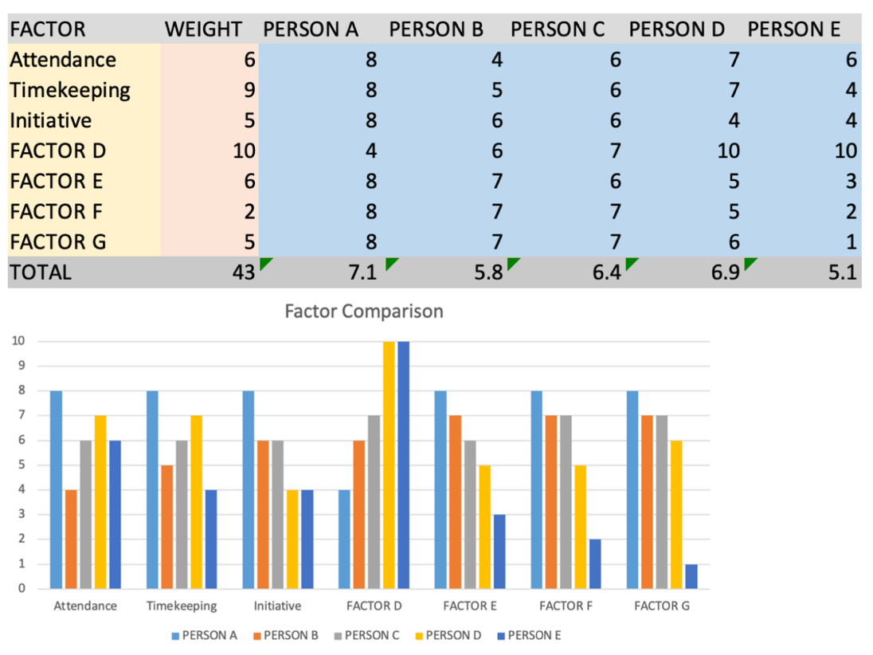

3.2 Weighted Scoring Model for Team …. (Developer’s Moderation)

3.3 Developer Evaluation

3.3.1 Person E (Alex)

In the first three sprints, he is the person who in charge of documentation. A tester in Sprint 4. Turns up as usual. Absent when there’s a basketball match happening. For that, his attendance is not that solid. A 6 out of 10 is the fair assessments. Even when turning up, usually will arrive late. Poor time management….

3.3.2 Person A

3.3.3 Person B

3.3.4 ….

# 4.0 Self-Evaluation

Explain how you have done well in every role, throughout all sprints to deserve the marks that you have scored yourself.

E.g.

As a scrum master, programmer, tester, the founding member to the team, I have done everything above and beyond to serve teammates. I even helped to develop, which a part of my role…., to test …., to wake up the members during night shift…

I deserve a full scored of 10. Full stop.