Assignment1 :-

• Install Power BI Desktop and share the final screenshot of the report view page which appears when power desktop starts.

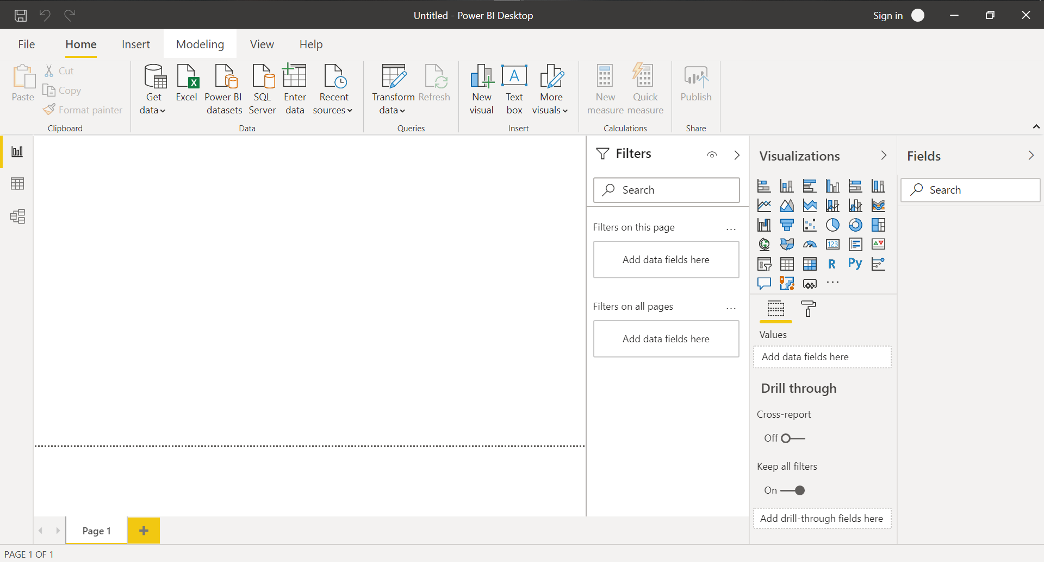

• Prepare a document and with the following screenshot –

Report View –

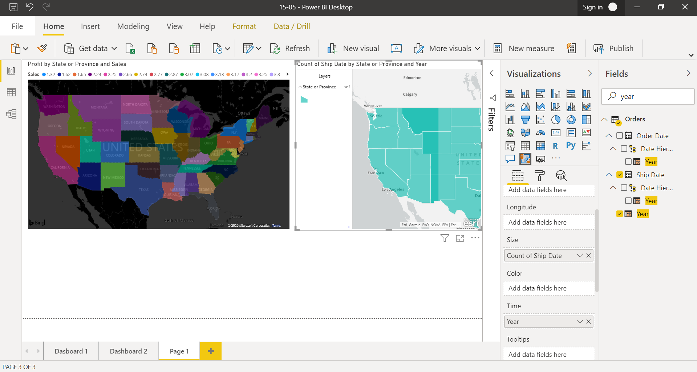

Data View –

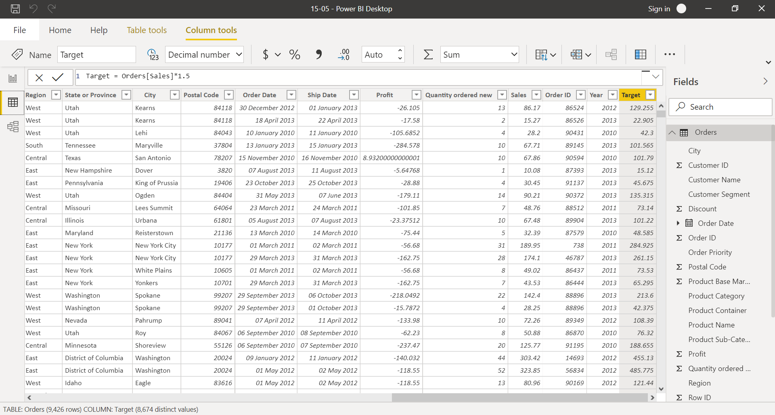

Model View –

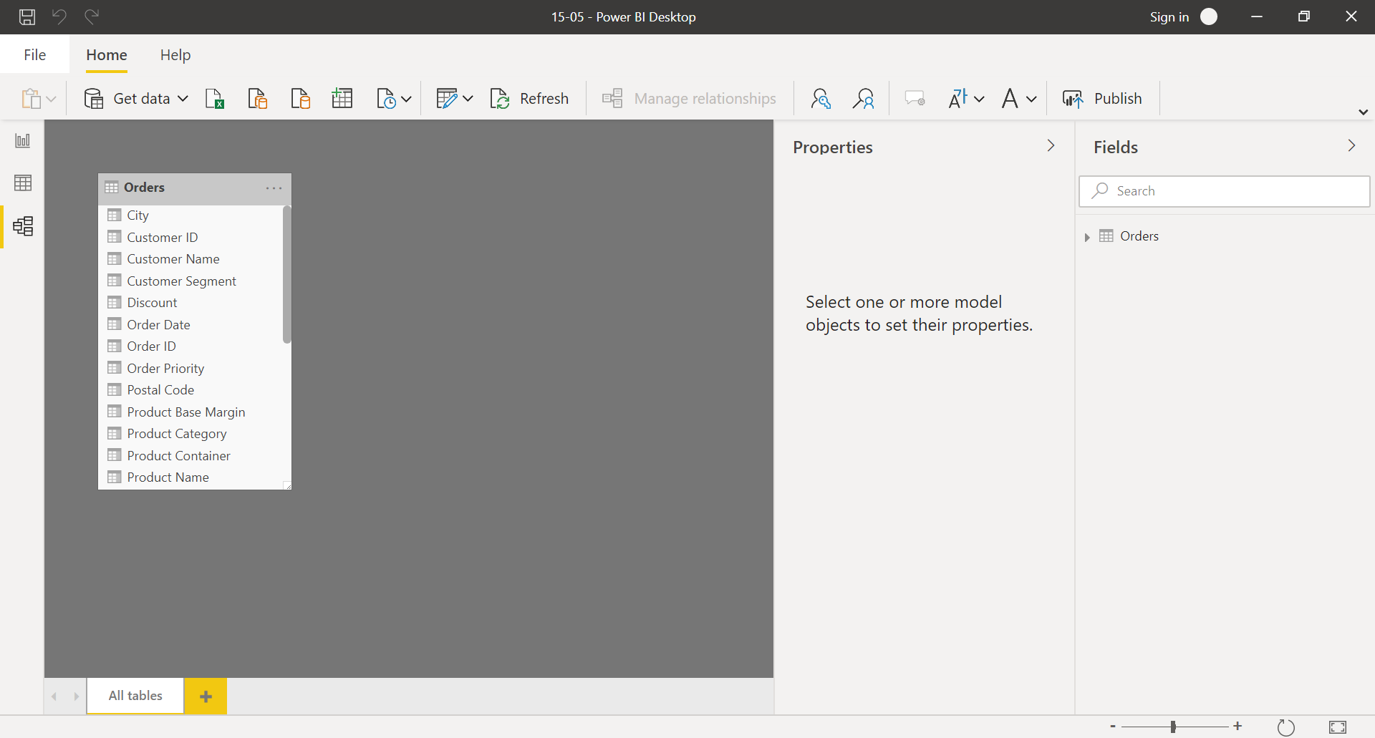

Power Query Editor − Advance Editor

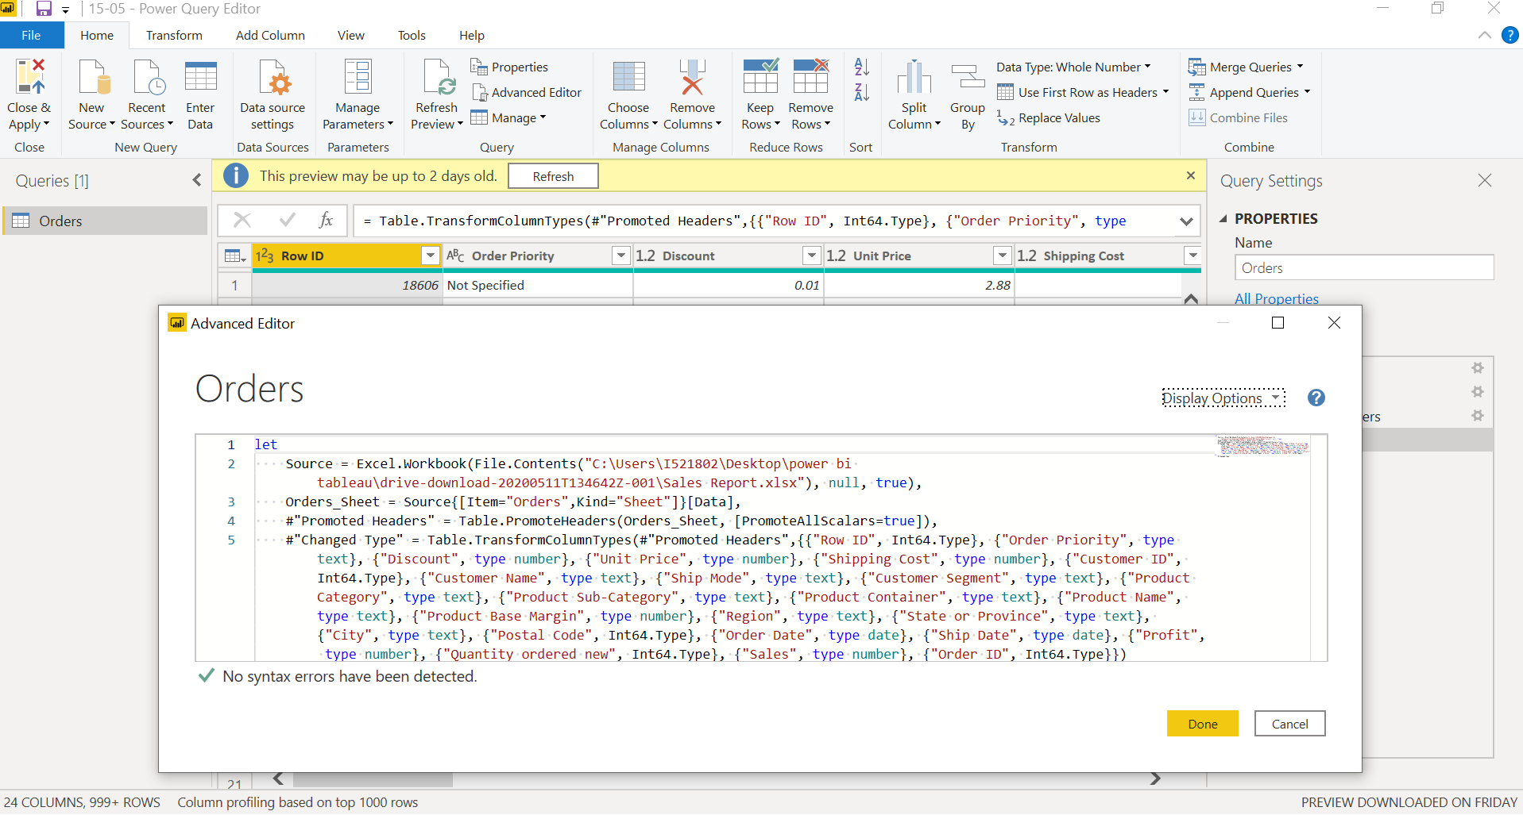

• Prepare a document with details of the following along with their price –

Power BI Desktop – Desktop is free for single user

Power BI Pro – The Pro plan costs $9.99/user/month.

Power BI Premium- The Premium plan starts at $4,995 a month per dedicated cloud compute and storage resource.