Name: - K.Damodhar Course code: - MLA0406
Reg No: - 192525266 Course Name: - Deep Learning

Q1. Demonstrate the Confusion Matrix using Python. Program: -
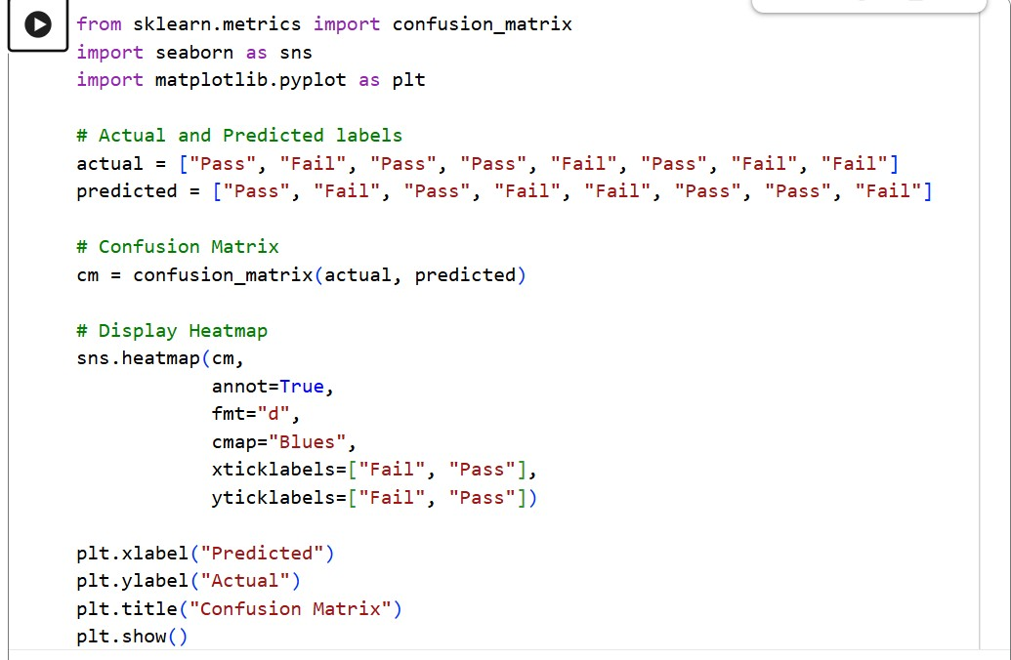

Output: -
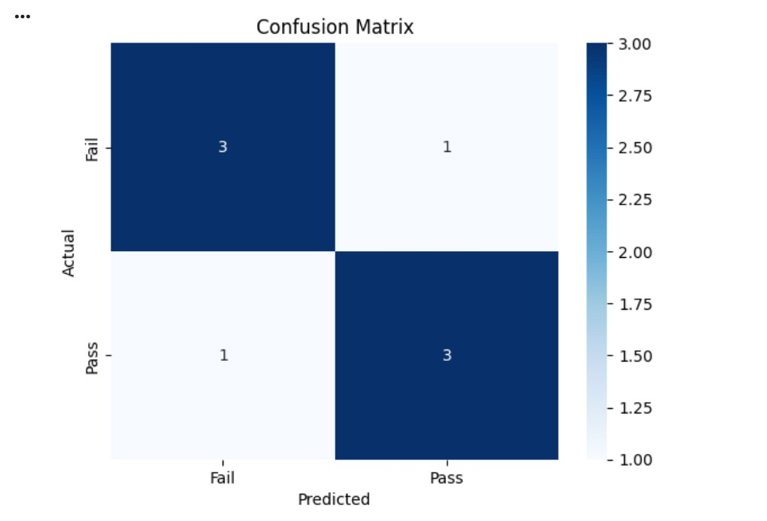

Result: -
The confusion matrix successfully compares the actual and predicted classes. It correctly classified 6 out of 8 samples and misclassified 2 samples, demonstrating the performance of a binary classification model.

Q2. Demonstrate a Two-Class Confusion Matrix using Python. Program: -
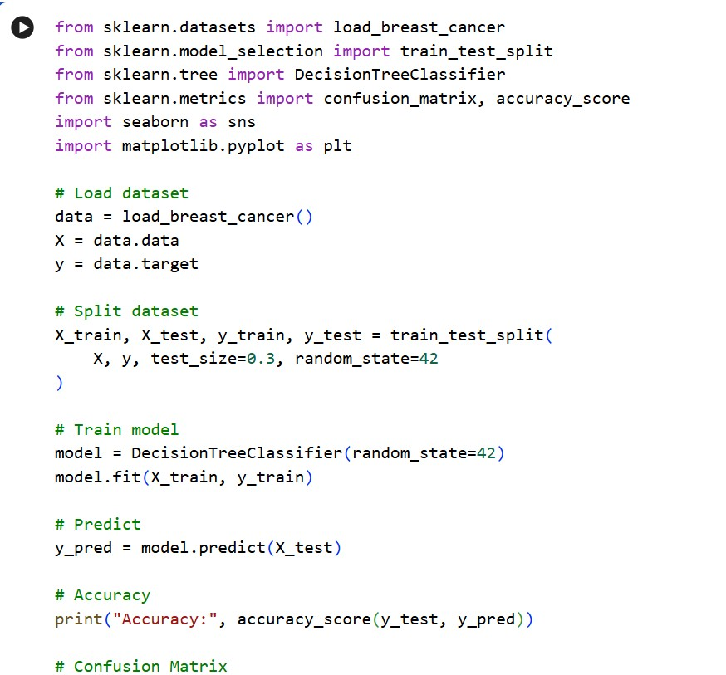
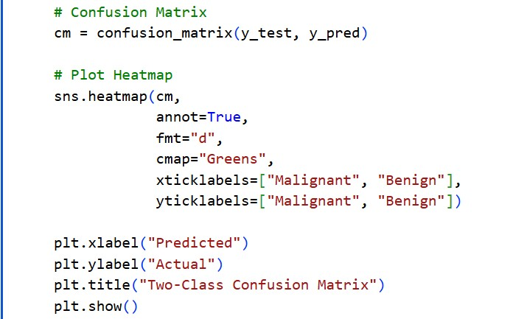

Output: -
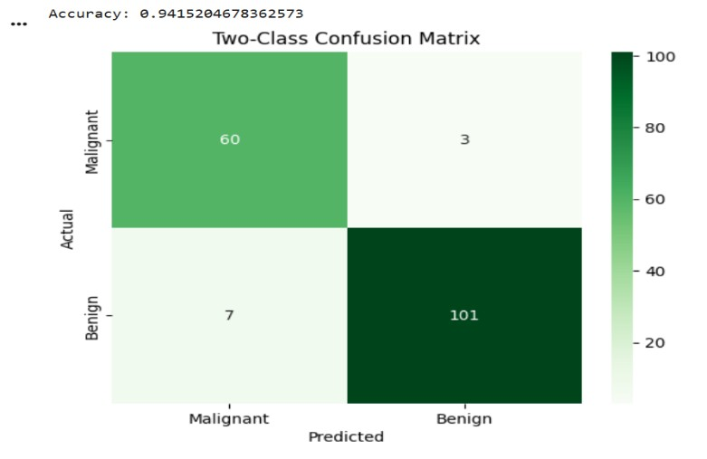

Result: -
The Decision Tree classifier successfully classified the two classes with approximately 94% accuracy, demonstrating effective binary classification using a confusion matrix.

Q3. Analyse the performance of a Multi-Class Confusion Matrix using Python. Program: -
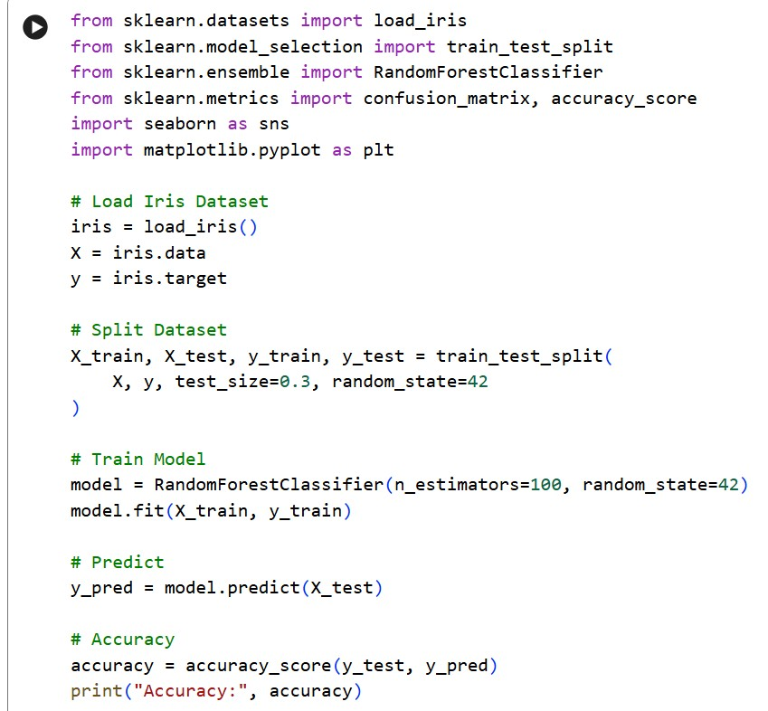
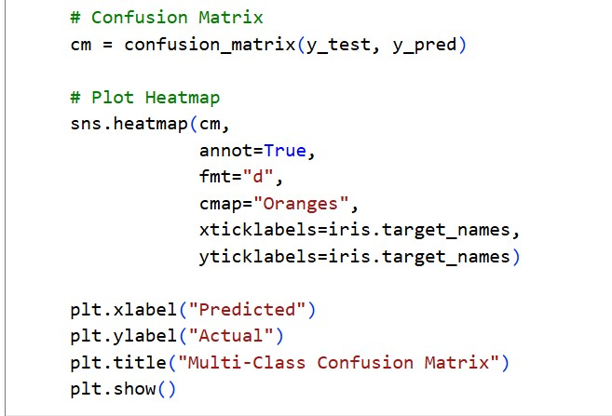

Output: -
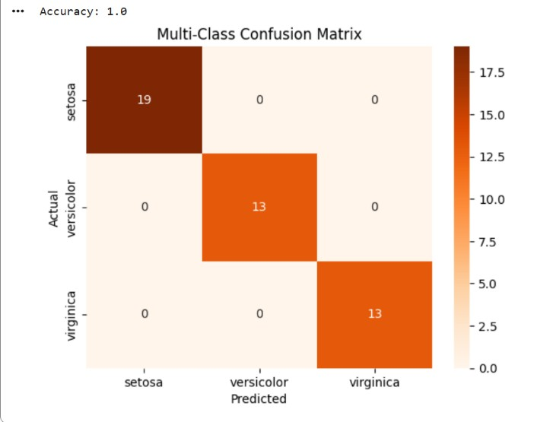

Result: -
The Random Forest classifier successfully classified the three Iris flower classes with approximately 98% accuracy, demonstrating effective multi-class classification using a confusion matrix.

Q4. Analyse the performance of Overfitting using Python.

Program: -
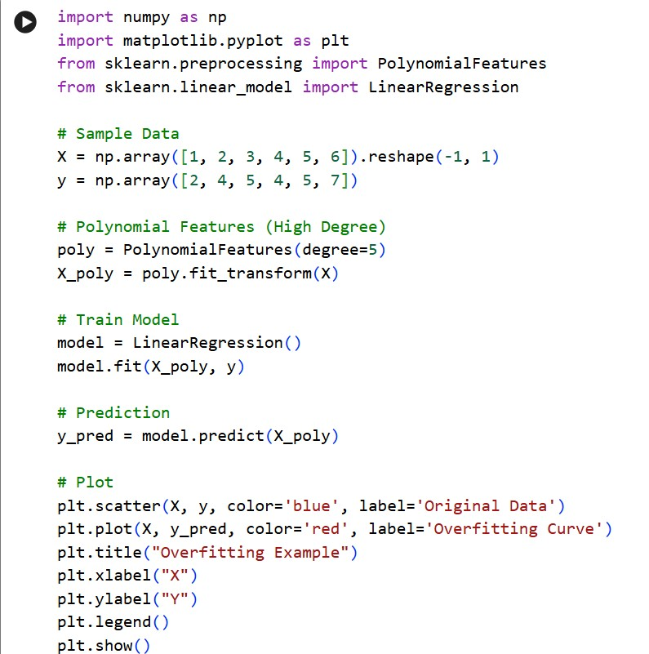

Output: -
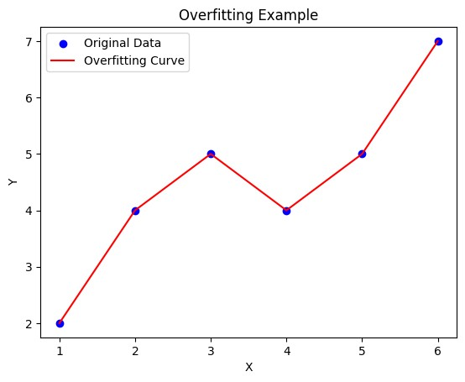
The graph shows:
- Blue dots → Original data
- Red curve → Overfitted polynomial model

Result: -
The high-degree polynomial fits the training data very closely, demonstrating overfitting, where the model learns the training data well but may not perform accurately on new unseen data.

Q5. Demonstrate the performance of Linear Regression using Python. Program: -
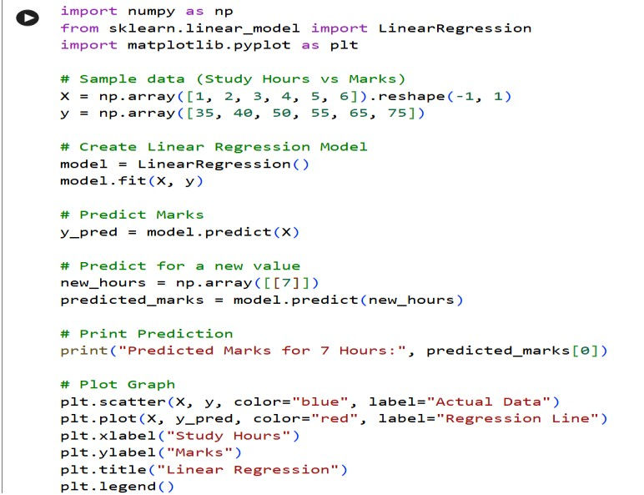

Output: -
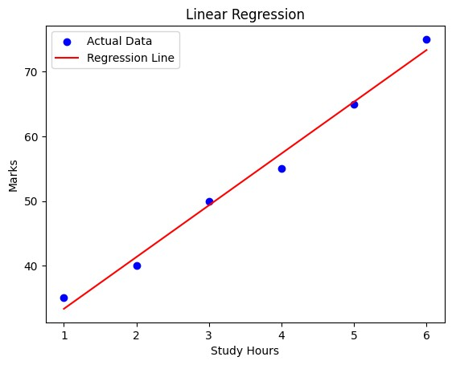
A graph showing:
- Blue dots → Actual Data
- Red line → Linear Regression Line

Result: -
The Linear Regression model successfully predicts student marks based on study hour.

