Webogy LLC

EasyIF Excel Add-in
User Guide



“Empowering the Excel Community”

Published: March 2002
Table of Contents
Introduction 1
Getting Started 2
Installing the EasyIF Excel Add-in 2
Setting EasyIF Options 3
EasyIF Add-in Functionality 4
EasyIF Worksheet Function 4
EasyQuote Worksheet Function 8
EasyEval Worksheet Function 8
Advanced Topics 9
EasyIF Wizards 9
EasyIF Parameter Resolution 12
EasyIF Solution Templates 12
Additional Product Information 12

Webogy LLC
EasyIF Excel Add-in
User Guide

Published: March 2002
For the latest information, please see http://www.webogy.com/easyif

Introduction
With EasyIf from Webogy, simple to comprehensive logical functions such as if/then relationships, and lookup and reference functions such as VLOOKUP and HLOOKUP can be combined into one easy worksheet function, replacing complex and at times, limiting standard functions. This Excel add-in product is easy to use and maintain, and delivers powerful logical relationship comparisons, unprecedented lookup capabilities and accurate value selection that were only previously available through custom macro programming.
This document provides an overview of a new comparative analysis function that, depending on the comparison criteria, Excel either does not offer or is so difficult and limiting to use via built-in logical and lookup/reference functions that users shun away from this comparative analysis thereby missing some of the value that Excel can provide. This product is so versatile that Webogy has applied for a patent on the concept and technology. We are continuing to extend the product’s capabilities through the addition of new grid libraries (pre-configured comparative relationships) that can be used in a standalone format or as a template by the Excel user.
EasyIF is available in two versions:
- Standard – client-based lookup and evaluation, enabling the end-user to compile complex searching/matching algorithms will very little effort. Lookup grids can be shared with other users provided they have the EasyIF add-in function installed. Grids can be stored locally or on file server on the network. Wizards are available to streamline the definition process and assist in getting the application up and running with as little effort as possible. The standard edition is currently available.
- Professional – includes all the functionality of the standard edition and extends the functionality to enable organizations to centrally store all lookup and comparison grids for enterprise use, and leverage the power and scalability of the Webogy Application Evaluation Engine. The Professional version includes complete role and individual-based authentication mechanisms to ensure that only authorized access is allowed to the service and more importantly, underlying grid structures. Complete check-in and check-out features enhance the integrity of the overall process. The professional edition is slated for release in Fall of 2002.

Getting Started

Installing the EasyIF Excel Add-in
To install the EasyIF add-in, please follow the instructions below. Please note that a Product Activation Key is required to ensure full-functionality mode of the Excel Add-in. Downloading of the Trial Version will entitle the user to 30 days of full-functionality before reverting to limited functionality mode, and prompting the user to optionally purchase the add-in immediately. Volume pricing is also available so please contact Webogy directly. To reinstall, please ensure that you have the Product Activation Key readily available.
Installation Instructions:
- Download the file from the Webogy Web site by clicking the Download Now button (below) and following the instructions in the dialog boxes.
Total Download Size = 316 KB
Total Download Time = 2 minutes @28.8k
- Double-click the EasyIF.exe program file on your hard disk to start the setup program.
- Follow the instructions on the screen to complete the installation.
- Start Excel.
- On the Tools menu, click Add-ins.
- Select the EasyIF Add-in check box.

Instructions for use:
Once you have installed the EasyIF Add-in, use Excel as you normally would. For additional information on the EasyIF Add-in, please refer to this document or do the following:
- On the Help menu, click Microsoft Excel Help.
- Type EasyIF in the Office Assistant or Answer Wizard, and then click Search to view the topics returned.
- Alternatively, click the Help on this function from the Insert Function dialog.

To remove this download:
- Start Excel
- On the Tools menu, click Add-ins.
- Clear the EasyIF Add-in check box.

Setting EasyIF Options
To change the default location of your EasyIf grids, on the EasyIF menu, click Options.
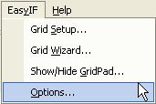
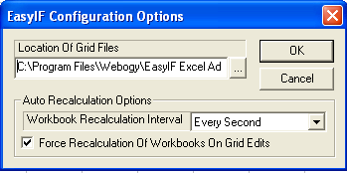
The location of the grid files can be on your local drive or on a shared directory within your corporate network. Please note that you should synchronize your local grids with the shared directory before disconnecting from your corporate network.
In addition to specifying your default grid location, you can also set up your auto-calculation options for interactively updating your grids and seeing the results in your worksheet. The recalculation option can be optionally changed interactively on the grid display panel.

Sharing EasyIF Grids:
There are a number of ways that users can share their grids:
- Setup a shared directory on your network or local computer, simply select options from the EasyIF menu and put in the shared directory path (supports UNC conventions \\ComputerName\SharedDirectoryName).
- You can email the Grids to anyone that has the EasyIF add-in installed. The EasyIF grids have a file extension of .xlg, making it easy to locate amongst the rest of your Excel files. Simply have the recipients save the attached grids to the same directory that they have specified in their Options dialog.

EasyIF Add-in Functionality
The EasyIF Add-in has incorporates three worksheet cell functions: EasyIF, EasyQuote and EasyEval, each of which are described below.

EasyIF Worksheet Function
The EasyIF function allows the user to create and maintain a library of relationship grids. Each grid is a user-defined combination of rows and columns that have comparative relationships. The user can define one to many grids, building a library of comparative relationships. The grids are assigned to cells within the worksheet, which provides the link between the worksheet and the assigned grid. Using a pattern matching algorithm, EasyIF selects either a cell or range of cell values, evaluates the variables to the assigned grid, finds the correct value and returns it to the Excel worksheet.
Power Excel users will take advantage of EasyIF’s ability to return Excel Formulas, adding another level of power and flexibility to their worksheet solutions. This powerful feature also provides for dynamic parameter passing and resolution, thereby providing the utmost flexibility and powerful when using the EasyIF worksheet function.

Creating and Viewing Grids
To add, view or maintain a grid:
- Select Grid Setup from the EasyIF menu or alternatively, select Show/Hide GridPad from the EasyIF menu.
- To view a specific grid, either double click on the selected grid or select Properties.
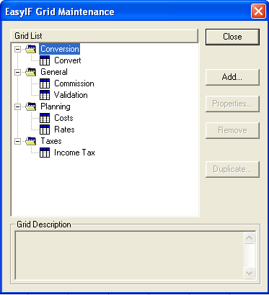
- New grids can be created by hitting either the Add or Duplicate buttons. Wizards are also available to assist in the generation and population of grids.
- Grids can be removed by selecting the grid and hitting the Remove button.
Maintaining Grids
There are three main areas that constitute a Grid definition:
- Grid Profile
- Grid Columns
- Grid Data Values

Grid Profile:
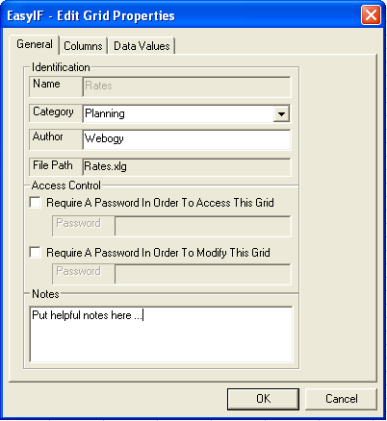
The Grid Profile identifies the name and relative path to the Grid in question. In addition, Grids can be categorized by user for ease of selection purposes. Categories are user-defined. Users can optionally enter in Notes to describe the Grid in more detail. The add-in defaults to displaying the input column parameters. To prevent authorized viewing and/or tampering of the Grid, a password can be optionally assigned to each access control function.

Grid Columns:
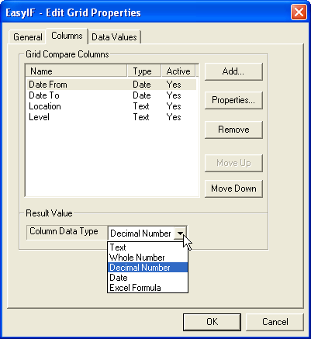
Any number of compare columns can be setup, including columns that are not used in the comparison processing but are used for reference purposes, or perhaps what-if scenarios. There are two types, actually three if you include the non-compare column, of columns: compare and result. In the standard version, only one result column can be returned; however, the result can be another formula that perhaps calls another formula or EasyIF expression. Compare columns can be re-ordered as required. Activating or deactivating a column is handled by the Active status (yes/no).
Result values are restricted to Text, Whole and Decimal numbers, Dates and an Excel Formula. Please note that a compare column can be used that incorporates the EasyIF worksheet function. For example, you are trying to determine a commission for a particular salesperson for a store; an EasyIF expression can be used to return the Salesperson responsible for that Store, and can be used as an input to determine the Commission rate applicable based on the sales dollar range and the returned Salesperson column.

Grid Column Properties:
To add, view or maintain a grid column:
- To add a new column, select the Add button.
- To view a specific grid column, either double click on the selected column or select Properties
- To remove a column, select the Remove button.

Column Properties:
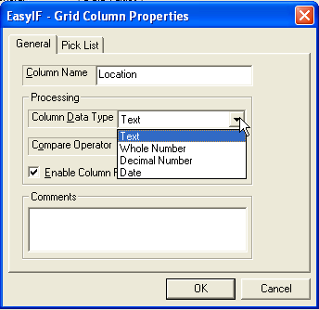
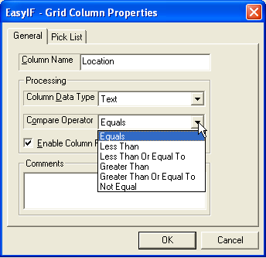
Each compare column consists of a Name field, a comments field for additional information, and three fields used specifically for the comparison processing: Data Type, Compare Operator, and a checkbox for determining whether or not to include this column in the comparison. The data types supported are Text, Whole Number, Decimal Number and Date, as shown below in the dropdown box.
In addition to the data types, the following comparison operators are allowed and provide for an extremely powerful and flexible evaluation process: Equals, Less Than, Less Than or Equal To, Greater Than, Greater Than or Equal To and Not Equal.
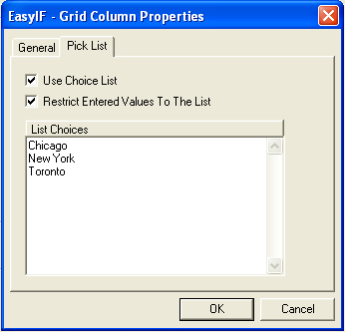
To speed data entry, as well as enforce integrity, each column can optionally be assigned a pick list, with each entry optionally validated against the pick list. For example, if you only have three store locations, then you can ensure that only those stores are included in the Grid for comparison purposes.

Grid Values:
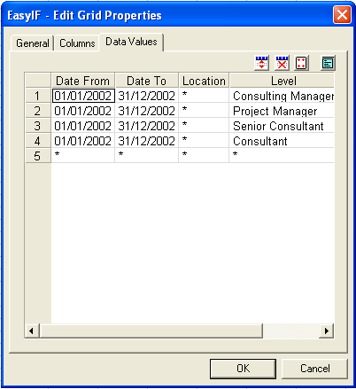
As expected, the grid is a combination of rows and columns as defined by the previous steps. Items can be explicated entered or implicitly entered as wildcard values. Rows can be inserted and deleted as required. A full screen mode is available for data entry purposes. A wizard is also available to import data from a worksheet.

Advanced Features of the EasyIF Worksheet function
The floating grid and viewer options will allow users to dynamically select and change their underlying comparisons while at the same time seeing the worksheet automatically reflect the changes. This enables very powerful what-if capabilities. All grids are accessible via the EasyIF Grid ViewPad.
To show or hide the Grid ViewPad:
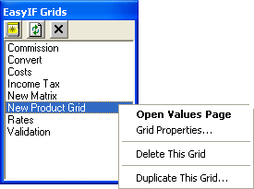
- From the EasyIF menu, select Show/Hide GridPad.
- Double-click or select Open Values Page from the right-click menu option to view the selected Grid Data.

From the Grid ViewPad, you can display the Grid Properties, delete a grid, duplicate a grid, as well as create a new grid (click on the menu bar). In addition, to refresh your Grid ViewPad, simply select the refresh button on the menu.
- To close the ViewPad or GridPad, simply click on the X in each dialog or from the EasyIF Menu, select Show/Hide GridPad.

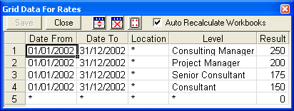
You can insert and delete rows by pressing the insert button and the delete button, respectively. To wild card a column for comparison purposes, please select the wildcard button. If you do not need interactive recalculations on our worksheet, please uncheck the Auto Recalculate Workbooks option.
To insert the EasyIF Worksheet Function:
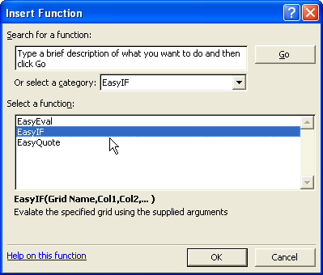
- From Insert menu, select Function
- Simply key in the function directly into the worksheet cell =EasyIF(“GridName”,Cell Reference or Value, …)

EasyQuote Worksheet Function
This worksheet function returns back the current price of given stock symbol.
To insert the EasyQuote Worksheet Function:
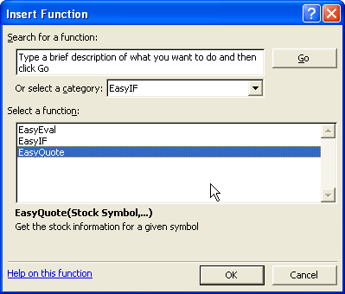
- From Insert menu, select Function
- Simply key in the function directly into the worksheet cell =EasyQuote(“StockSymbol”[, “InformationType”]) where the second optional parameter “InformationType” can be one of the following:

P = Price
N = Company Name
H = Today's High
L = Today's Low
C = Previous Close
V = Volume
% = Net Change Percent

EasyEval Worksheet Function
The EasyEval worksheet function simply evaluates any given string as a formula, returning the result back to the calling cell.
To insert the EasyEval Worksheet Function:
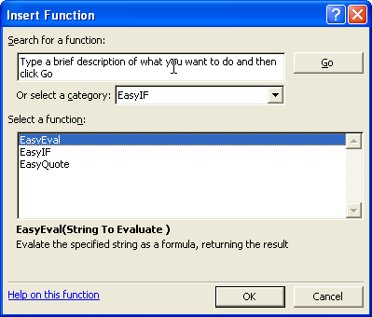
- From Insert menu, select Function
- Simply key in the function directly into the worksheet cell =EasyEval(“YourString”)

Advanced Topics

EasyIF Wizards
EasyIF comes with three built-in wizards to automate the maintenance and creation of EasyIF grids.

Create New Grid Structure
To create a new grid structure from a referenced cell:
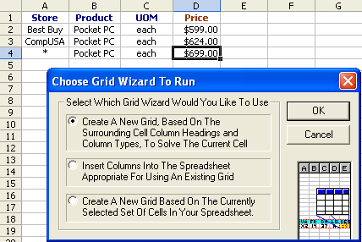
- From within your worksheet, select the cell that best meets your needs for creating a new grid based on the column headings and column types.
- From the EasyIF menu, select first option button as seen in the left.
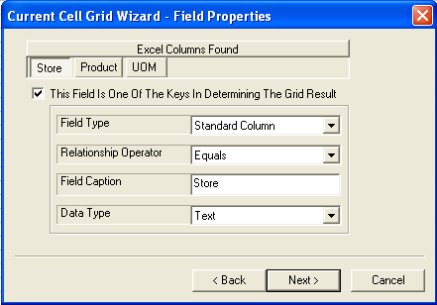
- Hit OK
- Follow the steps as outlined in the wizard. The first step is to define the compare columns, identifying the Field Type, Comparison Operator, Field Caption and Data Type. Hit next, the wizard will iteratively walk through all of the identified compare columns.
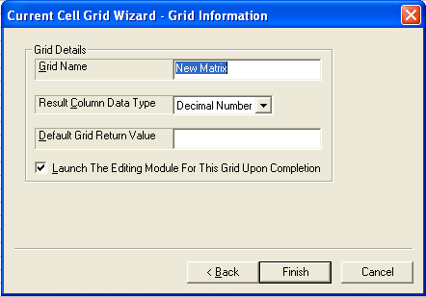
- The final step is to identify the grid attributes such as Name, the Result Column data type and a default value if no matches are found.

Insert Grid Columns into Worksheet
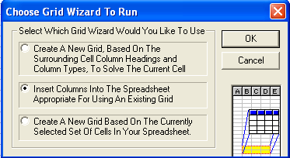
This wizard is used to copy the column headings and types from a specific grid to any cell reference on a worksheet. This is helpful is you would like to build a new grid based on the copied columns, or perhaps to interactively test the grid based on sample input.
To invoke:
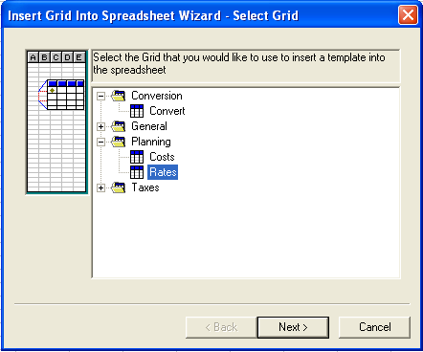
- Select Grid Wizard from the EasyIF menu.
- Select a grid from list provided.
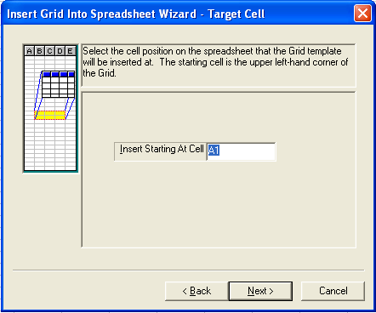
- Select a cell to write the output to.
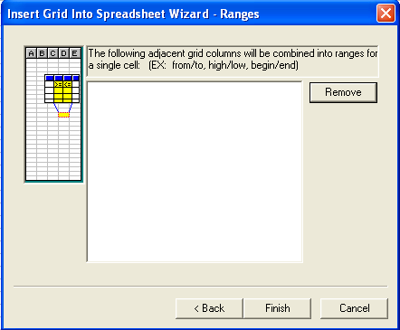
- Determine whether or not you would like to combine adjacent grid columns into ranges for a single cell.
- View the results in the worksheet.
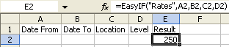

Create New Grid
The last wizard is probably the most powerful in that you can import a section of a worksheet to form a new grid.
To invoke:
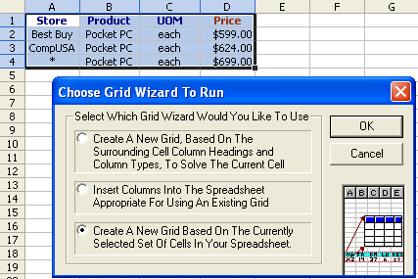
- Select the range of cells that you wish to include in the Grid.
- Select Grid Wizard from the EasyIF menu.
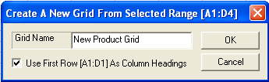
- Select the third option button.
- Provide a Grid Name and select the checkbox to determine if the first row in your selected range is to be used for the column headings.
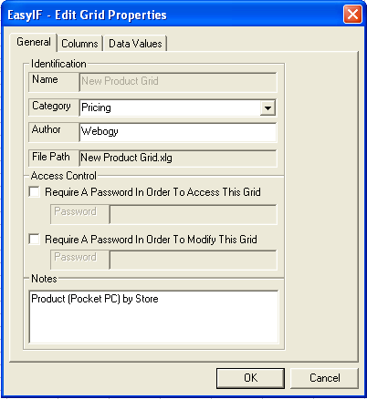
- Verify that the grid was created as outlined in your selected cell range by viewing the General, Columns and Data Value tabs, making any changes are required. You may also at this time, specify valid pick lists for the selected compare columns.
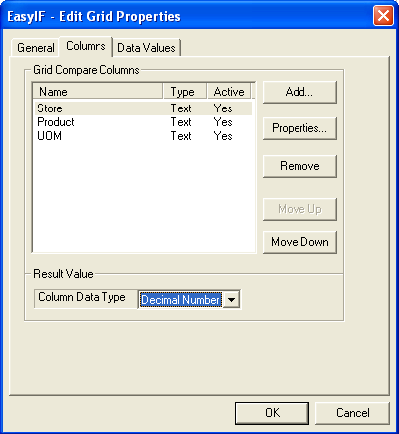
- Save your work and start using the grid in your worksheet immediately.
- By selecting the Hide/Show GridPad option on the EasyIF menu, you can interactively change your grid and have the result immediately update your worksheet.
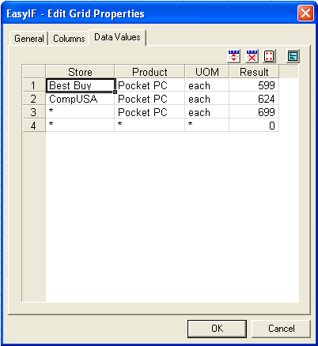

EasyIF Formula and Parameter Resolution
As previously mentioned, the EasyIF function allows for dynamic parameter and variable resolution, allowing the user to incorporate comparative columns in the calculation of the result. This is in addition to determining which result to use. As you can see, there are virtually no limits to the flexibility and power of the EasyIF Function. More importantly, EasyIF allows you to built complex solutions in a fraction of the time that it would take using standard logical and lookup functions within Excel or using Visual Basic for Applications, without the need for IT or programmer assistance.

Example:
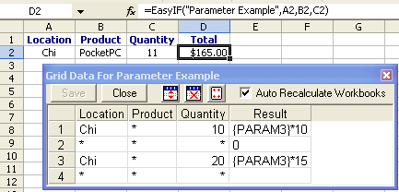
The following example depicts a very simple use of dynamic parameter resolution and the embedding of a parameter within an Excel formula result type. The quantity field (PARAMeter 3) is compared against the Grid Quantity Column (less than or equal to operator) to derive the total price of the transaction (Quantity (PARAM3) times Price).

EasyIF Solution Templates
In addition to the add-ins, Webogy will also be looking at offering a complete set of EasyIF templates and solutions to assist in the use of the EasyIF add-in. The templates and solutions will range in complexity from simple lookups to very complex tax and commission calculations. These templates and solutions will also be available in standard or professional formats.
For availability and pricing information on the EasyIF templates and solutions, please check the following web site: http://www.webogy.com/easyif/solutions.

Additional Product Information
Webogy is positioned to become a premier supplier of office extensions and add-ins. Webogy’s XML Web Service direction, coupled with our Office add-in technologies, will enable companies and individuals to quickly transcend the traditional power of the Office environment, and move their strategic applications to the forefront of technology, accessible by internal and external applications and resources, alike.
For more product information: http://www.Webogy.com/easyif


© 2002 Webogy LLC. All rights reserved.
The information contained in this document represents the current view of Webogy. on the issues discussed as of the date of publication. Because Webogy must respond to changing market conditions, it should not be interpreted to be a commitment on the part of Webogy, and Webogy cannot guarantee the accuracy of any information presented after the date of publication.
This document is for informational purposes only. WEBOGY MAKES NO WARRANTIES, EXPRESS OR IMPLIED, IN THIS DOCUMENT.
Complying with all applicable copyright laws is the responsibility of the user. Without limiting the rights under copyright, no part of this document may be reproduced, stored in or introduced into a retrieval system, or transmitted in any form or by any means (electronic, mechanical, photocopying, recording or otherwise), or for any purpose, without the express written permission of Webogy LLC.
Webogy may have patents, patent applications, trademarks, copyrights or other intellectual property rights covering subject matter in this document. Except as expressly provided in any written license agreement from Webogy, the furnishing of this document does not give you any license to these patents, trademarks, copyrights or other intellectual property.
EasyIF Add-in and EasyIF XML Web Service are either registered trademarks or trademarks of Webogy LLC in the United States and/or other countries.
The names of actual companies and products mentioned herein may be the trademarks of their respective owners.
Webogy LLC• 200E-2201 Waukegan Rd • Bannockburn, IL 60015-0000 • USA

