Uses need: automatically generate care plans based on information (clinicals) found within the patient’s record.

Expect input:
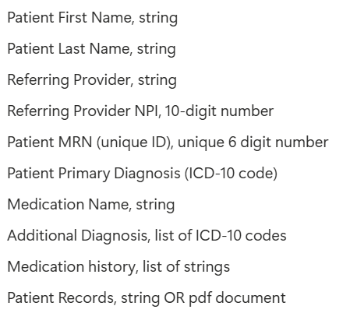

A system:
1 allow to input
2 webform must validate the data above
3 Warning if orders look like duplicates (define duplicate? After warning?)
4 Warning if a patient looks like it is duplicated(either name or NPI is the same but the other one is not-human check, and double confirm then update data.)
5 Provider only be entered once in the system
6 Call an LLM to generate a care plan as a text file they can download
7 export the report

