Data Exploration

Data Set Overview

The table below lists each of the files available for analysis with a short description of what is found in each one.

|  |  |  |
| --- | --- | --- |
| **File Name** | **Description** | **Fields** |
| ad-clicks.csv | A record of each ad that was clicked on. | timestamp: date / time the click occurred.  txId: a unique id for the click  userSessionid: the id of the user session for the user who made the click  teamid: the current team id of the user who made the click  userid: the user id of the user who made the click  adId: the id of the ad clicked on  adCategory: the category of ad clicked on |
| buy-clicks.csv | A list of purchases. | timestamp: when the purchase was made.  txId: a unique id (within buy-clicks.log) for the purchase  userSessionId: the id of the user session for the user who made the purchase  team: the current team id of the user who made the purchase  userId: the user id of the user who made the purchase  buyId: the id of the item purchased  price: the price of the item purchased |
| game-clicks.csv | A record of each click a user performed during the game. | timestamp: when the click occurred.  clickId: a unique id for the click.  userId: the id of the user performing the click.  userSessionId: the id of the session of the user when the click is performed.  isHit: denotes if the click was on a flamingo (value is 1) or missed the flamingo (value is 0)  teamId: the id of the team of the user  teamLevel: the current level of the team of the user |
| level-events.csv | A record of each level event for a team. Level events are recorded when a team ends or begins a new level | timestamp: when the event occurred.  eventId: a unique id for the event  teamId: the id of the team  teamLevel: the level started or completed  eventType: the type of event, either start or end |
| team-assignments.csv | A record of each time a user joins a team. | timestamp: when the user joined the team.  team: the id of the team  userId: the id of the user  assignmentId: a unique id for this assignment |
| team.csv | A record of each team in the game. | teamId: the id of the team  name: the name of the team  teamCreationTime: the timestamp when the team was created  teamEndTime: the timestamp when the last member left the team  strength: a measure of team strength, roughly corresponding to the success of a team  currentLevel: the current level of the team |
| user-session.csv | A record of each session a user plays.  When a team levels up, each current user session ends and a new session begins with the new level. | teamId: the id of the team  name: the name of the team  teamCreationTime: the timestamp when the team was created  teamEndTime: the timestamp when the last member left the team  strength: a measure of team strength, roughly corresponding to the success of a team  currentLevel: the current level of the team |
| users.csv | A record for each user playing the game | timestamp: when user first played the game.  userId: the user id assigned to the user.  nick: the nickname chosen by the user.  twitter: the twitter handle of the user.  dob: the date of birth of the user.  country: the two-letter country code where the user lives. |

Aggregation

|  |  |
| --- | --- |
| Amount spent buying items | $ 21407 |
| Number of unique items available to be purchased | 6 |

A histogram showing how many times each item is purchased:

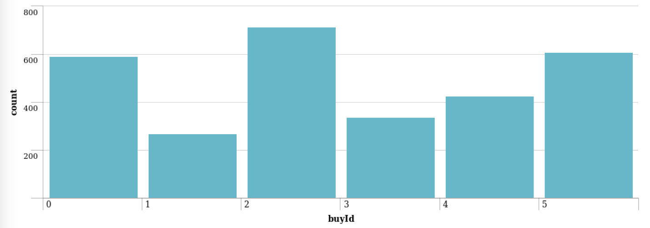

A histogram showing how much money was made from each item:

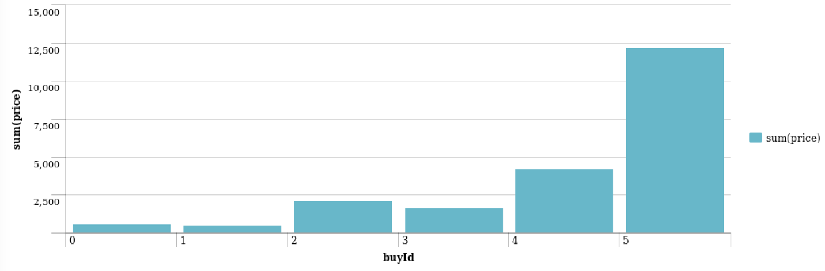

Filtering

A histogram showing total amount of money spent by the top ten users (ranked by how much money they spent).

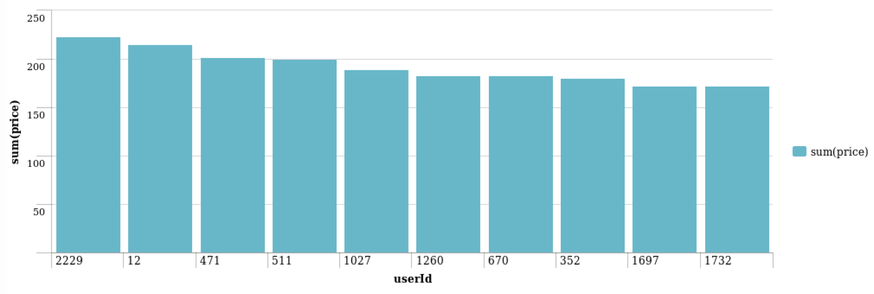

The following table shows the user id, platform, and hit-ratio percentage for the top three buying users:

|  |  |  |  |
| --- | --- | --- | --- |
| **Rank** | **User Id** | **Platform** | **Hit-Ratio (%)** |
| 1 | 2229 | iPhone | 11.5% |
| 2 | 12 | iPhone | 13% |
| 3 | 471 | iPhone | 14.5% |