**Training Data Set Creation**

The training data set used for this analysis is shown below (first 5 lines):

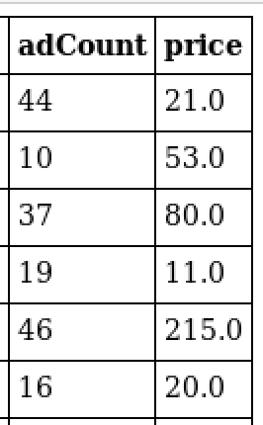

Dimensions of the training data set (rows x columns) : 543 x 2

# of clusters created: 2