Russian Federation: Recent Economic Developments and Outlook

# GDP growth in 2019 decreased

GDP growth decreased from 2.5% in 2018 to 1.3% in 2019. On the demand side, private consumption, accounting for 50.4% of GDP, contributed the most with 1.3 percentage points (pp). Gross capital formation gave 0.8pp. Government expenditure shared 0.4pp. On the other hand, net exports cut 1.4pp from growth. On the supply side, services, accounting for 54.0% of GDP, contributed the most with 0.9pp. Industry (including construction) gave 0.3pp. Meanwhile, agriculture had trivial contribution to growth this period.

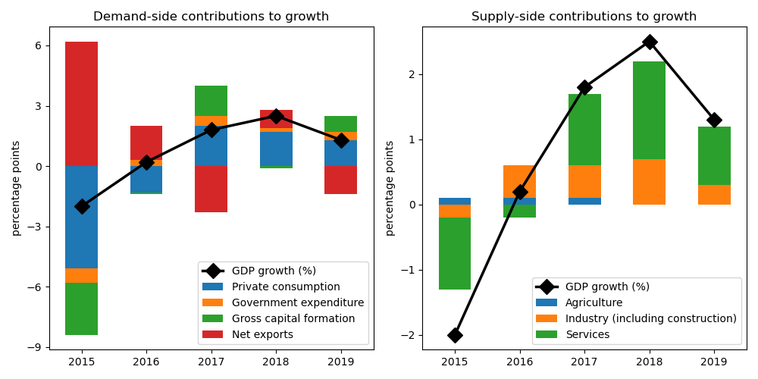

## Gross capital formation achieved largest gain on the demand side

Gross capital formation expanded by the biggest margin at 3.8% annual growth. Private consumption jumped by 2.5%. Government expenditure picked up by 2.2%. On the other hand, net exports decreased by 22.3%.

## On the supply side, growth in services accelerated the fastest

Services jumped by the largest edge at 1.6% annual growth. Industry (including construction) grew by 1.0%. Agriculture picked up by 0.6%.

## Unemployment improved; inflation increased

Unemployment rate improved from 4.8% in 2018 to 4.5% in 2019. Consequently, inflation increased from 2.9% to 4.5%. At the end of the year, the central bank set the policy rate at 6.25%.

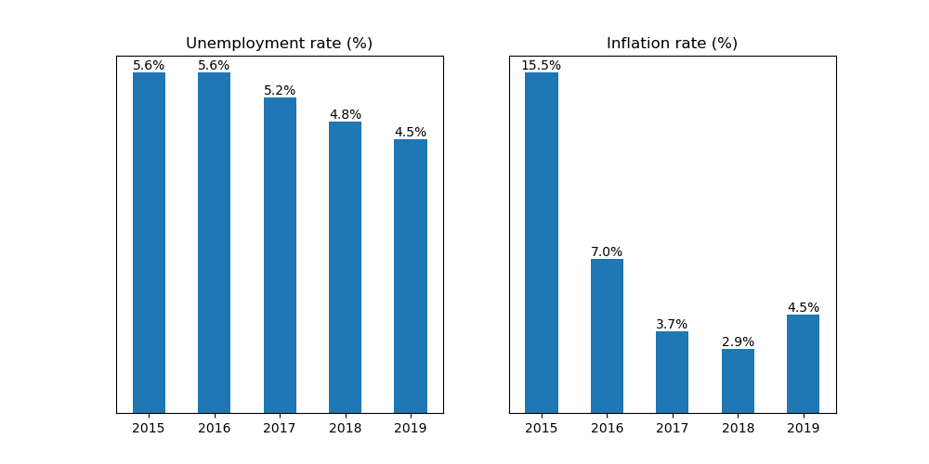

## Current account balance posted a surplus

Current account balance (CAB) recorded a surplus at 3.8% of GDP in 2019. Net trade in goods and services reached USD 129.0 billion. In 2018, CAB posted a surplus at 6.9% of GDP.

China is the country's top export destination accounting for 13.4% of total exports in 2019. Other major exports partners include Netherlands (10.5%), Germany (6.6%), Belarus (5.1%), and Turkey (5.0%). Top export commodities are mineral fuels, mineral oils and products of their distillation; bituminous substances; mineral waxes, accounting for 52.0% of total exports.

For imports, top imports origin in 2019 is China (21.9% of total imports), followed by Germany (10.2%), Belarus (5.5%), USA (5.4%), and Italy (4.4%). Major import commodities are nuclear reactors, boilers, machinery and mechanical appliances; parts thereof, accounting for 17.5% of total imports.

# Output contracted in Q2 2020

Output plunged by 8.1% year-on-year in Q2 of 2020. Growth in overall economic activity worsened from 1.7% in the previous quarter. Net exports increased by the biggest margin at 227.5% annual growth. Government expenditure picked up by 1.6%. On the other hand, private consumption and gross capital formation decreased by 22.2% and 6.2%, respectively.

## Retail sales contracted

Retail sales contracted by 2.5% year-on-year in October of 2020. Growth in the retail sector increased from a contraction of 3.1% in September, reflecting increased trade activity.

## Consumer confidence down

Meanwhile, consumer confidence index was in the negative territory at -22.0 points in Q3 of 2020. Confidence improved from -30.0 points in the previous quarter. Expectations of consumers about the general economic situation in the next 12 months turned pessimistic at -15.0 points from -20.0 points over the same period, reflecting improved consumer sentiments.

## Industrial output shrank

Industrial production shrank by 5.6% year-on-year in October, a decrease from -5.1% growth in the previous month. Looking at the details, growth in manufacturing worsened to -3.5% from -0.7%, while mining and quarrying output growth improved to -8.8% from -9.5%. Meanwhile, growth in water supply, sewerage, waste management & remediation jumped to 1.9% from -0.9%, while electricity, gas, steam and air conditioning supply output growth declined to -3.2% from -2.6%

## Inflation rose

Overall inflation rose to 4.0% year-on-year in October from 3.7% in the previous month. Prices for food products worsened to 4.8% from 4.3%, while housing, rent, water, electricity, gas & other fuels jumped to 3.4% from 3.3%. Transportation slowed down to -0.1% from 0.5%, while communication slowed down to 4.3% from 5.2%. Meanwhile, prices for health/medical care rose to 4.2% from 4.1%, recreation rose to 2.3% from 2.0%, and education improved to 1.9% from 2.1%

Russian Federation's central bank maintained the official policy rate to 4.25% in November from the same in October.

# Outlook tilted downwards this year

On November 2020, Consensus Economics panelists project Russian Federation's economic growth ending in 2020 at -3.8%. In 2021, the panelists foresee growth at 3.1%. Over the same period, consumption is expected to grow by -6.5% and 3.8%, while investment is projected to grow by -7.8% and 4.1%. On the supply side, industrial production is seen to grow by -3.5% and -3.5%.

Meanwhile, Consensus Economics panelists foresee inflation ending in 2020 at 3.9%. In 2021, the panelists project inflation at 3.6%.