**Bug Report**

After spending some time testing the Factorial app (<http://qainterview.pythonanywhere.com/>) & it’s endpoints, I have discovered the following bugs.

*Note:I initially thought the page title,* ***Factoriall*** *was intended, so I named my feature files to match that. I now think that may have been a typo, but for the sake of getting this challenge back to you quickly, I left them as-is.*

1. **Receiving a 500 HTTP response when POSTing to /factorial endpoint**

* I tried to send a POST request to the /factorial endpoint using Postman & Cypress.
* I was receiving a 500 error response.
* This is strange behaviour as the endpoint is being hit via the web page, so some further investigation is required here as to why we can’t hit the endpoint independent of the web page.
* I discovered the endpoint using the Chrome dev tools, & looking under the network tab.
* I saw you require a number value in the POST body also.

Below, you can see the /factorial endpoint being hit via the web page.

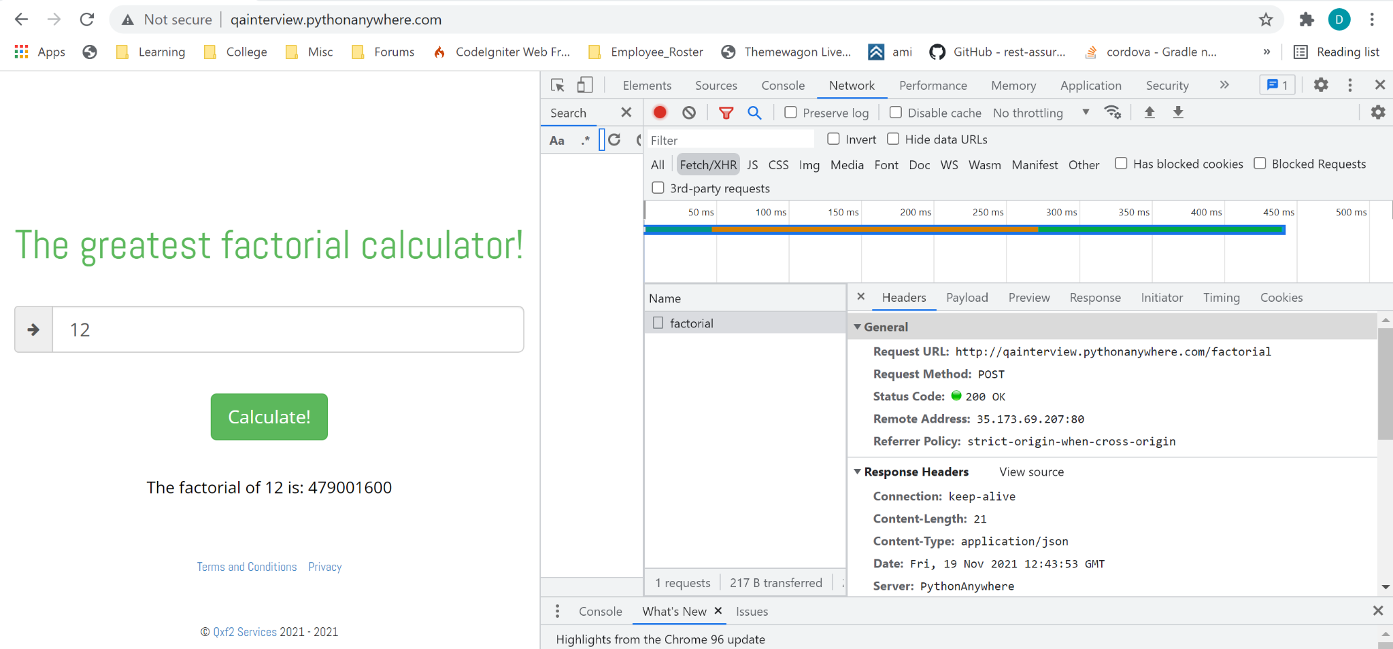

And here is the payload being passed from the web page to the endpoint:

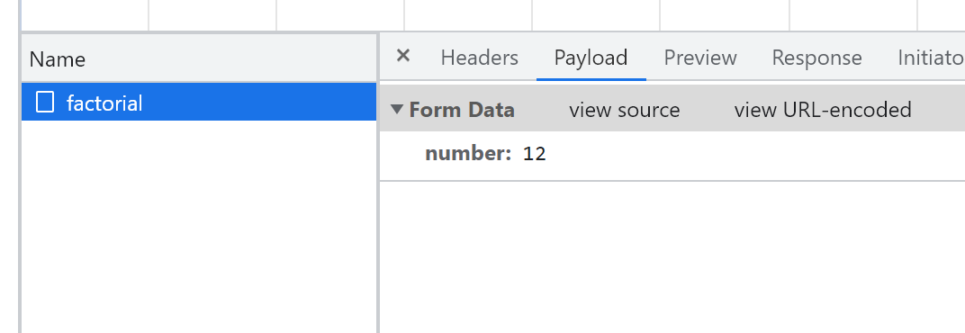

1. **Data Limit issue**

* Entering 999 as the input, we receive the below 500 error response.
* However, no error message is displayed to the user.
* As you can see, the previous message is displayed

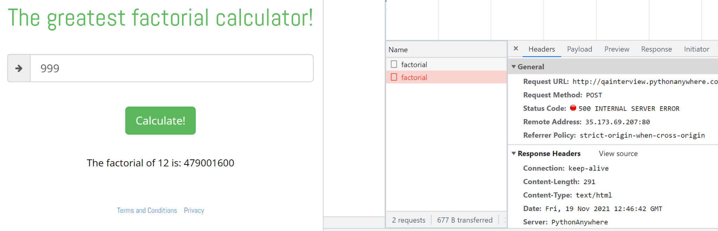

1. **Page title typo**

* As you can see below, the title reads Factoriall rather than Factorial.
* I’m not 100% sure if this is a defect, or if it’s expected.
* I thought it might have been a trademarked name, or something like that, but would need to confirm.

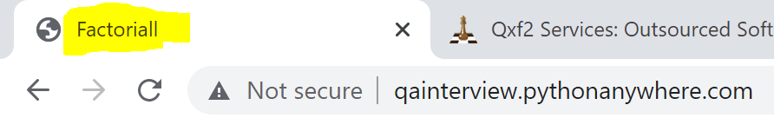

1. **Incorrect copyright dates**

* In the below screenshot, you can see the copyright dates are from 2021 - 2021.
* This should be updated to reflect the correct dates.

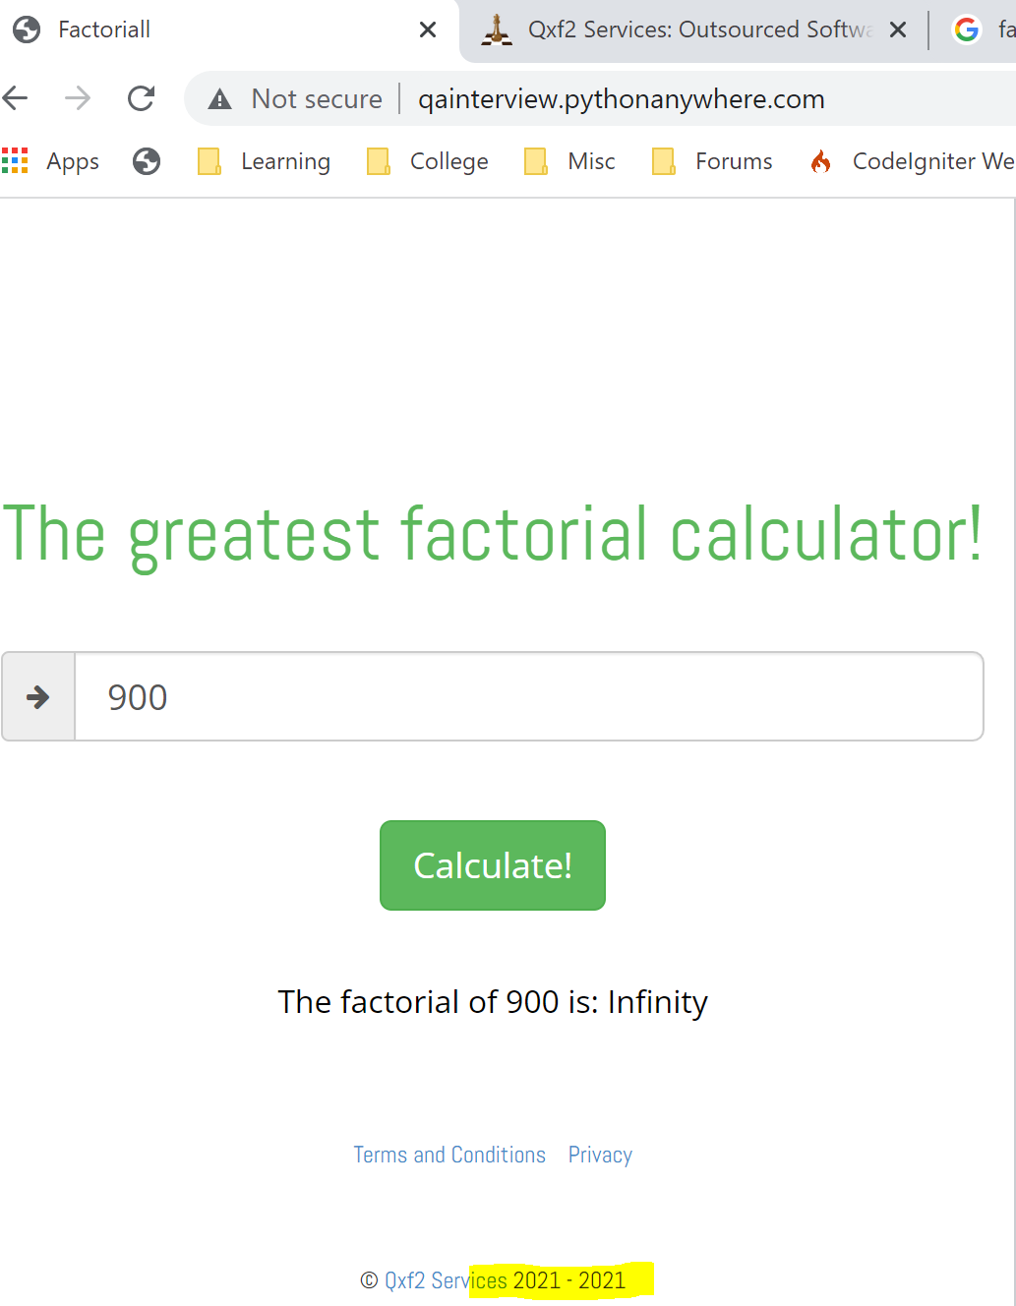

1. **Terms and Conditions link & Privacy link**

* In the below screenshot, I have highlighted both the Terms and Conditions link, & the Privacy link.
* If you click the Terms and Conditions link, you are currently brought to the Privacy page.
* If you click the Privacy link, you are currently brought to the Terms and Conditions page.
* This behaviour should be reversed (href’s, etc. updated), & users should be brought to the correct pages.

