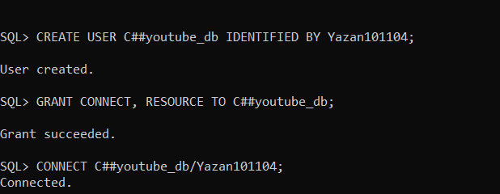
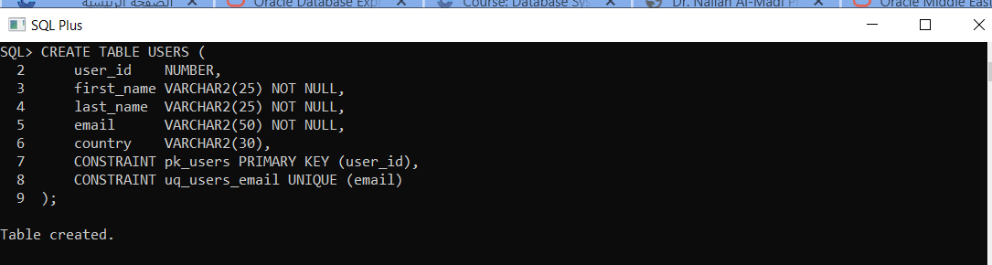
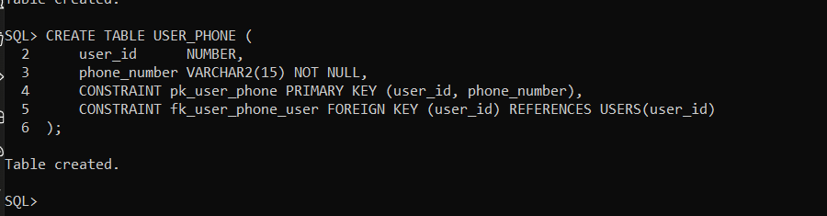
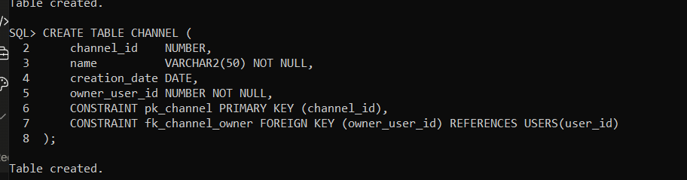
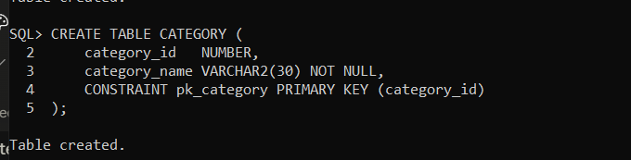
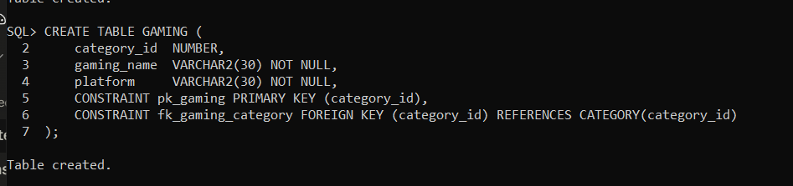
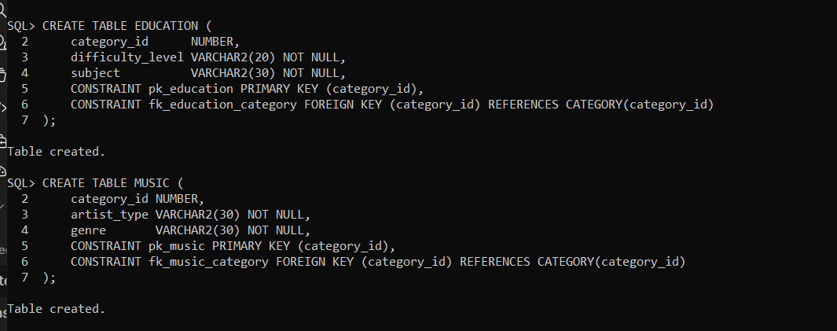
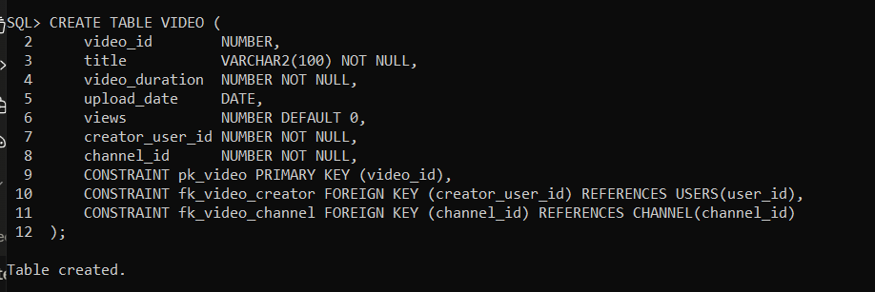
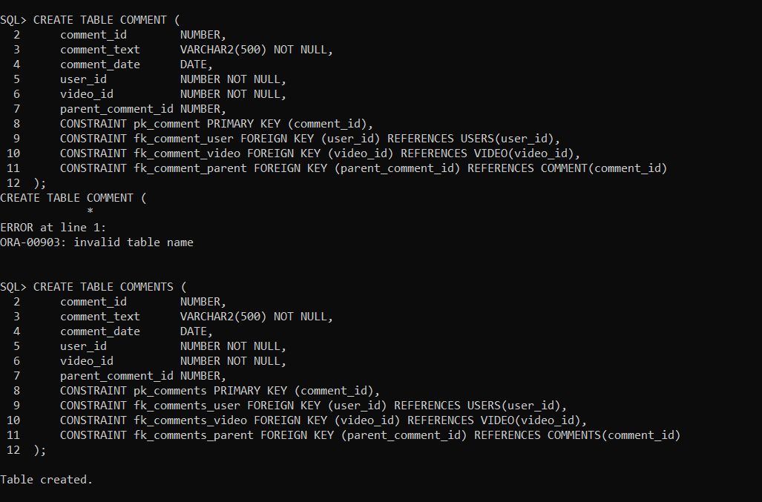
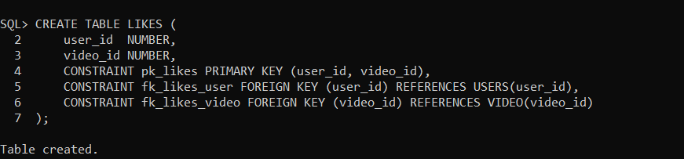
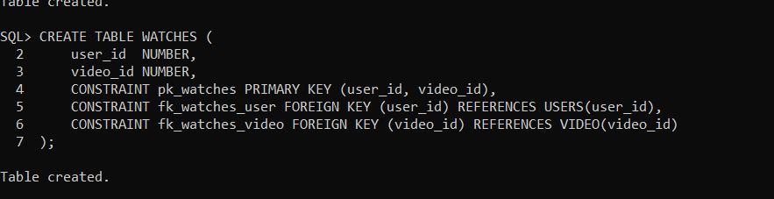
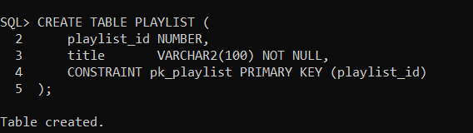
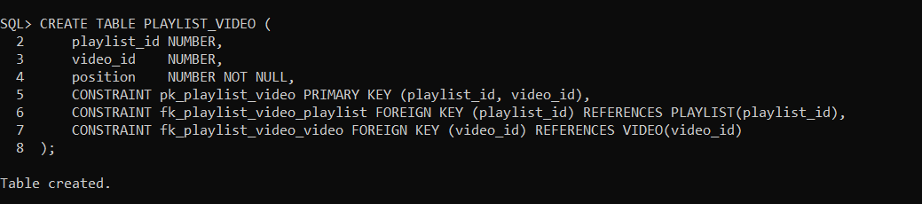
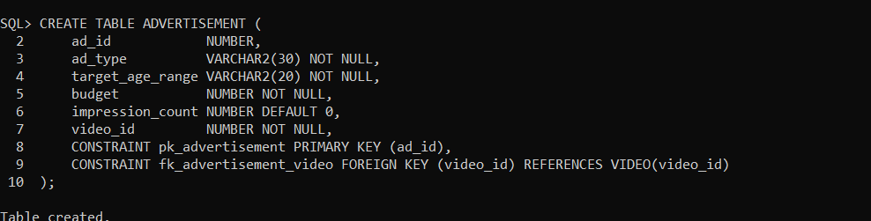
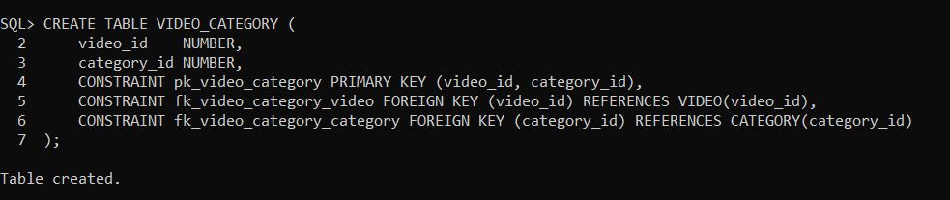

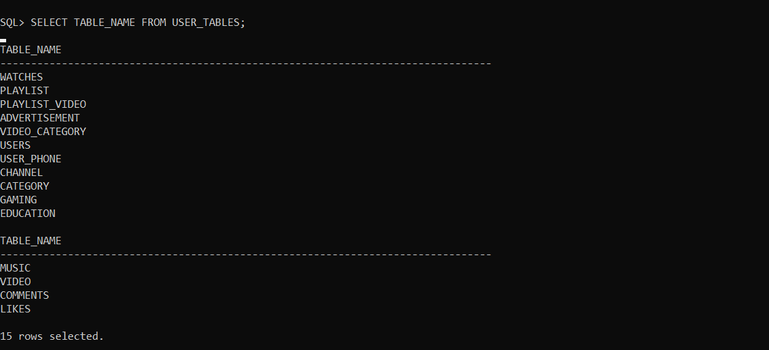
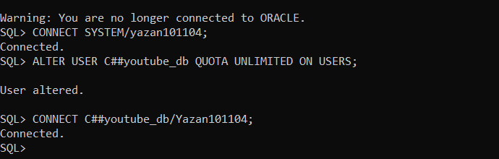
inserting a fake data into the database:
-- USERS
INSERT INTO USERS VALUES (1, 'Ahmed', 'Al-Salem', 'ahmed.salem@gmail.com', 'Jordan');
INSERT INTO USERS VALUES (2, 'Sara', 'Hassan', 'sara.hassan@gmail.com', 'Egypt');
INSERT INTO USERS VALUES (3, 'Omar', 'Khalid', 'omar.khalid@gmail.com', 'Saudi Arabia');
INSERT INTO USERS VALUES (4, 'Lina', 'Nasser', 'lina.nasser@gmail.com', 'UAE');
INSERT INTO USERS VALUES (5, 'Yousef', 'Amin', 'yousef.amin@gmail.com', 'Kuwait');

-- USER_PHONE
INSERT INTO USER_PHONE VALUES (1, '+962791234567');
INSERT INTO USER_PHONE VALUES (1, '+962771234567');
INSERT INTO USER_PHONE VALUES (2, '+201012345678');
INSERT INTO USER_PHONE VALUES (3, '+966501234567');
INSERT INTO USER_PHONE VALUES (4, '+971501234567');
INSERT INTO USER_PHONE VALUES (5, '+965501234567');

-- CHANNEL
INSERT INTO CHANNEL VALUES (1, 'Ahmed Tech', DATE '2020-01-15', 1);
INSERT INTO CHANNEL VALUES (2, 'Sara Cooks', DATE '2019-06-20', 2);
INSERT INTO CHANNEL VALUES (3, 'Omar Plays', DATE '2021-03-10', 3);
INSERT INTO CHANNEL VALUES (4, 'Lina Learns', DATE '2022-07-05', 4);
INSERT INTO CHANNEL VALUES (5, 'Yousef Music', DATE '2018-11-30', 5);

-- CATEGORY
INSERT INTO CATEGORY VALUES (1, 'Gaming');
INSERT INTO CATEGORY VALUES (2, 'Education');
INSERT INTO CATEGORY VALUES (3, 'Music');
INSERT INTO CATEGORY VALUES (4, 'Gaming');
INSERT INTO CATEGORY VALUES (5, 'Education');

-- GAMING
INSERT INTO GAMING VALUES (1, 'FIFA 2024', 'PlayStation');
INSERT INTO GAMING VALUES (4, 'Minecraft', 'PC');

-- EDUCATION
INSERT INTO EDUCATION VALUES (2, 'Beginner', 'Mathematics');
INSERT INTO EDUCATION VALUES (5, 'Intermediate', 'Computer Science');

-- MUSIC
INSERT INTO MUSIC VALUES (3, 'Solo', 'Pop');

-- VIDEO
INSERT INTO VIDEO VALUES (1, 'How to Build a PC', 3600, DATE '2023-01-10', 15000, 1, 1);
INSERT INTO VIDEO VALUES (2, 'Best Pasta Recipe', 1800, DATE '2023-02-15', 8000, 2, 2);
INSERT INTO VIDEO VALUES (3, 'FIFA 2024 Tips', 2700, DATE '2023-03-20', 25000, 3, 3);
INSERT INTO VIDEO VALUES (4, 'Learn Python in 1 Hour', 3600, DATE '2023-04-25', 50000, 4, 4);
INSERT INTO VIDEO VALUES (5, 'Top 10 Arabic Songs', 2400, DATE '2023-05-30', 12000, 5, 5);

-- COMMENTS
INSERT INTO COMMENTS VALUES (1, 'Great video!', DATE '2023-01-11', 2, 1, NULL);
INSERT INTO COMMENTS VALUES (2, 'Very helpful, thanks!', DATE '2023-02-16', 3, 2, NULL);
INSERT INTO COMMENTS VALUES (3, 'I learned a lot!', DATE '2023-03-21', 4, 3, NULL);
INSERT INTO COMMENTS VALUES (4, 'Amazing content!', DATE '2023-04-26', 5, 4, NULL);
INSERT INTO COMMENTS VALUES (5, 'Keep it up!', DATE '2023-05-31', 1, 5, NULL);
INSERT INTO COMMENTS VALUES (6, 'I agree with you!', DATE '2023-01-12', 3, 1, 1);

-- LIKES
INSERT INTO LIKES VALUES (1, 2);
INSERT INTO LIKES VALUES (2, 1);
INSERT INTO LIKES VALUES (3, 4);
INSERT INTO LIKES VALUES (4, 3);
INSERT INTO LIKES VALUES (5, 5);

-- WATCHES
INSERT INTO WATCHES VALUES (1, 1);
INSERT INTO WATCHES VALUES (2, 2);
INSERT INTO WATCHES VALUES (3, 3);
INSERT INTO WATCHES VALUES (4, 4);
INSERT INTO WATCHES VALUES (5, 5);
INSERT INTO WATCHES VALUES (1, 3);

-- PLAYLIST
INSERT INTO PLAYLIST VALUES (1, 'My Favorites');
INSERT INTO PLAYLIST VALUES (2, 'Watch Later');
INSERT INTO PLAYLIST VALUES (3, 'Gaming Videos');
INSERT INTO PLAYLIST VALUES (4, 'Study Material');
INSERT INTO PLAYLIST VALUES (5, 'Music Collection');

-- PLAYLIST_VIDEO
INSERT INTO PLAYLIST_VIDEO VALUES (1, 1, 1);
INSERT INTO PLAYLIST_VIDEO VALUES (1, 2, 2);
INSERT INTO PLAYLIST_VIDEO VALUES (2, 3, 1);
INSERT INTO PLAYLIST_VIDEO VALUES (3, 3, 1);
INSERT INTO PLAYLIST_VIDEO VALUES (4, 4, 1);
INSERT INTO PLAYLIST_VIDEO VALUES (5, 5, 1);

-- ADVERTISEMENT
INSERT INTO ADVERTISEMENT VALUES (1, 'Banner', '18-25', 500, 1500, 1);
INSERT INTO ADVERTISEMENT VALUES (2, 'Video', '25-35', 1500, 3200, 2);
INSERT INTO ADVERTISEMENT VALUES (3, 'Banner', '13-18', 300, 800, 3);
INSERT INTO ADVERTISEMENT VALUES (4, 'Video', '18-30', 2000, 5000, 4);
INSERT INTO ADVERTISEMENT VALUES (5, 'Banner', '30-45', 750, 2100, 5);

-- VIDEO_CATEGORY
INSERT INTO VIDEO_CATEGORY VALUES (1, 2);
INSERT INTO VIDEO_CATEGORY VALUES (2, 2);
INSERT INTO VIDEO_CATEGORY VALUES (3, 1);
INSERT INTO VIDEO_CATEGORY VALUES (4, 2);
INSERT INTO VIDEO_CATEGORY VALUES (5, 3);

COMMIT;
