Title

Table of Contents

Introduciton

In game theory, a game tree is a directed graph whose nodes are positions in a game and whose edges are moves. The complete game tree for a game is the game tree starting at the initial position and containing all possible moves from each position; the complete tree is the same tree as that obtained from the extensive-form game representation.

The first two plies of the game tree for tic-tac-toe.

The diagram shows the first two levels, or plies, in the game tree for tic-tac-toe. The rotations and reflections of positions are equivalent, so the first player has three choices of move: in the center, at the edge, or in the corner. The second player has two choices for the reply if the first player played in the center, otherwise five choices. And so on.

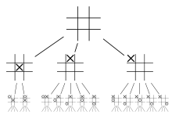

The first two plies of the game tree for tic-tac-toe.

The number of leaf nodes in the complete game tree is the number of possible different ways the game can be played. For example, the game tree for tic-tac-toe has 255,168 leaf nodes.

Each game consists of a problem space, an initial state, and a single (or a set of) goal states. A problem space is a mathematical abstraction in a form of a tree:
- the root represents current state
- nodes represent states of the game
- edges represent moves
- leaves represent final states (win, loss or draw)

Methodology

The branching factor - the average number of children of the nodes in the space.
  - The eight puzzle has a branching factor of 2.13
  - Chess has a branching factor of about 35
The solution depth - the length of the shortest path from the initial node to a goal node.
The size of a solution space:
  - Tic-Tac-Toe is 9! = 362,880
  - 8-puzzle - 9!/2
  - Checkers - 10^40
  - Chess - 10^120 (40 moves, 35 branch factor - 35^(2*40))

Game trees are important in artificial intelligence because one way to pick the best move in a game is to search the game tree using the minimax algorithm or its variants. The game tree for tic-tac-toe is easily searchable, but the complete game trees for larger games like chess are much too large to search. Instead, a chess-playing program searches a partial game tree: typically as many plies from the current position as it can search in the time available.

Methods to search a game tree
1 Brute-Force Searches
- Breadth-First Search (BFS)
Breadth-first search (BFS) is an algorithm for traversing or searching tree or graph data structures. It starts at the tree root (or some arbitrary node of a graph, sometimes referred to as a 'search key') and explores the neighbor nodes first, before moving to the next level neighbors.
PSEUDOCODE FOR BFS
Breadth-First-Search(G, v):
for each node n in G:
n.distance = INFINITY
n.parent = NIL

create empty queue Q

v.distance = 0
Q.enqueue(v)

while Q is not empty:
u = Q.dequeue()

for each node n that is adjacent to u:
if n.distance == INFINITY:
n.distance = u.distance + 1
n.parent = u
Q.enqueue(n)
BFS expands nodes in order of their depth from the root. Implemented by first-in first-out (FIFO) queue.BFS will find a shortest path to a goal.

Time/Space Complexity - branching factor b and the solution depth d. Generate all the nodes up to level d.
Total number of nodes = 1 + b + b^2 + ... + b^d = O(b^d)

Disadvantage of BFS-It will exhaust the memory in minutes.

- Depth First Search(DFS)
Depth-first search (DFS) is an algorithm for traversing or searching tree or graph data structures. One starts at the root (selecting some arbitrary node as the root in the case of a graph) and explores as far as possible along each branch before backtracking.

Psuedocode for A non-recursive implementation of DFS

Input: A graph G and a vertex v of G
Output: All vertices reachable from v labeled as discovered

procedure DFS-iterative(G,v):
let S be a stack
S.push(v)
while S is not empty
v = S.pop()
if v is not labeled as discovered:
label v as discovered
for all edges from v to w in G.adjacentEdges(v) do
S.push(w)
Implemented by LIFO stack.
Space Complexity is linear in the maximum search depth.
DFS generate the same set of nodes as BFS - Time Complexity is O(b^d)
The first solution DFS found may not be the optimal one.
On infinite tree DFS may not terminate.
The time and space analysis of DFS differs according to its application area. In theoretical computer science, DFS is typically used to traverse an entire graph, and takes time Θ(|V| + |E|), linear in the size of the graph. In these applications it also uses space O(|V|) in the worst case to store the stack of vertices on the current search path as well as the set of already-visited vertices. Thus, in this setting, the time and space bounds are the same as for breadth-first search and the choice of which of these two algorithms to use depends less on their complexity and more on the different properties of the vertex orderings the two algorithms produce.

2 Minimax
Minimax is a decision rule used in game theory for minimizing the possible loss for a worst case (maximum loss) scenario.We consider games with two players in which one person's gains are the result of another person's losses (so called zero-sum games). The minimax algorithm is a specialized search algorithm which returns the optimal sequence of moves for a player in an zero-sum game. In the game tree that results from the algorithm, each level represents a move by either of two players, say A- and B-player. Below is a game tree for the tic-tac-toe game .
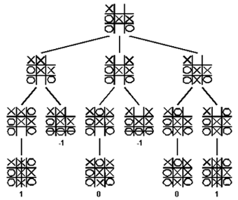

game tree for the tic-tac-toe game

The minimax algorithm explores the entire game tree using a depth-first search. At each node in the tree where A-player has to move, A-player would like to play the move that maximizes the payoff. Thus, A-player will assign the maximum score amongst the children to the node where Max makes a move. Similarly, B-player will minimize the payoff to A-player. The maximum and minimum scores are taken at alternating levels of the tree, since A and B alternate turns.
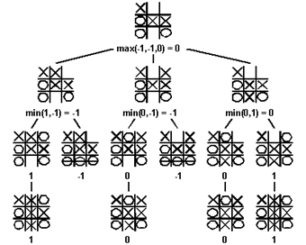

Minmax search for the tic-tac-toe game
The minimax algorithm computes the minimax decision for the leaves of the game tree and than backs up through the tree to give the final value to the current state.

3 Alpha-Beta pruning
Alpha–beta pruning is a search algorithm that seeks to decrease the number of nodes that are evaluated by the minimax algorithm in its search tree. It is an adversarial search algorithm used commonly for machine playing of two-player games (Tic-tac-toe, Chess, Go, etc.). It stops completely evaluating a move when at least one possibility has been found that proves the move to be worse than a previously examined move.

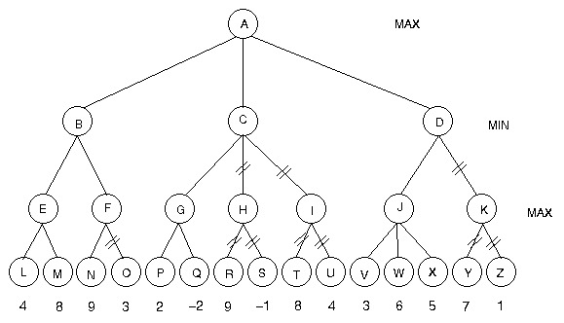

Alpha Beta prunning
Psuedocode for Alpha-Beta Minimax
alpaBetaMinimax(node, alpha, beta)
if node is at depthLimit
return staticEval(node)
children = successors(node)
if len(children) == 0
if node is root
bestMove = []
return staticEval(node)
if node is root
bestMove = operator of first child
if len(children) == 1
return None
if it is MAX's turn to move
for child in children
result = alphaBetaMinimax(child, alpha, beta)
if result > alpha
alpha = result
if node is root
bestMove = operator of child
if alpha >= beta
return alpha
return alpha
if it is MIN's turn to move
for child in children
result = alphaBetaMinimax(child, alpha, beta)
if result < beta
beta = result
if node is root
bestMove = operator of child
if beta <= alpha
return beta
return beta

4 Heuristic Search
Sometimes it is not feasible to search the whole search space - it's just too big. In this case we need to use heuristic search. The basic idea of heuristic search is that, rather than trying all possible search paths, we focus on paths that seem to be getting us closer to the goal state. Of course, we generally can't be sure that we are really near the goal state, but we might be able to have a good guess. Heuristics are used to help us make that guess.
To use heuristic search we need an evaluation function that rankes nodes in the search tree according to some criteria (for example, how close we are to the target). This function provides a quick way of guessing.

5 Best First Search
The search is similar to BFS, but instead of taking the first node it always chooses a node with the best score, according to an evaluation function. If we create a good evalution function, best first search may drastically cut down the amount of search time.
Here are the two most important properties of a heuristic function:
- it must provide an accurate estimator of the cost to reach a goal.
- it must be cheap to compute.
- it always must be a lower bound on actual solution cost.
6 A* algorithm
Best first search doesn't take into account the cost of the path from a start state to the current state. So, we may find a solution but it may be not a very good solution. There is a variant of best first search known as A* which attempts to find a solution which minimizes the total cost of the solution path. This algorithm combines advantages of breadth first search with advantages of best first search.
In the A* algorithm the score assigned to a node is a combination of the cost of the path so far A(S) and the estimated cost E(S) to solution.
H(S) = A(S) + E(S)
The A* algorithm looks the same as the best first algorithm, but we use this slightly more complex evaluation function.

Latest Advancements
1 Learning of Evaluation Functions
The most extensively studied learning problem in game playing is the automatic adjustment of the weights of an evaluation function. Typically, the situation is as follows: the game programmer has provided the program with a library of routines that compute important features of the current board position (e.g., the number of pieces of each kind on the board, the size of the territory controlled, etc.). What is not known is how to combine these pieces of knowledge and how to quantify their relative importance. Most frequently, these parameters are combined linearly, so that the learning task is to adjust the weights of a weighted sum. The main problem is that there are typically no direct target values that could be used as training signals.In general, algorithms use preference learning or reinforcement learning (where moves or positions are trained based on information about the eventual outcome of the game ) for tuning the evaluation functions. The key problem with reinforcement learning approaches is the credit assignment problem, i.e., even though a game has been won (lost), there might be bad (good) moves in the game. Reinforcement learning takes a radical stance at this problem, giving all positions the same reinforcement signal, hoping that erroneous signals will be evened out over time.The premier example of a system that has tuned its evaluation function to expert strength by playing millions of games against itself is the backgam-mon program TD-Gammon.
2 Learning Search Control
A more challenging, but considerably less investigated task is to automat-ically tune the various parameters that control the search in game-playing programs. These parameters influence, for example, how aggressive the search algorithm is in pruning unpromising parts of the search tree and which lines are explored in more depth. The key problem here is that these parameters are intertwined with the search algorithm, and cannot be optimized independently, making the process very tedious and expensive.
There have been a few attempts to use explanation-based learning to automatically learn predicates that indicate which branches of the search tree are the most promising to follow. These approaches are quite related to various uses of explanation-based learning in planning, but these could
not be successfully be carried over to game-tree search.
3 Opening Book Learning
Human game players not only rely on their ability to estimate the value of moves and positions but are often also able to play certain positions “by heart”, i.e., without having to think about their next move. This is the result of home preparation, opening study, and rote learning of important
lines and variations. As computers do not forget, the use of an opening book provides an easy way for increasing their playing strength.

4Player Modeling
Player modeling is an important research area in game playing, which can serve several purposes. The goal of opponent modeling is to improve the capabilities of the machine player by allowing it to adapt to its opponent and exploit his weaknesses. Even if a game-theoretical optimal solution to
a game is known, a system that has the capability to model its opponent’s behavior may obtain a higher reward. Consider, for example, the game of rock-paper-scissors, where either player can expect to win one third of the games (with one third of draws) if both players playtheir optimal strategies (i.e., randomly select one of their three moves).However, against a player that always plays rock, a player that is able toadapt his strategy to always playing paper can maximize his reward, while a player that sticks with the “optimal” random strategy will still win only one third of the games.

Programming Paradigm and Language Used
Programming is dominated by the C and C++ languages.Therefore we use imperative progrmming paradigm but now object oriented programming is used in order to simplify the source code.

Real world applications of game tree
Game tree is used in order tom solve games like checkers,connect 4,tic-tac-toe etc and it also helps sportsperson to improve their performance.

Refferences

