Task 1
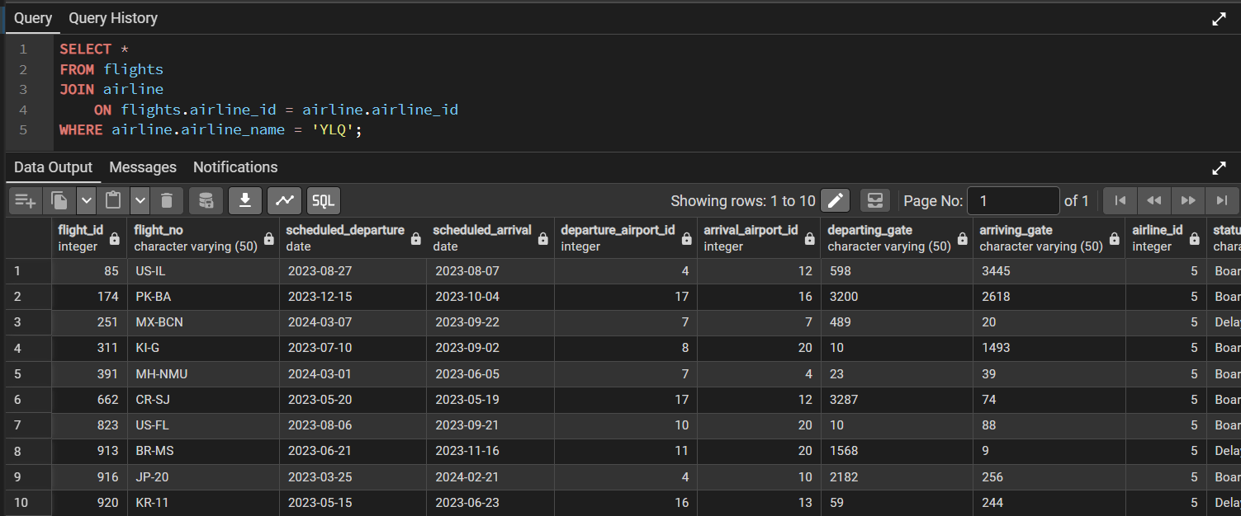
Explanation
This query displays all flights operated by a specific airline. The JOIN clause connects the flights table with the airline table using the common airline_id column. The WHERE clause filters the results and shows only flights operated by the airline named 'YLQ'.
Task 2
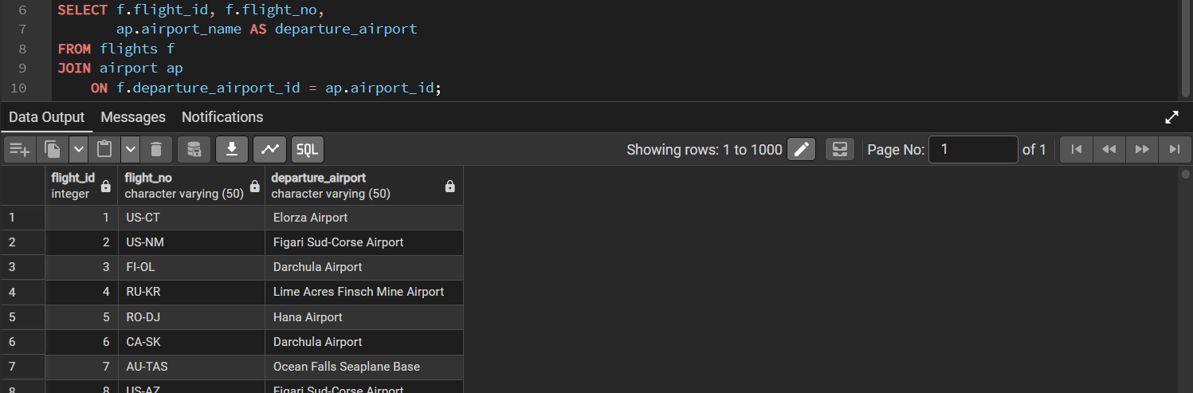
Explanation
The flights table is joined with the airport table using the departure_airport_id and airport_id columns. The aliases f and ap simplify table references. The AS keyword renames the airport_name column to departure_airport in the result.
Task 3
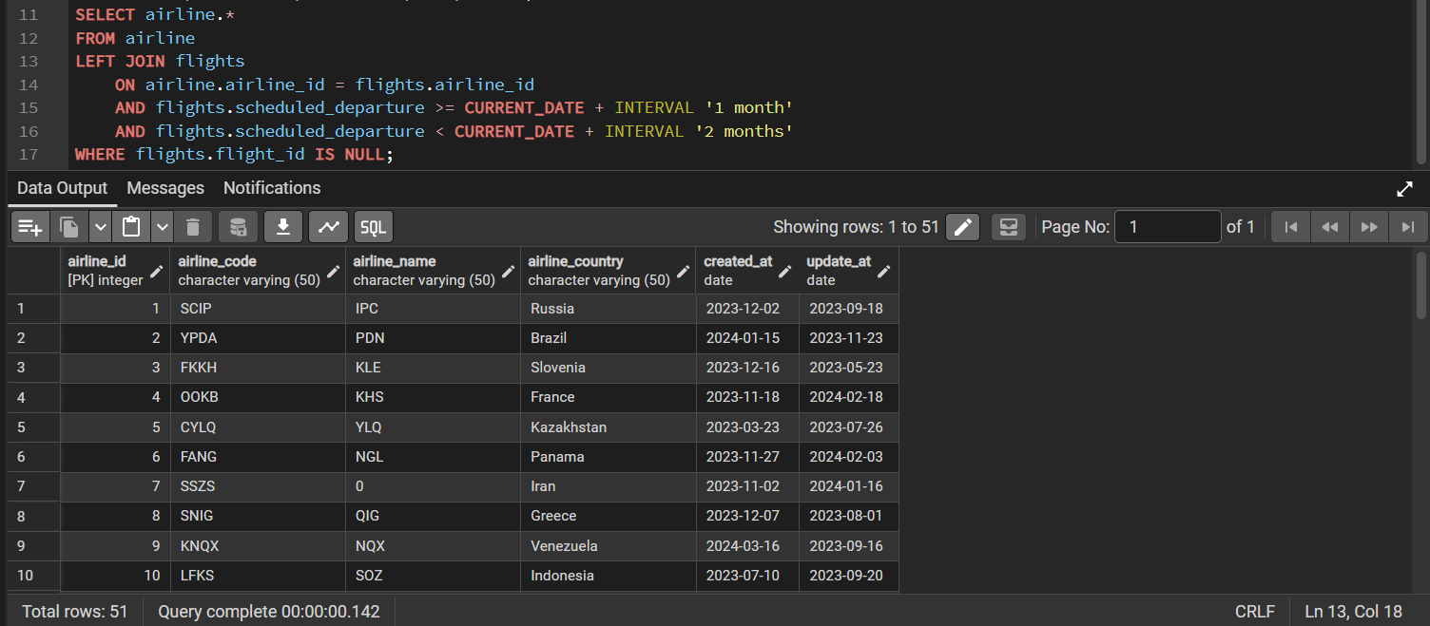
Explanation
This query finds airlines with no flights scheduled for next month. The LEFT JOIN and IS NULL condition identify airlines without flights during the specified period.
Task 4
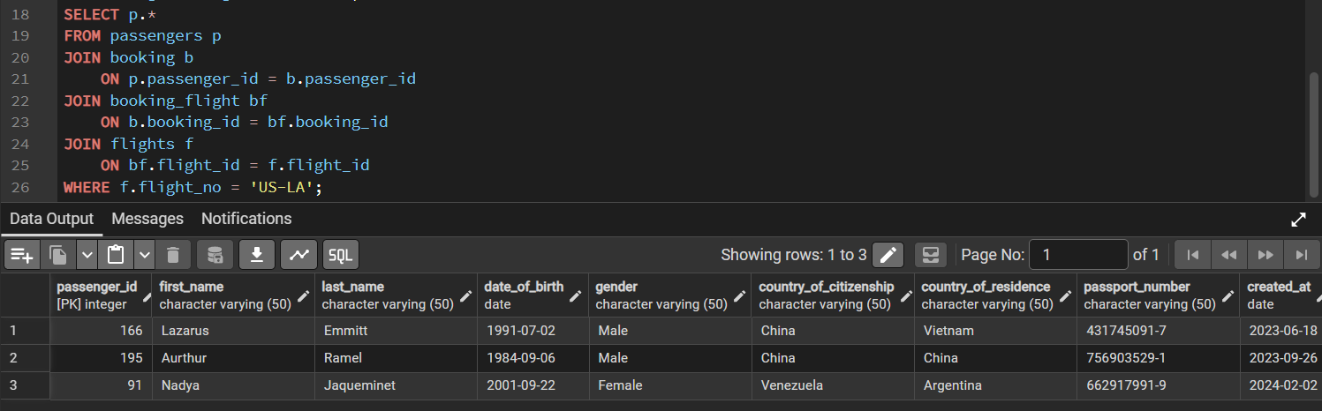
Explanation
This query displays passengers booked on a specific flight. The JOIN clauses connect passengers, bookings, and flights using their corresponding IDs.

Task 5
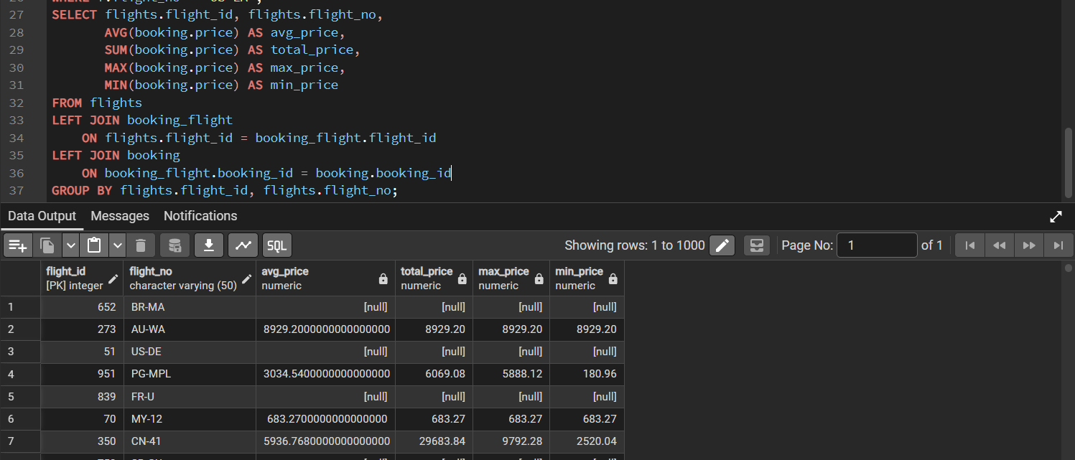
Explanation
This query calculates the average, total, maximum, and minimum ticket prices for each flight. The LEFT JOIN includes flights even if they have no bookings.
Task 6
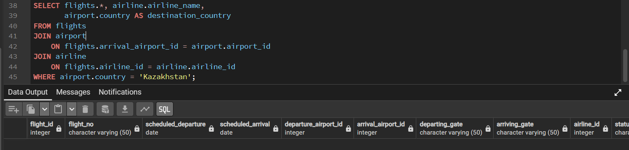
Explanation
This query displays flights arriving in Kazakhstan, along with airline names and destination countries.

Task 7
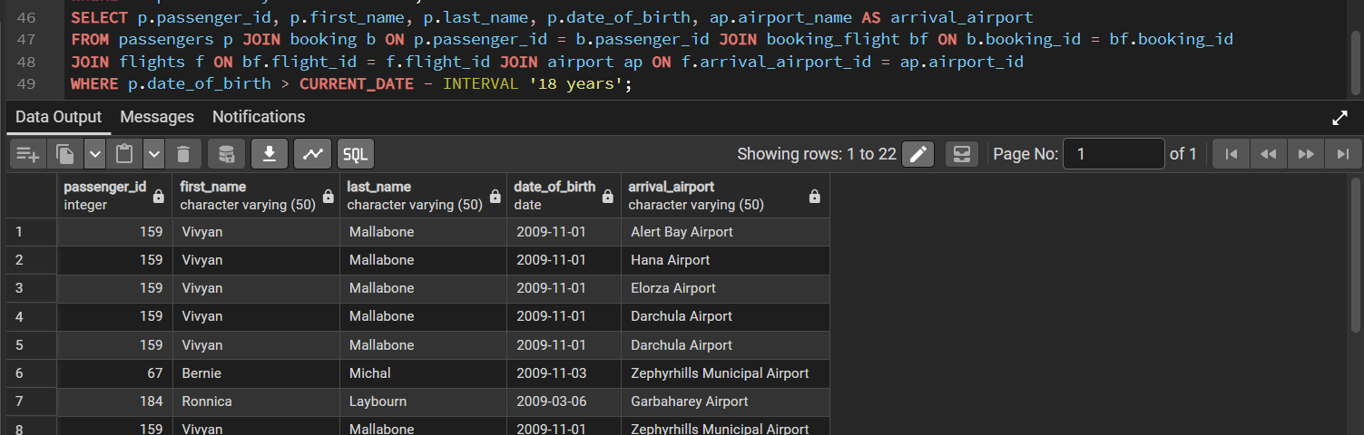
Explanation
This query displays passengers under 18 years old and their arrival airports. The JOIN clauses connect passengers with their booked flights and destinations.
Task 8
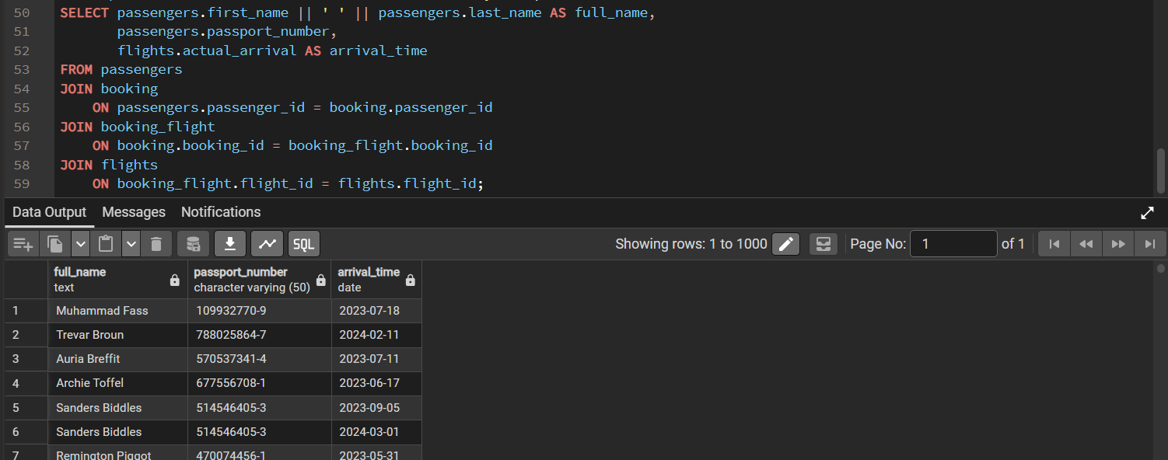
Explanation
This query displays passengers' full names, passport numbers, and actual arrival times.

Task 9
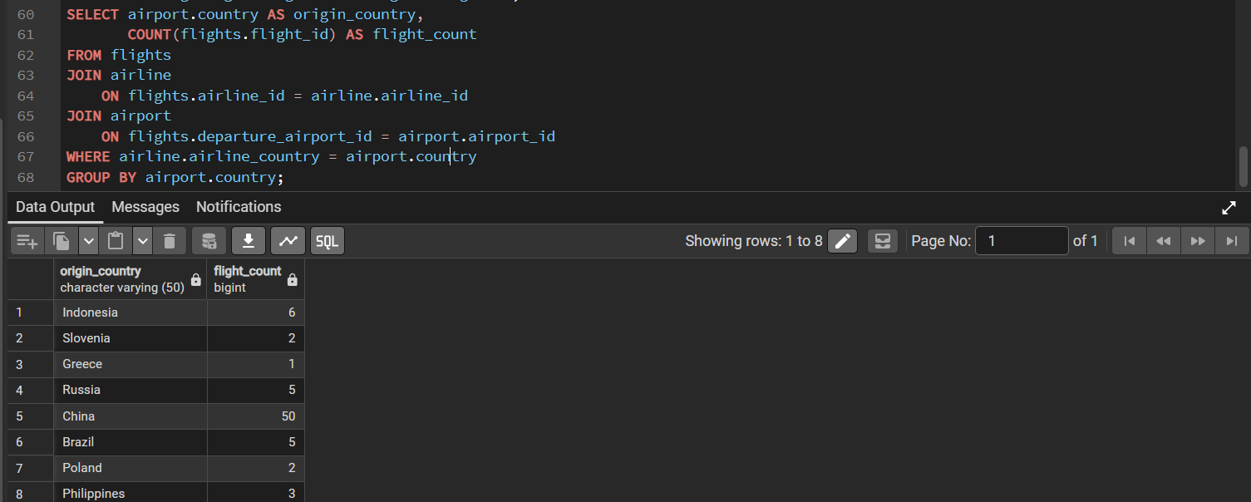
Explanation
This query counts flights where the airline's home country matches the departure airport's country, grouped by country.
Task 10
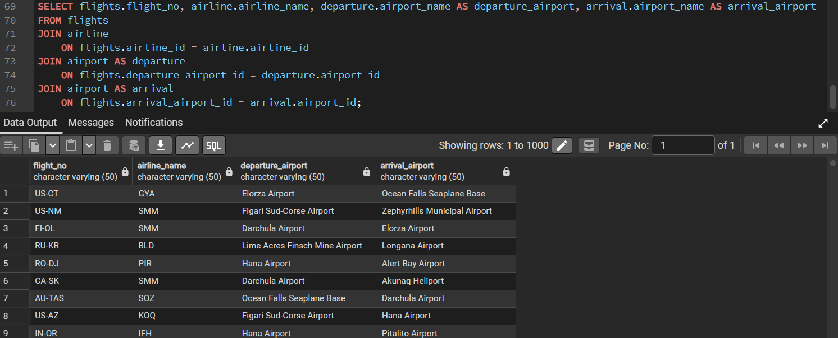
Explanation
This query displays flight numbers, airline names, departure airports, and arrival airports.

Task 11
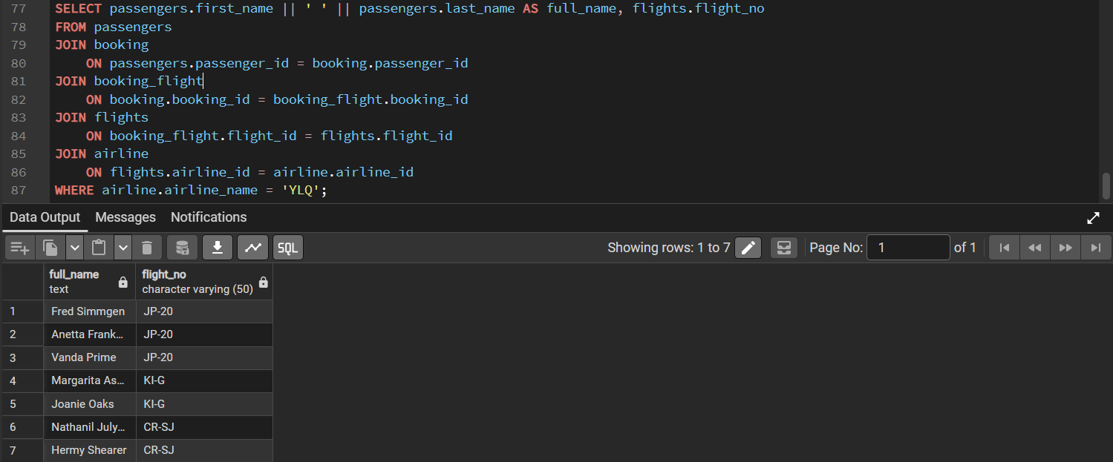
Explanation
This query displays passengers who booked flights operated by YLQ, along with their full names and flight numbers.
Task 12
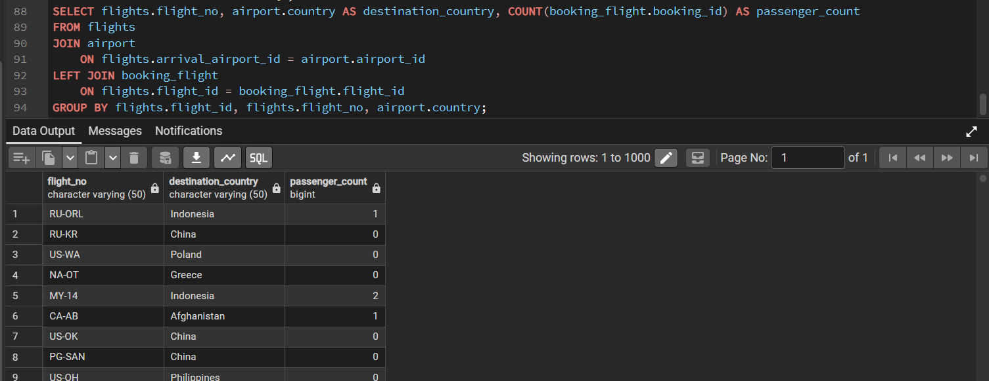
Explanation
This query counts passengers for each flight and displays the destination country, including flights with no passengers.

Task 13
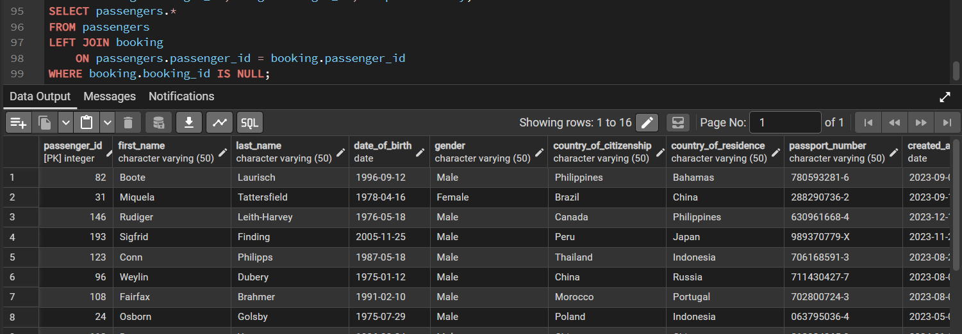
Explanation
This query displays passengers who have no bookings. The LEFT JOIN and IS NULL condition identify passengers without booked tickets.
Task 14
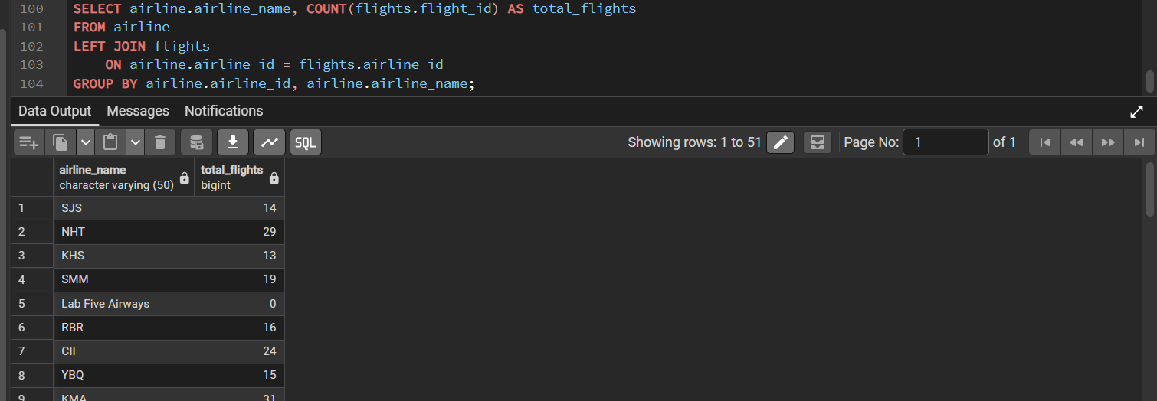
Explanation
This query counts the number of flights for each airline, including airlines with no flights.

Task 15
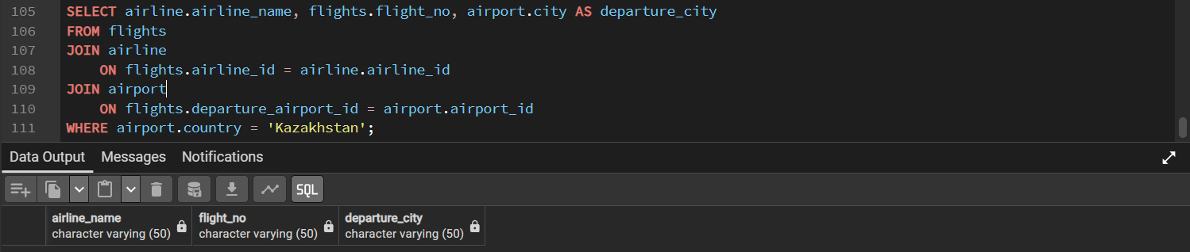
Explanation
This query displays airlines, flight numbers, and departure cities for flights departing from airports in Kazakhstan.

