ENLACES
SISISISI
https://vuetifyjs.com/en/components/buttons/#size
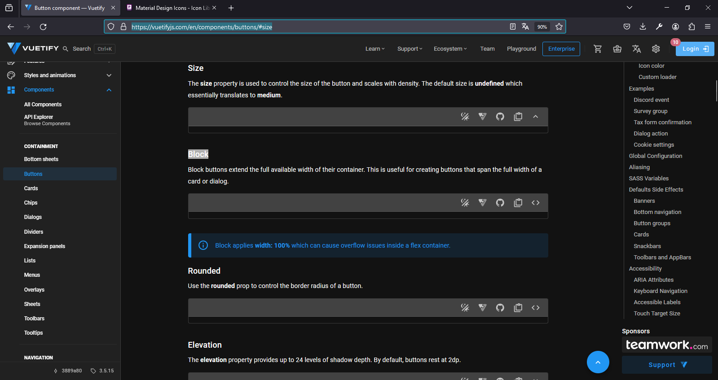
https://pictogrammers.com/library/mdi/
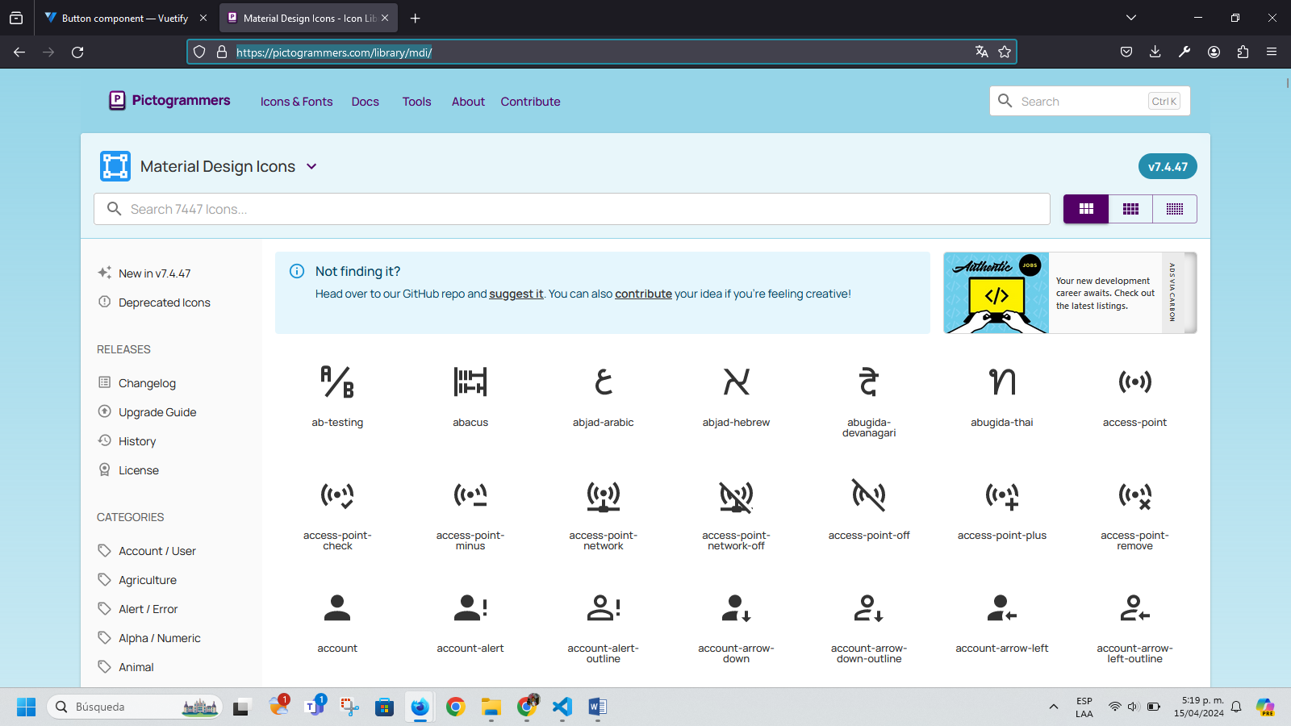

https://eslint.org/
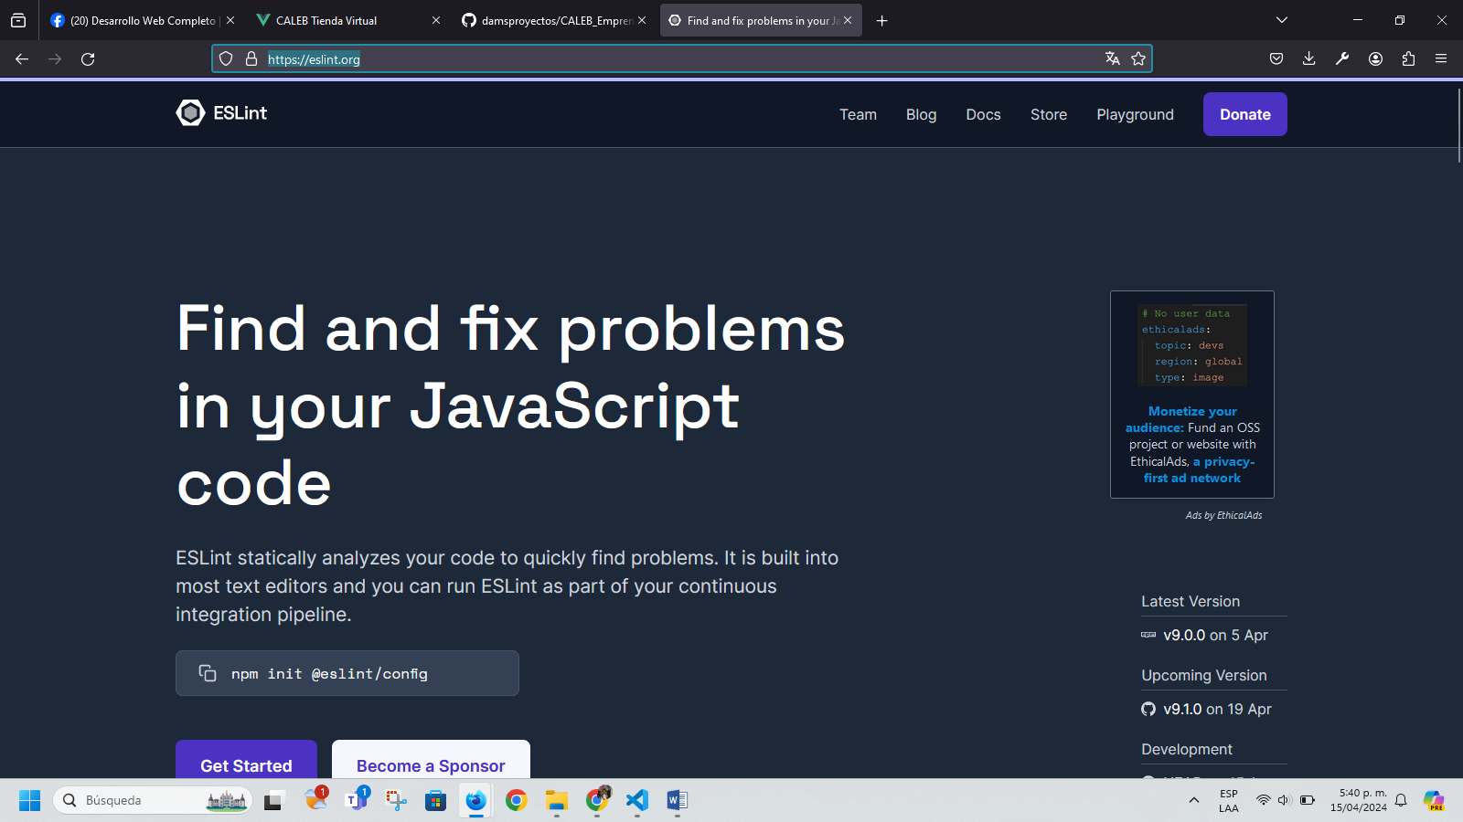

PS C:\laragon\www\dams_proyectos> npm run lint

> dams_proyectos@0.0.0 lint
> eslint . --ext .vue,.js,.jsx,.cjs,.mjs,.ts,.tsx,.cts,.mts --fix --ignore-path .gitignore

C:\laragon\www\dams_proyectos\src\App2.vue
1:1 error Component name "App2" should always be multi-word vue/multi-word-component-names

C:\laragon\www\dams_proyectos\src\components\CategoryList.vue
8:18 error Parsing error: '}' expected

C:\laragon\www\dams_proyectos\src\components\ProductList.vue
12:25 error Parsing error: '}' expected

C:\laragon\www\dams_proyectos\src\components\TopBar.vue
3:10 warning 'RouterLink' is defined but never used @typescript-eslint/no-unused-vars

✖ 4 problems (3 errors, 1 warning)

PS C:\laragon\www\dams_proyectos>

PS C:\laragon\www\dams_proyectos> npm run lint

> dams_proyectos@0.0.0 lint
> eslint . --ext .vue,.js,.jsx,.cjs,.mjs,.ts,.tsx,.cts,.mts --fix --ignore-path .gitignore

C:\laragon\www\dams_proyectos\src\App2.vue
1:1 error Component name "App2" should always be multi-word vue/multi-word-component-names

✖ 1 problem (1 error, 0 warnings)

PS C:\laragon\www\dams_proyectos>
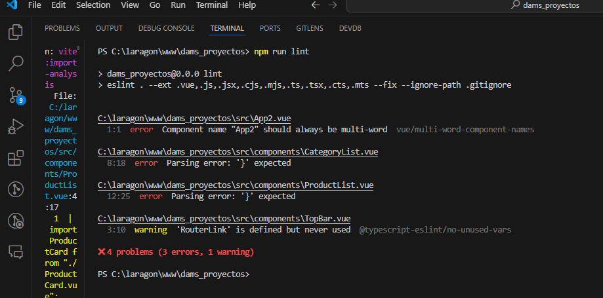
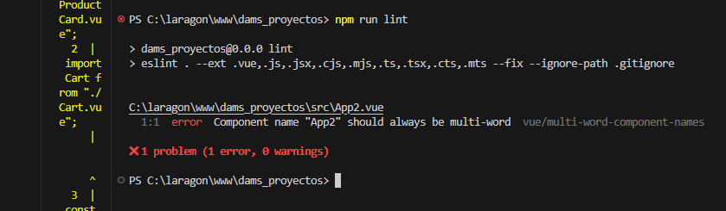

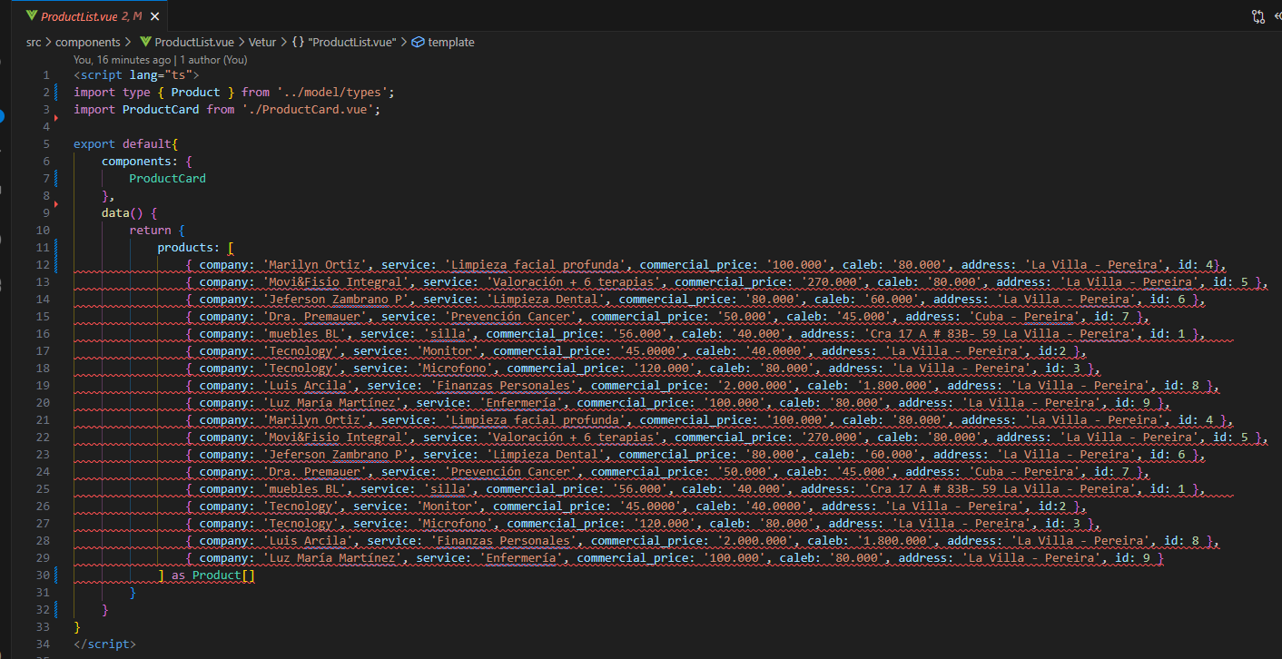
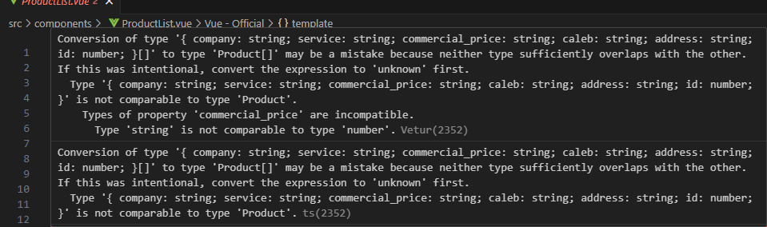

Silla free copyrigth
Png.pngtree.com
https://img.freepik.com/foto-gratis/mujer-visitando-cosmetologa-realizando-procedimientos-rejuvenecimiento_1303-26040.jpg?w=900&t=st=1713478321~exp=1713478921~hmac=4f54a059e9141747b58e4ad4e7960c71bf05379dbf87ae423fd3003af1784306
fake random image

https://www.freepik.es/search?format=search&query=fisioterapia%20fisica%20
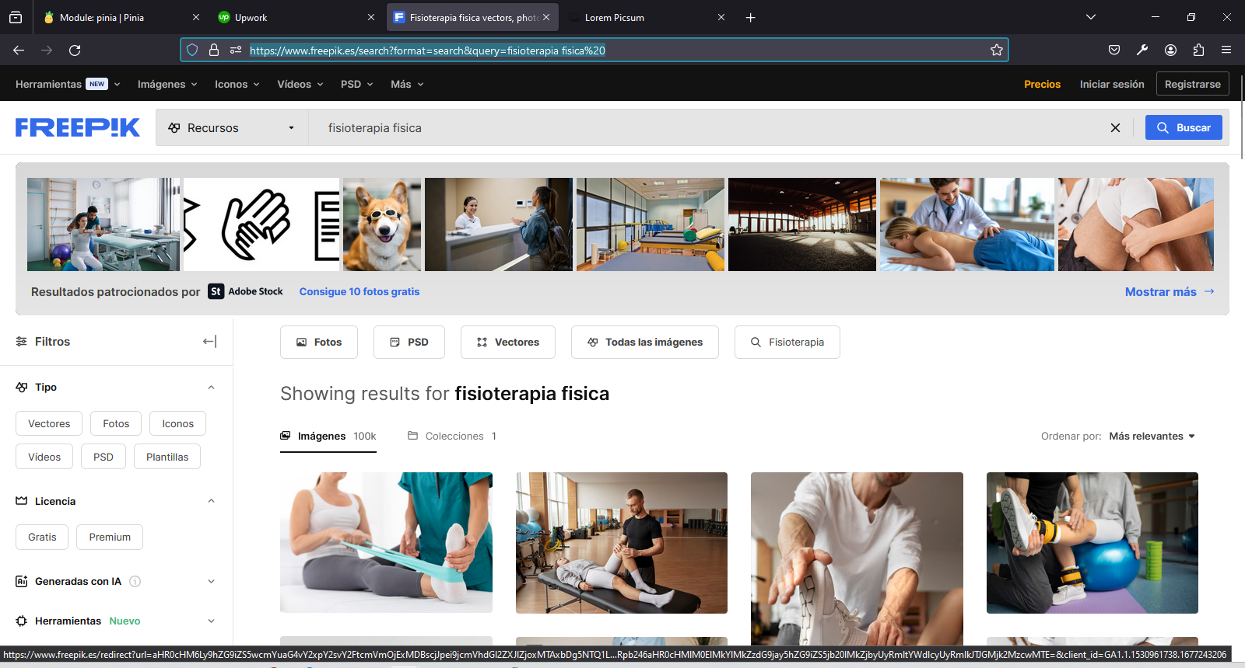

https://picsum.photos/
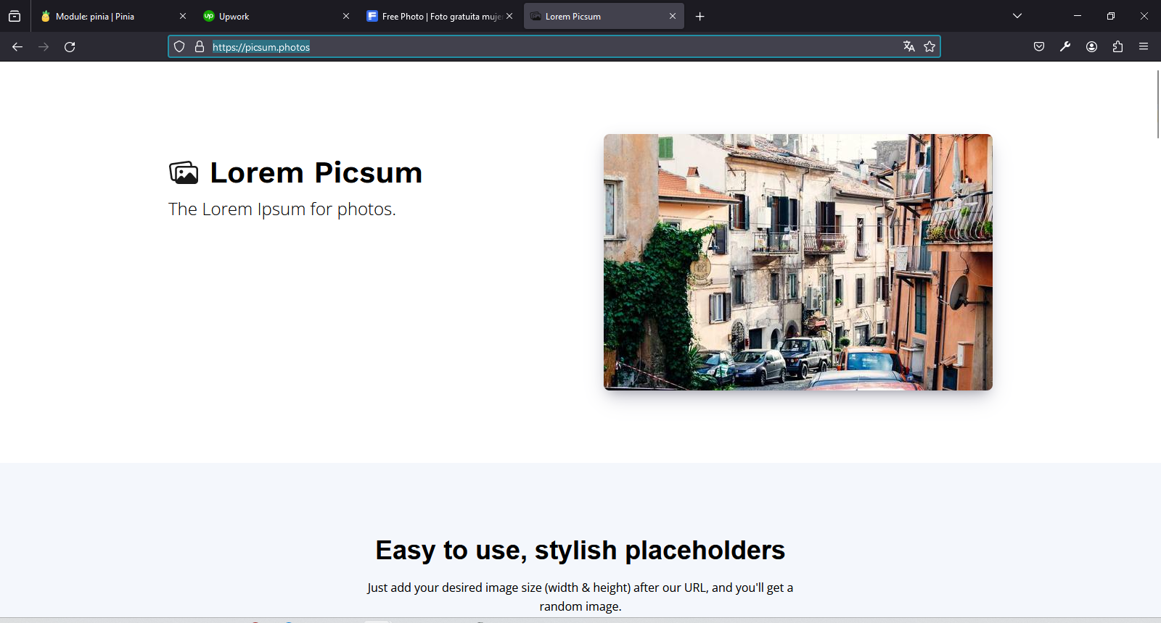

https://definicion.de/silla/
Definición.de
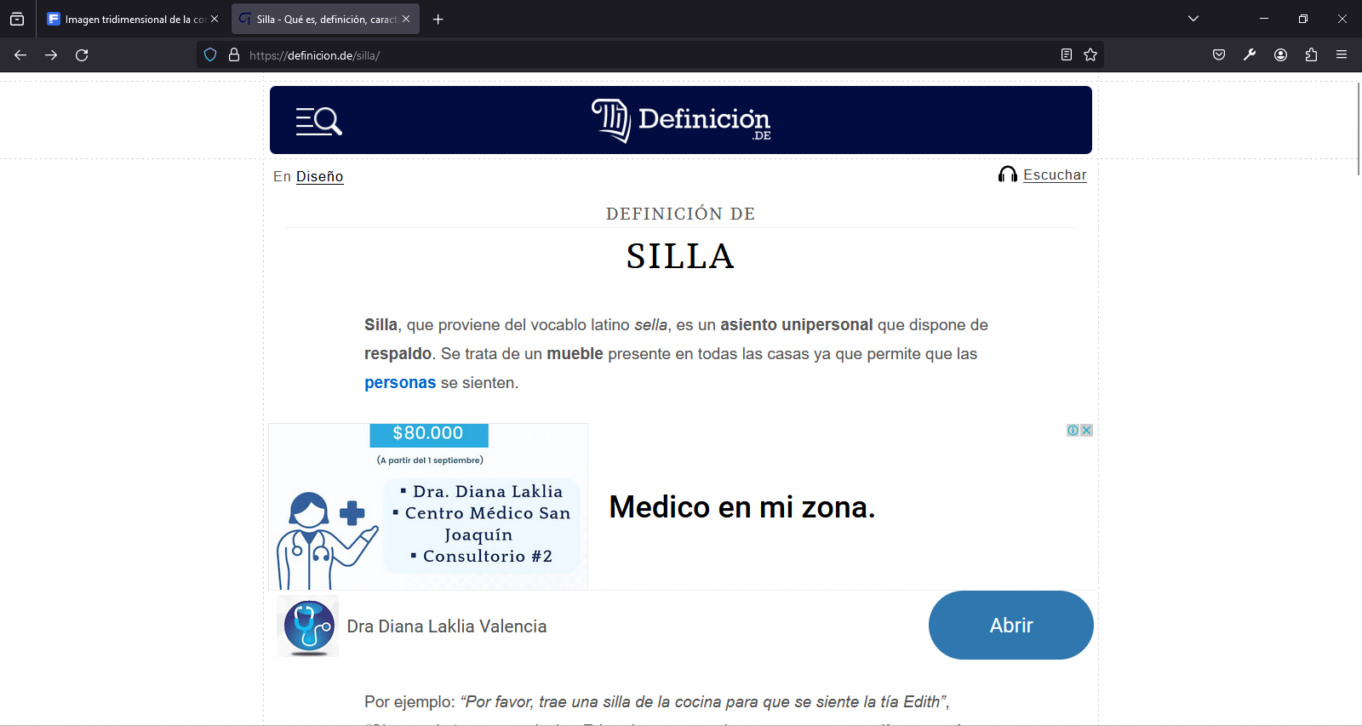
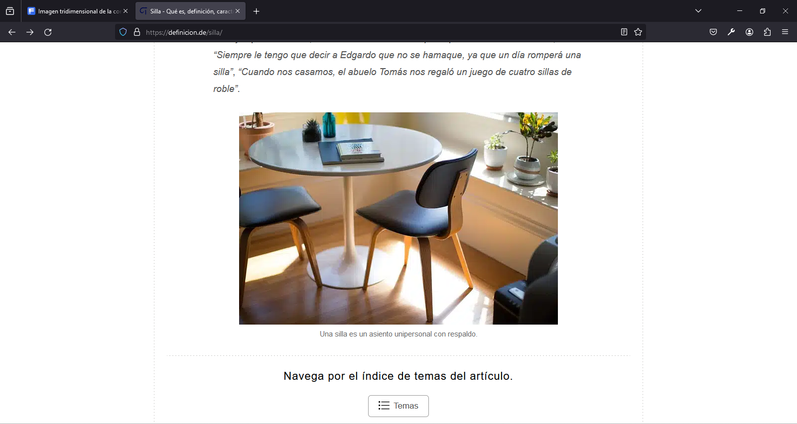

https://vuetifyjs.com/en/components/tables/
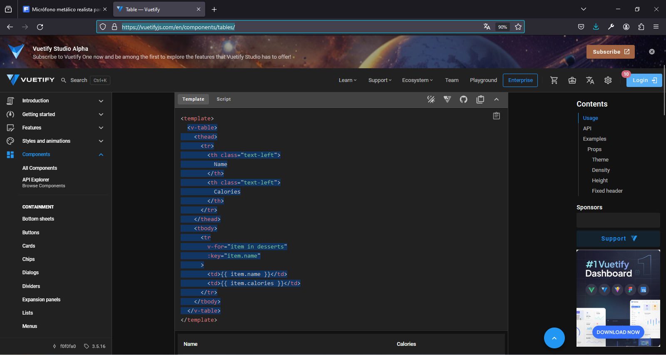
PROBLEMA: No carga los productos en la página
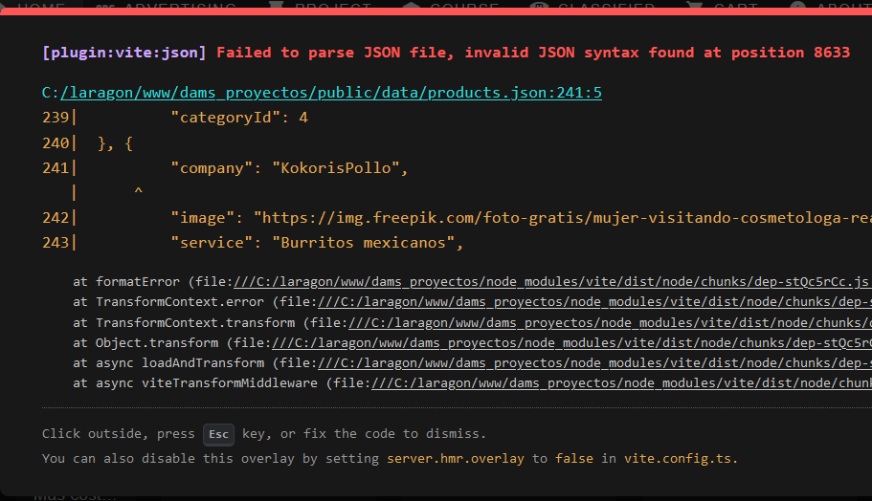
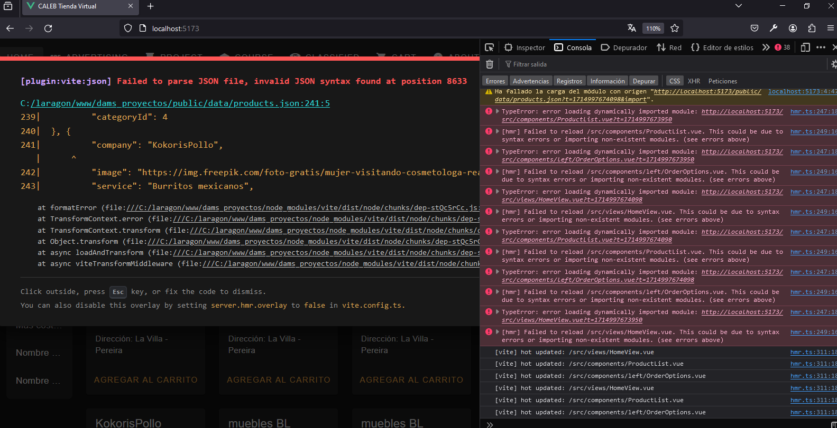
SOLUCIÓN
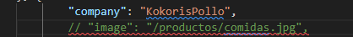
En archivos json no se puede comentar líneas; ya que crean errores de carga de páginas; debí borrar el comentario de image.
"company": "KokorisPollo",
// "image": "/productos/comidas.jpg",
"service": "Pollo entero",
"commercial_price": 30000,
"caleb": "25000",
"address": "La Villa - Pereira",
"id": 27,
"categoryId": 4

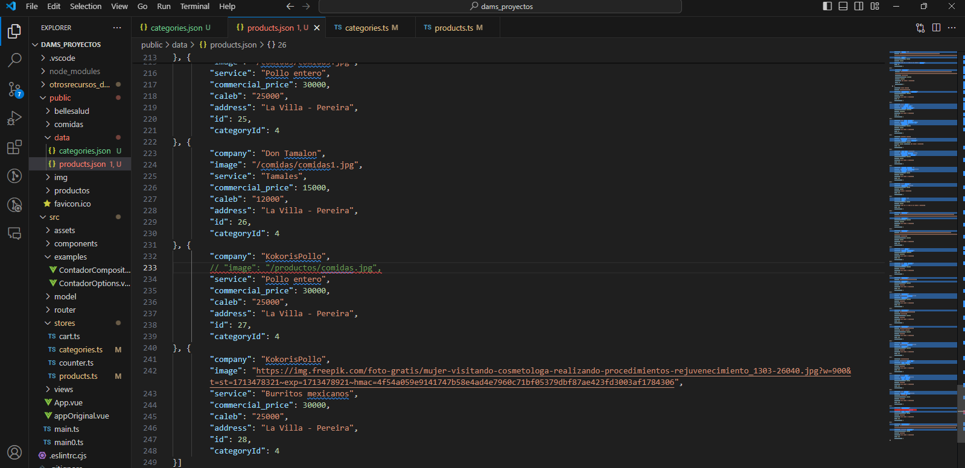
Al borrar el comentario de imagen me abrió correctamente la tienda
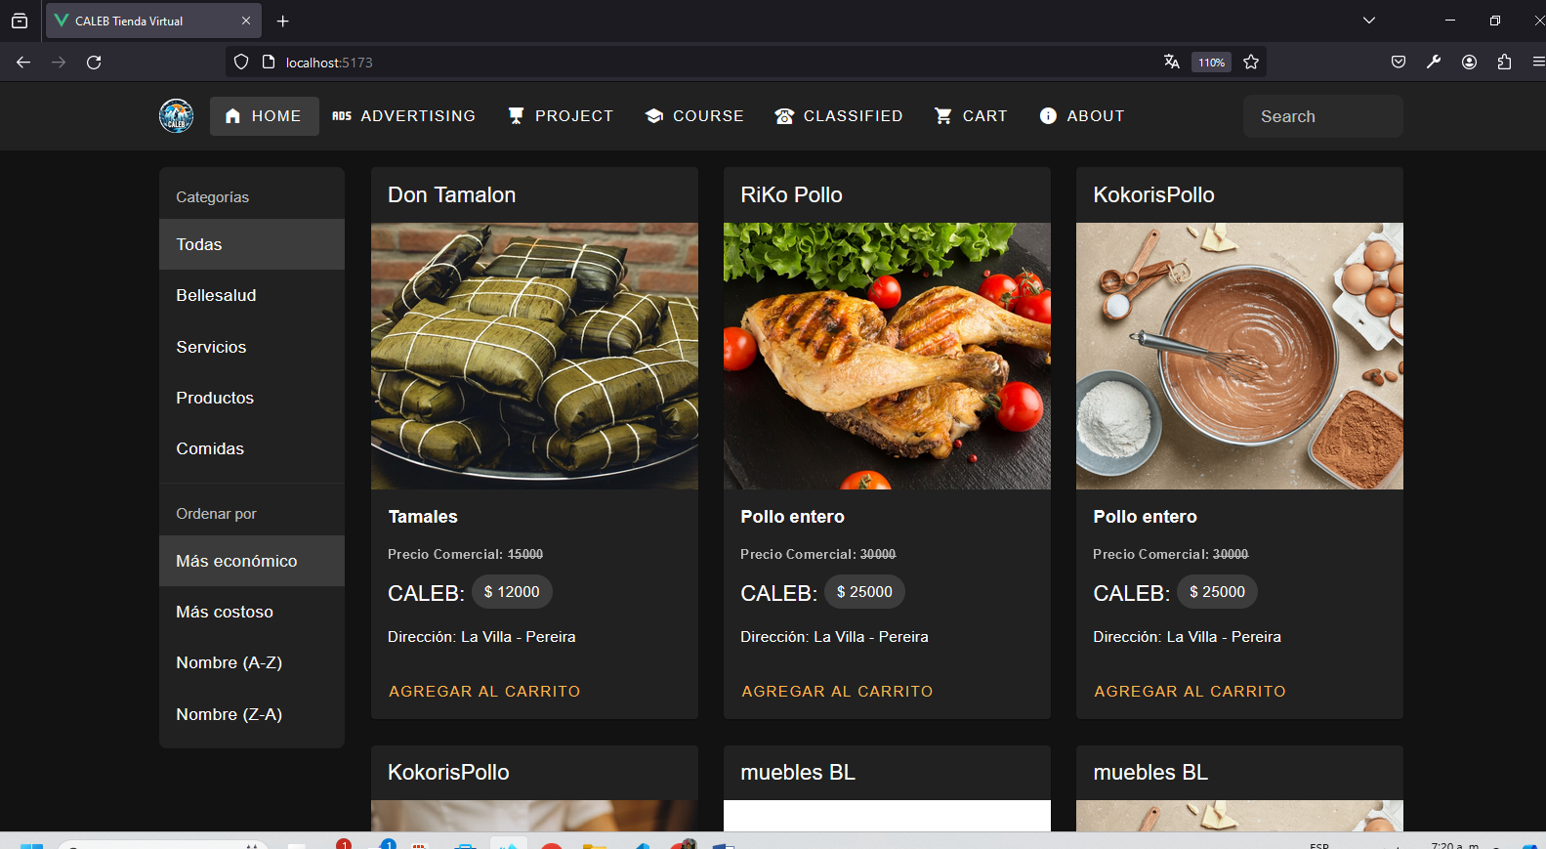

console.log(categoriesData): Agregamos un console.log para verificar cual es el contenido de categoriesData; para ver si realmente estamos leyendo bien los datos del archivo categories.json, osea que vemos los datos en la consola; eso significa que el import al store categories.ts es ÉXITOSO.

https://developer.mozilla.org/en-US/docs/Web/API
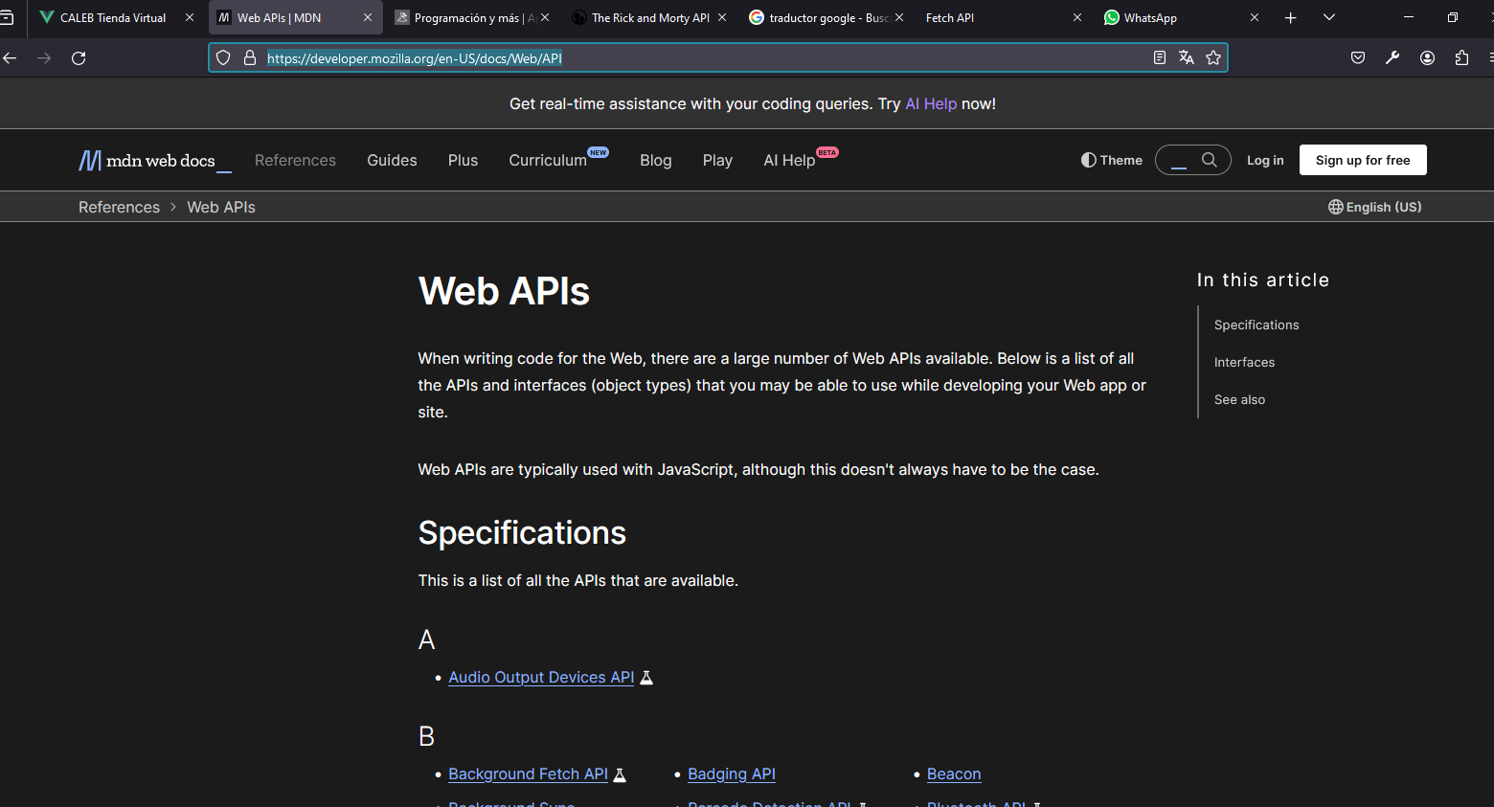
https://programacionymas.com/

https://rickandmortyapi.com/


https://www.youtube.com/watch?v=DaGI20KYgS8

Ajax, Fetch, Axios & jQuery ⚡ 5 minutos 🎉 Desde cero
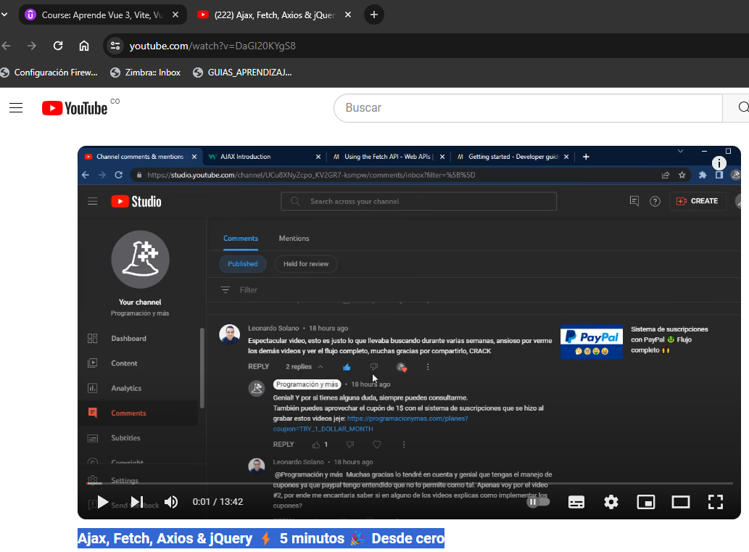

https://vuetifyjs.com/en/components/progress-linear/#buffering
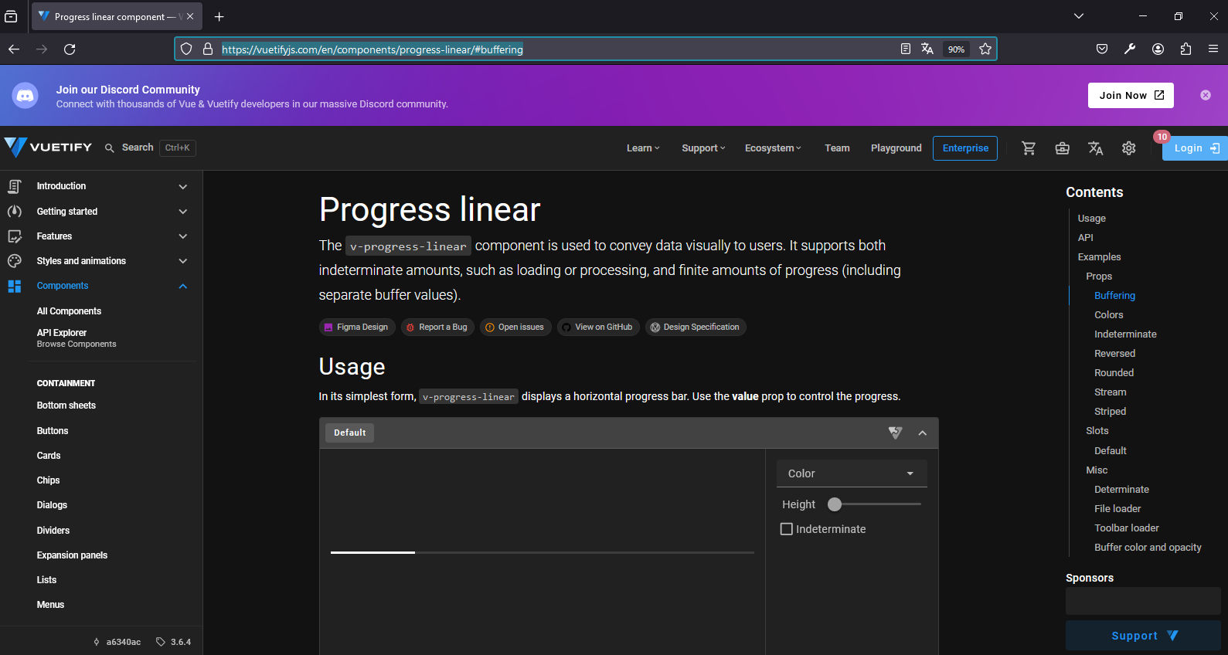

REPOSISTORIO GIT HUB
https://github.com/damsproyectos/CALEB_Emprendimiento_Liderazgo
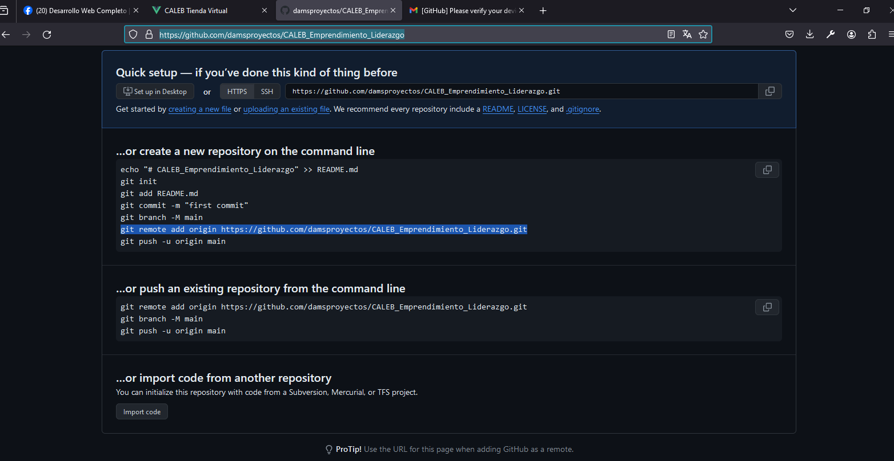
PS C:\laragon\www\dams_proyectos> git
usage: git [-v | --version] [-h | --help] [-C <path>] [-c <name>=<value>]
[--exec-path[=<path>]] [--html-path] [--man-path] [--info-path]
[-p | --paginate | -P | --no-pager] [--no-replace-objects] [--bare]
[--git-dir=<path>] [--work-tree=<path>] [--namespace=<name>]
[--super-prefix=<path>] [--config-env=<name>=<envvar>]
<command> [<args>]

These are common Git commands used in various situations:

start a working area (see also: git help tutorial)
clone Clone a repository into a new directory
init Create an empty Git repository or reinitialize an existing one

work on the current change (see also: git help everyday)
add Add file contents to the index
mv Move or rename a file, a directory, or a symlink
restore Restore working tree files
rm Remove files from the working tree and from the index

examine the history and state (see also: git help revisions)
bisect Use binary search to find the commit that introduced a bug
diff Show changes between commits, commit and working tree, etc
grep Print lines matching a pattern
log Show commit logs
show Show various types of objects
status Show the working tree status

grow, mark and tweak your common history
branch List, create, or delete branches
commit Record changes to the repository
merge Join two or more development histories together
rebase Reapply commits on top of another base tip
reset Reset current HEAD to the specified state
switch Switch branches
tag Create, list, delete or verify a tag object signed with GPG

collaborate (see also: git help workflows)
fetch Download objects and refs from another repository
pull Fetch from and integrate with another repository or a local branch
push Update remote refs along with associated objects

'git help -a' and 'git help -g' list available subcommands and some
concept guides. See 'git help <command>' or 'git help <concept>'
to read about a specific subcommand or concept.
See 'git help git' for an overview of the system.
PS C:\laragon\www\dams_proyectos> git init
Initialized empty Git repository in C:/laragon/www/dams_proyectos/.git/
PS C:\laragon\www\dams_proyectos> git add .
warning: in the working copy of '.eslintrc.cjs', LF will be replaced by CRLF the next time Git touches it
warning: in the working copy of '.gitignore', LF will be replaced by CRLF the next time Git touches it
warning: in the working copy of '.vscode/extensions.json', LF will be replaced by CRLF the next time Git touches it
warning: in the working copy of 'README.md', LF will be replaced by CRLF the next time Git touches it
warning: in the working copy of 'env.d.ts', LF will be replaced by CRLF the next time Git touches it
warning: in the working copy of 'index.html', LF will be replaced by CRLF the next time Git touches it
warning: in the working copy of 'package-lock.json', LF will be replaced by CRLF the next time Git touches it
warning: in the working copy of 'package.json', LF will be replaced by CRLF the next time Git touches it
warning: in the working copy of 'src/App.vue', LF will be replaced by CRLF the next time Git touches it
warning: in the working copy of 'src/App2.vue', LF will be replaced by CRLF the next time Git touches it
warning: in the working copy of 'src/assets/base.css', LF will be replaced by CRLF the next time Git touches it
warning: in the working copy of 'src/assets/logo.svg', LF will be replaced by CRLF the next time Git touches it
warning: in the working copy of 'src/assets/main.css', LF will be replaced by CRLF the next time Git touches it
warning: in the working copy of 'src/components/HelloWorld.vue', LF will be replaced by CRLF the next time Git touches it
warning: in the working copy of 'src/components/TheWelcome.vue', LF will be replaced by CRLF the next time Git touches it
warning: in the working copy of 'src/components/WelcomeItem.vue', LF will be replaced by CRLF the next time Git touches it
warning: in the working copy of 'src/components/icons/IconCommunity.vue', LF will be replaced by CRLF the next time Git touches it
warning: in the working copy of 'src/components/icons/IconDocumentation.vue', LF will be replaced by CRLF the next time Git touches it
warning: in the working copy of 'src/components/icons/IconEcosystem.vue', LF will be replaced by CRLF the next time Git touches it
warning: in the working copy of 'src/components/icons/IconSupport.vue', LF will be replaced by CRLF the next time Git touches it
warning: in the working copy of 'src/components/icons/IconTooling.vue', LF will be replaced by CRLF the next time Git touches it
warning: in the working copy of 'src/main.ts', LF will be replaced by CRLF the next time Git touches it
warning: in the working copy of 'src/router/index.ts', LF will be replaced by CRLF the next time Git touches it
warning: in the working copy of 'src/stores/cart.ts', LF will be replaced by CRLF the next time Git touches it
warning: in the working copy of 'src/stores/counter.ts', LF will be replaced by CRLF the next time Git touches it
warning: in the working copy of 'src/views/AboutView.vue', LF will be replaced by CRLF the next time Git touches it
warning: in the working copy of 'src/views/HomeView.vue', LF will be replaced by CRLF the next time Git touches it
warning: in the working copy of 'tsconfig.app.json', LF will be replaced by CRLF the next time Git touches it
warning: in the working copy of 'tsconfig.json', LF will be replaced by CRLF the next time Git touches it
warning: in the working copy of 'tsconfig.node.json', LF will be replaced by CRLF the next time Git touches it
warning: in the working copy of 'vite.config.ts', LF will be replaced by CRLF the next time Git touches it
PS C:\laragon\www\dams_proyectos> git commit -m "Base Project"
[master (root-commit) 14a154d] Base Project
46 files changed, 8319 insertions(+)
create mode 100644 .eslintrc.cjs
create mode 100644 .gitignore
create mode 100644 .vscode/extensions.json
create mode 100644 README.md
create mode 100644 env.d.ts
create mode 100644 index.html
create mode 100644 package-lock.json
create mode 100644 package.json
create mode 100644 public/favicon.ico
create mode 100644 src/App.vue
create mode 100644 src/App2.vue
create mode 100644 src/assets/base.css
create mode 100644 src/assets/logo.svg
create mode 100644 src/assets/main.css
create mode 100644 src/components/Cart.vue
create mode 100644 src/components/CategoryList.vue
create mode 100644 src/components/HelloWorld.vue
create mode 100644 src/components/ProductCard.vue
create mode 100644 src/components/ProductList.vue
create mode 100644 src/components/TheWelcome.vue
create mode 100644 src/components/TopBar.vue
create mode 100644 src/components/WelcomeItem.vue
create mode 100644 src/components/icons/IconCommunity.vue
create mode 100644 src/components/icons/IconDocumentation.vue
create mode 100644 src/components/icons/IconEcosystem.vue
create mode 100644 src/components/icons/IconSupport.vue
create mode 100644 src/components/icons/IconTooling.vue
create mode 100644 src/examples/ContadorComposition.vue
create mode 100644 src/examples/ContadorOptions.vue
create mode 100644 src/main.ts
create mode 100644 src/main0.ts
create mode 100644 src/model/types.ts
create mode 100644 src/router/index.ts
create mode 100644 src/stores/cart.ts
create mode 100644 src/stores/counter.ts
create mode 100644 src/views/AboutView.vue
create mode 100644 src/views/AdvertisingView.vue
create mode 100644 src/views/CartView.vue
create mode 100644 src/views/ClassifiedView.vue
create mode 100644 src/views/CourseView.vue
create mode 100644 src/views/HomeView.vue
create mode 100644 src/views/ProjectView.vue
create mode 100644 tsconfig.app.json
create mode 100644 tsconfig.json
create mode 100644 tsconfig.node.json
create mode 100644 vite.config.ts
PS C:\laragon\www\dams_proyectos> git remote add origin https://github.com/damsproyectos/CALEB_Emprendimiento_Liderazgo.git
PS C:\laragon\www\dams_proyectos> git push -u origin master
Enumerating objects: 58, done.
Counting objects: 100% (58/58), done.
Delta compression using up to 4 threads
Compressing objects: 100% (53/53), done.
Writing objects: 100% (58/58), 83.20 KiB | 781.00 KiB/s, done.
Total 58 (delta 2), reused 0 (delta 0), pack-reused 0
remote: Resolving deltas: 100% (2/2), done.
To https://github.com/damsproyectos/CALEB_Emprendimiento_Liderazgo.git
* [new branch] master -> master
branch 'master' set up to track 'origin/master'.
PS C:\laragon\www\dams_proyectos>
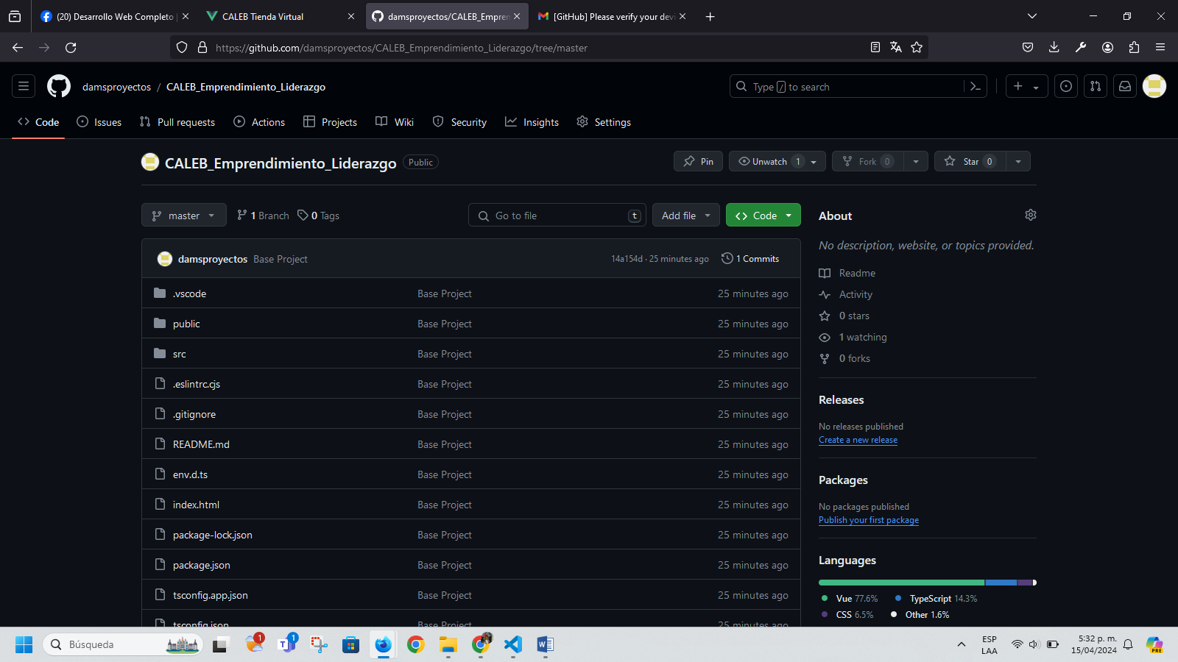
PS C:\laragon\www\dams_proyectos> git status
On branch master
Your branch is up to date with 'origin/master'.

Changes not staged for commit:
(use "git add/rm <file>..." to update what will be committed)
(use "git restore <file>..." to discard changes in working directory)
modified: src/App.vue
deleted: src/components/Cart.vue
modified: src/components/CategoryList.vue
modified: src/components/ProductList.vue
modified: src/components/TopBar.vue
modified: src/views/CartView.vue

Untracked files:
(use "git add <file>..." to include in what will be committed)
otrosrecursos_damsproyectos/
src/components/ShoppingCart.vue

no changes added to commit (use "git add" and/or "git commit -a")
PS C:\laragon\www\dams_proyectos> git add .
warning: in the working copy of 'src/App.vue', LF will be replaced by CRLF the next time Git touches it
PS C:\laragon\www\dams_proyectos> git commit -m "Fix Lint Warnings"
[master dfb6686] Fix Lint Warnings
8 files changed, 21 insertions(+), 28 deletions(-)
create mode 100644 otrosrecursos_damsproyectos/otrosrecursos_damsproyectos.docx
create mode 100644 otrosrecursos_damsproyectos/~$rosrecursos_damsproyectos.docx
rename src/components/{Cart.vue => ShoppingCart.vue} (93%)
PS C:\laragon\www\dams_proyectos> git push origin master
Enumerating objects: 23, done.
Counting objects: 100% (23/23), done.
Delta compression using up to 4 threads
Compressing objects: 100% (14/14), done.
Writing objects: 100% (14/14), 7.64 MiB | 676.00 KiB/s, done.
Total 14 (delta 8), reused 0 (delta 0), pack-reused 0
remote: Resolving deltas: 100% (8/8), completed with 8 local objects.
To https://github.com/damsproyectos/CALEB_Emprendimiento_Liderazgo.git
14a154d..dfb6686 master -> master
PS C:\laragon\www\dams_proyectos>
https://github.com/damsproyectos/CALEB_Emprendimiento_Liderazgo
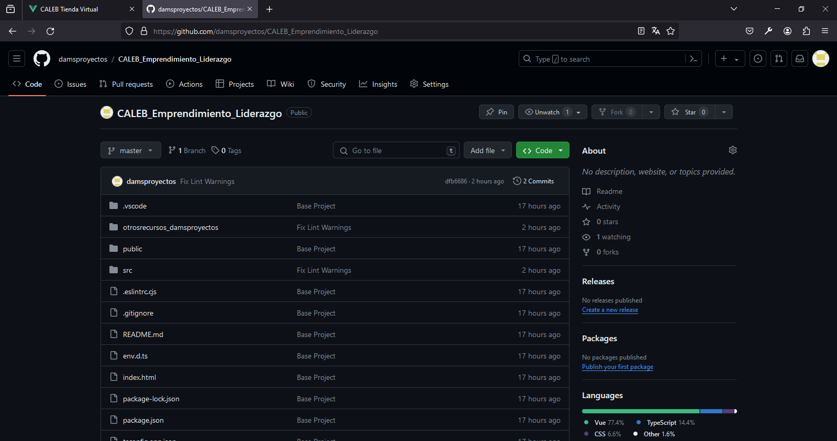
PS C:\laragon\www\dams_proyectos> git status
On branch master
Your branch is up to date with 'origin/master'.

Changes not staged for commit:
(use "git add <file>..." to update what will be committed)
(use "git restore <file>..." to discard changes in working directory)
modified: src/components/CategoryList.vue
modified: src/components/ProductCard.vue
modified: src/components/ProductList.vue
modified: src/model/types.ts

Untracked files:
(use "git add <file>..." to include in what will be committed)
public/bellesalud/
public/productos/

no changes added to commit (use "git add" and/or "git commit -a")
PS C:\laragon\www\dams_proyectos> git add .
PS C:\laragon\www\dams_proyectos> git commit -m "Add images for products, Add categoryId"
[master e7c5adf] Add images for products, Add categoryId
14 files changed, 261 insertions(+), 33 deletions(-)
create mode 100644 public/bellesalud/enfermeria.webp
create mode 100644 public/bellesalud/marilyn.jpeg
create mode 100644 public/bellesalud/movifisio.jpeg
create mode 100644 public/bellesalud/odontologia.jpeg
create mode 100644 public/productos/headphones.jpg
create mode 100644 public/productos/microfono.jpg
create mode 100644 public/productos/monitor.jpg
create mode 100644 public/productos/mouse.jpg
create mode 100644 public/productos/parlantes.jpg
create mode 100644 public/productos/silla.webp
PS C:\laragon\www\dams_proyectos> git push origin master
Enumerating objects: 31, done.
Counting objects: 100% (31/31), done.
Delta compression using up to 4 threads
Compressing objects: 100% (21/21), done.
Writing objects: 100% (22/22), 3.60 MiB | 608.00 KiB/s, done.
Total 22 (delta 6), reused 0 (delta 0), pack-reused 0
remote: Resolving deltas: 100% (6/6), completed with 6 local objects.
To https://github.com/damsproyectos/CALEB_Emprendimiento_Liderazgo.git
d95e701..e7c5adf master -> master
PS C:\laragon\www\dams_proyectos>

Problema:
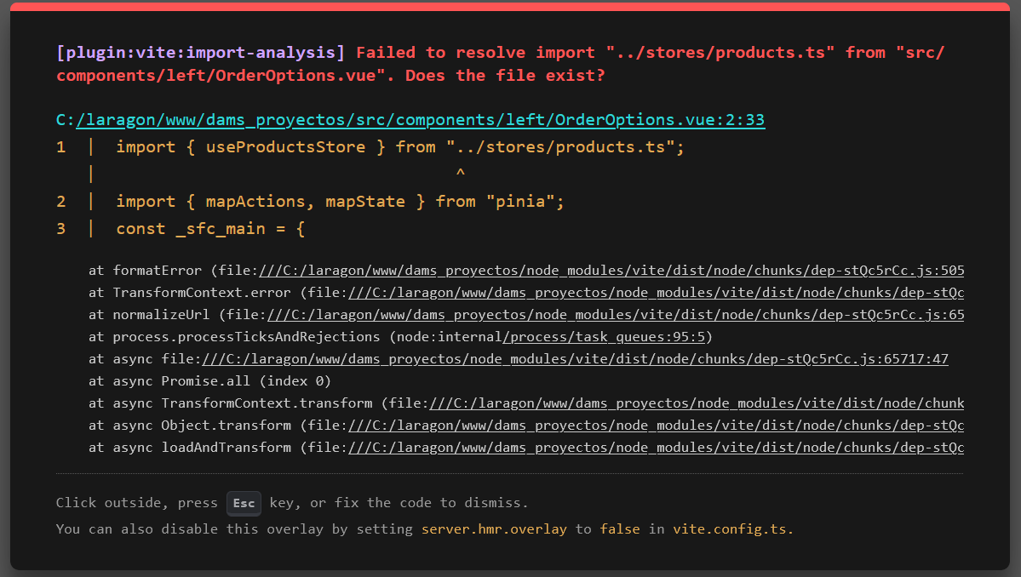

Solución:
CategoryList
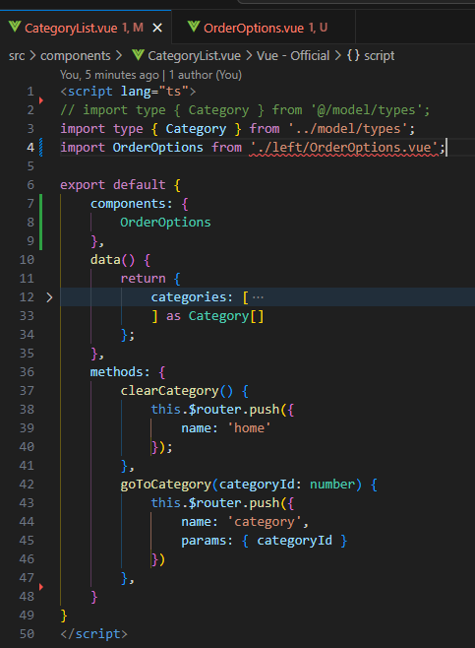
OrderOptions.vue

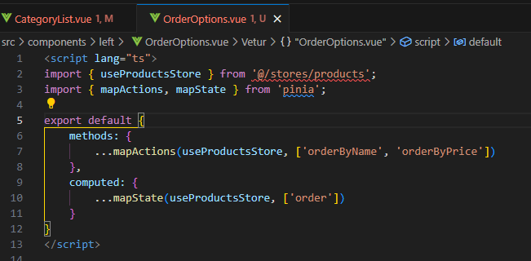
Problema:
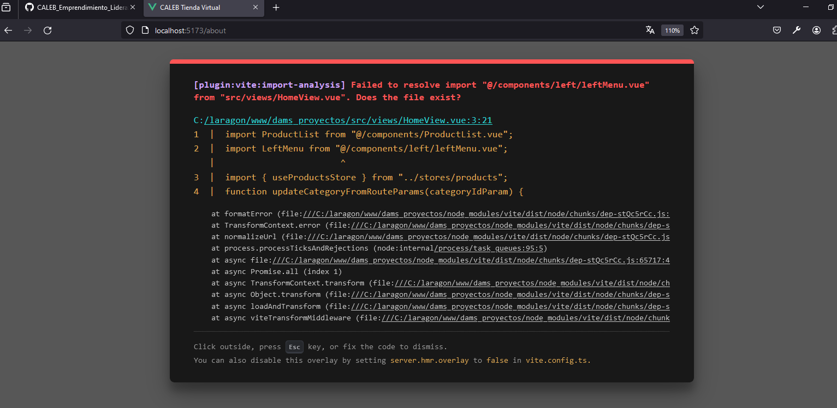

Solución: Se cambió la letra (l) minúscula por la letra (L) Mayuscula en /LeftMenu.vue y dejó de presentar el error; y volvió a funcionar el aplicativo Caleb Tienda Virtual
import LeftMenu from '@/components/left/LeftMenu.vue';

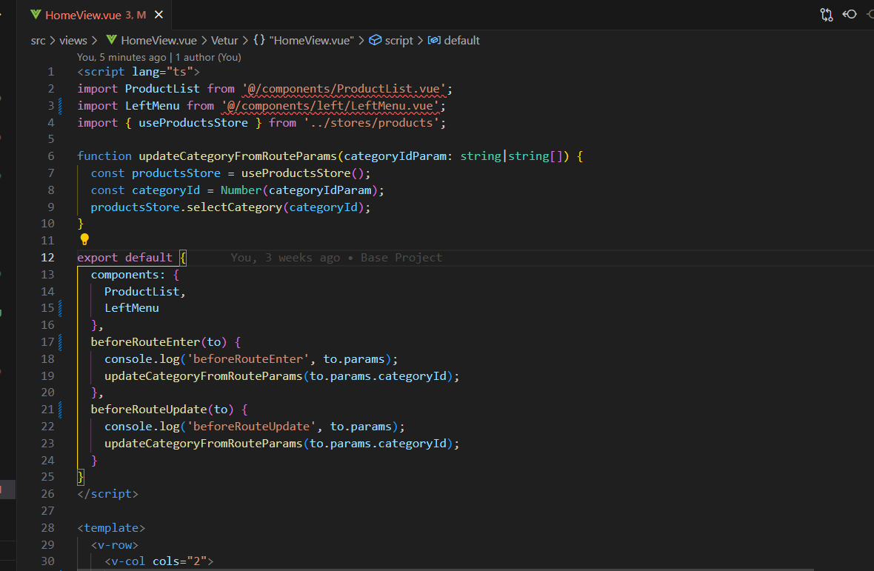
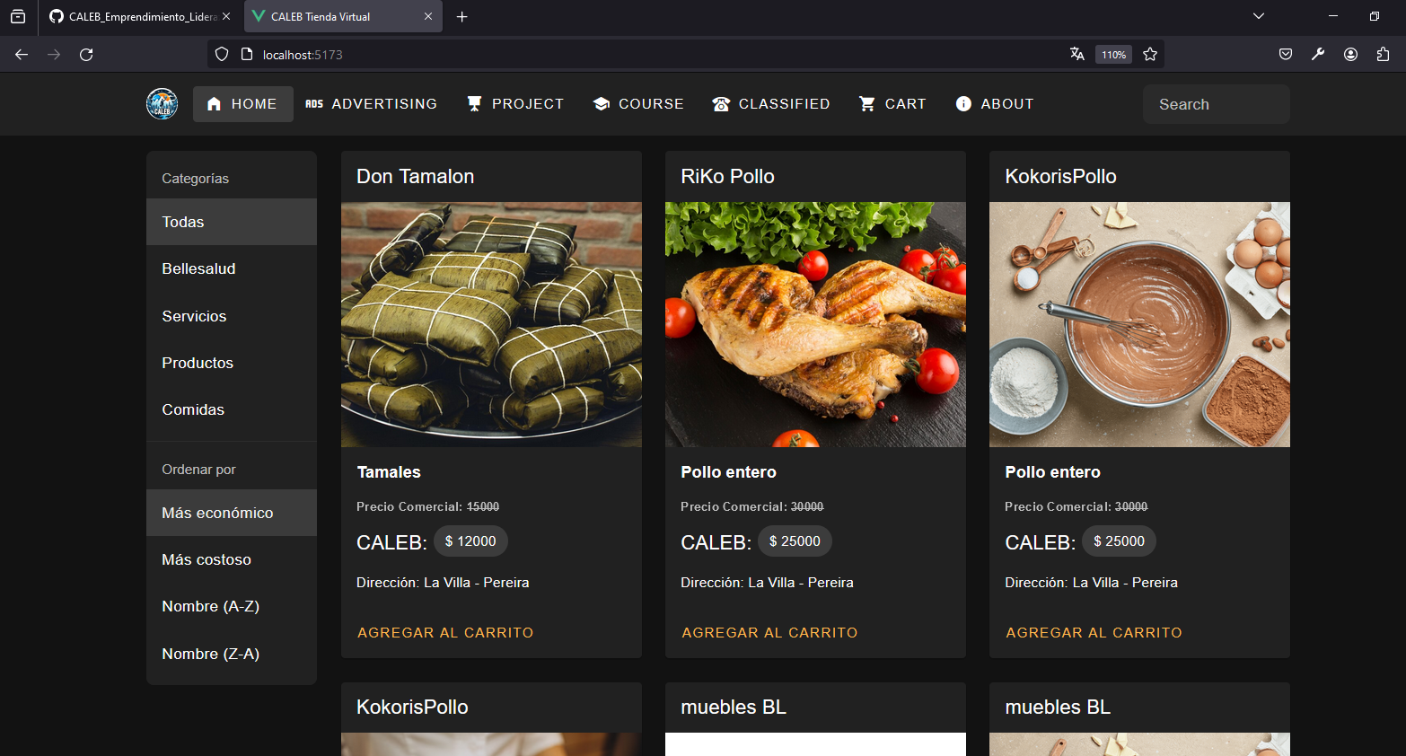
Section 15: Network Request & JSON
https://www.youtube.com/watch?v=DaGI20KYgS8

Ajax, Fetch, Axios & jQuery ⚡ 5 minutos 🎉 Desde cero

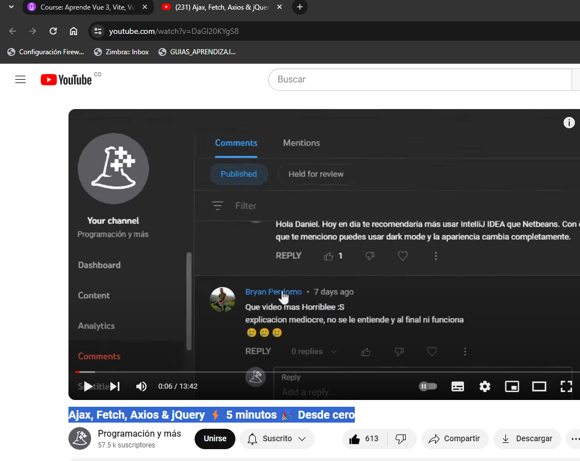

Section 15: Network Request & JSON
https://www.youtube.com/watch?v=Oj0yF8w0jwE

Desarrolla y publica una API Rest en Laravel (en menos de 1h) - Ejercicio de postulación

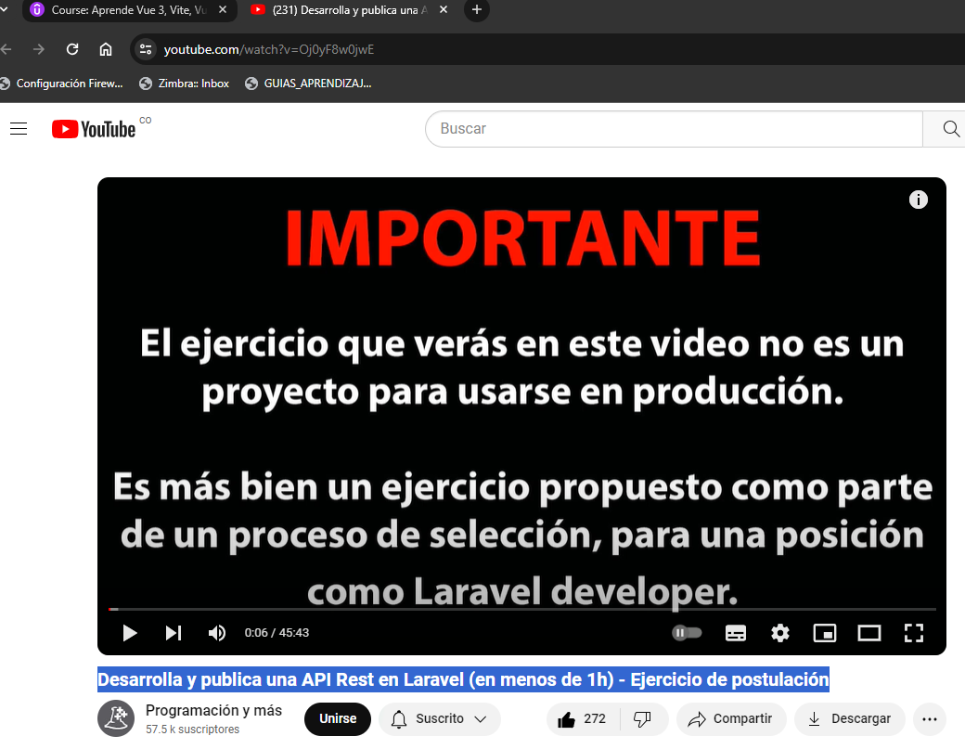
Section 15: Network Request & JSON
https://www.youtube.com/watch?v=BTDUrKfmWj8

Promesas en Javascript 🚀 PROMETO que lo entenderás
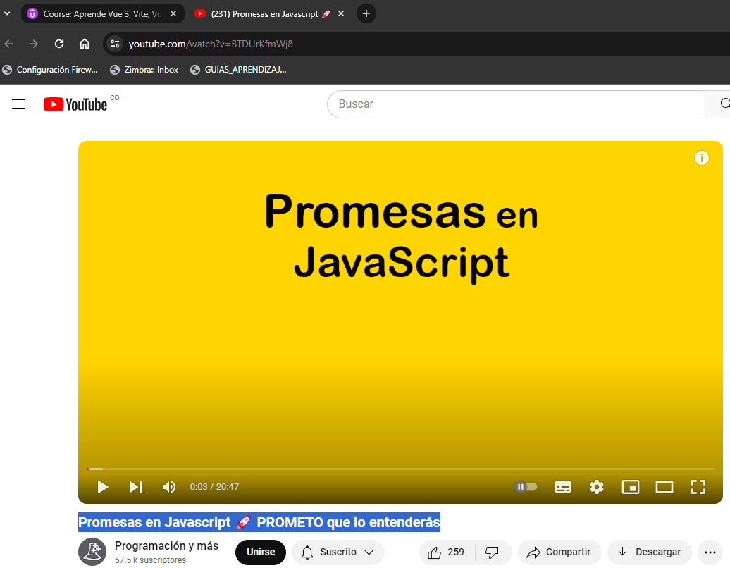

https://www.vuemastery.com/?gad_source=1&gclid=CjwKCAjwrvyxBhAbEiwAEg_Kgmoki0d4o40dPS4np9yAKIZ_ls3yIbFN527GFOGQAa3SdOj9IZCHmBoCGMEQAvD_BwE

https://faq.whatsapp.com/?locale=es_LA
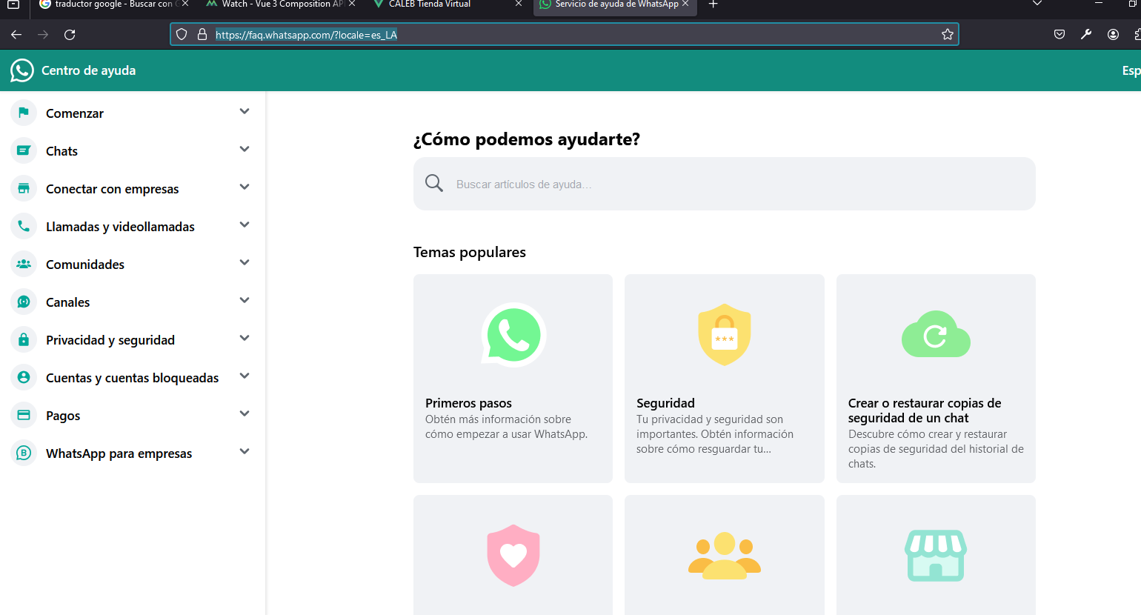

GIT HUB
PS C:\laragon\www\dams_proyectos> git status
On branch master
Your branch is up to date with 'origin/master'.

Changes not staged for commit:
(use "git add <file>..." to update what will be committed)
(use "git restore <file>..." to discard changes in working directory)
modified: otrosrecursos_damsproyectos/otrosrecursos_damsproyectos.docx
modified: src/components/CategoryList.vue

Untracked files:
(use "git add <file>..." to include in what will be committed)
otrosrecursos_damsproyectos/~$rosrecursos_damsproyectos.docx
otrosrecursos_damsproyectos/~WRL0892.tmp
src/components/left/

no changes added to commit (use "git add" and/or "git commit -a")
PS C:\laragon\www\dams_proyectos> git add .
PS C:\laragon\www\dams_proyectos> git commit -m "video 101 Vlist Active Order Item"
[master 2b9a308] video 101 Vlist Active Order Item
5 files changed, 37 insertions(+), 17 deletions(-)
create mode 100644 otrosrecursos_damsproyectos/~$rosrecursos_damsproyectos.docx
create mode 100644 otrosrecursos_damsproyectos/~WRL0892.tmp
create mode 100644 src/components/left/OrderOptions.vue
PS C:\laragon\www\dams_proyectos> git push origin master
Enumerating objects: 16, done.
Counting objects: 100% (16/16), done.
Delta compression using up to 4 threads
Compressing objects: 100% (9/9), done.
Writing objects: 100% (10/10), 181.31 KiB | 748.00 KiB/s, done.
Total 10 (delta 6), reused 0 (delta 0), pack-reused 0
remote: Resolving deltas: 100% (6/6), completed with 5 local objects.
To https://github.com/damsproyectos/CALEB_Emprendimiento_Liderazgo.git
1885cc4..2b9a308 master -> master
PS C:\laragon\www\dams_proyectos>
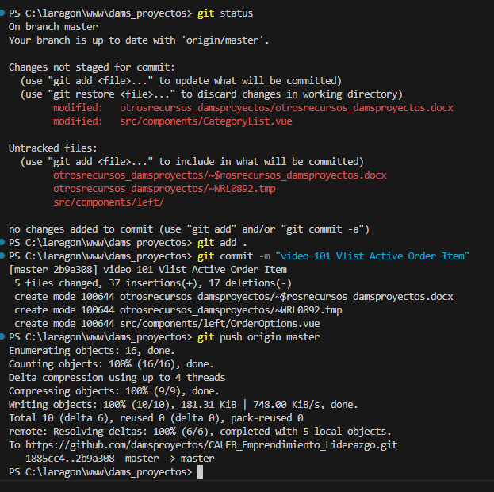
npm run lint
PS C:\laragon\www\dams_proyectos> npm run lint

> dams_proyectos@0.0.0 lint
> eslint . --ext .vue,.js,.jsx,.cjs,.mjs,.ts,.tsx,.cts,.mts --fix --ignore-path .gitignore

C:\laragon\www\dams_proyectos\src\App2.vue
1:1 error Component name "App2" should always be multi-word vue/multi-word-component-names

C:\laragon\www\dams_proyectos\src\views\HomeView.vue
17:24 warning 'from' is defined but never used @typescript-eslint/no-unused-vars
21:25 warning 'from' is defined but never used @typescript-eslint/no-unused-vars

✖ 3 problems (1 error, 2 warnings)

PS C:\laragon\www\dams_proyectos>
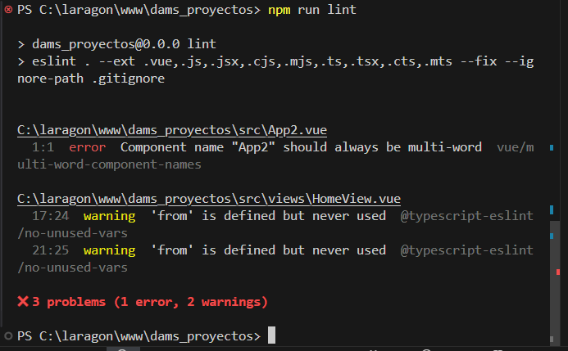
Después de solucionado los errores:
PS C:\laragon\www\dams_proyectos> npm run lint

> dams_proyectos@0.0.0 lint
> eslint . --ext .vue,.js,.jsx,.cjs,.mjs,.ts,.tsx,.cts,.mts --fix --ignore-path .gitignore

PS C:\laragon\www\dams_proyectos>
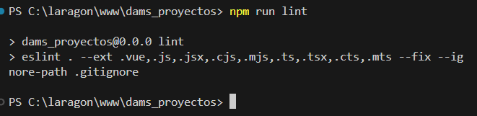

https://tablericons.com/

Tabler Icons
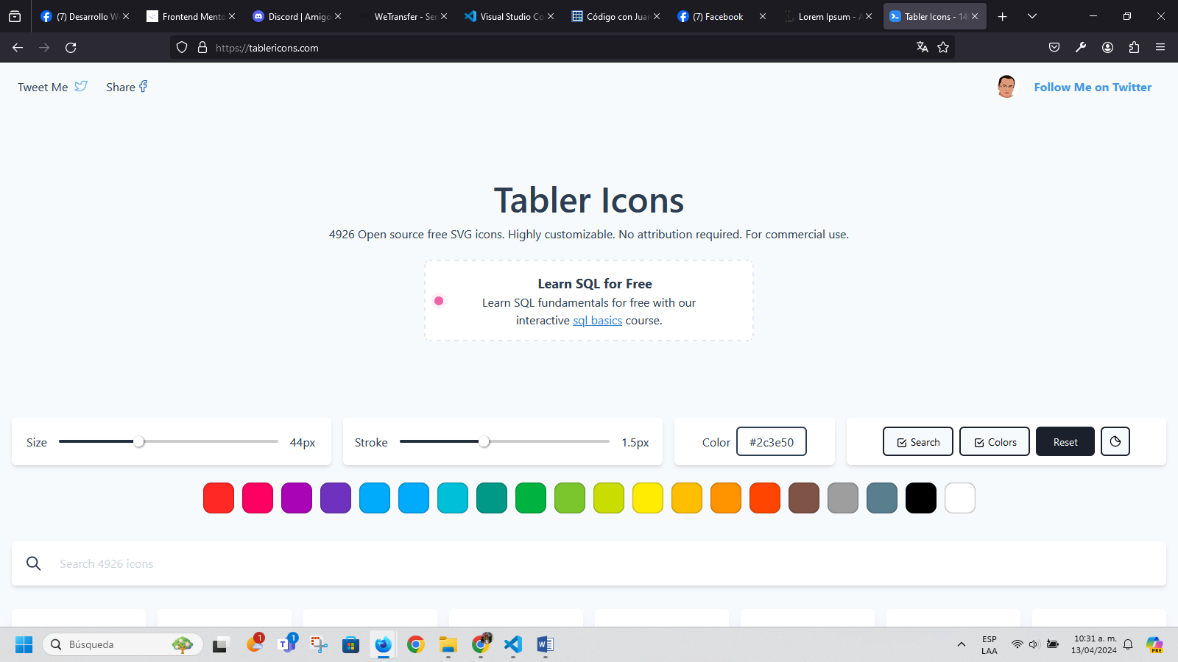
https://es.lipsum.com/

Lorem Ipsum
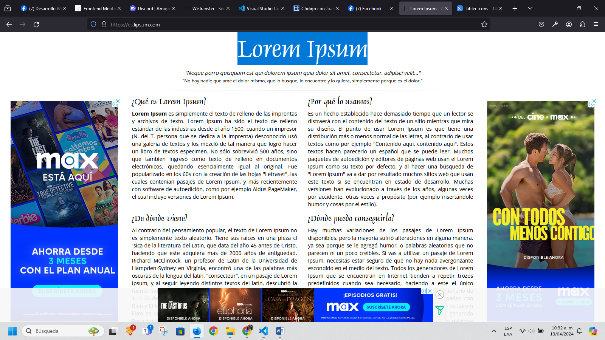
https://heroicons.dev/
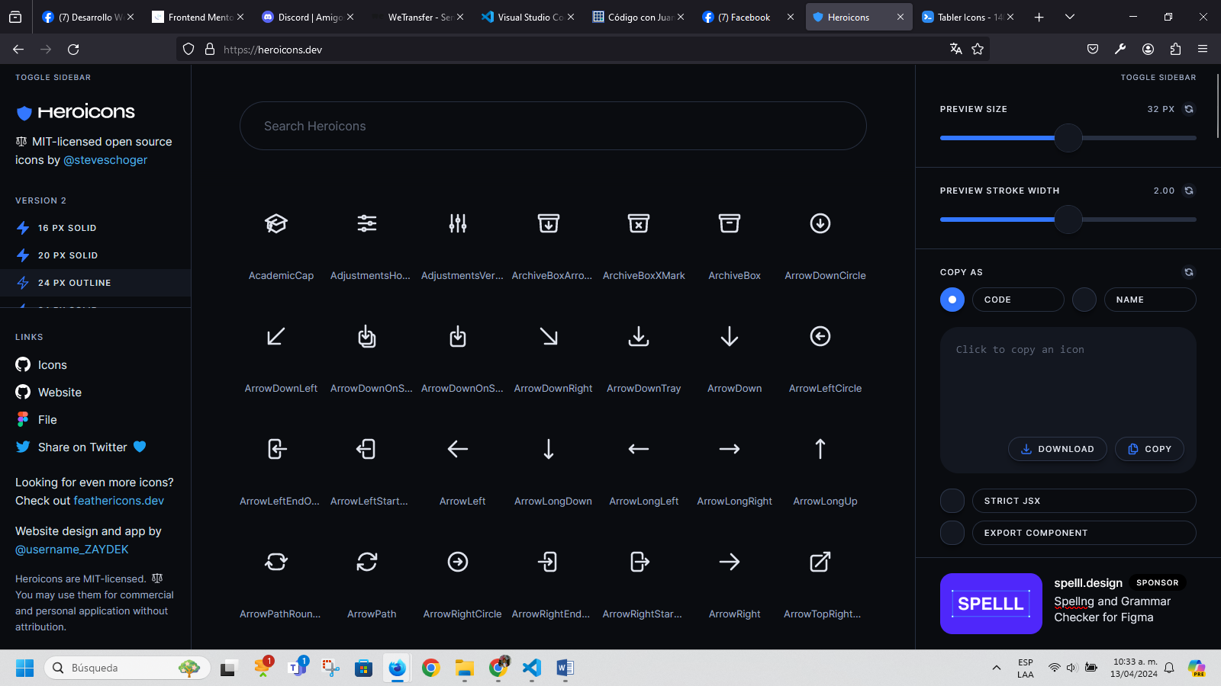
https://fontawesome.com/

Take the hassle out of icons in your website.
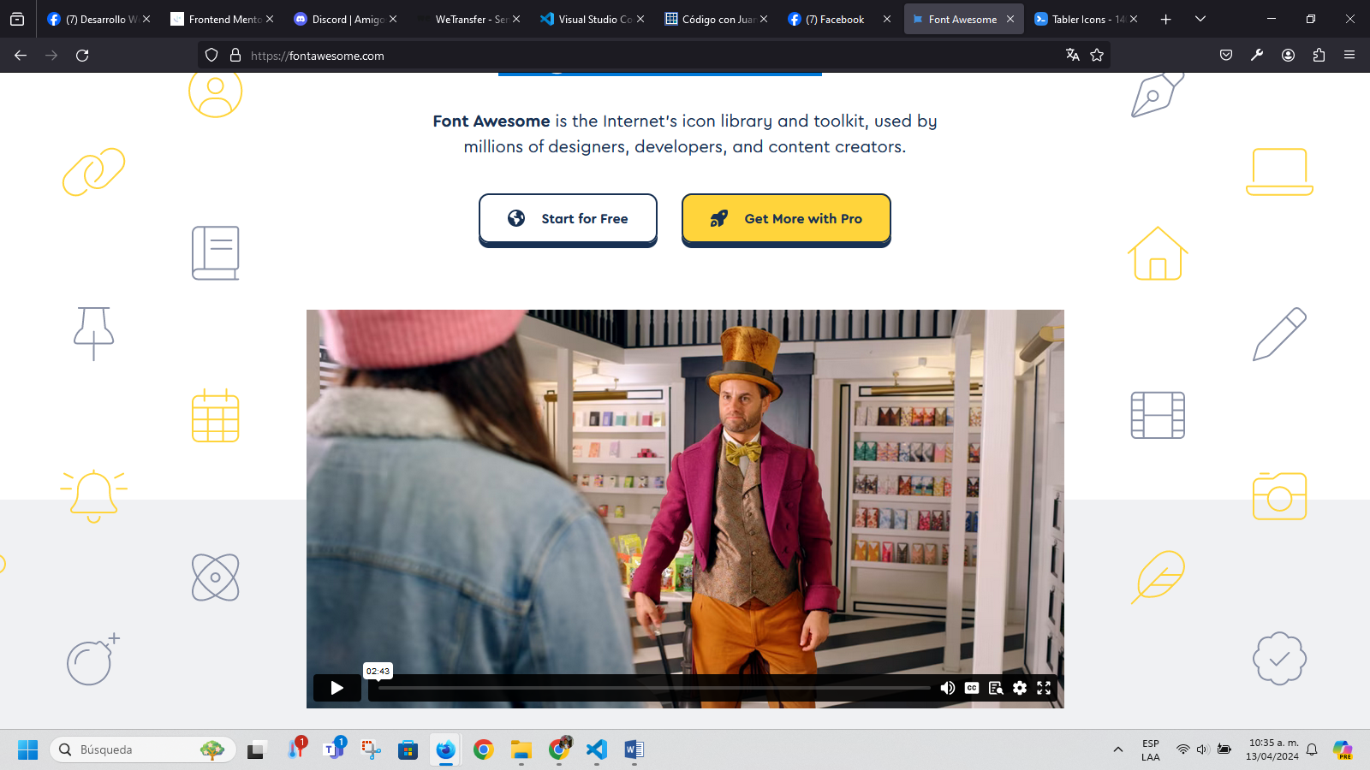
https://www.frontendmentor.io/

Improve your coding skills by building realistic projects
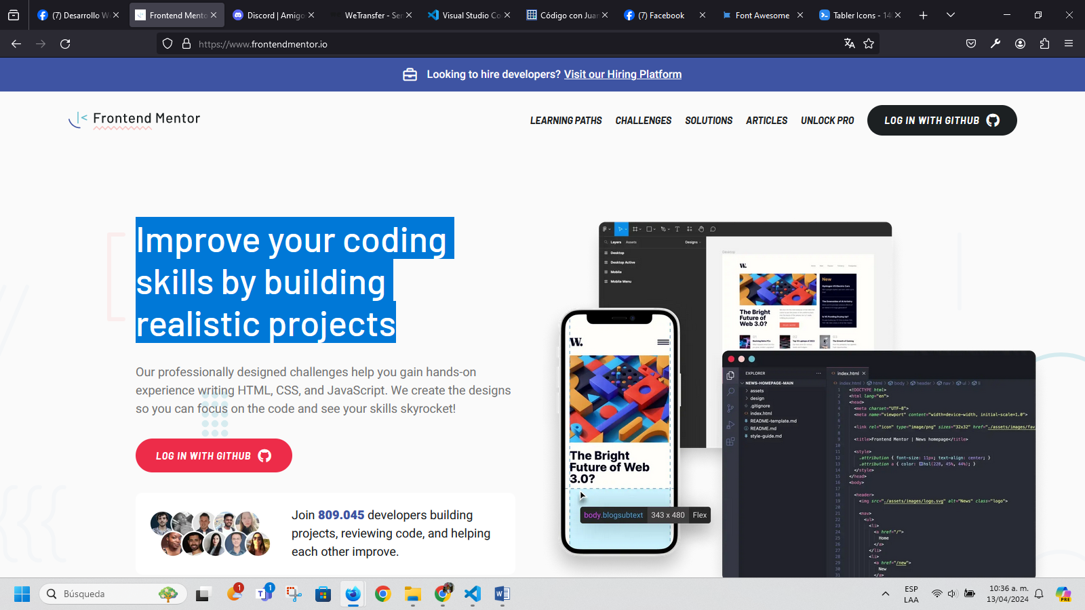
https://discord.com/channels/@me
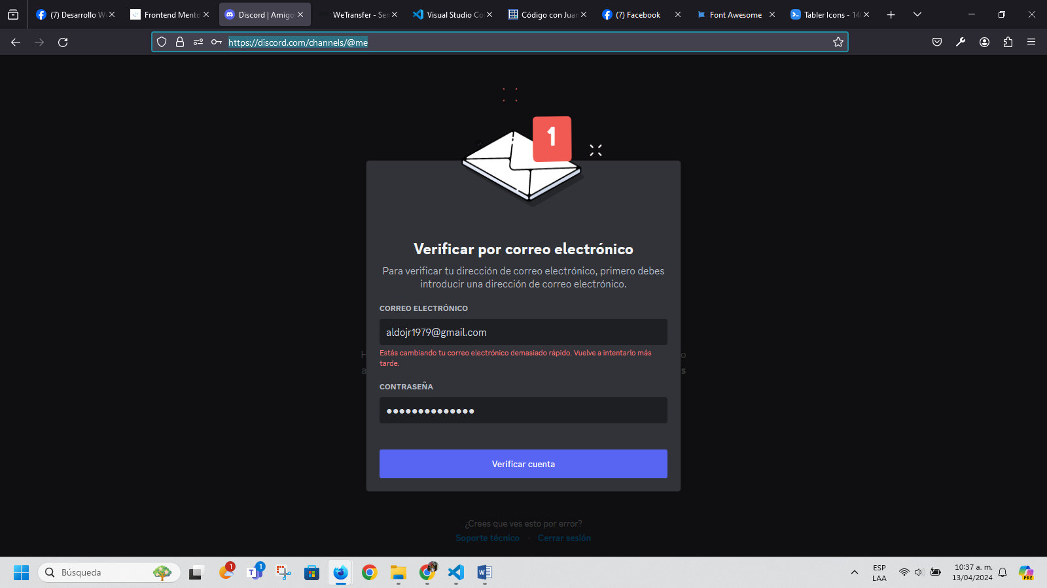
https://wetransfer.com/
Transfiere ideas.Cambia el mundo.
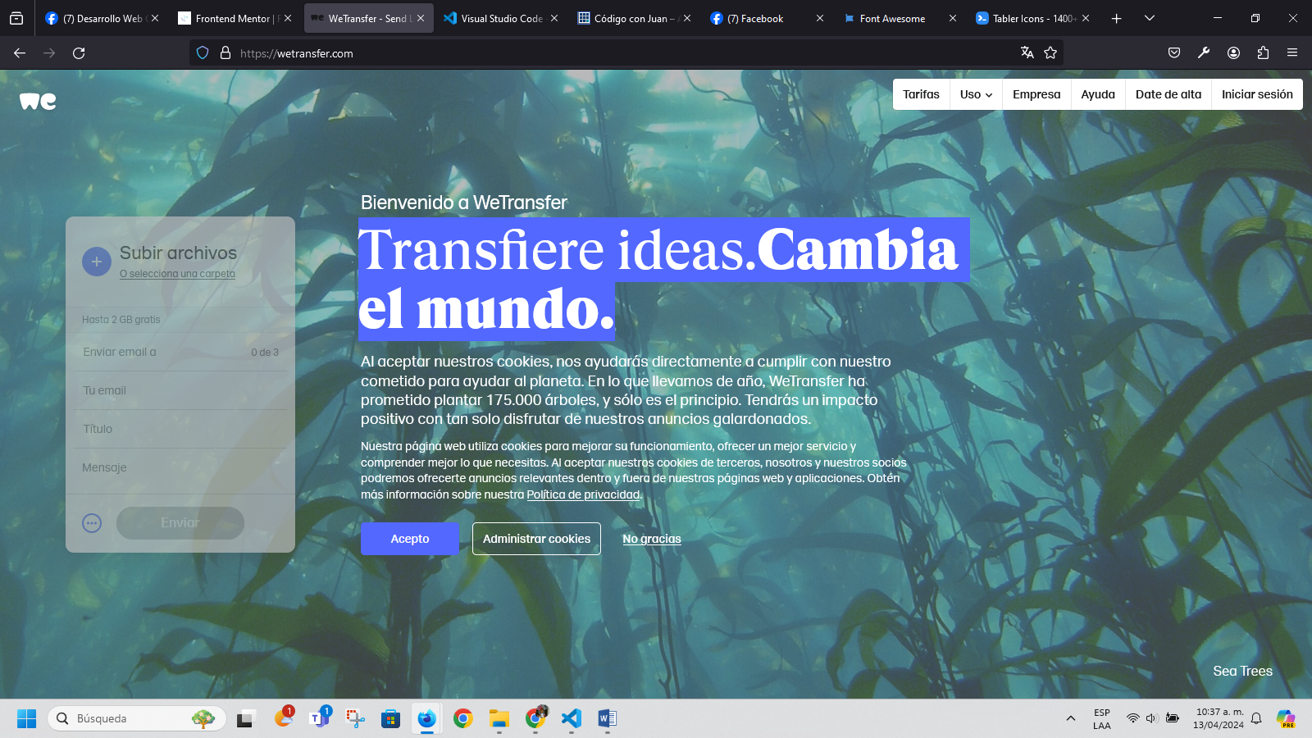
https://www.facebook.com/groups/1929227720680271/
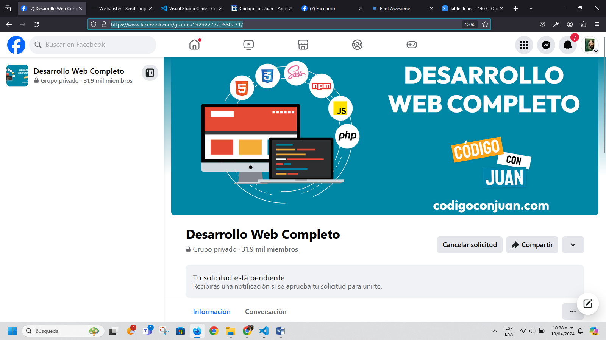
https://code.visualstudio.com/

Code editing. Redefined.
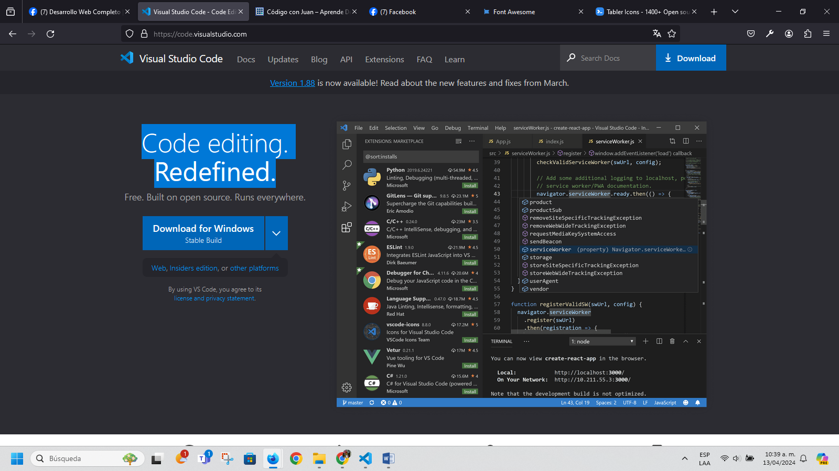

https://codigoconjuan.com/

AprendeDesarrollo Web
Aprende a crear páginas web para clientes u obtener un trabajo, conoce cada tecnología con cursos prácticos y paso a paso, los siguientes proyectos te enseñarán todo lo que debes saber de HTML, CSS, JS, PHP y MySQL
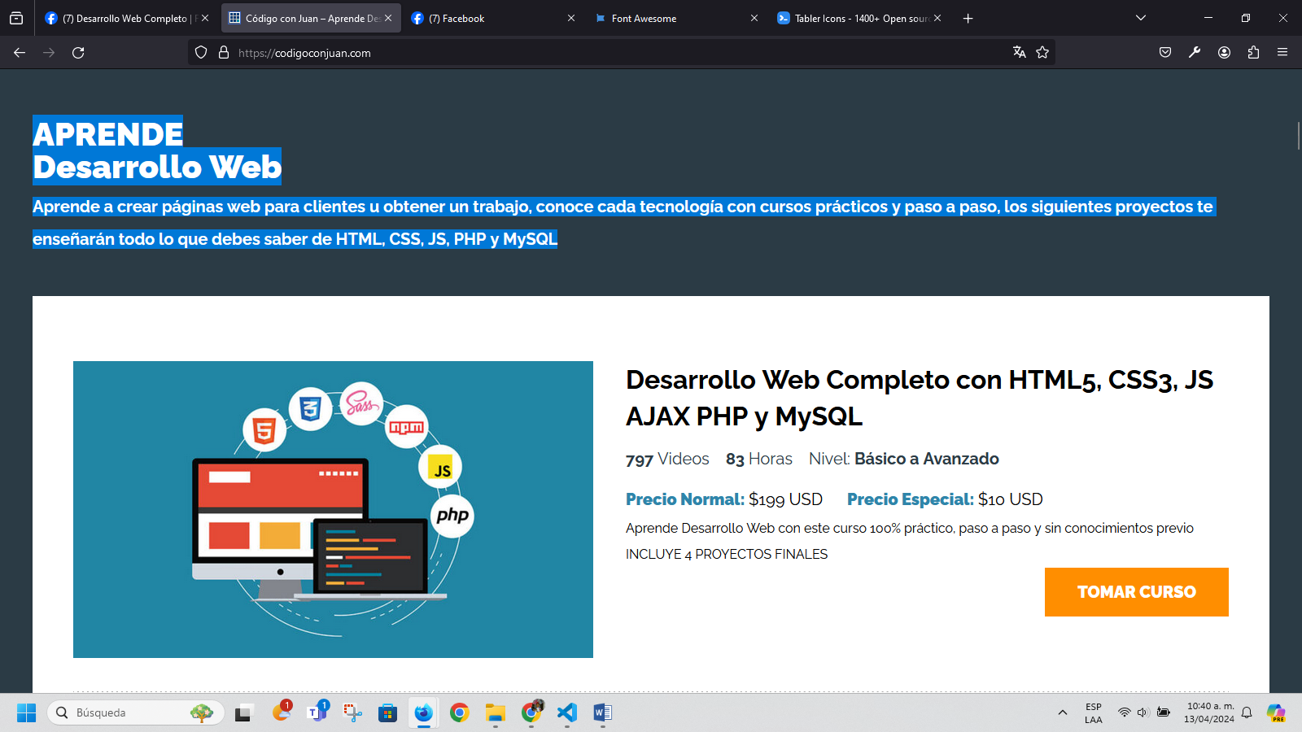
https://www.facebook.com/CodigoConJuanTuts
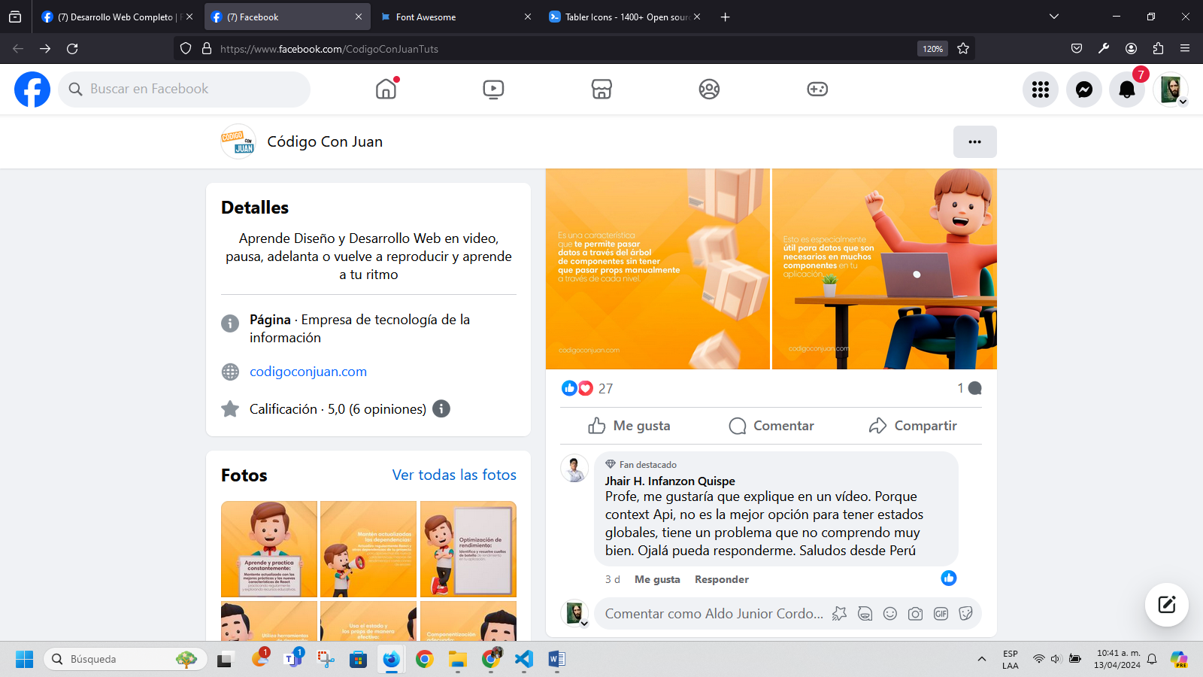
https://codigoconjuan.com/que-es-y-como-funciona-la-especificidad-en-css/
QUÉ ES Y COMO FUNCIONA LA ESPECIFICIDAD EN CSS
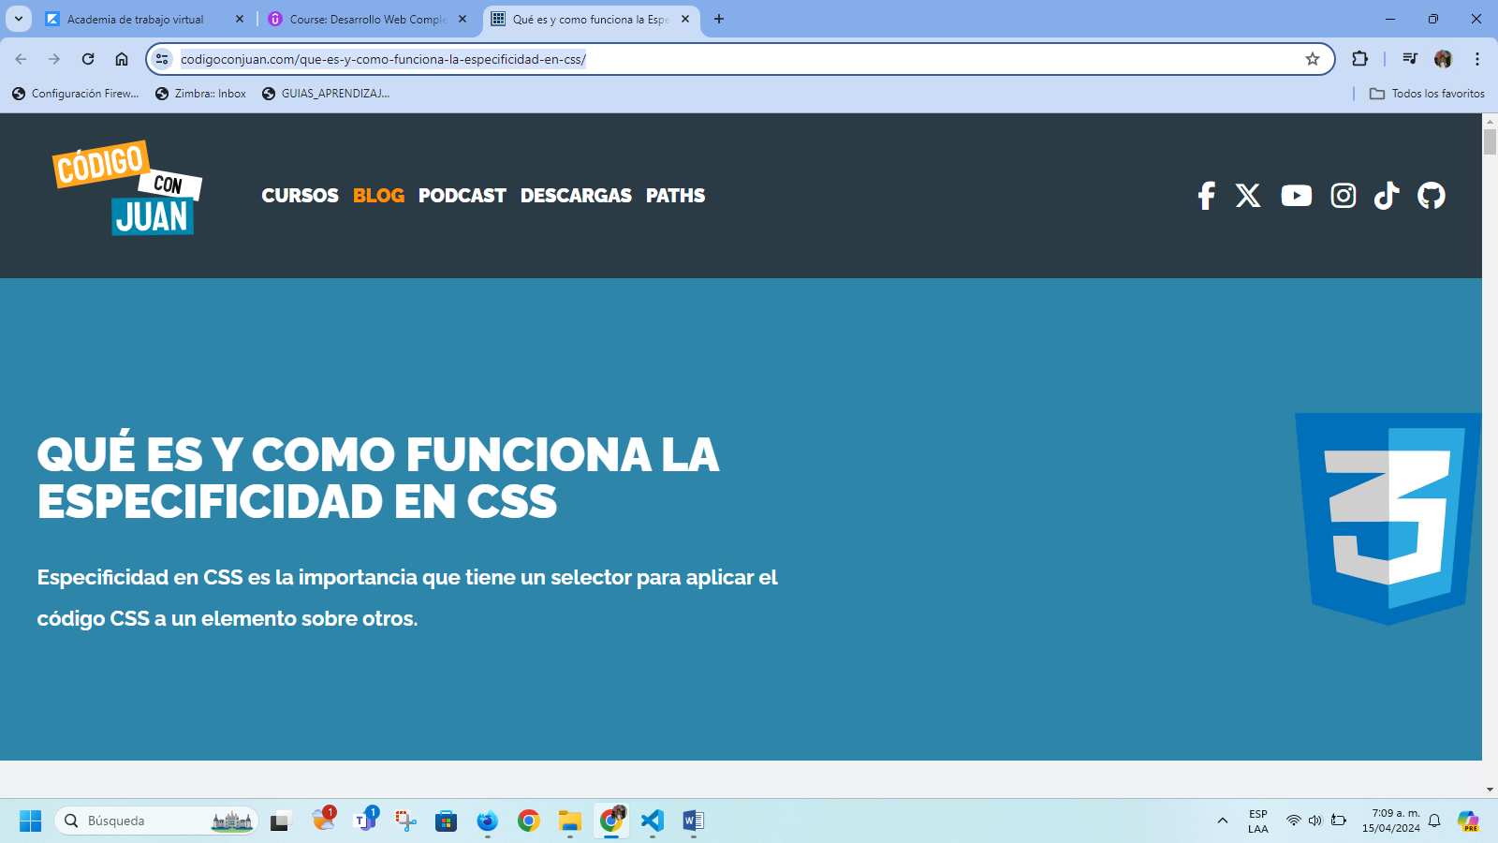
https://fonts.google.com/
Google FONTS


http://necolas.github.io/normalize.css/
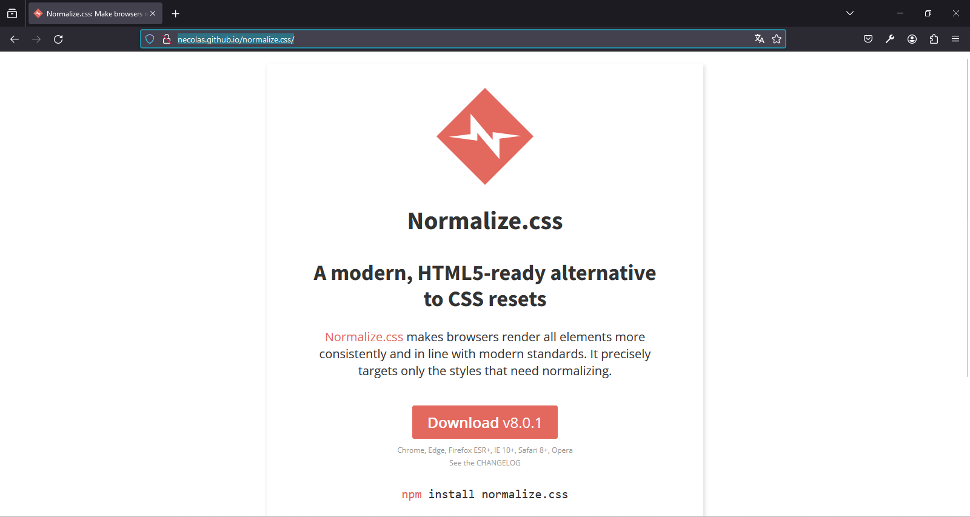
https://necolas.github.io/normalize.css/8.0.1/normalize.css
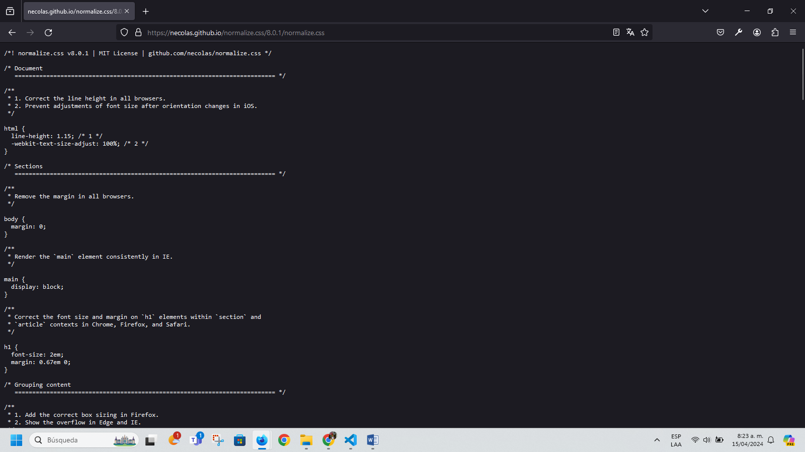
Gastos
Cámaras de seguridad o IP
Fibras ópticas
- Mirar empresas que hagan fibra óptica – cámaras de seguridad – eléctrica – paneles solares – Interenet saltelital – administración y configuración red LAN – Domotica – ampliación de zonas WIFI – radioenlace punto a punto y punto multipunto.
Estudio de campo – administración del tigre
Portafolio:
Redes WAN
Redes LAN
Ingeniero de Datos
Tema de proveedores.
Radios punto a punto Ubiquiti.
https://www.youtube.com/watch?v=se4B6__DVrI

Cómo importar una base de datos a Laragon: guía sencilla paso a paso

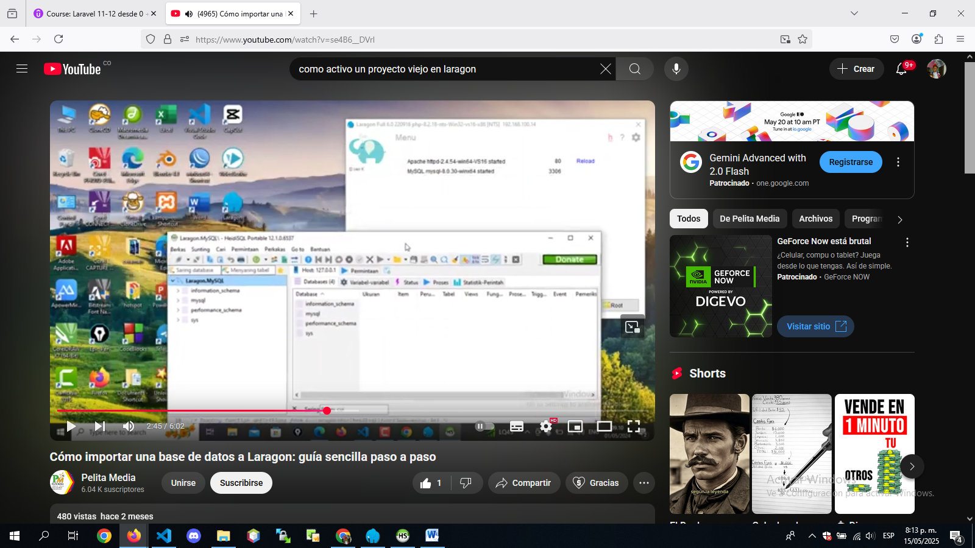

Lunes 23 junio de 2025
NECESITO VOLVER A ACTIVAR UN PROYECTO DE VUEJS 3 EN LARAGON
necesito volver a activar un proyecto de vuejs 3 en laragon

ChatGPT dijo:
Para volver a activar un proyecto de Vue.js 3 en Laragon, solo necesitas seguir unos pasos clave. Aquí te detallo el procedimiento paso a paso:

✅ 1. Abrir Laragon
Asegúrate de que Laragon esté ejecutándose:
- Inicia Laragon.
- Verifica que Apache o Nginx y MySQL (si lo usas) estén encendidos.

✅ 2. Ir a la carpeta del proyecto
Tu proyecto Vue debe estar en una carpeta como:
makefile
CopiarEditar
C:\laragon\www\mi-proyecto-vue
Si no está allí, puedes moverlo manualmente o clonar desde Git.

✅ 3. Abrir terminal en la carpeta del proyecto
Desde Laragon:
- Ve al menú: Menu > Terminal o Menu > www > [tu proyecto] > Terminal Here.
O desde el explorador:
- Shift + clic derecho en la carpeta del proyecto → “Abrir terminal aquí”.

✅ 4. Instalar dependencias
Si no has corrido esto aún (o si has formateado, movido o clonado el proyecto):
bash
CopiarEditar
npm install
Esto reinstala todos los paquetes necesarios a partir del archivo package.json.

✅ 5. Levantar el servidor de desarrollo
Usualmente con:
bash
CopiarEditar
npm run dev
También puede ser:
bash
CopiarEditar
npm run serve
dependiendo de cómo esté configurado el package.json.

✅ 6. Ver en el navegador
Por defecto, Vue usa localhost:5173, localhost:3000, o similar. El terminal te lo dirá claramente, algo como:
arduino
CopiarEditar
VITE v4.0.0 ready in 500 ms

➜ Local: http://localhost:5173/

⚙️ Tips adicionales
- Archivos .env: Si el proyecto usa Vite, verifica que exista .env o .env.local si hay rutas personalizadas o puertos.
- Error de versión de Node.js: Verifica con node -v. Vue 3 y Vite requieren Node 14 o superior (idealmente 16+).
- Si tienes errores relacionados con paquetes, puedes probar:
bash
CopiarEditar
rm -rf node_modules
npm install

¿Quieres que revisemos el package.json o tienes un error específico? Puedes copiar el error aquí y te ayudo a resolverlo.
Principio del formulario

Herramientas
Final del formulario
ChatGPT puede cometer errores. Comprueba la
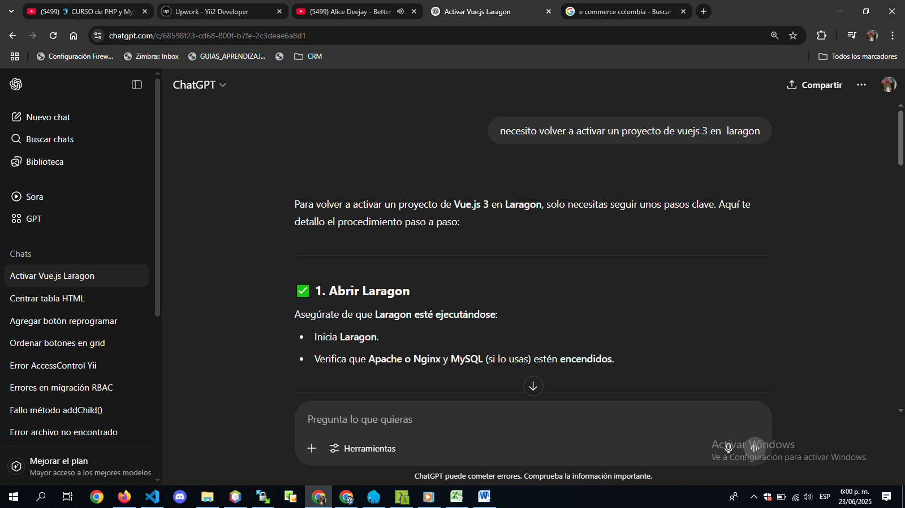
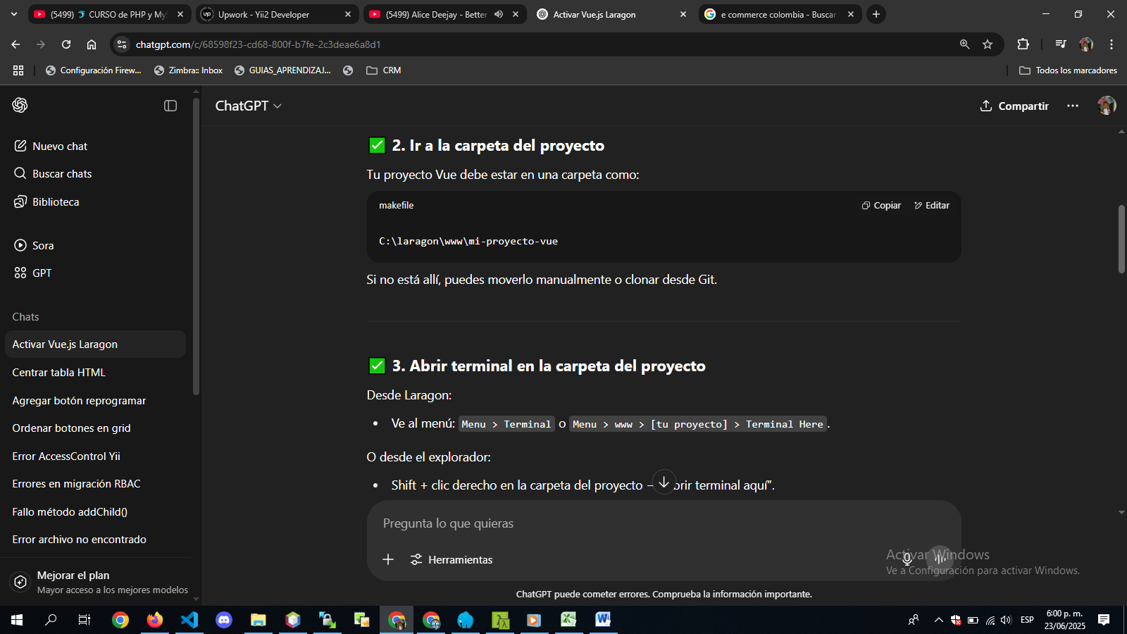
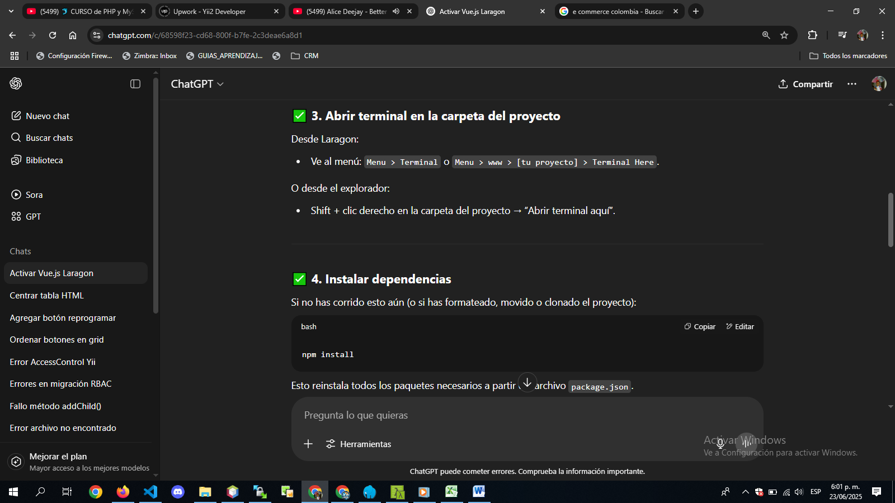
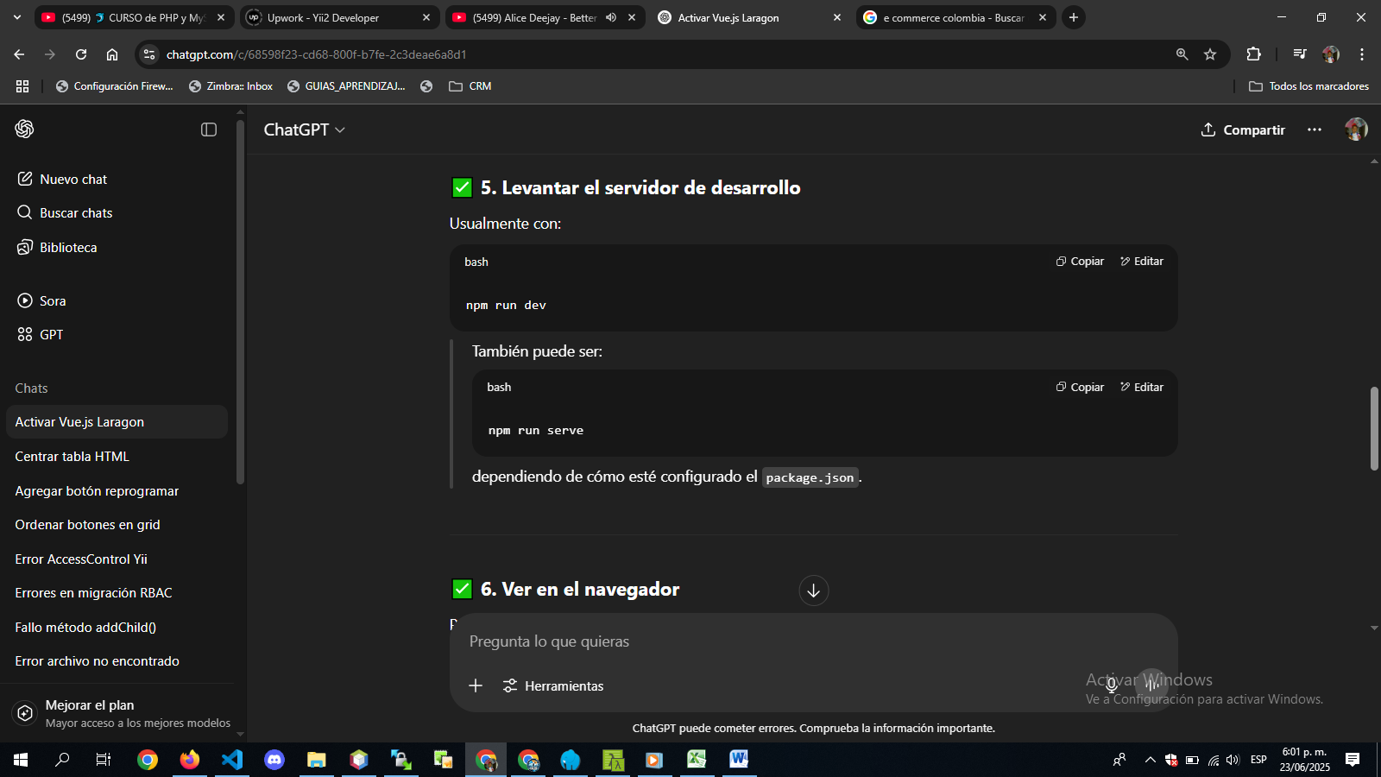
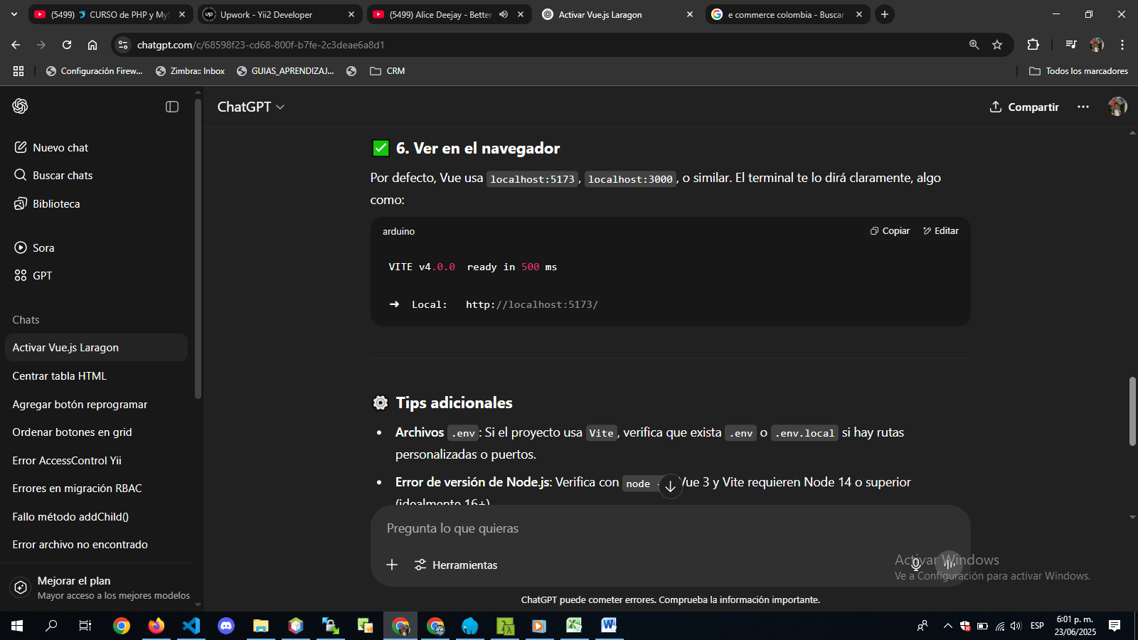
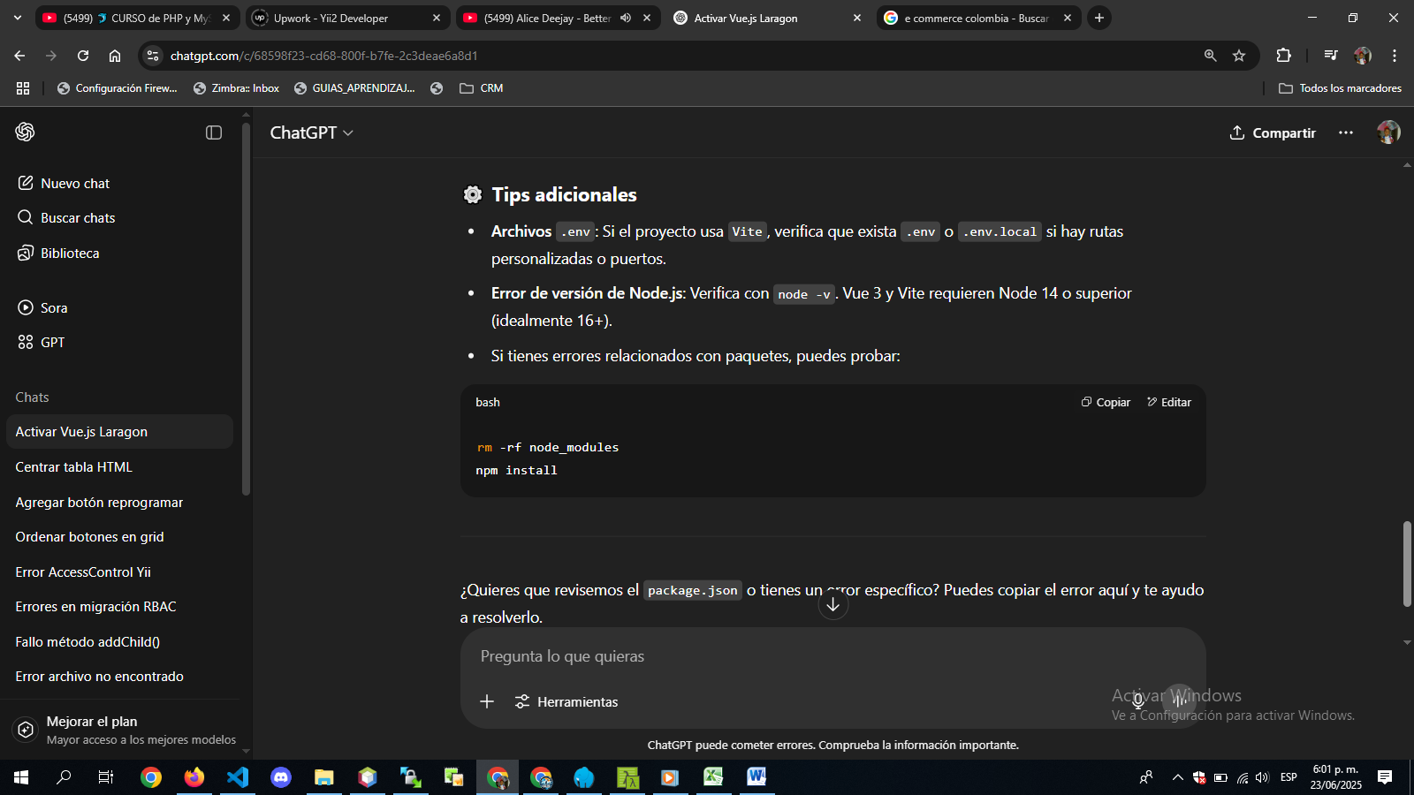
C:\laragon\www\caleb-emprender-lider-tienda-virtual
λ cd..

C:\laragon\www
λ cd CALEB_Emprendimiento_Liderazgo

C:\laragon\www\CALEB_Emprendimiento_Liderazgo
λ npm install

added 290 packages, and audited 291 packages in 31s

55 packages are looking for funding
run `npm fund` for details

12 vulnerabilities (1 low, 8 moderate, 3 high)

To address issues that do not require attention, run:
npm audit fix

To address all issues (including breaking changes), run:
npm audit fix --force

Run `npm audit` for details.

C:\laragon\www\CALEB_Emprendimiento_Liderazgo
λ npm run dev

> dams_proyectos@0.0.0 dev
> vite

VITE v5.1.3 ready in 8335 ms

➜ Local: http://localhost:5173/
➜ Network: use --host to expose
➜ press h + enter to show help
4:44:48 p. m. [vite] hmr update /src/views/AboutView.vue
4:46:05 p. m. [vite] hmr update /src/views/AboutView.vue (x2)
5:07:17 p. m. [vite] hmr update /src/components/ProductCard.vue
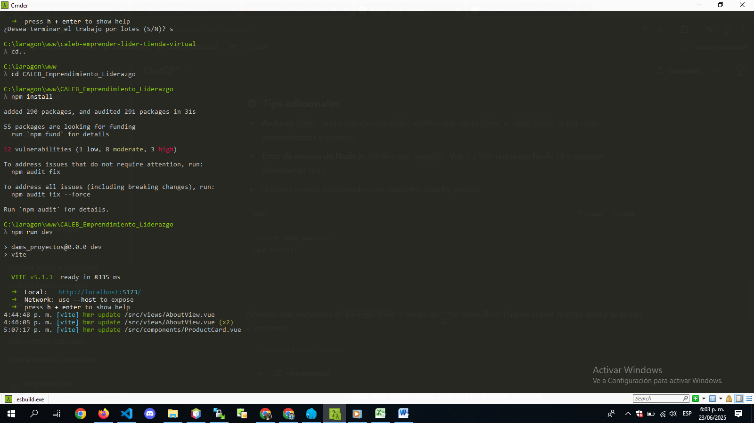
http://localhost:5173/
