UFO Sightings

I have received the UFO sightings data in a data.js file. The data contains UFO sightings in several cities between January 1, 2010 and January 13, 2010. Besides city name, each sighting had datetime of the sighting, the state and country of the city, shape of the UFO, duration of the sighting in minutes.

An html page was developed to show the sightings with a UFO image. The page has a striped table to show the rows of the data, and a form with text input and filter button to filter this data by datetime. The bootstrap CSS striped table style, a navbar, and bootstrap columns were used to display the data in a responsive page.

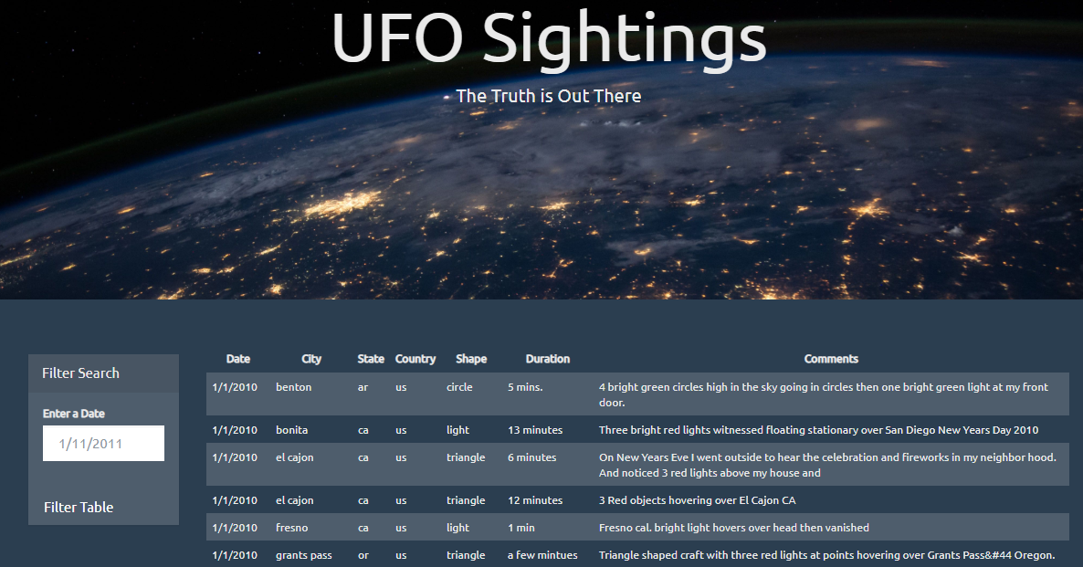

**Figure**: All Data

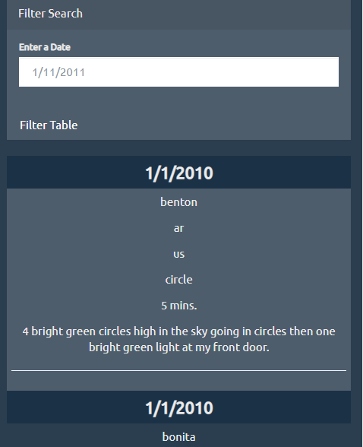

**Figure**: Responsive page with Data

A user input filter 1/5/2010 was provided to test filtering the sightings for that day.

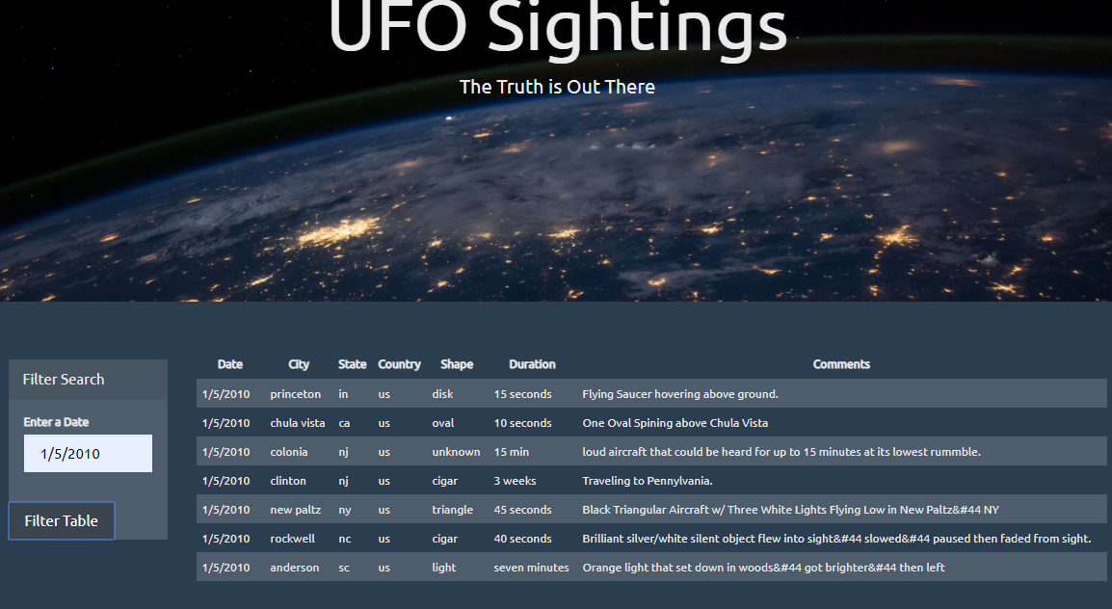

**Conclusion**

Several sightings lasted in seconds, minutes, hours, and even weeks. Sightings were in the form of lights, circles, and objects in several colors. A few sightings were in triangle, square, disc, V, and tear-drop shaped.