**Earthquake Data Analysis**

The earthquake data analysis was performed on a dataset from USGS website containing one month GeoJSON data with earthquakes of magnitude greater than 2.5. This dataset contain feature collections and features only. Each feature provided the magnitude and place of the earth quake information. These features were used to add circle markers on a leaflet mapped page. The markers increase in size as the magnitudes increase. The colors on the map are indicated using legends on the bottom right hand side of the map while the top right hand side contains options to switch the map between street map and dark map layers. In addition, a checkbox was provided on the same options to turn on or clear the earthquake markers on the map.

**Street Map with Markers and Legends**

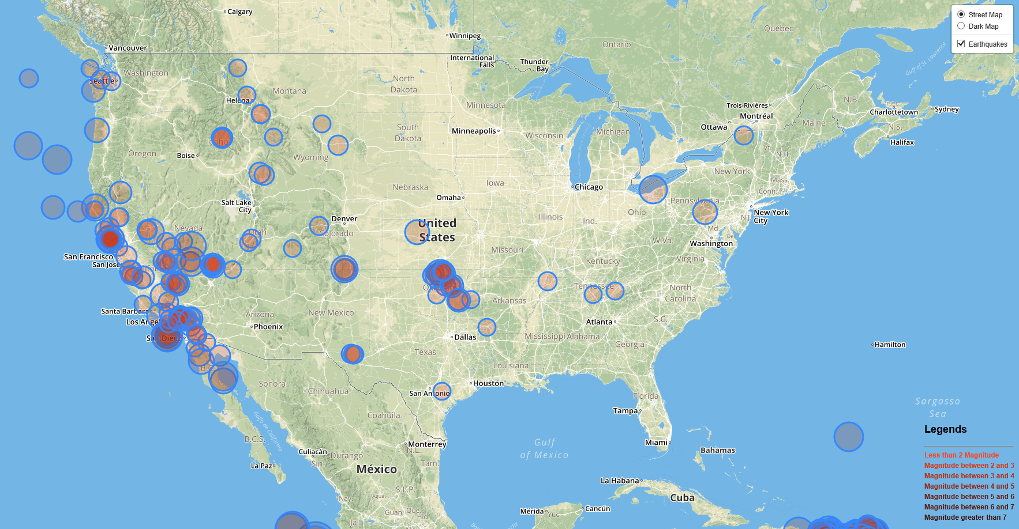

**Dark Map with Markers and Legends**

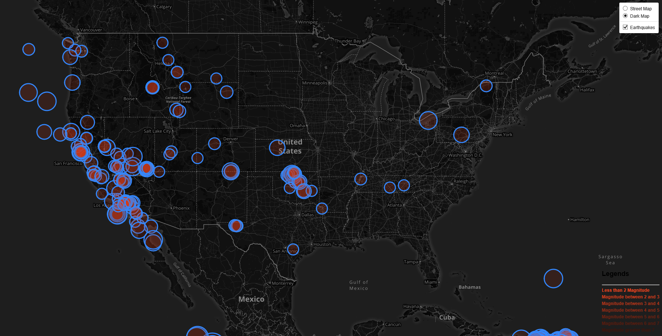

**Conclusion**

Most of earthquakes were concentrated on the California coast and a few towards Oregon coast. A few more were well concentrated in the Oklahoma region. The higher magnitude earthquakes occurred on the California and Oregon coast indicated by bigger circles.