Sub-National Statistical Profile: Ankole

 | lbl_score_metric_header | 2020 | 2021 | 2022 | 2023 | 2024 | 2025
title_score_monthly_complete
1a | lbl_score_1a | 99 | 99 | 99 | 99 | 99 | 98
1b | lbl_score_1b_prefix90 | 100 | 100 | 100 | 100 | 100 | 100
1c | lbl_score_1c_rmncah | 88 | 90 | 91 | 93 | 94 | 77
title_score_extreme_outliers
2a | lbl_score_2a | 99 | 100 | 97 | 100 | 99 | 88
2b | lbl_score_2b | 87 | 91 | 91 | 91 | 83 | 71
title_score_consist_annual
3a | lbl_consist_ratio_anc1_penta1 | 1.02 | 1.05 | 1.07 | 1.02 | 0.94 | 0.96
3b | lbl_consist_ratio_penta1_penta3 | 1.01 | 1.02 | 1.03 | 1.02 | 1.01 | 1.01
3c | lbl_score_range_anc1_penta1 | 46 | 54 | 54 | 38 | 31 | 31
3d | lbl_score_range_penta1_penta3 | 69 | 69 | 92 | 77 | 46 | 62
4 | lbl_score_annual_score | 84 | 86 | 89 | 86 | 79 | 75

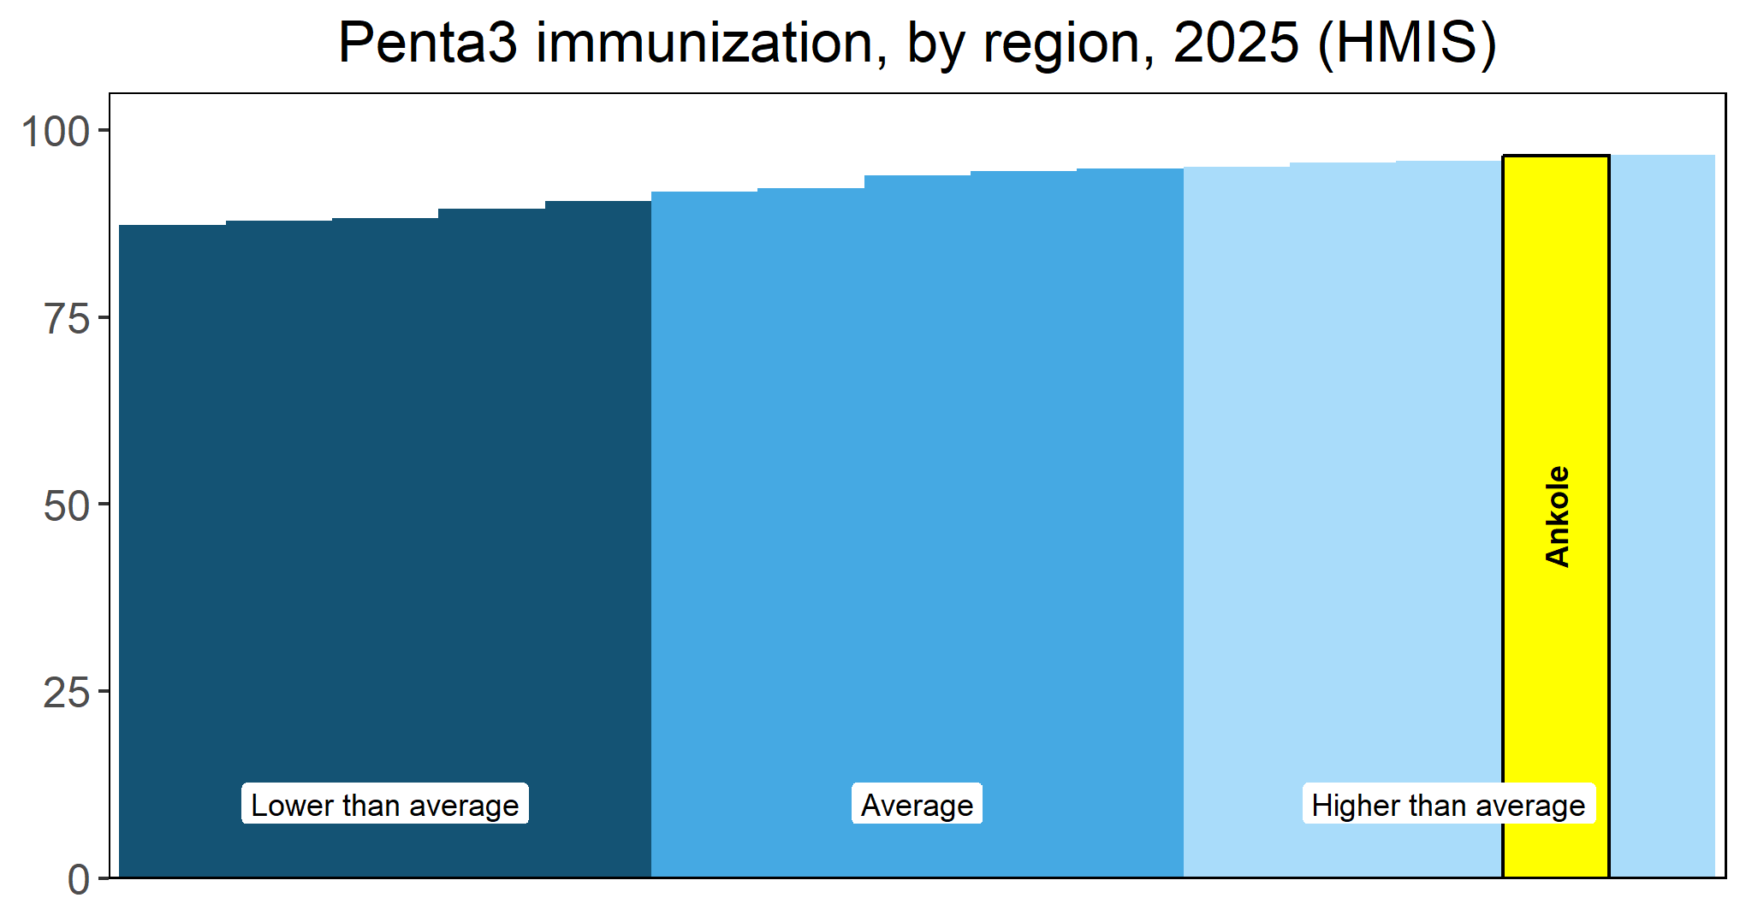
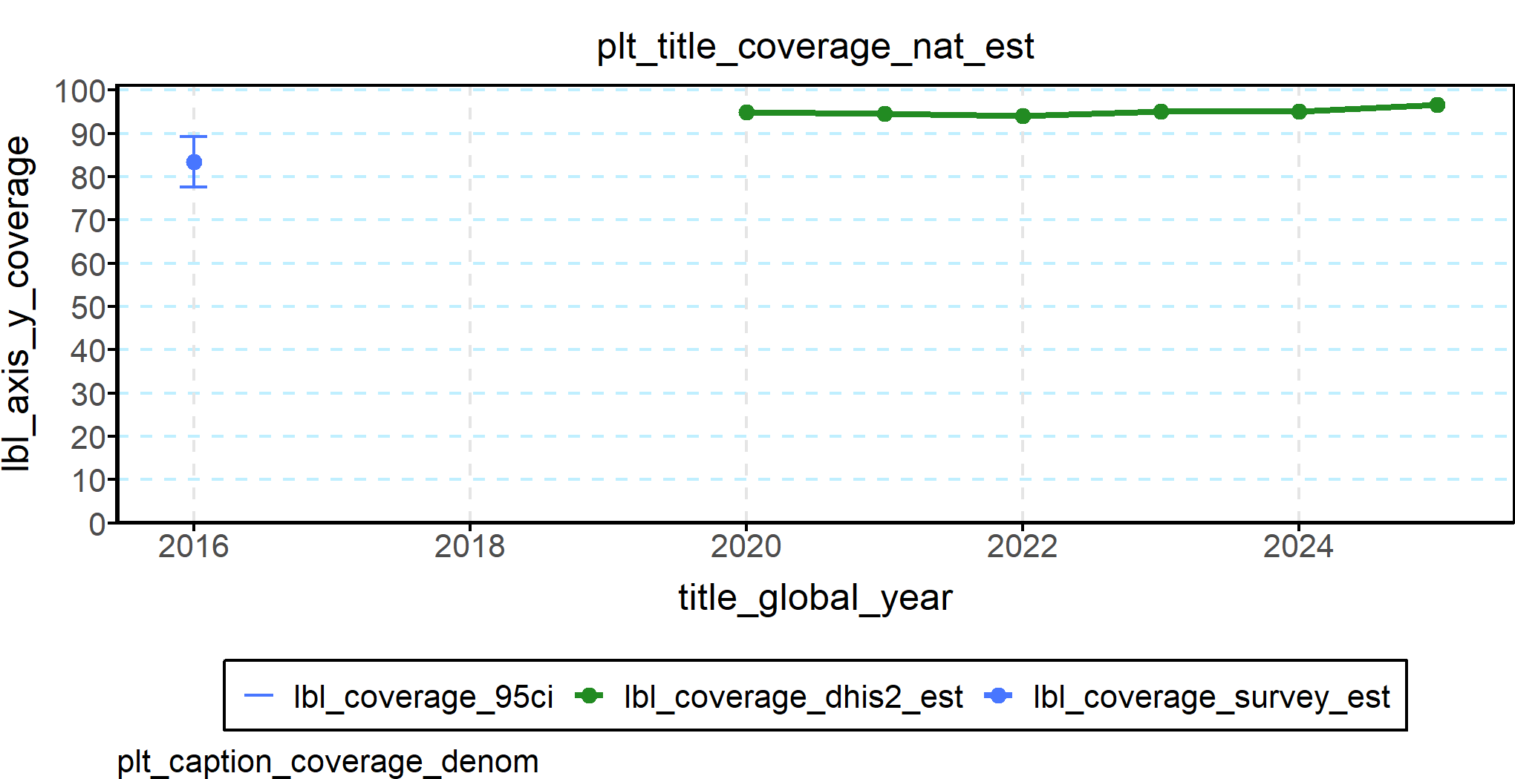

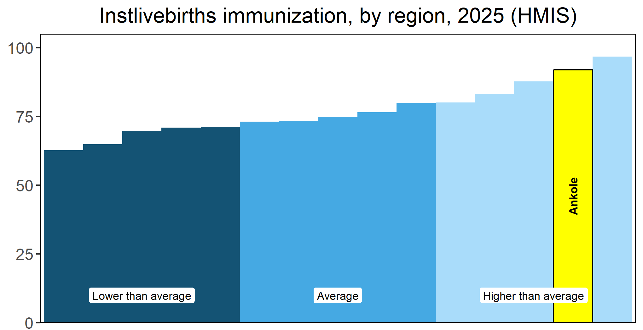
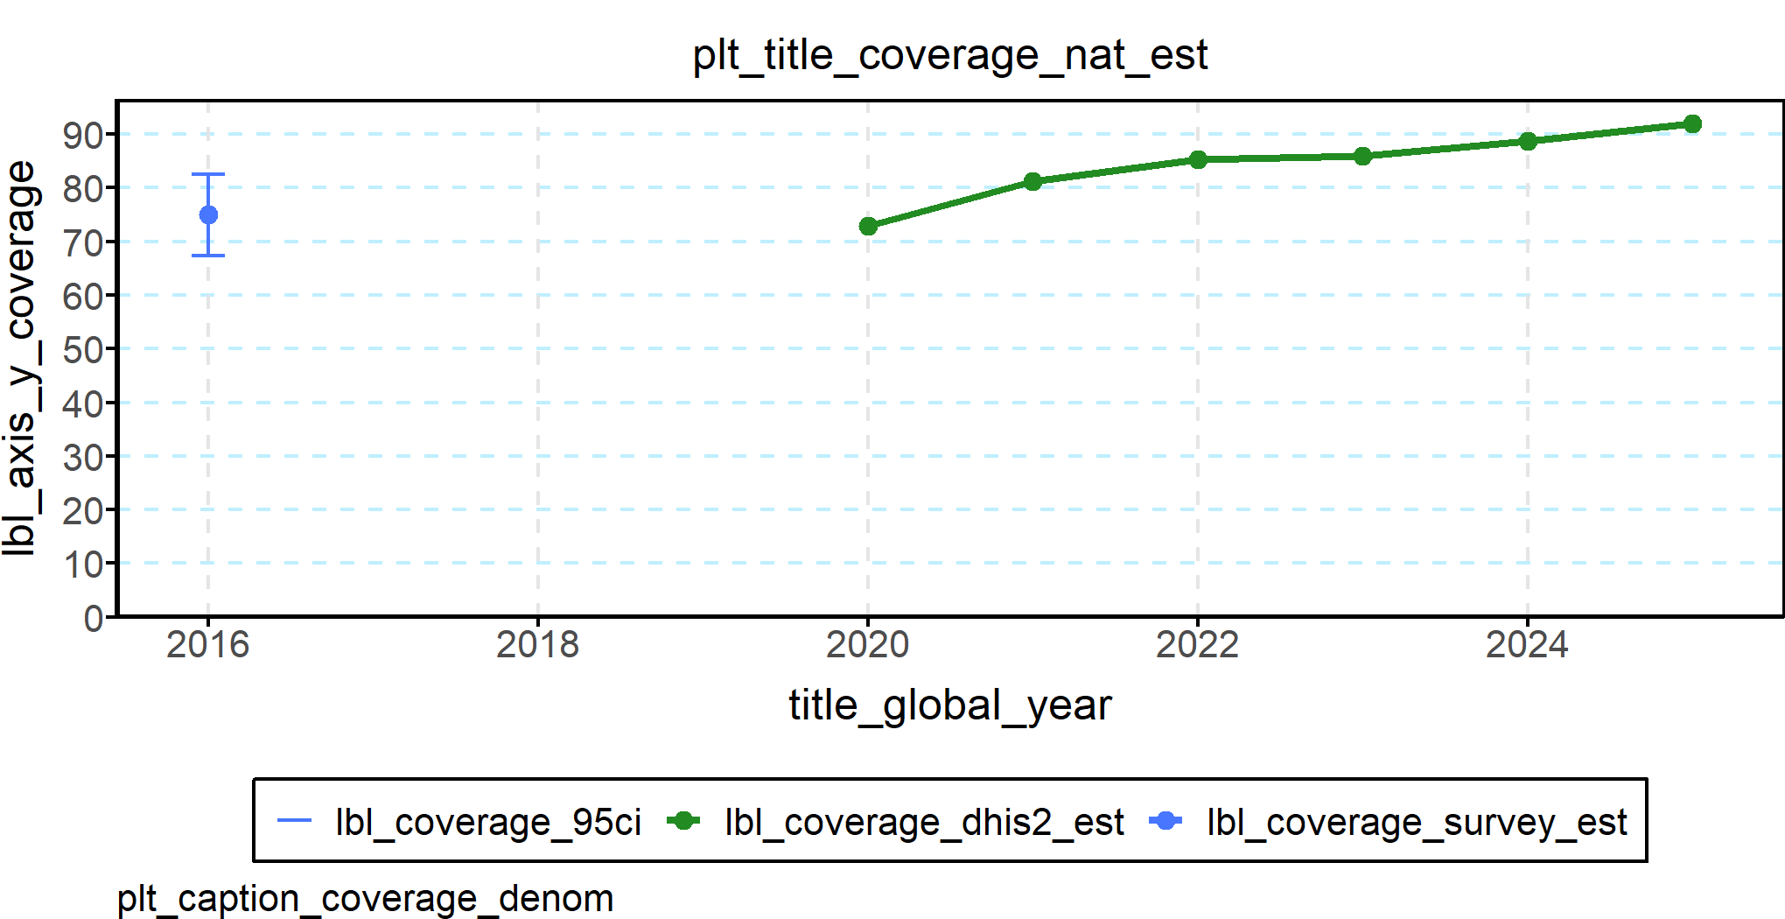

district | opt_anc4 | opt_instlivebirths | opt_csection | opt_pnc48h | opt_penta3 | opt_mcv1
Buhweju District | 73.4 | 87.4 | 4.8 | 89.4 | 98.6 | 96.6
Bushenyi District | 78.3 | 101.7 | 19.0 | 97.3 | 94.7 | 91.9
Ibanda District | 76.1 | 79.9 | 14.3 | 79.8 | 96.8 | 88.4
Isingiro District | 61.2 | 85.9 | 12.6 | 84.6 | 96.8 | 92.7
Kazo District | 86.9 | 82.2 | 5.0 | 83.7 | 99.7 | 93.0
Kiruhura District | 88.4 | 89.2 | 3.7 | 88.2 | 93.9 | 90.8
Mbarara City | 67.1 | 104.6 | 39.1 | 103.0 | 94.6 | 85.6
Mbarara District | 72.7 | 84.2 | 13.0 | 82.0 | 97.1 | 85.5
Mitooma District | 91.9 | 95.6 | 7.5 | 94.9 | 99.1 | 95.7
Ntungamo District | 59.1 | 91.6 | 14.0 | 88.5 | 93.7 | 89.5
Rubirizi District | 87.4 | 78.5 | 13.1 | 75.8 | 103.4 | 103.3
Rwampara District | 72.6 | 71.2 | 9.0 | 65.4 | 96.1 | 91.5
Sheema District | 83.3 | 141.4 | 22.6 | 142.5 | 97.6 | 91.5

