Age and gender estimation based on Convolutional Neural Network and TensorFlow

Installation

Dependencies
- Tensorflow==1.4
- dlib==19.7.99
- cv2
- matplotlib==2.1.0
- imutils==0.43
- numpy==1.13.3
- pandas==0.20.3

Usage

Make tfrecords
- In order to train your own models, you should first download imdb or wiki dataset, and then extract it under data path, after that images path should look like
  - path/to/project/data/imdb_crop/00/somepictures
  - path/to/project/data/imdb_crop/01/somepictures
  - ……
  - path/to/project/data/imbd_crop/99/somepictures
- Then you can run
  - python convert_to_records_multiCPU.py –imdb –nworks 8
- To convert images to tfrecords.--imdb means using imdb dataset, –nworks 8 means using 8 cpu cores to convert the dataset parallelly. Because we will first detect and align faces in the pictures, which is a time consuming step, so we recommend to use as many cores as possible

Train model
- Once you have converted images to tfrecords, you should have the following path:
  - path/to/project/data/train/train-000.tfrecords
  - path/to/project/data/test/test-000.tfrecords
- At present, our deep CNN uses FaceNet architecture, which based on inception-resnet-v1 to extract features. To speed up training, we use the pretrained model’s weight from project facenet and have converted the weight to adapt our model, you can download this converted pretrained facenet weight checkpoint from here. Extract it to path models.
  - path/to/project/models/checkpoint
  - path/to/project/models/model.ckpt-0.data-00000-of-00001
  - path/to/project/models/model.ckpt-0.index
  - path/to/project/models/model.ckpt-0.meta
- This step is optional, you can also train your model from scratch. To start training, run
  - python train.py –lr 1e-3 –weight_decay 1e-5 –epoch 6 –batch_size 128 –keep_prob 0.8 –cuda
- Using the flag –cuda will train the model with CPU.

Test model
- You can test all your trained models on testset through
  - python test.py –images “./data/test” --model_path “./models” --batch_size 128 –choose_best –cuda
- Flag –cuda means means using GPU when testing, --choose_best means testing all trained models and return the best one.

How is estimate age and gender of people in the picture?
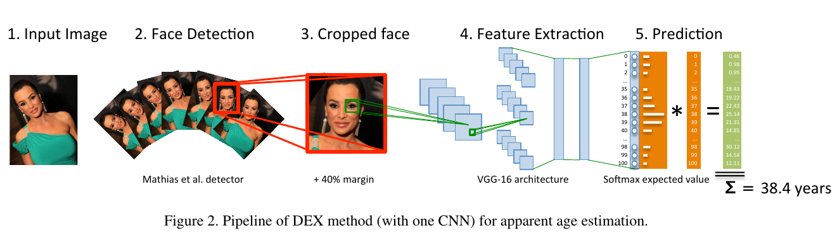

Face detection
- Use library dlib and face landmarks

Classification use neural network
- Feature extraction use inception-resnet v1 (than accuracy VGG16 model)
- Use softmax classification with ouput (2: gender, 100: age)

