## General Description

The SPIRALS project team, from Inria Centre at the University of Lille and UMR 9189, works in the energy consumption of software by providing the PowerAPI toolkit, which enables us defining software power meters. The objective of this project is to use principles from this toolkit in order to define software power meters dedicated to Modular Robots (MRs) such as Blinky Blocks (BBs).

### Title

Building software power meters for Modular Robots in VisibleSim

### Summary

The main objective of the project is to define software power meters for BBs in order to estimate energy consumption of programs running on this kind of robots, which are put together to create a system. This may require several kind of raw information related to BBs: execution time of the program, LED colors used, usage of speakers, usage of recording system, energy consumption of the Operating System (OS), system configuration or motif. The software power meters will be integrated into VisibleSim, a framework for behavior simulation of modular robots.

### Key words

Energy consumption estimation, simulation, Blinky Blocks

## Project details

SPIRALS team participates to the ADAPT Project, which searches to define tools to support hierarchical modeling of self-adaptive systems by using as use case Modular Robots known as Blinky Blocks (BBs). This kind of robots provides RGB LEDs, speakers and recording capabilities. The BBs also have sensors for detecting their orientation and sensing actions such as tapping or shaking. All these actuators and sensors can be manipulated via programs that BBs are able to run thanks to their integrate OS. Figure 1 show an example of Blinky Block.

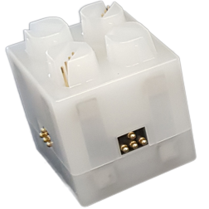

Figure 1. An example of Blinky Block

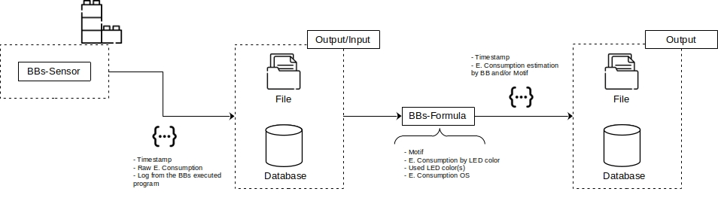
To build a system, BBs can be attached to each other via magnets. The robots in a system can communicate via serial links and run the same program. Each robot can be connected to a power supply but one BB connected to a power supply can power serveral other BBs.. Figure 2 depicts several systems of BBs. As noticed in this figure, systems can have different forms which are called motifs.

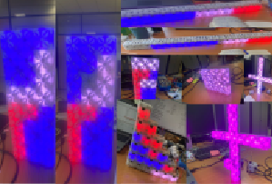

Figure 2. BBs Systems and motifs

In ADAPT project, this kind of systems needs to be adapted according to environmental and physical conditions, such as the energy consumption of programs running on BBs. However, robots do not provide this kind of information. This is why, we propose to use software power meters to estimate consumption of software running on BBs. To do that, the architecture proposed by the PowerAPI toolkit can be exploited. Indeed, this architecture fosters modularity and reuse to easily build different power meters. Figure 3 shows the architecture of a software power meter by using principles from PowerAPI.

Figure 3. Software Power Meter for BBs

As in PowerAPI, software power meters for BB systems are composed by sensors, formulas, outputs, and inputs. A sensor provides raw information related to energy consumption of the system and of each BB, with its related timestamp as well as a log of the running program with timestamps related to start time and end time of its operations. The sensor will store this information in an output, such as a CSV file or a no-SQL database (e.g. mongoDB). A formula pulls the raw information from the input and, taking into account the BBs system motif, the energy consumption from LEDs, speakers, recording system, and the OS estimates the energy consumption of the entire system and/or each BB. Similarly to the raw information, estimations are stored in a file or a no-SQL database. These estimations can be used then to adapt system behavior at runtime or to find opportunities for optimizing programs deployed on BBs in postmortem mode.

In order to test BBs software power meters, we propose to integrate them on VisibleSim, a framework to simulate behavior of modular robots, including BBs. The code of this framework, developed in C++, is open source and available on GitHub.

### Requirements

- Knowledge of an object-oriented language (e.g., Java, C++)
- Knowledge of no-SQL databases (e.g., MongoDB)

### Context

The Spirals Team is part of the ADAPT Project Consortium. This project searches to build self-adaptative components systems by using as use case Blinky Blocks Systems. Adaptations are triggered by environmental and physical conditions, including the energy consumption of the system.

### Problem

Blinky Blocks do not provide a mechanism (sensor or other) that enables users to retrieve information related to the energy consumption of running programs. A solution allowing the estimation of this consumption needs to be provided.

### Work to be done

Define software power meters following the principles of PowerAPI architecture and integrate them into the VisibleSim framework. At least a sensor and a formula need to be provided as well as several input/output for storing and retrieving the information related to energy consumption.

### References

- PowerAPI: A Python framework for building software-defined power meters: G. Fieni, D. Romero Acero, P. Rust, R. Rouvoy. Journal of Open Source Software. 9(98):6670, June 2024
- PowerAPI Web Site
- Blinky Blocks Website
- VisioSim Website
- VisioSim GitHub repository

### Other Information

N/A

