
68K Assembly Language Game
Milo Maze
Code Documentation

Name | Oyindamola Olaosun
Student ID | C00313475
Start Date | 16th February, 2026
End Date | 6th March, 2026

1. Brief Description 3
1.1 Grid Legend 3
2. Constants 3
3. Game Map (5×5 Grid) 4
3.1 Grid Cell Offset Formula 4
4. Player State (Resources) 4
5. Pseudocode — Game Loop 5
5.1 Initialisation 5
5.2 Main Loop (per turn) 5
5.3 End Game 5
6. Bugs & Issues 5
7. Flowcharts 6
7.1 Demo Flowchart (Initial Design) 6
7.2 Updated Flowchart (Final Implementation) 7

1. Brief Description
Milo Maze is a text-based physics game inspired by the animated series Milo Murphy's Law. The player guides Milo and his friends through a maze filled with obstacles, power-ups, and unexpected hazards, working towards the goal of reaching the end of the episode.

The game is a single-player experience set on a 5×5 grid. The player navigates the maze, avoiding obstacles and collecting energy boosts, while managing a limited number of moves and energy points to reach the goal.


Figure 1: Milo — represented as M on the game map.

1.1 Grid Legend
Value | Symbol | Description
0 | Empty | Open path — player can move freely
1 | # | Obstacle — blocks movement in that direction
2 | * | Pick-up — grants a +10 energy boost when collected
3 | G | Goal — reaching this cell wins the game
M | M | Player current position on the grid

2. Constants
The following constant values are defined at the start of the program and govern the core game rules:

Constant | Value | Description
MAX_MOVES | 50 | Maximum moves before game over
MAX_ENERGY | 100 | Starting and maximum player energy
BOOST_VALUE | 10 | Energy gained from a pick-up cell

3. Game Map (8×8 Grid)
The maze is defined as a 8X8 array stored in memory. Each cell holds an integer value representing the tile type (see Grid Legend above). The player starts at position (0,0) — the top-left corner.

3.1 Grid Cell Offset Formula
To access any cell in the flat memory array, the following formula calculates the byte offset from the base address:

offset = (NUM_COLS × Y) + X
Where X is the column index and Y is the row index (both zero-based), and NUM_COLS = 5.

4. Player State (Resources)
The following variables track the player's state throughout the game. They are stored in memory and updated after each move.

Variable | Initial | Direction | Description
player_score | 0 | ↑ Increases | Incremented when reaching goal or collecting boosts
player_energy | 100 | ↓ Decreases | Decremented each move; boosted by pick-ups (+10)
move_count | 0 | ↑ Increases | Counts total moves made; game ends at MAX_MOVES
player_x | 0 | ± | Current column position (0–4)
player_y | 0 | ± | Current row position (0–4)

5. Pseudocode — Game Loop
The game runs in a continuous loop until a win or lose condition is triggered. Below is the high-level logic for each iteration of the main game loop.

5.1 Initialisation
- Set player_x = 0, player_y = 0
- Set player_energy = 100, move_count = 0, player_score = 0
- Load maze grid into memory

5.2 Main Loop (per turn)
- Welcome Screen — display title and game status
- Display current player resources (energy, score, move count)
- Get player input: W (up), A (left), S (down), D (right)
- Validate move — if out of bounds or blocked by obstacle, display error and GOTO step 1
- Check cell type at new position; if invalid, GOTO step 1
- Execute move: update position, increment move_count, decrement energy
- If cell is a pick-up (2): add BOOST_VALUE to energy, clear cell
- If cell is the goal (3): trigger win sequence
- Check lose conditions: energy ≤ 0 OR move_count ≥ MAX_MOVES → trigger lose sequence
- Otherwise: repeat loop from step 1

5.3 End Game
- Display final score and outcome (win/lose)
- Exit game and return control to the OS terminal

6. Bugs & Issues
The following bugs were encountered during development and have been resolved:

# | Bug / Issue | Resolution
1 | Label arrangement in the console causing display corruption | Implemented Clear Screen and TRAP Function 13 & 14 to reset the terminal state before each render
2 | Wrong register used for clear screen (D0 instead of D1) | Corrected the data register assignment; D1 must be used to pass the TRAP function code for screen clear
3 | Mistakes in stack pointer management | Audited all subroutine calls to ensure balanced PUSH/POP operations and correct stack frame setup  e.g MOVEM.L D1/D3/A0, -(SP)
4 | Pick-up function not affecting player energy (Data Registers) | Fixed incorrect data register usage; ensured the energy variable address was correctly loaded and BOOST_VALUE properly added
5 | Infinite loops in END_GAME function | Added correct branch conditions and exit logic to break out of the game loop and reach the end-game routine
6 | SIMHALT in data section | Should not be sitting randomly in the data section causes errors in the loop

7. Flowcharts
The following flowcharts illustrate the program's control flow. The Demo Flowchart was produced as rough working material during initial design; the Updated Flowchart reflects the final implemented logic.

7.1 Demo Flowchart (Initial Design)
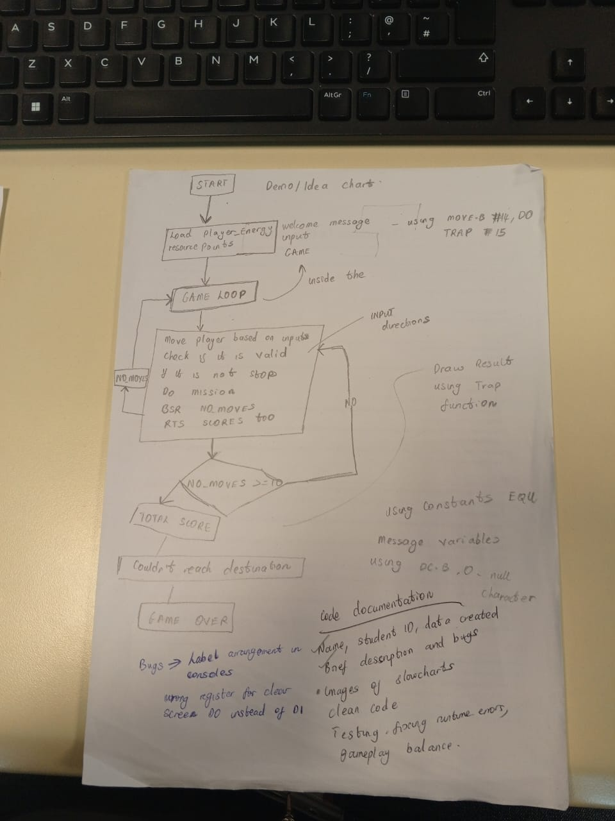
Figure 2: Initial demo flowchart — rough working design produced at the start of development.

7.2 Updated Flowchart (Final Implementation)
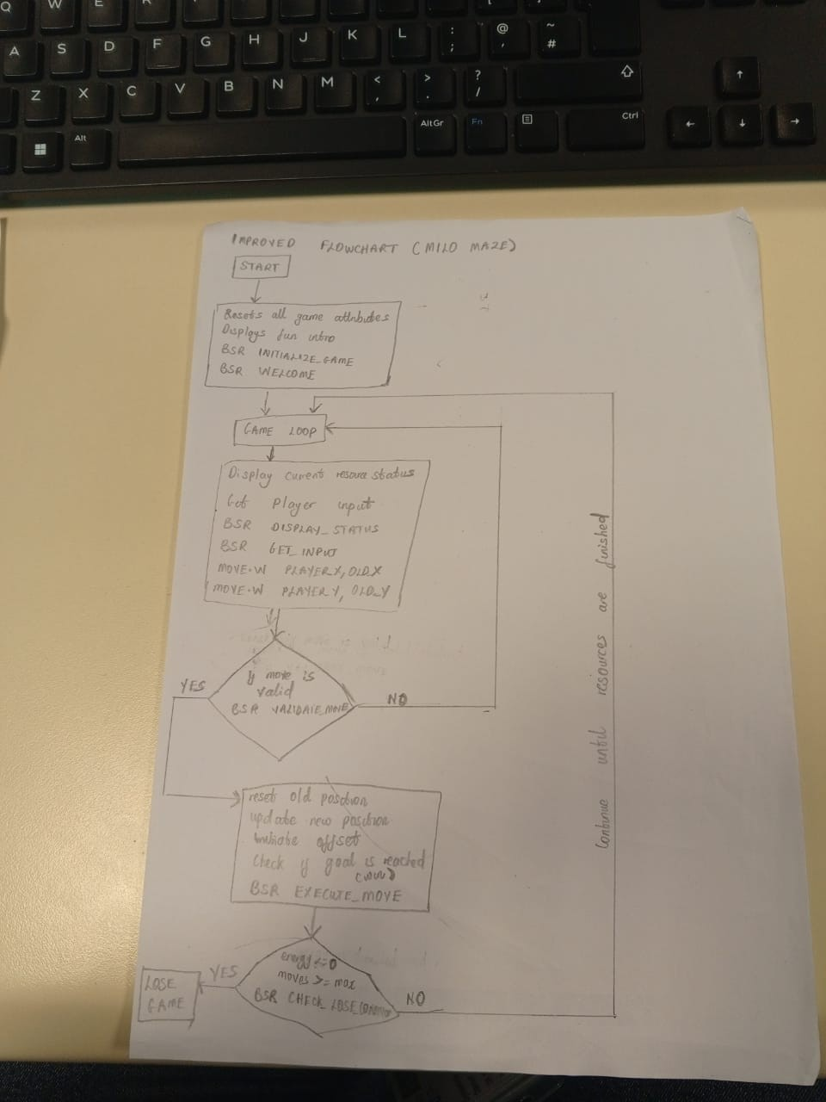
Figure 3: Updated flowchart — reflects the final 68K assembly implementation including all bug fixes.

8. Testing

8.1 Test Cases
The following test cases were used to verify the correct behaviour of the Milo Maze game:
Test 1 — Welcome Screen Display
Input: Program start. Expected: Welcome screen displays title, instructions, and “Press any key to start” message. Result: Pass.
Test 2 — Valid Movement (D = Move Right)
Input: Press D from position (0,0). Expected: Player moves to (1,0), maze updates showing M at new position. Result: Pass.
Test 3 — Wall Collision
Input: Move into a cell containing value 1 (wall). Expected: Player position does not change, move is rejected. Result: Pass.
Test 4 — Pickup Collection
Input: Move onto a cell containing value 2 (pickup). Expected: Score increases by 10, energy increases by 15 (capped at 100), cell cleared to 0. Result: Pass.
Test 5 — Goal Reached (Win Condition)
Input: Follow winning path D D S D D S S S. Expected: Win screen displays, score shows +100 goal bonus, final score and move count shown. Result: Pass.
Test 6 — Energy Depletion (Lose Condition)
Input: Make moves until energy reaches 0. Expected: Game over screen displays with lose message and final score. Result: Pass.
Test 7 — Move Limit Exceeded (Lose Condition)
Input: Make 50 moves without reaching the goal. Expected: Game over screen displays after move count reaches MAX_MOVES. Result: Pass.
Test 8 — Invalid Input
Input: Press any key other than W, A, S, D. Expected: Error message displays, player position unchanged, game continues. Result: Pass.
Test 9 — Boundary Check
Input: Attempt to move outside the maze boundary (e.g. move left from column 0). Expected: Move rejected, player stays in place. Result: Pass.

8.2 Test Summary
All 9 test cases passed. The game correctly handles valid movement, wall collisions, pickup collection, win and lose conditions, invalid input, and boundary checks. The visual maze display updates correctly after each move, and player statistics (score, energy, move count) are accurately maintained throughout gameplay.

9. Initial Grid Layout
The maze is an 8×8 grid stored as a flat byte array (GAME_MAP). Each cell holds one of five values: 0 = empty, 1 = wall, 2 = pickup, 3 = goal, 4 = player trail. The player starts at position (0,0) top-left and must reach the goal at (7,7) bottom-right.

9.1 Cell Value Legend
Value | Symbol | Meaning
0 | . (dot) | Empty cell
1 | # (hash) | Wall (impassable)
2 | * (asterisk) | Pickup (+10 score, +15 energy)
3 | G (letter) | Goal (+100 bonus score)
4 | + (plus) | Player trail (visited cell)

9.2 Initial Grid (8×8)
Below is the starting state of the maze. M marks the player start position at (0,0). Each row corresponds to one DC.B line in the assembly source.
Col→ | 0 | 1 | 2 | 3 | 4 | 5 | 6 | 7 | Row
Row 0 | M | . | * | . | # | . | . | . | 0
Row 1 | # | . | . | . | . | . | # | . | 1
Row 2 | . | * | # | * | . | . | . | . | 2
Row 3 | . | . | . | . | # | . | * | . | 3
Row 4 | * | . | # | . | . | . | . | . | 4
Row 5 | . | . | . | # | . | . | # | . | 5
Row 6 | . | # | . | . | . | * | . | . | 6
Row 7 | . | . | . | # | . | . | . | G | 7
Colour key: Green = player start (M), Red = wall (#), Yellow = pickup (*), Dark green = goal (G)

