

**Assignment 2: Caesar Cipher**

**Data Structures and Algorithms**

**Arnaiz, Dan Floyd L.**

**Instructions:**

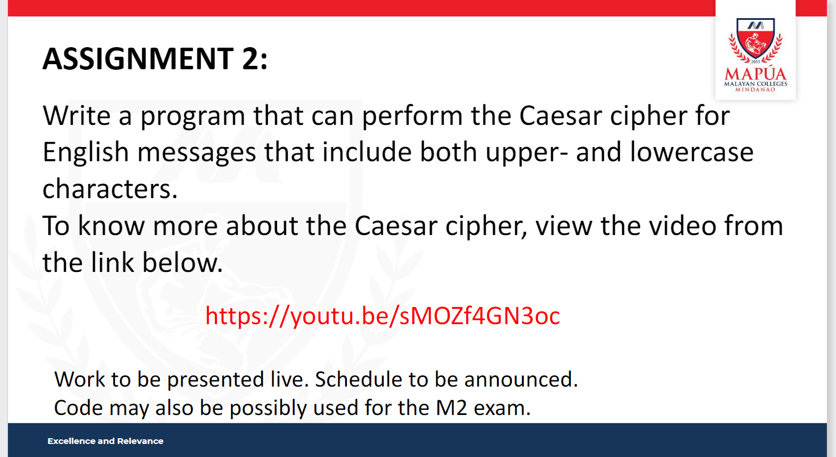

**Code:**

**CaeserCipher.java**

/* author: @dan-arnaiz

*

*

*/

public class CaesarCipher {

public static String caesarCipher(String text, int shift) {

StringBuilder result = new StringBuilder();

char ch;

for (int i = 0; i < text.length(); i++) {

if (Character.isUpperCase(text.charAt(i))) {

ch = (char)(((int)text.charAt(i) + shift - 65) % 26 + 65);

} else {

ch = (char)(((int)text.charAt(i) + shift - 97) % 26 + 97);

}

result.append(ch);

}

return result.toString();

}

public static void main(String[] args) {

String text = "HelloWorld";

int shift = 3;

System.out.println("Text : " + text);

System.out.println("Shift : " + shift);

System.out.println("Cipher: " + caesarCipher(text, shift));

}

}

**Testing:**

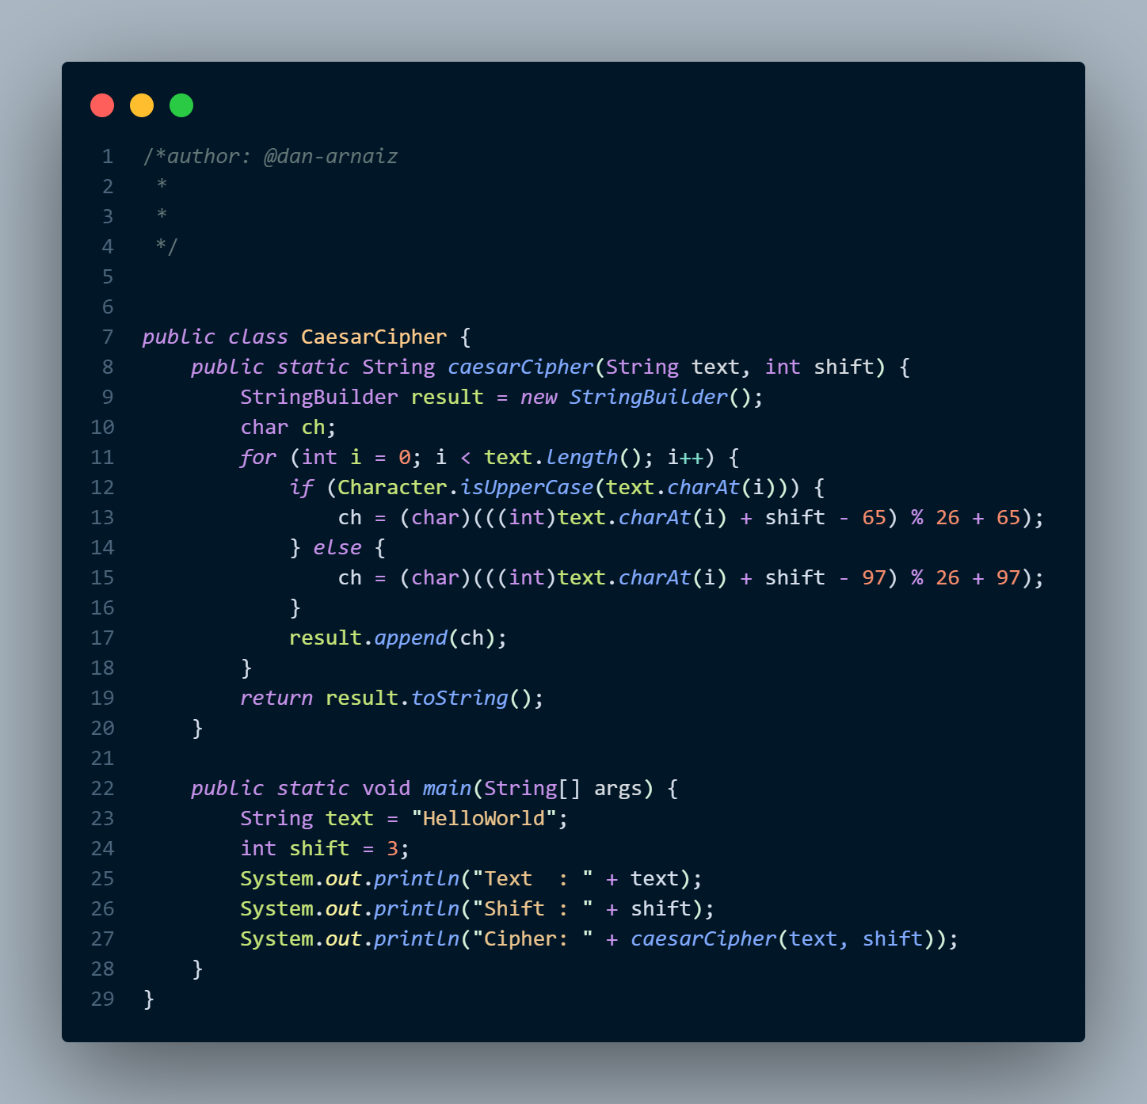

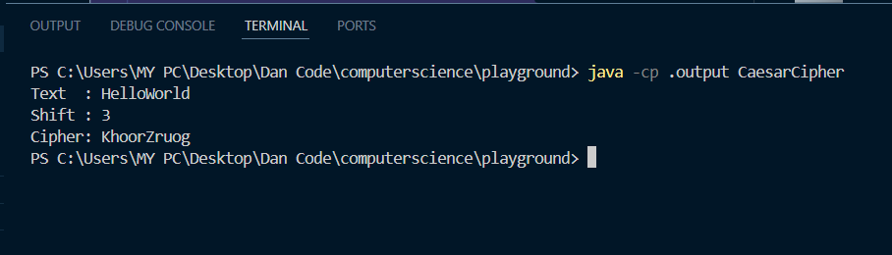**Result:**