

Project Report on
“VIBESHIELD”
Deterministic Vulnerability Assessment and Reporting
Completed as a part of fulfilling the Enterprise
Computing Lab for Third Semester requirement
MASTER OF COMPUTER APPLICATIONS (MCA)
Submitted by
Daniel Hneturopui
25MCAC17
Under the guidance of
Dr. Princess Maria John
July 2026 – November 2026

CERTIFICATE
This certificate is to attest to the successful completion of the project entitled “VibeShield” by Mr. Daniel Hneturopui, Reg. No. 25MCAC17, as part of the Enterprise Computing Project with course code “25MCC7P231”, for the 3rd Semester MCA program from July 2026 to November 2026, as per the regulations of Kristu Jayanti University.
Faculty In-charge Head of the Department
Valued by
Examiner 1: __________________ Date: ______________
Examiner 2: __________________
Location: Kristu Jayanti Institute of Technology
DECLARATION
I, Daniel Hneturopui (25MCAC17), hereby affirm that the report of the project titled “VibeShield”, presented to Kristu Jayanti (Deemed to be University), Bengaluru, is an authentic report of the work carried out under the guidance of Dr. Princess Maria John and has not been submitted elsewhere for any other degree or diploma.
The report describes the project implementation, design, analysis and verification using the available source code and recorded project evidence. External software, documentation and other sources used in the project are acknowledged in the references section.
Date: __________________ Place: Bengaluru
________________________
Daniel Hneturopui
25MCAC17
ACKNOWLEDGEMENT
First and foremost, I thank the Almighty for the strength and perseverance to undertake and complete this project.
I express my gratitude to Kristu Jayanti University and the Kristu Jayanti Institute of Technology for providing the academic environment, facilities and opportunity to undertake this Enterprise Computing Project.
I sincerely thank the Dean, Head of the Department, Programme Coordinator and faculty members of the MCA programme for their support and encouragement throughout the project.
I am especially grateful to Dr. Princess Maria John, my project guide, for guidance in project development, process identification and preparation of this report.
I thank my classmates and all those who provided feedback, discussed implementation challenges and supported the completion of VibeShield. I also acknowledge the maintainers of the open-source tools and libraries used in this project.
ABSTRACT
VibeShield is a deterministic cybersecurity coursework application that combines static source analysis and controlled local website checks in a single evidence-oriented workflow. Separate security tools often produce different output formats, while missing tools and parsing failures can make a scan appear cleaner than its actual coverage. VibeShield addresses these problems by preserving candidate findings together with explicit stage outcomes and errors.
The application uses a React dashboard, a local Python HTTP backend and a common scanner pipeline. Repository assessment combines Semgrep, a Python abstract syntax tree heuristic for potential missing object-ownership checks in Flask routes, and Gitleaks. Local website assessment combines a bundled Nuclei header template and passive OWASP ZAP analysis. Authorized local directories and public GitHub repositories are supported for static analysis; website inputs are restricted to loopback addresses.
Scan jobs are stored as local JSON records and can be reviewed through scan history, searchable findings, evidence details and PDF or JSON reports. Detection, classification and report guidance use fixed rules and heuristics without LLM inference. Findings remain candidates requiring contextual review; incomplete coverage is explicitly retained.
This report follows the institutional project-documentation structure and presents the system study, requirements, configuration, software description, design diagrams, representative source code, tests, deployment procedure, limitations and future enhancements. Verification on 5 November 2026 records 37 passing scanner tests and 6 passing backend tests. Earlier browser and scanner smoke-test results are identified separately.
Keywords: VibeShield; deterministic analysis; vulnerability candidates; Flask; AST; Semgrep; Gitleaks; Nuclei; OWASP ZAP; React; Python.
TABLE OF CONTENTS
CH. NO. | CONTENT | PAGE
 | Abstract | v
 | List of Tables | viii
 | List of Figures | ix
1 | INTRODUCTION | 1
 | 1.1 Problem Statement | 1
 | 1.2 Project Description | 2
2 | SYSTEM STUDY | 4
 | 2.1 Existing System | 4
 | 2.2 Proposed System | 4
 | 2.3 Use Case Diagram | 6
 | 2.4 Sequential Diagram | 7
 | 2.5 Activity Diagram | 9
3 | SYSTEM CONFIGURATION | 10
 | 3.1 Hardware Configuration | 10
 | 3.2 Software Configuration | 10
4 | SOFTWARE DESCRIPTION | 11
 | 4.1 Overview of Front End | 11
 | 4.2 Overview of Back End | 12
5 | SYSTEM DESIGN | 15
 | 5.1 Architectural Design | 15
 | 5.2 Input Design | 20
 | 5.3 Output Design | 21
 | 5.4 Database and Persistence Design | 22
6 | SOURCE CODE | 25
 | 6.1 Project Structure | 25
 | 6.2 Back End Source Code | 26

TABLE OF CONTENTS (continued)
CH. NO. | CONTENT | PAGE
 | 6.3 Front End Source Code | 29
 | 6.4 Stored Data and Report Representation | 30
7 | SYSTEM TESTING | 31
 | 7.1 Test Cases and Testing Strategy | 31
8 | SYSTEM IMPLEMENTATION / DEPLOYMENT | 35
 | 8.1 Prerequisites | 35
 | 8.2 Storage and Environment Setup | 35
 | 8.3 Backend Setup | 35
 | 8.4 Frontend Setup and Application Launch | 36
 | 8.5 Controlled Fixture and Repository Acquisition | 37
 | 8.6 Common Problems | 38
9 | CONCLUSION AND FUTURE ENHANCEMENT | 39
 | 9.1 Present Status | 39
 | 9.2 Work Remaining | 39
 | 9.3 Limitations | 40
 | 9.4 Risk Assessment | 40
 | 9.5 Future Enhancements | 41
 | 9.6 Conclusion | 41
10 | APPENDICES | 42
 | 10.1 Screenshots | 42
 | 10.2 API Reference | 45
 | 10.3 User Guide | 47
11 | REFERENCES / BIBLIOGRAPHY | 48

LIST OF TABLES
TABLE NO | TITLE | PAGE NO
1.1 | Module-wise implementation status | 2
2.1 | Existing and proposed assessment workflows | 4
2.2 | Functional requirements and acceptance conditions | 5
3.1 | Recommended hardware for local coursework | 10
3.2 | Software components and prerequisites | 10
4.1 | Frontend technologies and responsibilities | 11
4.2 | Backend modules and responsibilities | 12
5.1 | Process specification for main data flows | 18
5.2 | Input validation rules | 20
5.3 | Output representations and completeness information | 21
5.4 | Data dictionary of the persisted scan job | 23
5.5 | Data dictionary of an individual stage | 23
5.6 | Candidate fields and report additions | 24
7.1 | Verification evidence and dates | 31
7.2 | Scanner regression scenarios | 32
7.3 | Backend validation and persistence scenarios | 33
7.4 | Historical local-fixture scanner observations | 34
8.1 | Troubleshooting and verification actions | 38
9.1 | Present status and evidence boundaries | 39
9.2 | Project risks and mitigations | 40
10.1 | Implemented API endpoints | 45
10.2 | HTTP status codes used by the backend | 46

LIST OF FIGURES
FIGURE NO | TITLE | PAGE NO
2.1 | Use case view of the local assessment workflow | 6
2.2 | Sequence diagram for scan submission and review | 7
2.3 | Sequence diagram for PDF report export | 8
2.4 | Activity flow of an authorized assessment | 9
5.1 | Layered architecture of VibeShield | 15
5.2 | Single-machine deployment view | 16
5.3 | DFD Level 0 showing system context | 17
5.4 | DFD Level 1 of assessment processing | 18
5.5 | DFD Level 2 of scanner execution | 19
5.6 | Conceptual relationship model of stored scan records | 22
10.1 | Desktop Overview with target form and recent scans | 42
10.2 | Findings view with Semgrep and AST fixture candidates | 43
10.3 | Mobile Overview with compact navigation | 44

CHAPTER 1
INTRODUCTION

1.1 Problem Statement
Security coursework commonly uses separate command-line tools for source inspection, secret detection and website assessment. Each tool reports different fields and uses its own terminology. A researcher must connect a rule identifier to a file or endpoint, distinguish an observation from a confirmed vulnerability, and remember which tools actually completed. This becomes difficult when results are copied manually into a report.
An additional problem is incomplete coverage. A scanner may be missing, exceed a timeout or fail to parse part of a source file while still returning useful findings elsewhere. If the wrapper discards those findings or labels the run as a clean success, the researcher receives a misleading account of the assessment. An empty list alone cannot describe what was checked.
VibeShield addresses the following question: how can authorized repository and local website checks be combined into an explainable workflow that preserves both evidence and uncertainty? The project emphasizes deterministic decisions, clear target boundaries and traceable exports rather than automatic exploit confirmation.

1.1.1 Objectives
• Provide one dashboard for authorized local directories, public GitHub repositories and loopback website inputs.
• Combine Semgrep, Python AST analysis, Gitleaks, Nuclei and passive ZAP through a shared finding representation.
• Retain source evidence, rule identifiers, confidence, scanner outcomes and diagnostic information.
• Record actual progress without inventing scan percentages or silently hiding failed stages.
• Support persistent scan history and PDF or JSON reports for successful and incomplete terminal runs.
• Keep detection and guidance rule-based, with no LLM SDK or AI inference dependency in the workflow.

1.2 Project Description
VibeShield is a local, single-user cybersecurity research application. Its React interface communicates with a Python server that serves both the compiled frontend and the API from 127.0.0.1:8787. A background worker runs the applicable scanner stages and persists each job as a JSON file. The browser polls current records while the page is visible.
Static assessment examines repository content without executing the target application. Dynamic assessment contacts an owned loopback website using a narrow Nuclei template and passive ZAP analysis. Candidate findings retain their source tool so that overlapping observations remain distinguishable.
Table 1.1: Module-wise implementation status
Module | Implemented behavior | Status
Target validation | Consent, loopback URL validation, public GitHub URL and local directory checks | Implemented
Static pipeline | Semgrep, Flask AST ownership heuristic and Gitleaks adapters | Implemented
Dynamic pipeline | Bundled missing-nosniff Nuclei template and passive ZAP adapters | Implemented; runtime setup required
Dashboard | Overview, Scans, Findings, Reports and Settings | Implemented
Persistence and exports | Private JSON history, restart interruption, PDF and JSON exports | Implemented
Exploit verification and scoring | Confirmed exploitation, numeric risk and CVSS calculation | Outside current scope

1.2.1 Intended Users
The primary user is a student researcher conducting authorized defensive coursework. A guide or examiner can review the exported evidence and coverage record. These are review responsibilities rather than separate software account roles; the current application has no student, teacher or administrator login system.

1.2.2 Scope of the Project
The project accepts local repositories and authorized public GitHub repository URLs for static inspection. Website inputs accept HTTP or HTTPS on localhost, 127.0.0.1 or ::1. The permission checkbox records the user's declaration before a dashboard scan is created. It does not independently establish legal or organizational authorization.
In scope are candidate discovery, a narrow Flask ownership heuristic, secret-pattern redaction, stage-level progress, persistent history, evidence inspection, incomplete-coverage reporting and deterministic review guidance. Public GitHub acquisition uses a shallow temporary checkout and records the checked-out commit.
Outside the current scope are public or LAN website scans, private GitHub authentication, authenticated website navigation, a multi-user hosted service, exploit verification, complete historical Git scanning, general authorization proofs and numeric risk scoring. The local target allowlist is an input restriction rather than a full network-isolation mechanism.

1.2.3 Development Methodology
The implemented design supports incremental development: validate inputs, adapt scanner outputs, consolidate evidence, add persistence and reporting, and expose the workflow through the dashboard. Regression tests exercise each layer using controlled inputs and the deliberately vulnerable local fixture. Source inspection, automated tests and earlier runtime records provide separate kinds of evidence.
The academic workflow follows requirements analysis, design, implementation, verification and documentation. This describes the engineering approach visible in the project; it does not assert an undocumented sprint schedule, effort estimate or development history.

1.2.4 Organization of the Report
Chapter 2 covers system study and behavioral diagrams. Chapter 3 lists configuration needs. Chapter 4 explains the frontend, backend and scanner algorithms. Chapter 5 presents architecture, data flow, input/output and storage design. Chapter 6 gives source excerpts. Chapters 7 and 8 describe testing and operation. Chapter 9 discusses status and future work. Chapter 10 contains screenshots, API details and a user guide. Chapter 11 lists the source material and technical references.

CHAPTER 2
SYSTEM STUDY

2.1 Existing System
The baseline workflow uses individual tools directly: a researcher runs a static scanner, a secret detector and website checks, then manually reviews their output. This offers access to native tool detail but requires repeated setup and manual interpretation. Tool discovery, output parsing, error tracking and academic reporting become separate tasks.
The main limitations are fragmented evidence, inconsistent field names, manual report preparation, difficulty distinguishing partial scans from clean results, and limited guidance about which scanner applies to each target. These are workflow problems; the external scanners remain valuable detection components.

2.2 Proposed System
VibeShield provides a common workflow around those tools. It validates target inputs, selects applicable stages, stores their outcomes, normalizes candidate evidence and presents a report with explicit coverage. The built-in AST heuristic adds a narrow check for potentially missing object-ownership controls in Flask handlers.
Table 2.1: Existing and proposed assessment workflows
Aspect | Separate tools | VibeShield
Target selection | Repeated per command | One validated target request
Output formats | Native JSON, JSONL and alerts | Shared candidate representation
Progress | Separate process output | Actual per-stage states
Failure visibility | Researcher tracks each failure | Stored errors and incomplete status
Reporting | Manual collation | PDF / JSON from stored evidence
Interpretation | Tool-specific terminology | Evidence, confidence and severity separated

2.2.1 Feasibility Study
Technical feasibility comes from Python subprocess integration, standard-library AST parsing, local file persistence and a React frontend. Operational feasibility comes from a single-machine workflow and visible setup requirements. Economic feasibility benefits from open-source components and the absence of an AI inference subscription; hardware, maintenance and tool installation still have costs. Schedule feasibility is improved by keeping exploitation, cloud hosting and multi-user roles outside the current scope.

2.2.2 Functional Requirements
Table 2.2: Functional requirements and acceptance conditions
ID | Requirement | Acceptance condition
FR-01 | Validate target and permission | Reject missing consent and unsupported target forms
FR-02 | Assess repository sources | Select Semgrep, AST and Gitleaks stages
FR-03 | Assess owned local website | Select Nuclei and passive ZAP stages
FR-04 | Preserve evidence | Store candidates with native details and tool identity
FR-05 | Expose incomplete coverage | Retain errors and valid findings in the same job
FR-06 | Retain scan history | Reload terminal jobs from local JSON records
FR-07 | Handle restart interruption | Mark unfinished jobs interrupted on startup
FR-08 | Export reports | Download PDF or JSON for terminal jobs
FR-09 | Inspect tool readiness | Display executable availability and setup notes

2.2.3 Non-Functional Requirements
The system should remain explainable, responsive and maintainable. The API uses a local origin, bounded request size and session verification for scan creation. Scanner subprocesses have timeouts. Scan files use a private directory and atomic replacement. The interface supports keyboard use, visible focus, reduced motion and compact mobile navigation.

2.2.4 Rules, Assumptions and Constraints
Only five unfinished jobs may be queued or running; a single worker processes them sequentially. A discovered executable may still fail at runtime. All findings are candidates, and an empty result cannot certify safety. External rules and installed tool versions affect reproducibility. Native ZAP requires compatible Java; Docker mode additionally requires an accessible daemon and image.

2.3 Use Case Diagram
The system has one operational actor: the local researcher. The actor selects a target, records permission, starts a scan, reviews outcomes and exports a report. Scanner processes are supporting components, not additional human roles. A guide or examiner normally consumes the exported document outside the running application.
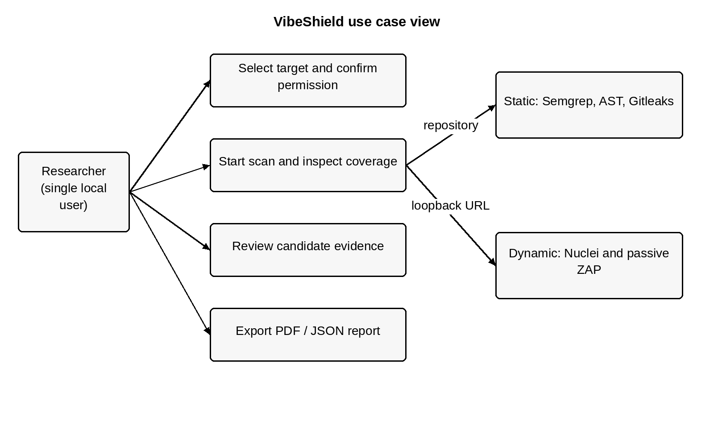
Figure 2.1: Use case view of the local assessment workflow

2.3.1 Main Use Case: Assess an Authorized Repository
The researcher selects Local project or GitHub repository, supplies a supported location, confirms permission and submits. The API validates the request and creates a queued record. The worker runs static stages; the researcher reviews candidate evidence and downloads a report after the job reaches a terminal state. Failed stages remain visible.

2.4 Sequential Diagram

2.4.1 Scan Submission and Evidence Retrieval
The dashboard obtains a session token through the status endpoint. A scan request includes that token and the user's authorization declaration. The server persists the job before scheduling work. The worker writes stage transitions and findings, and subsequent polling retrieves those actual changes.
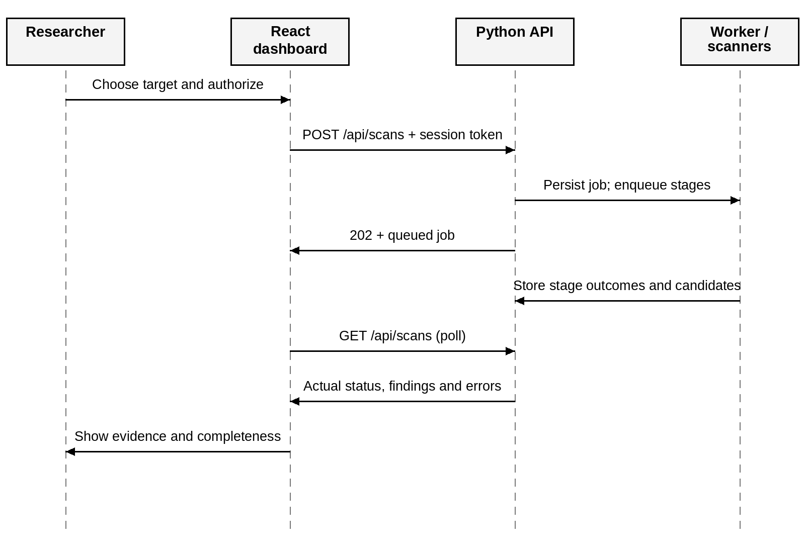
Figure 2.2: Sequence diagram for scan submission and review
If a stage raises ScanError with valid findings, the worker preserves those findings and records the diagnostic. The final state reflects the completed coverage and failures. The diagram omits individual subprocess details, which are expanded in the design chapter.

2.4.2 Report Export Sequence
Reports are generated from stored job data. The request selects a terminal scan and an export format. The report builder adds deterministic guidance, display severity, summary counts and limitations to the preserved candidate evidence. The PDF renderer escapes untrusted strings before they enter document markup.
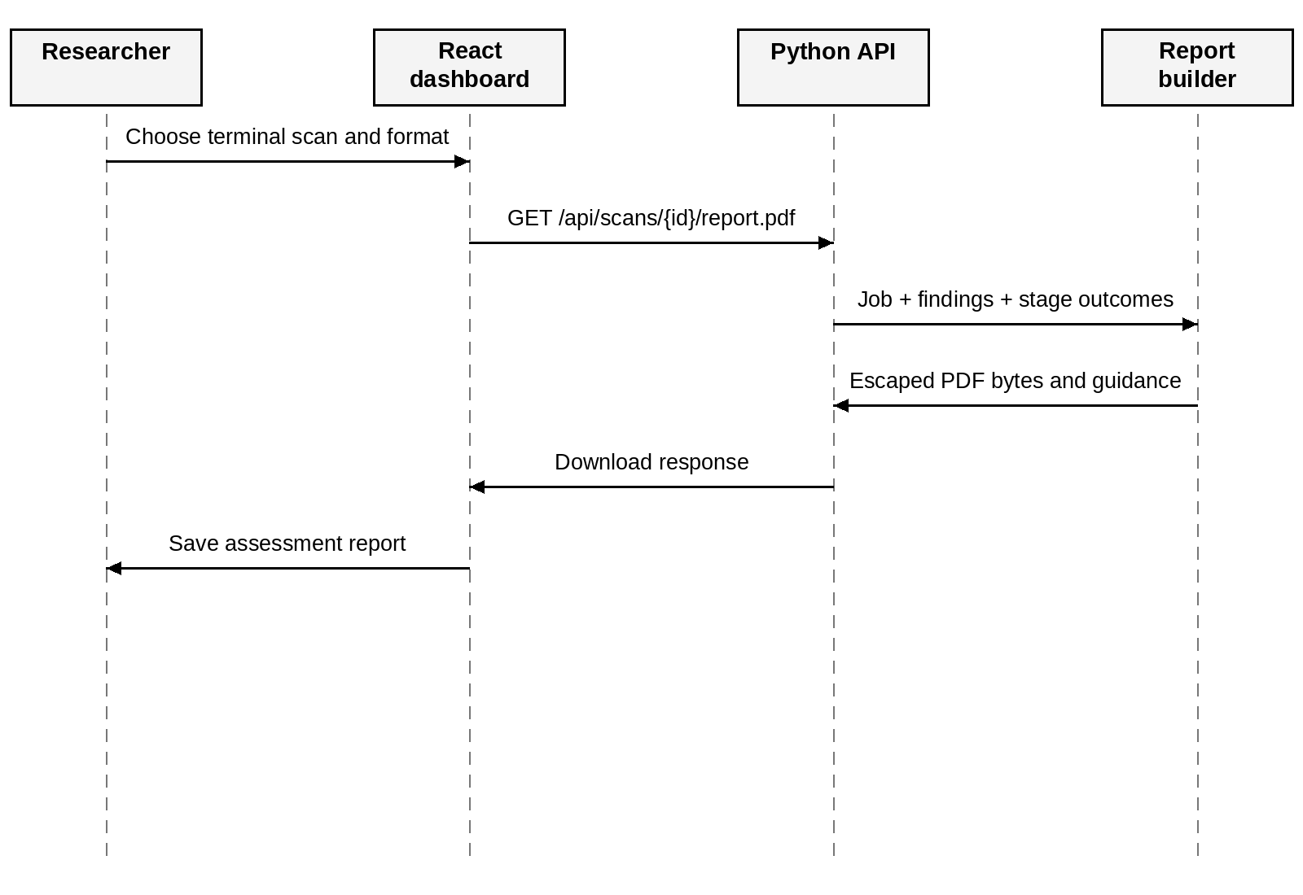
Figure 2.3: Sequence diagram for PDF report export
A running scan returns a conflict response for report export. An unknown scan returns not found. If ReportLab is unavailable, PDF export returns a service-unavailable response while the JSON representation remains the alternative. Exporting a report does not rerun the scanners or verify exploitation.

2.5 Activity Diagram
The activity begins with a target and permission declaration. Accepted inputs become queued jobs. Applicable stages execute and contribute evidence and errors. The researcher can inspect the terminal record and export it regardless of whether coverage was complete.
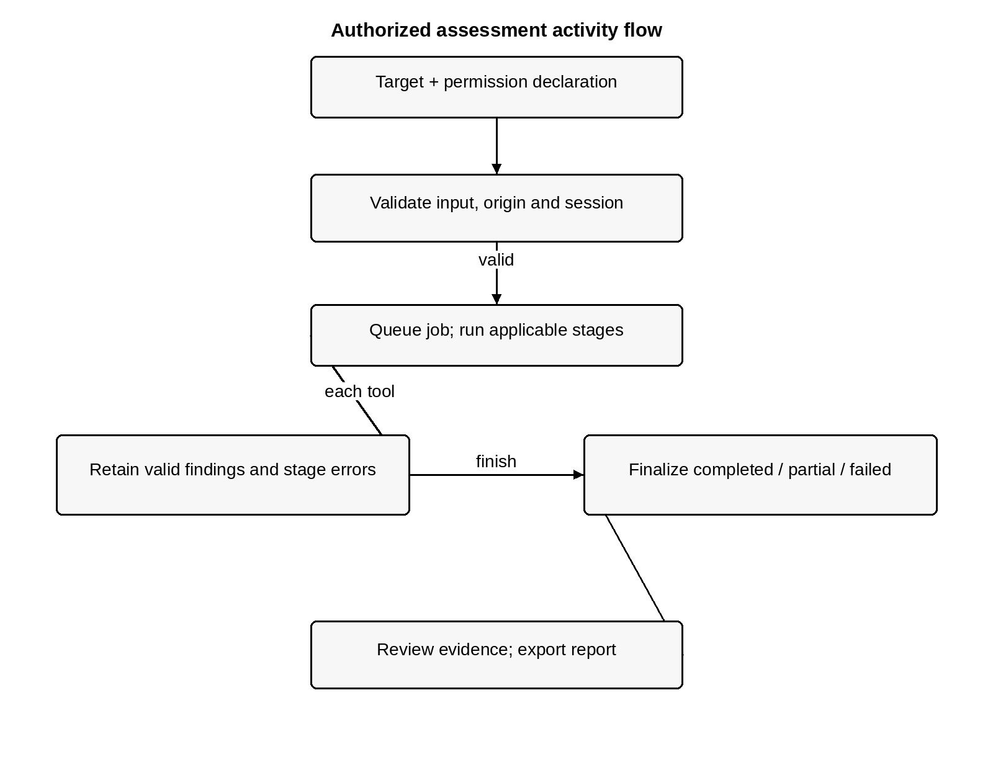
Figure 2.4: Activity flow of an authorized assessment

2.5.1 Job State Model
The normal path is queued → running → completed. Stage errors can produce partial or failed outcomes. A checkout-level or unexpected orchestration failure produces failed. On server restart, unfinished jobs become interrupted. These are coverage and lifecycle states; none represents a confirmed vulnerability or a security certification.

CHAPTER 3
SYSTEM CONFIGURATION

3.1 Hardware Configuration
VibeShield runs locally. Resource demand depends mainly on repository size and external scanners; ZAP and Semgrep may require considerably more resources than the Python API itself. The following values are practical academic setup recommendations rather than benchmark-derived minimums.
Table 3.1: Recommended hardware for local coursework
Component | Practical recommendation | Reason
Processor | Modern 64-bit multicore CPU | External scanner execution
Memory | 8 GB RAM or more | Browser, Semgrep and Java-based ZAP
Storage | Several GB of free space | Dependencies, tools, checkouts and reports
Display | Laptop or desktop display | Reviewing tables and source evidence
Network | Internet when acquiring tools or public repositories | Downloads, GitHub and Semgrep auto rules

3.2 Software Configuration
Table 3.2: Software components and prerequisites
Component | Requirement or purpose
Python | Python 3.10+ for the backend and scanner modules
Node.js and npm | Version compatible with the installed Vite toolchain
Browser | Modern browser supporting React, fetch and dialog
React / Vite | Frontend rendering and production asset build
ReportLab | PDF rendering; pinned by dashboard/requirements.txt
Git | Authorized public repository checkout
External scanners | Semgrep, Gitleaks, Nuclei and OWASP ZAP
Java / Docker | Compatible Java for native ZAP; daemon/image for Docker fallback

POSIX execution is implemented; native Windows remains unverified. Project manifests and lockfiles specify dependency versions.

CHAPTER 4
SOFTWARE DESCRIPTION

4.1 Overview of Front End
The frontend is a React application built by Vite. It keeps navigation, input state, selected scans, filters, downloads and evidence dialogs in component state. The compiled assets are served locally by the Python backend, so the browser and API share one origin after a production build.
Table 4.1: Frontend technologies and responsibilities
Technology | Responsibility | Project location
React and React DOM | Interactive views and component state | dashboard/web/src/main.jsx
Vite | Development server and production build | dashboard/web/vite.config.js
CSS | Layout, responsive states, tables and focus | dashboard/web/src/style.css
Phosphor icons | Navigation and control symbols | @phosphor-icons/react dependency
Manrope font | Local application typography | @fontsource-variable/manrope dependency
Playwright and axe | Browser workflow and scoped accessibility checks | dashboard/web/tests

4.1.1 Navigation and Interaction
Overview contains target choices, the permission checkbox, coverage information and recent scans. Scans supports history search and state filtering. Findings supports scan selection, severity filtering, evidence search and a details dialog. Reports lists terminal runs and export controls. Settings explains tool availability and binary-path configuration.

4.1.2 Loading, Errors and Accessibility
The browser refreshes status and scan records every two seconds while visible. Connection failures show a retry action. Submission and download states prevent ambiguous repeated actions. The evidence dialog supports Escape, and mobile navigation manages focus. Empty states describe the next action and avoid implying that no candidates means safety.

4.2 Overview of Back End
The backend uses Python's ThreadingHTTPServer to serve compiled frontend assets and JSON endpoints on loopback. ScanStore owns local persistence, an in-memory job index, a lock for updates and a single-thread worker executor. Scanner wrappers translate native tool outputs into common records.
Table 4.2: Backend modules and responsibilities
Module | Responsibility
dashboard/server.py | HTTP API, validation, job storage and scheduling
pipeline/scan/common.py | Shared findings, errors, URL validation and subprocess handling
pipeline/scan/run_scan.py | Candidate consolidation and CLI orchestration
pipeline/scan/*_runner.py | Semgrep, Gitleaks, Nuclei and ZAP adapters
pipeline/scan/ast_heuristic_analyzer.py | Narrow Flask ownership heuristic
pipeline/report/report_builder.py | Deterministic JSON and PDF report projection

4.2.1 Static Scanner Adapters
Semgrep runs with the auto configuration and the bundled Flask rule. JSON results retain the affected file, line, rule, message, native severity and source context. The auto configuration requires registry access, so offline behavior depends on the selected configuration.
Gitleaks scans for secret-pattern candidates. Values are redacted before results are consolidated or displayed. A matching pattern does not establish whether a credential is active. A missing report, invalid output, timeout or unavailable binary is recorded as an error rather than a clean result.

4.2.2 Diagnostic Preservation
Semgrep can return valid results alongside parsing diagnostics. The adapter decodes tagged diagnostic forms, bounds displayed locations to the checkout and raises ScanError carrying the valid findings. This avoids losing evidence when coverage is incomplete and avoids echoing arbitrary diagnostic text that may contain source or credentials.

4.2.3 Python AST Ownership Heuristic
The analyzer uses Python's ast module to parse files without importing or executing the scanned application. It recognizes supported Flask app or blueprint route decorators and ID-like path parameters. The heuristic examines whether such a parameter reaches a recognized storage lookup and whether a supported inline guard protects the fetched resource.
Recognized lookup names include execute, query, get, get_or_404, filter and filter_by. Supported principal shapes include common identity names, session access, current_user, g.user and token-derived aliases. Supported owner fields include owner_id, user_id, created_by and author_id. These sets are implementation conventions rather than a complete model of all applications.

4.2.4 Detection Procedure
• Identify a supported route decorator and extract an ID-like parameter used by the handler.
• Walk local statements while excluding nested function or class bodies as evidence of inline protection.
• Track supported authenticated-principal aliases and resource assignments.
• Recognize a rejecting inline identity check or an ownership guard before relevant disclosure.
• Emit IDOR-AST-01 with MEDIUM confidence if a supported lookup lacks a recognized protecting guard.
The fixture's get_note function authenticates a user and queries a note using note_id. It returns note fields without an inline comparison between the fetched owner and the authenticated principal. This produces an IDOR candidate at app.py:122. Authentication and object authorization are separate concerns.

4.2.5 Algorithmic Limitations
The rule does not prove general authorization correctness. Middleware, decorators, helper functions, service layers, complex aliases and custom ORM behavior may be missed. Public resources and unfamiliar identity names can also lead to incorrect classification. Supported clean guards are tested, but false positives and false negatives remain possible. AST confidence is not a severity assignment.

4.2.6 Dynamic Scanner Adapters
Nuclei uses the bundled missing X-Content-Type-Options: nosniff template and parses JSONL output. This is a narrow header observation, not the coverage of the full community template collection. No template generation or AI-based assessment is used.
ZAP supports a baseline executable, native Automation Framework execution and a Docker fallback. The native plan performs passive analysis. ZAP preserves alert identifiers and affected endpoints. Finding a Docker executable alone does not establish that the daemon or required image is available.
The fixture has an explicit health endpoint at http://127.0.0.1:5000/api/health. Its root URL is not the smoke-test target. The local target validator restricts submitted hosts, but it does not isolate scanner-internal networking, redirects, rule downloads or update behavior.

4.2.7 Consolidation and Report Guidance
All candidates have a location, vulnerability type, confidence, source tool and details. Native evidence remains available inside details. AST candidates use type IDOR. Gitleaks candidates use SECRET_EXPOSURE. Other tool rules retain their identifiers. Cross-tool overlaps are deliberately retained.
Display severity uses the tool's native label: WARNING becomes MEDIUM, ERROR becomes HIGH, INFORMATIONAL becomes INFO, and absent severity becomes UNRATED. Evidence confidence is a separate field. The project does not invent CVSS values or numeric risk scores.
Report guidance uses a fixed mapping for known findings, including IDOR, secret exposure, missing nosniff and version disclosure. Unknown rules receive generic contextual-review advice. A report includes stage outcomes and limitations so that an incomplete scan remains useful without being described as complete.

CHAPTER 5
SYSTEM DESIGN

5.1 Architectural Design
VibeShield separates presentation, request validation, assessment execution and storage/reporting. The frontend does not run scanners directly. The API validates a request and persists a job; the background worker invokes adapters. The report builder projects stored evidence into export formats without making new detection decisions.
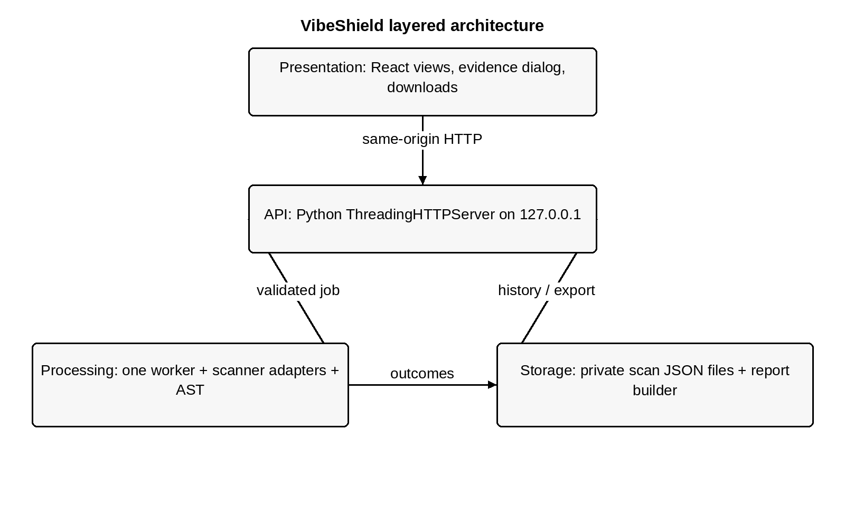
Figure 5.1: Layered architecture of VibeShield

5.1.1 Design Rationale
Adapters keep tool-specific parsing outside the interface. A shared candidate model supports evidence tables and reports. Local JSON storage avoids an external database service for the current single-user workload. A single worker simplifies scanner resource use and ordering. Explicit states keep lifecycle and coverage visible across process failure and restart.

5.1.2 Deployment View
The browser, Python server, scanner executables and scan records reside on the researcher's machine. The server binds to 127.0.0.1. The compiled React bundle and API use the same origin. An owned fixture website is a separate local target and is not deployed as part of the dashboard server.
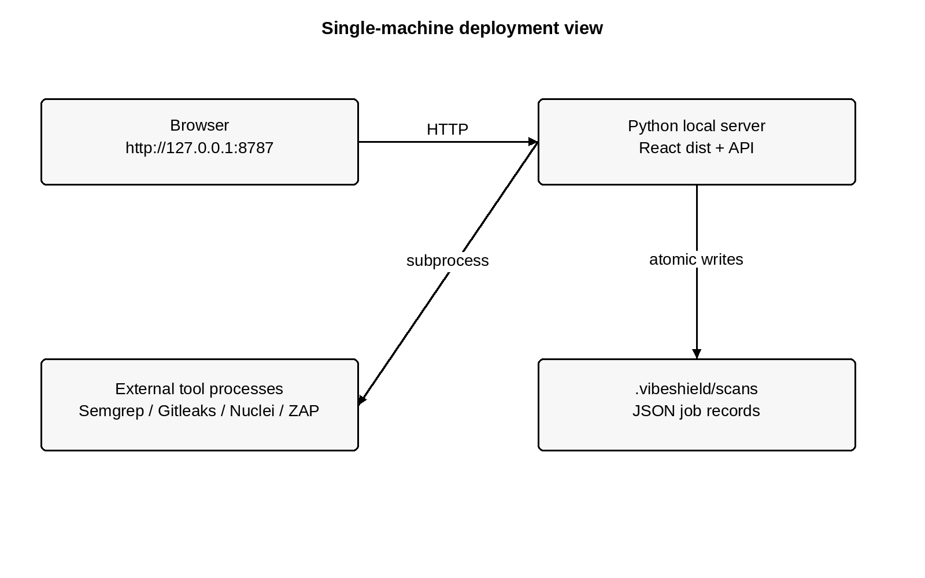
Figure 5.2: Single-machine deployment view

5.1.3 Module Dependencies
The root run_dashboard.py delegates to dashboard.server. That module imports scanner adapters, shared validation, orchestration helpers and report functions. run_scan.py provides the CLI entry point. Individual adapters depend on common.py for subprocess behavior and error handling. The AST analyzer depends mainly on Python's parser and the shared error/path helpers. ReportLab is imported for PDF creation; JSON reporting uses standard-library serialization.

5.1.4 Data Flow Diagram: Context
The context view describes the system boundary. The researcher provides the target and permission declaration and receives evidence and reports. Source repositories and loopback websites supply assessment content. The diagram does not represent a hosted service, external user accounts or automated exploitation.
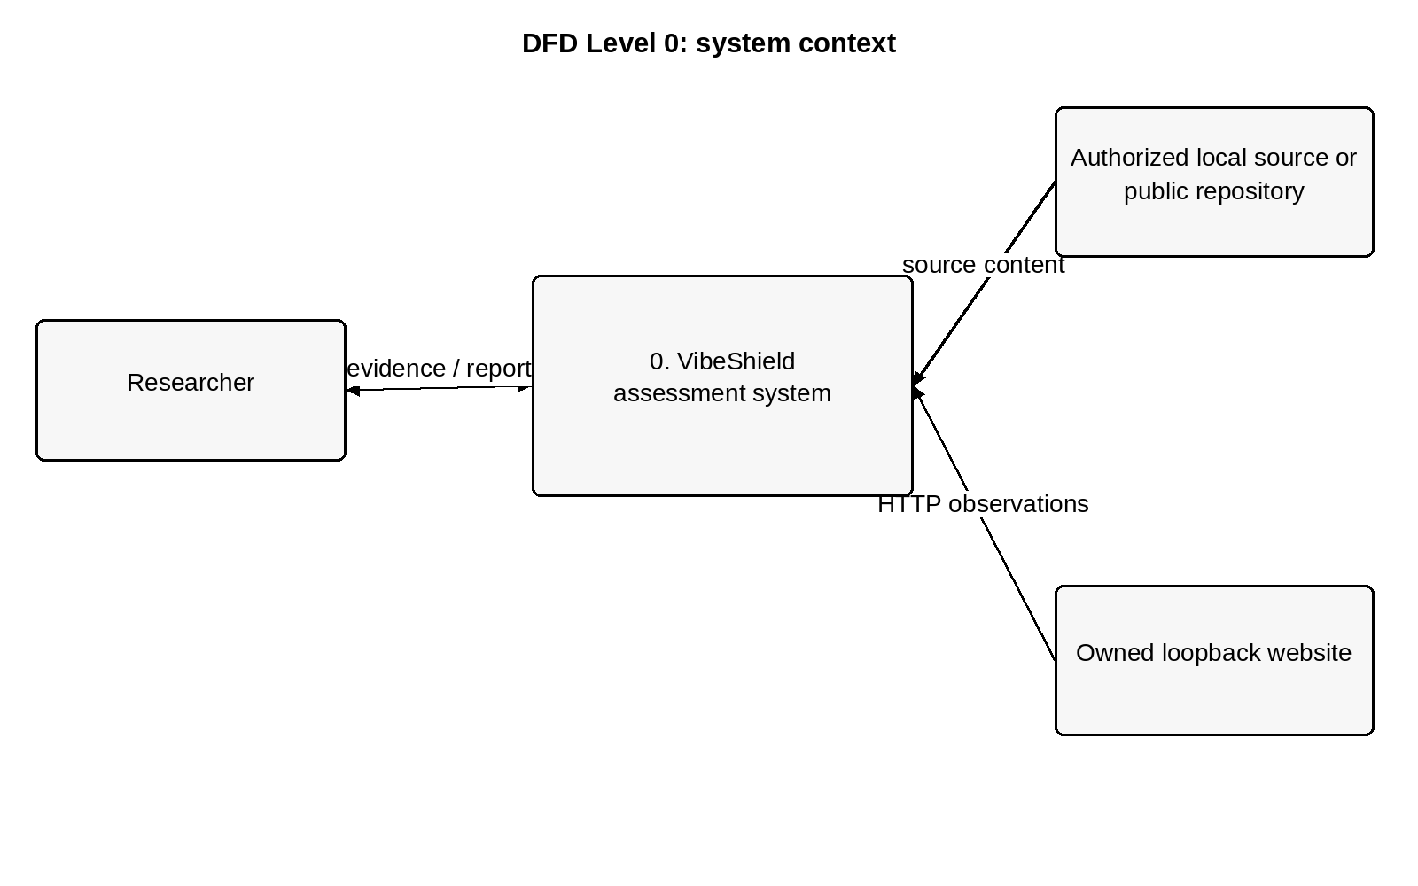
Figure 5.3: DFD Level 0 showing system context
The user's input is validated before assessment. Repository code is inspected statically; it is not imported or installed as an application. A website check necessarily interacts with the owned local HTTP endpoint. Reports may contain source context and should be reviewed before academic sharing.

5.1.5 Data Flow Diagram: Main Processes
The main processes validate inputs, create a job, execute the selected tools, normalize evidence and expose a review/export projection. Persistent JSON records connect execution to later review. Each record contains both successful results and failures.
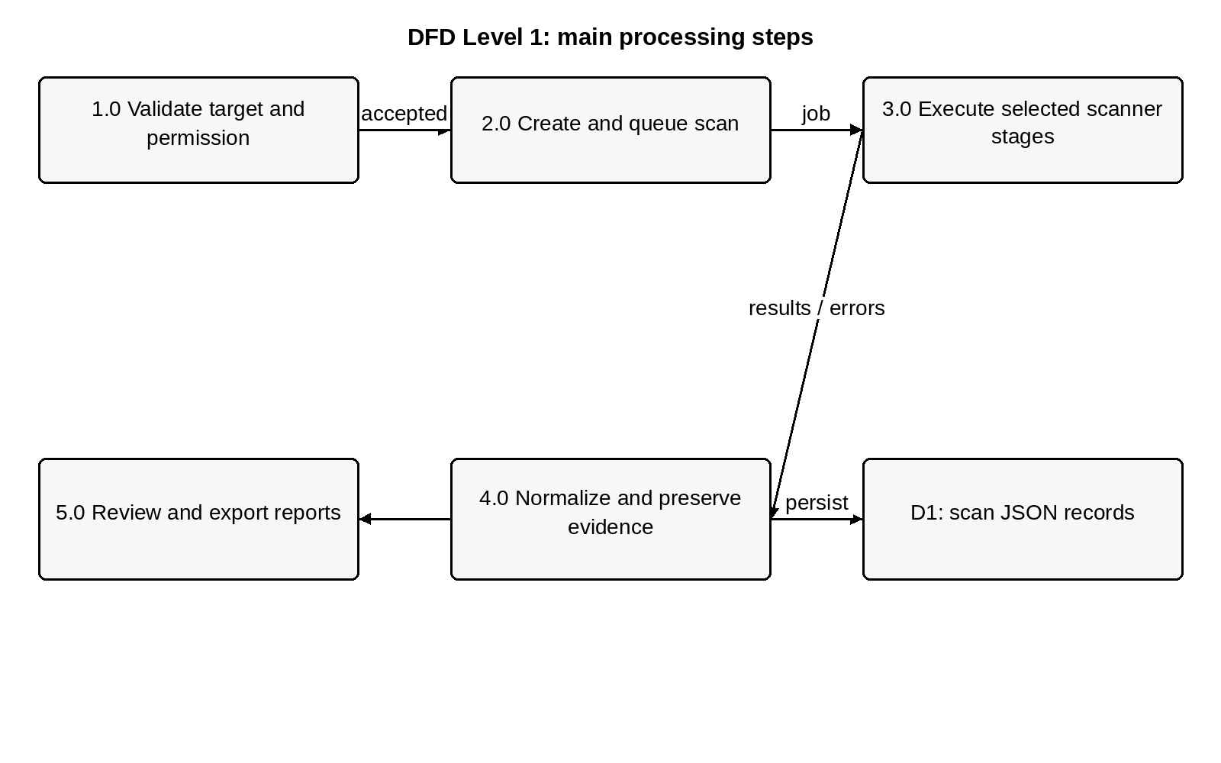
Figure 5.4: DFD Level 1 of assessment processing
Table 5.1: Process specification for main data flows
Process | Main input | Main output
1.0 Validate | Target type, location, permission | Normalized accepted target or error
2.0 Queue | Validated request | Persistent queued job
3.0 Execute | Applicable stages | Native findings and diagnostics
4.0 Normalize | Parsed records and errors | Candidates and stage outcomes
5.0 Review/export | Stored job | History, evidence, PDF and JSON

5.1.6 Data Flow Diagram: Scanner Execution
Each stage invokes an adapter with a bounded timeout. The adapter validates output and creates normalized evidence. A diagnostic may coexist with valid results. The job stores the candidate count and failed coverage independently so that partial results remain inspectable.
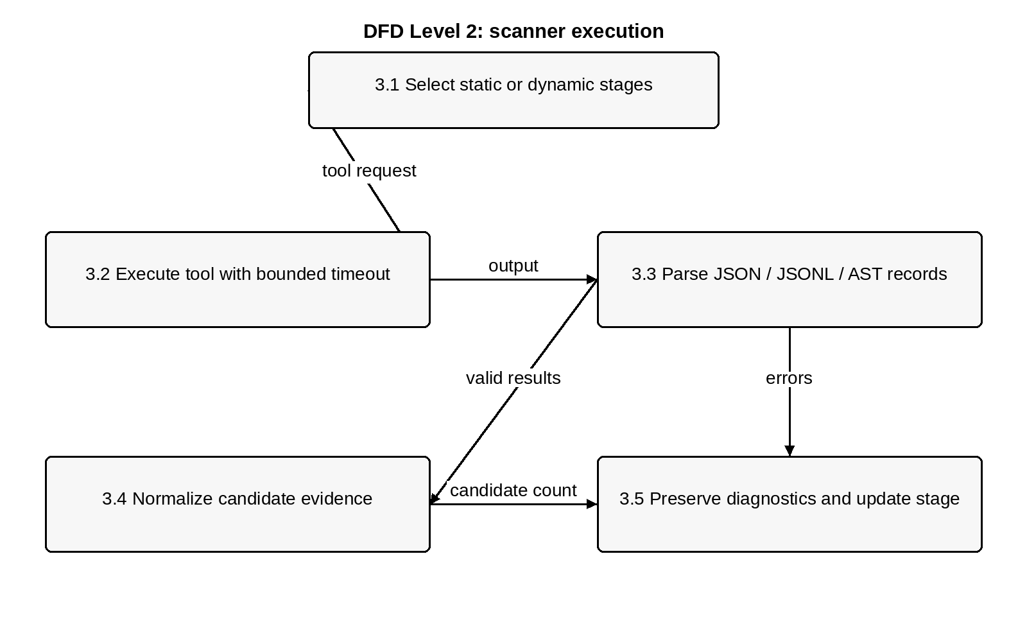
Figure 5.5: DFD Level 2 of scanner execution

5.1.7 Error and Timeout Design
Subprocesses start in a new process session. The helper terminates the process group on timeout, including child processes started by launchers. Missing tools, non-accepted exit codes and malformed JSON become ScanError. Sanitized error summaries avoid copying arbitrary scanner output into shared reports. Unexpected orchestration errors are recorded as failed runs rather than completed empty scans.

5.2 Input Design
The Overview form presents three target choices and a matching example. Website inputs may omit the scheme, which the dashboard normalizes to HTTP before shared validation. Local relative paths are resolved from the project root. GitHub input accepts a public owner/repository location and normalizes a .git suffix.
Table 5.2: Input validation rules
Input | Validation or transformation | Rejection examples
Permission | authorized must be true | Missing or false declaration
Target text | Nonempty string, at most 2,048 characters | Empty or oversized target
Website | HTTP(S), exact loopback host, no credentials or fragment | LAN IP, external host, deceptive host
Local project | Resolve and require an existing directory | Missing directory
GitHub | Public owner/repository URL | Credentials, private access, tree/branch URL
API body | JSON object, 1–8,192 request bytes | Invalid JSON or oversized body
Session | Same local Host/Origin and X-VibeShield-Token | Wrong token or untrusted origin

5.2.1 Interface Feedback
The Start scan action exposes submission state, and errors remain near the form. The fixture shortcut selects the local fixture without granting permission automatically. Tool availability explains expected coverage but does not guarantee execution success. A progress list displays real stage states and candidate counts.

5.2.2 Layout and Interaction Design
The interface uses a persistent desktop navigation rail, readable tables, restrained status badges and an evidence dialog. On narrow viewports navigation becomes a compact menu. Focus indicators and reduced-motion support are included. These behaviors support evidence review; the interface does not substitute a single numerical score for the underlying observations.

5.3 Output Design
VibeShield produces three related outputs: the live dashboard view, the persisted job and the exported assessment report. All derive from scanner evidence and explicit outcomes. Their purpose is to support review and reproducibility rather than certify that a target is secure.
Table 5.3: Output representations and completeness information
Output | Main content | Coverage behavior
Dashboard | Target, states, stage counts, findings and evidence | Errors and incomplete states remain visible
Stored JSON job | Timestamps, authorization, stages, findings and errors | Terminal state persists across restart
CLI JSON | Consolidated candidate list on stdout | Errors on stderr; partial failures return nonzero
JSON report | Metadata, evidence, guidance, summary and limitations | complete reflects completed job status
PDF report | Human-readable coverage and candidate details | Includes errors and candidate limitations

5.3.1 Finding Presentation
A finding row shows the observation, affected location, display severity, source tool and confidence. Opening it reveals available source context, a plain-language reason and the rule reference. AST results are intentionally unrated because the heuristic supplies confidence but no native severity.

5.3.2 Report Interpretation
Reports preserve overlapping observations from separate tools. Nuclei and ZAP may both report a missing nosniff header, but their evidence is retained separately. The report's candidate count therefore represents emitted records rather than unique confirmed vulnerabilities. A failed stage must be considered when interpreting a zero-candidate result.

5.3.3 Export Safety
Secret findings are redacted by their adapter, while PDF text is escaped before rendering. Other findings can still include application source context. Exported material should be reviewed by the researcher before submission or distribution. Export availability depends on a terminal job; it does not imply that every tool completed successfully.

5.4 Database and Persistence Design
The current implementation uses JSON files rather than a relational database. The default location is .vibeshield/scans. ScanStore creates the directory with mode 0700, indexes loaded jobs and serializes changes under a lock. A temporary file is atomically replaced onto the job path to reduce the risk of partially written records.
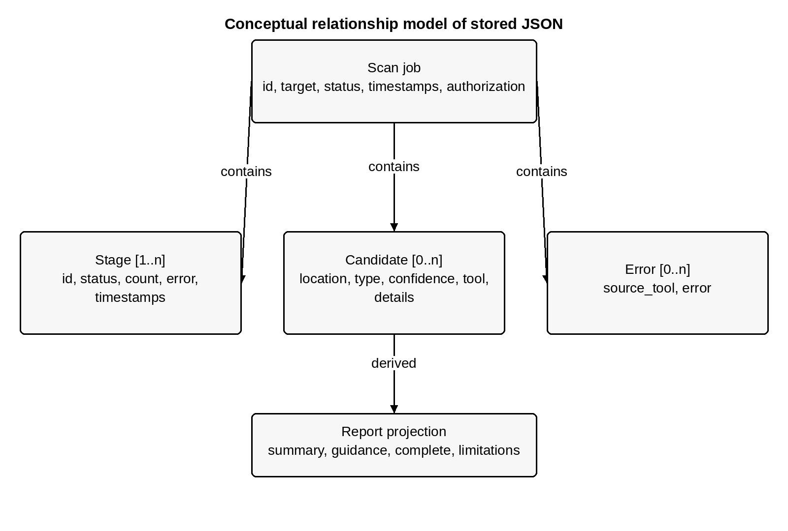
Figure 5.6: Conceptual relationship model of stored scan records

5.4.1 Relationship Design
One scan contains multiple stage records, zero or more candidate findings and zero or more errors. Authorization is embedded in the scan. A repository commit is recorded when a GitHub checkout succeeds. Report summaries, guidance and display severity are derived projections. This conceptual model replaces the template's SQL entity model because no application SQL schema is implemented.

5.4.2 Data Dictionary: Scan and Stage
Table 5.4: Data dictionary of the persisted scan job
Field | Type | Meaning
id | String | 12-character job identifier
target / target_type | Strings | Normalized location and website, github or local type
status | String | queued, running, completed, partial, failed or interrupted
created_at | ISO timestamp | Time the job was created
started_at / finished_at | Timestamp or null | Execution boundaries
authorization | Object | confirmed, confirmed_at and scope
repository_commit | String or null | Checked-out commit for GitHub jobs
stages | Array | Ordered applicable stage records
findings | Array | Consolidated candidate records
errors | Array | Tool and orchestration diagnostics

Table 5.5: Data dictionary of an individual stage
Field | Type | Meaning
id / name | Strings | Machine identifier and displayed tool name
status | String | queued, running, completed, failed, interrupted or skipped
finding_count | Integer | Number of retained findings from this stage
started_at / finished_at | Timestamp, when set | Stage execution boundaries
error | String, when present | Failure or coverage diagnostic

5.4.3 Recovery Rules
On restart, records whose status is unfinished are marked interrupted and receive an explanatory error. Their queued or running stages become interrupted. The system does not silently resume them or label them complete. Terminal historical records remain available. Corrupt or structurally invalid files are skipped by the current loader; a dedicated recovery interface is future work.

5.4.4 Data Dictionary: Candidate and Export
Table 5.6: Candidate fields and report additions
Field | Type | Purpose
file_or_endpoint | String | Affected source location or URL
vulnerability_type | String | IDOR, SECRET_EXPOSURE or native rule ID
confidence | String | Evidence confidence, separate from severity
source_tool | String | ast, semgrep, gitleaks, nuclei or zap
details | Object | Native file, line, rule, reason or source context
details.status | String | CANDIDATE marker
display_severity | String in report | Normalized native severity; UNRATED when absent
recommendation / limitation | Report strings | Fixed review guidance and interpretation bounds

5.4.5 Security Design
The server checks Host and Origin against its local origin and requires a session token for scan creation. Responses include no-store caching, nosniff, frame denial, referrer restrictions and a Content Security Policy. Static file paths are resolved and checked against the frontend root.
GitHub acquisition disables prompts, user Git configuration, credential helpers and hooks. It performs a shallow checkout without running dependency installation or repository application code. A 200 MiB limit is checked after cloning; this does not bound bytes transferred during the download. The temporary checkout is removed after execution.
Scanner environments remove selected AI/cloud-related credential prefixes. This is a scoped precaution and is not complete process isolation. Local files, runtime privileges, external tools and scanner networking remain important operational boundaries. The dashboard is designed for local coursework and has no multi-user access control or production sandbox.

CHAPTER 6
SOURCE CODE

6.1 Project Structure
The following structure identifies the implementation and verification entry points. Generated frontend assets, scan history and installed environments are omitted to keep the source layout readable.
vibeshield/
run_dashboard.py
run_scan.py
README.md
dashboard/
server.py
requirements.txt
tests/test_dashboard.py
web/
src/main.jsx
src/style.css
package.json
tests/dashboard.spec.js
pipeline/
scan/
common.py
run_scan.py
semgrep_runner.py
ast_heuristic_analyzer.py
secrets_runner.py
nuclei_runner.py
zap_runner.py
rules/flask.yaml
templates/missing-nosniff.yaml
tests/
report/report_builder.py
fixtures/idor-notes-app/app.py
docs/

6.1.1 Source Presentation
The following pages contain selected implementation excerpts rather than an entire repository listing. File paths identify the authoritative source. Excerpts focus on the shared model, candidate consolidation, local URL validation, persistence and report projection. The deliberately vulnerable fixture is a separate test target, not the VibeShield server.

6.2 Back End Source Code

6.2.1 Shared Errors and Candidate Consolidation
The error object can carry useful findings when a scan is incomplete. Candidate consolidation adds the CANDIDATE marker while retaining the native detail record. The following excerpts are from pipeline/scan/common.py and pipeline/scan/run_scan.py.
class ScanError(Exception):
"""An incomplete scan may still carry valid findings."""
def __init__(self, message, findings=()):
super().__init__(message)
self.findings = tuple(findings)
@dataclass(frozen=True)
class CandidateFinding:
file_or_endpoint: str
vulnerability_type: str
confidence: str
source_tool: str
details: dict
def consolidate(finding):
details = asdict(finding)
details['status'] = 'CANDIDATE'
if isinstance(finding,
ast_heuristic_analyzer.HeuristicFinding):
return CandidateFinding(
finding.file, 'IDOR', finding.confidence,
'ast', details)
confidence = ('HIGH' if finding.source == 'gitleaks'
else 'MEDIUM')
if finding.severity.upper() in {'INFO', 'INFORMATIONAL'}:
confidence = 'LOW'
vulnerability = ('SECRET_EXPOSURE'
if finding.source == 'gitleaks'
else finding.rule_id)
return CandidateFinding(finding.file, vulnerability,
confidence, finding.source, details)
Line wrapping is adjusted for the report. This logic assigns evidence confidence; it does not calculate exploitability or numerical risk. Candidate fields remain stable while tool-specific details vary.

6.2.2 Local URL Validation
The shared validator in pipeline/scan/common.py parses the supplied URL, validates the port and enforces exact supported loopback hostnames. It rejects user credentials and fragments. The docstring explicitly distinguishes the scope check from network isolation.
def local_url(value):
"""Development scope check, not network isolation
or a redirect sandbox."""
try:
url = urlsplit(value)
url.port
except ValueError as exc:
raise ScanError(f"Invalid target URL: {exc}") from exc
if (url.scheme not in {"http", "https"} or
url.hostname not in
{"localhost", "127.0.0.1", "::1"} or
url.username or url.password or url.fragment):
raise ScanError(
"This phase accepts only http(s) "
"localhost/127.0.0.1/[::1] URLs "
"without credentials or fragments.")
return value

6.2.3 Atomic Persistence
ScanStore.persist in dashboard/server.py writes a full JSON record to a temporary sibling path and replaces the destination. The store's update method holds a lock while changing and persisting the in-memory job.
def persist(self, job):
dest = self.directory / (job['id'] + '.json')
temp = dest.with_suffix('.tmp')
temp.write_text(json.dumps(
job, ensure_ascii=False, indent=2))
temp.replace(dest)
Atomic replacement protects an individual update. It is not a transactional database, backup system or complete crash-recovery facility.

6.2.4 AST Heuristic Configuration and Evidence
The analyzer defines supported route, lookup, principal and owner names explicitly. These implementation sets make the heuristic explainable and constrain its coverage.
ROUTES = {"route", "get", "post", "put", "patch",
"delete", "head", "options"}
LOOKUPS = {"execute", "executemany", "query", "get",
"get_or_404", "filter", "filter_by"}
OWNERS = {"owner", "owner_id", "user_id",
"created_by", "author_id"}
The following excerpt from fixtures/idor-notes-app/app.py illustrates the deliberately vulnerable lookup. The surrounding function has already authenticated user. The omitted ownership check is the reason for the candidate; the query's parameterization alone does not enforce access to the correct owner's record.
db = get_db()
note = db.execute(
"SELECT * FROM notes WHERE id = ?",
(note_id,)).fetchone()
if not note:
return jsonify({"error": "not found"}), 404
# BUG: no check that note["owner_id"] == user["id"]
return jsonify(
{"id": note["id"], "title": note["title"],
"body": note["body"]}
)

6.2.5 Reviewing a Candidate
Within an owned test application, a developer can constrain the lookup to authorized objects or compare the fetched owner against the authenticated principal before returning protected content. VibeShield's analyzer recognizes only supported forms. A production application's middleware or policy layer may require manual analysis even when the local heuristic emits a candidate.

6.3 Front End Source Code

6.3.1 Scan Submission
The React submit handler posts a target request with the session token. The full handler also manages submission state, errors, the selected job and success notification. The following is its request expression, formatted for readability from dashboard/web/src/main.jsx.
const job = await api('/api/scans', {
method: 'POST',
headers: {
'Content-Type': 'application/json',
'X-VibeShield-Token': status.csrf_token
},
body: JSON.stringify({
target_type: kind,
target,
authorized
})
});

6.3.2 Actual Status Polling
The effect performs an initial refresh and polls every two seconds while the document is visible. The refresh function requests both status and scan history and updates connection-error state if the server cannot be reached.
useEffect(() => {
refresh();
const id = setInterval(() => {
if (!document.hidden) refresh();
}, 2000);
return () => clearInterval(id);
}, []);

6.3.3 Evidence and Export Controls
Finding rows open a dialog backed by the actual selected record. Report buttons fetch the stored scan's report endpoint and create a browser download from the returned bytes. Reports are enabled for terminal jobs; no synthetic finding list is inserted for demonstration. Native browser dialog behavior supports modal evidence inspection and Escape handling.

6.4 Stored Data and Report Representation
VibeShield has no SQL migration script because its application storage is file-based. A persisted record contains an embedded stages array, findings array and errors array. A report adds derived guidance, display severity, counts, completeness and limitations.

6.4.1 Illustrative JSON Candidate
The following example shows the schema, not a newly executed scan. The location and heuristic correspond to the owned fixture, while job identifiers and timestamps are intentionally omitted.
{
"file_or_endpoint": "app.py",
"vulnerability_type": "IDOR",
"confidence": "MEDIUM",
"source_tool": "ast",
"details": {
"file": "app.py",
"line": 122,
"function_name": "get_note",
"heuristic_id": "IDOR-AST-01",
"confidence": "MEDIUM",
"status": "CANDIDATE"
}
}
The abbreviated example omits the full reason string for readability; real AST details include that explanation. The JSON report wraps candidates with project metadata, authorization, repository provenance when available, stage coverage and errors.

6.4.2 Completeness Rule
In pipeline/report/report_builder.py, complete is derived from scan['status'] == 'completed'. A partial, failed or interrupted job can still be exported, but complete is false. Report generation timestamps vary. Deterministic assessment refers to rule decisions under the same code, rules and runtime conditions rather than byte-identical exports.

CHAPTER 7
SYSTEM TESTING

7.1 Test Cases and Testing Strategy
The verification strategy separates source-level regression tests, local backend behavior, browser interaction and real external-scanner execution. These layers establish different facts. A passing parser test does not establish that a particular installed scanner or daemon is ready, and a historical runtime record is not a fresh live check.

7.1.1 Current Regression Results
On 5 November 2026, the following commands were run in the project environment. Both suites passed. The backend suite uses real AST analysis against the fixture alongside controlled scanner outcomes, allowing incomplete-report behavior to be checked without relying on unavailable external tools.
.venv/bin/python -m unittest discover \
-s pipeline/scan/tests -v
Ran 37 tests — OK
.venv/bin/python -m unittest discover \
-s dashboard/tests -v
Ran 6 tests — OK
Table 7.1: Verification evidence and dates
Check | Result | Evidence boundary
Scanner regression suite, 5 Nov 2026 | 37 passed | AST, adapters, orchestration and diagnostics
Dashboard backend suite, 5 Nov 2026 | 6 passed | Validation, consent, persistence and exports
Browser workflow, 6 Oct 2026 record | Passed | Historical Chromium local-fixture workflow
Dynamic scanner smoke, 5 Oct 2026 record | Passed | Historical native Nuclei / ZAP fixture run
Fresh live external-tool scans for this report | Not run | No new runtime coverage claim

7.1.2 Test Environment
The current project environment provides the Python dependencies required by these suites. Exact external-scanner versions used in earlier live checks are documented in pipeline/scan/VERIFICATION.md. Browser-test dependencies and configuration are maintained under dashboard/web. Current unit-test success does not reconfirm those earlier installed binaries.

7.1.3 Scanner Test Cases
Table 7.2: Scanner regression scenarios
ID | Scenario | Expected behavior | Current evidence
SC-01 | Owned vulnerable Flask fixture | Emit IDOR-AST-01 candidate | Passing AST suite
SC-02 | Supported rejecting owner guard | Do not emit missing-guard candidate | Passing AST suite
SC-03 | Comparison used only for logging | Do not treat it as protection | Passing AST suite
SC-04 | Guard after disclosure or nested helper | Do not infer inline protection | Passing AST suite
SC-05 | Missing scanner executable | Raise explicit incomplete-scan error | Passing runner suite
SC-06 | Malformed scanner JSON | Reject unsupported output | Passing runner suite
SC-07 | Secret-pattern candidate | Redact secret before presentation | Passing runner suite
SC-08 | Tool timeout | Terminate process group and report failure | Passing runner suite
SC-09 | Tagged Semgrep diagnostic plus finding | Retain finding and mark incomplete | Passing regression suite
SC-10 | Overlapping dynamic findings | Preserve each source observation | Passing orchestration suite

7.1.4 Partial Parsing Regression
Semgrep may encode a diagnostic type as a tagged list such as PartialParsing with a payload. The current error formatter decodes that form and reports bounded checkout-relative locations. A parsing diagnostic does not automatically establish that application syntax is invalid; template syntax may be unsupported by the scanner.
The regression is meaningful because it verifies both sides of the behavior: useful findings survive, and the incomplete coverage is still visible. Silently suppressing diagnostics or discarding all concurrent results would weaken the evidence record.

7.1.5 Dashboard and Report Test Cases
Table 7.3: Backend validation and persistence scenarios
ID | Scenario | Expected result
DB-01 | localhost, 127.0.0.1 and [::1] input | Accept supported normalized local URL
DB-02 | External host, LAN IP or deceptive URL | Reject unsupported target
DB-03 | Valid public GitHub owner/repository | Normalize to HTTPS .git URL
DB-04 | GitHub credentials or branch path | Reject unsupported repository form
DB-05 | Missing authorization declaration | Reject before job creation
DB-06 | Real AST plus scanner diagnostic | Persist partial status and valid evidence
DB-07 | JSON and PDF export of partial run | complete false; valid PDF bytes
DB-08 | Reload completed history | Preserve stored findings
DB-09 | Restart with unfinished stage | Mark job and applicable stages interrupted

7.1.6 Historical Browser Verification
The 6 October 2026 dashboard record documents a Chromium workflow against the unchanged owned fixture: submit a scan, inspect the IDOR rule in the evidence dialog, close it with Escape, download the PDF, inspect mobile navigation and check responsive widths. It records zero automated axe violations on the populated findings view and overflow checks at 320, 390 and 768 pixels.
Those are scoped recorded observations, not a full accessibility certification or a new browser run for this report. Existing desktop, findings and mobile screenshots are reproduced in Chapter 10 with their provenance.

7.1.7 Verification Boundaries
Live public GitHub cloning, private repository access, authenticated website workflows and Docker-mode ZAP are not established by these tests. The project records no exploit verification. External rules, dependency changes and environmental differences can change later runtime results.

7.1.8 Historical Scanner Observations
The earlier scanner verification record documents the owned fixture source hash and tested tool versions. Static assessment returned one AST ownership candidate and one Semgrep bind-address observation. Gitleaks returned no candidates in that recorded run. Local dynamic checks returned one Nuclei missing-nosniff candidate and two passive ZAP alerts.
Table 7.4: Historical local-fixture scanner observations
Tool | Recorded observation | Interpretation
AST | IDOR-AST-01 at app.py:122 | Missing recognized ownership guard; MEDIUM confidence
Semgrep | Flask wildcard bind observation at app.py:139 | Deployment context required
Gitleaks | Zero emitted candidates | Not proof of no secrets in all history
Nuclei | Missing nosniff header at health endpoint | Narrow header-template coverage
ZAP | Version disclosure and missing nosniff | Passive candidates; overlap retained

7.1.9 Defects and Corrective Design
The notable diagnostic-handling defect was an assumption that Semgrep error.type was always a string. The current implementation handles tagged forms, limits surfaced metadata and preserves concurrent findings through ScanError.findings. Backend reporting retains the resulting partial coverage.
Other important failure paths are treated explicitly: invalid JSON is an error, missing binaries do not become empty success, stage timeouts terminate their process group, and restart does not silently complete unfinished work. These are verified behaviors or design controls, not claims that all possible failures have been eliminated.

7.1.10 Reproducibility Record
An academic experiment should preserve the target source or commit, tool versions, rule files, exact input endpoint, execution date and exported report. Semgrep auto rules are mutable. Shallow GitHub acquisition does not establish full repository-history coverage. Repeated findings should be compared using source and rule identity rather than only candidate counts.

CHAPTER 8
SYSTEM IMPLEMENTATION / DEPLOYMENT

8.1 Prerequisites
Use a Python installation compatible with the project, Node.js compatible with the installed Vite version, npm and a modern browser. Install Git for public repository assessment. External scanners are separate prerequisites; the Python requirements file does not install Semgrep, Gitleaks, Nuclei or ZAP.
The following commands document the repository's POSIX workflow. They were not rerun as a dependency installation during preparation of this report. Native Windows operation is not verified because the current subprocess helper uses POSIX session and process-group handling.

8.2 Storage and Environment Setup
No database server or SQL migration is required. Create a virtual environment from the repository root and install the dashboard's PDF dependency. The server creates its scan-data directory on startup. Use --data-dir to select another location without deleting existing records.
python3 -m venv .venv
.venv/bin/pip install -r dashboard/requirements.txt

8.3 Backend Setup
The backend entry point is run_dashboard.py. It imports the application modules from the checkout and serves the production frontend assets. Select scanner paths in the environment before starting the server. Use executable paths, not commands with arguments.
SEMGREP_BIN
GITLEAKS_BIN
NUCLEI_BIN
ZAP_BIN or ZAP_CLI_BIN
DOCKER_BIN
GIT_BIN
JAVA_HOME (for native ZAP when required)
The AST stage uses Python's standard library and does not require a separate scanner executable. Native ZAP needs a compatible Java runtime; Docker fallback needs both daemon access and the required image.

8.4 Frontend Setup and Application Launch
Install frontend packages and build the production bundle. The Python server serves that bundle and the API together. A Vite development server is a separate development workflow and is not required for the documented production start.
npm install --prefix dashboard/web
npm run build --prefix dashboard/web
.venv/bin/python run_dashboard.py
Open http://127.0.0.1:8787. The backend prints the dashboard URL at startup. Stop the server with Ctrl+C. Stored history remains in the selected data directory; stopping does not delete it. If the server ends before a job finishes, restart recovery marks that record interrupted rather than resuming it silently.

8.4.1 Alternate Port and Storage Directory
.venv/bin/python run_dashboard.py \
--port 8788 --data-dir /path/to/private/scan-records

8.4.2 First Local Repository Scan
Choose Local project or press Use test fixture. Check that the target is fixtures/idor-notes-app, read the displayed scope and confirm permission. Submit the scan and inspect the stage list. A missing external tool may yield partial coverage while the built-in AST stage still returns evidence. Use the final record, not the readiness display alone, to assess coverage.

8.4.3 CLI Operation
python3 run_scan.py --repo-path fixtures/idor-notes-app
python3 run_scan.py --url http://127.0.0.1:5000/api/health
The flags may be combined. Standard output is a JSON candidate list; diagnostics go to standard error. Partial failures return a nonzero exit status. A saved CLI list is not identical to the dashboard's metadata-rich report format.

8.5 Controlled Fixture and Repository Acquisition
The local fixture is deliberately vulnerable and intended for owned academic exercises. The preserved fixture image can be run, when present, with loopback-only host publishing. This checkout does not provide an original Compose file or a fixture image-build procedure.
docker run --rm --name vibeshield-scan-fixture \
-p 127.0.0.1:5000:5000 \
vibeshield-idor-notes-app:latest
The target health endpoint is http://127.0.0.1:5000/api/health. Stop the foreground container with Ctrl+C, or stop the named container from another terminal with docker stop vibeshield-scan-fixture. The --rm option removes that run's container, so any fixture data stored only in it is temporary. This does not delete dashboard scan history.

8.5.1 Public GitHub Assessment
Select GitHub repository and enter the public owner/repository URL. Confirm authorization for static assessment. The server normalizes the location, performs a shallow temporary checkout, records the commit and runs static scanners. It does not run the repository application or its package installation scripts. Credentials, private repositories and branch/tree URLs are unsupported.

8.5.2 Operational Verification
After launch, verify that the expected local URL loads and Settings displays tool availability. Run the owned fixture and inspect actual stage outcomes. A successful static run does not establish dynamic-scanner readiness. Check that PDF and JSON exports include the same selected job and report incomplete coverage when a stage fails.

8.5.3 Data Preservation
Retain exported reports and selected scan records for coursework evidence. Back up the private data directory before moving the project between machines. Tool paths and temporary downloaded runtimes may differ after migration. Avoid copying live credentials or unreviewed source snippets into the academic submission.

8.6 Common Problems
Table 8.1: Troubleshooting and verification actions
Symptom | Likely cause | Action
Frontend build message or 503 | Production assets missing | Install frontend packages and run the build
Scanner shown as unavailable | Executable absent or wrong path | Install the tool or set its binary variable
Tool available but stage fails | Runtime, rules, permissions or configuration issue | Review the stored stage error and local tool setup
ZAP fails to start | Java incompatibility or inaccessible Docker fallback | Verify the chosen runtime, daemon and image
Website rejected | Target outside supported loopback scope | Use the owned local fixture endpoint
Session verification failed | Stale page token or wrong origin | Refresh the local page and submit again
Report conflict | Job still queued or running | Wait for a terminal state
PDF unavailable | ReportLab missing from server environment | Install dashboard requirements or export JSON
Semgrep partial parsing | Unsupported source region or rule parse issue | Review affected locations and preserve partial evidence
Restarted job interrupted | Earlier server stopped before completion | Start a new scan; retain the old record

8.6.1 Interpreting Setup Problems
Treat setup failures as incomplete coverage. Do not manually remove errors from a report to make the result appear successful. For Semgrep template diagnostics, review the affected file and rule locally; a parser limitation is not automatically an application syntax defect. Excluding files changes the assessment scope and must be documented.

8.6.2 Shutdown and Recovery
Ctrl+C stops the dashboard's serving loop. A later start reloads stored records and marks unfinished jobs interrupted. Job cancellation and production process isolation are not implemented; do not assume that the application provides a full external-process supervisor. Keep fixture operation and dashboard operation explicit and local.

CHAPTER 9
CONCLUSION AND FUTURE ENHANCEMENT

9.1 Present Status
VibeShield implements an end-to-end local assessment workflow: target validation, permission declaration, scanner selection, evidence consolidation, persistent history, candidate review and report export. It supports both repository inspection and controlled loopback website checks. Current scanner and backend regression suites pass.
Table 9.1: Present status and evidence boundaries
Area | Current implementation | Verification position
Static assessment | Semgrep, AST and Gitleaks adapters | Current regression tests; earlier live fixture record
Dynamic assessment | Narrow Nuclei template and passive ZAP | Current adapter tests; earlier native live record
Dashboard and reports | Five views, evidence dialog, PDF / JSON | Current backend tests; earlier browser record
GitHub acquisition | Validated shallow public checkout | Validation tested; live cloning not reconfirmed
Exploit verification | No implementation in dashboard | No claim of confirmed exploitation
Cloud / multi-user service | Outside current design | No hosted-service verification

9.2 Work Remaining
Operational deployment still requires installed external tools and compatible runtimes. Current live behavior must be checked in that environment before presenting new scanner results. Improvements to the product would require cancellation, stronger isolation, pinned rule reproducibility, broader heuristic coverage, storage recovery and explicit retention controls.
These are remaining operational or product improvements rather than hidden completed features. Earlier references to an idor_prober.py exploit workflow do not describe this checkout: that file is absent and has not been reconstructed. The implemented dashboard reports candidate evidence only.

9.3 Limitations
The AST heuristic is intentionally narrow and can miss policy enforcement outside the inspected handler or report legitimate public-resource patterns. Semgrep coverage depends on installed rules and parsing support. Nuclei currently uses one bundled header template, while ZAP is configured for passive analysis. Together these tools do not establish comprehensive vulnerability coverage.
The application is local and single-user, with no account separation, hosted database, per-user access control or production sandbox. A local website allowlist does not constrain every network action inside external tools. Public GitHub checkouts are shallow, and the post-clone size limit does not constrain download volume. Reports can contain source context even though secret-pattern values are redacted.

9.4 Risk Assessment
Table 9.2: Project risks and mitigations
Risk | Effect | Existing control or improvement
Missing or incompatible tools | Incomplete stage coverage | Visible setup state, explicit runtime errors
Mutable external rules | Different results across dates | Record versions and inputs; pin rules in future
False candidate classification | Misleading interpretation | Evidence, confidence and candidate limitations
Sensitive source in exports | Accidental disclosure | Redaction and researcher review before sharing
Oversized checkout or slow tools | Resource pressure | Timeouts, sequential worker and post-clone size check
Interrupted process | Unfinished assessment | Persistent history and interrupted recovery state
Weak isolation | Unintended external-process effects | Controlled fixture use; stronger sandboxing planned

The table is a qualitative engineering assessment. It is not a calculated project risk score or evidence that every listed risk has been eliminated. Reported completeness always refers to the requested scanner stages, not proof of target safety.

9.5 Future Enhancements
Future work should first improve assessment reliability and control. Candidate improvements include cancellable jobs, tighter subprocess resource limits, scanner egress isolation, pinned rule bundles and a reproducibility manifest containing tool versions, target commits and rule hashes. Retention controls and recovery tooling would improve long-term scan-history management.
The AST analyzer could be extended through explicitly tested support for more authorization shapes, frameworks and data-access patterns. Broader detection should be accompanied by clean controls and documented false-positive boundaries. Additional Nuclei templates and authenticated local website workflows would require careful scope design and new runtime verification.
An optional review workflow could let a researcher annotate a candidate as reviewed, contextual, corrected or requiring further investigation while retaining the original scanner evidence. Any future exploit-verification component would need its own authorized scope, isolation and evidence model. These features are proposed and are not present in the current dashboard.

9.6 Conclusion
VibeShield demonstrates how deterministic security tools can be integrated into a coherent academic workflow. Its central contribution is preserving explainable observations together with the coverage record: the target, permission declaration, tool stages, candidate evidence, errors and report limitations remain connected.
The project combines source-pattern analysis, a narrow Flask ownership heuristic, secret detection and controlled local website checks. A React interface makes the results searchable and reviewable, while Python persistence and report generation support repeatable coursework submission. The current 37 scanner tests and 6 backend tests passed during report preparation.
The implementation also makes its limits explicit. A candidate is a starting point for review. Partial results remain useful, and empty results do not certify security. Further work can expand coverage and operational controls while retaining those evidence-centered principles.

CHAPTER 10
APPENDICES

10.1 Screenshots
The following screenshots are existing project verification artifacts from 6 October 2026. They show the implemented interface and recorded local fixture history. Tool-readiness indicators and timestamps reflect that capture, not a fresh runtime check on the documentation date.
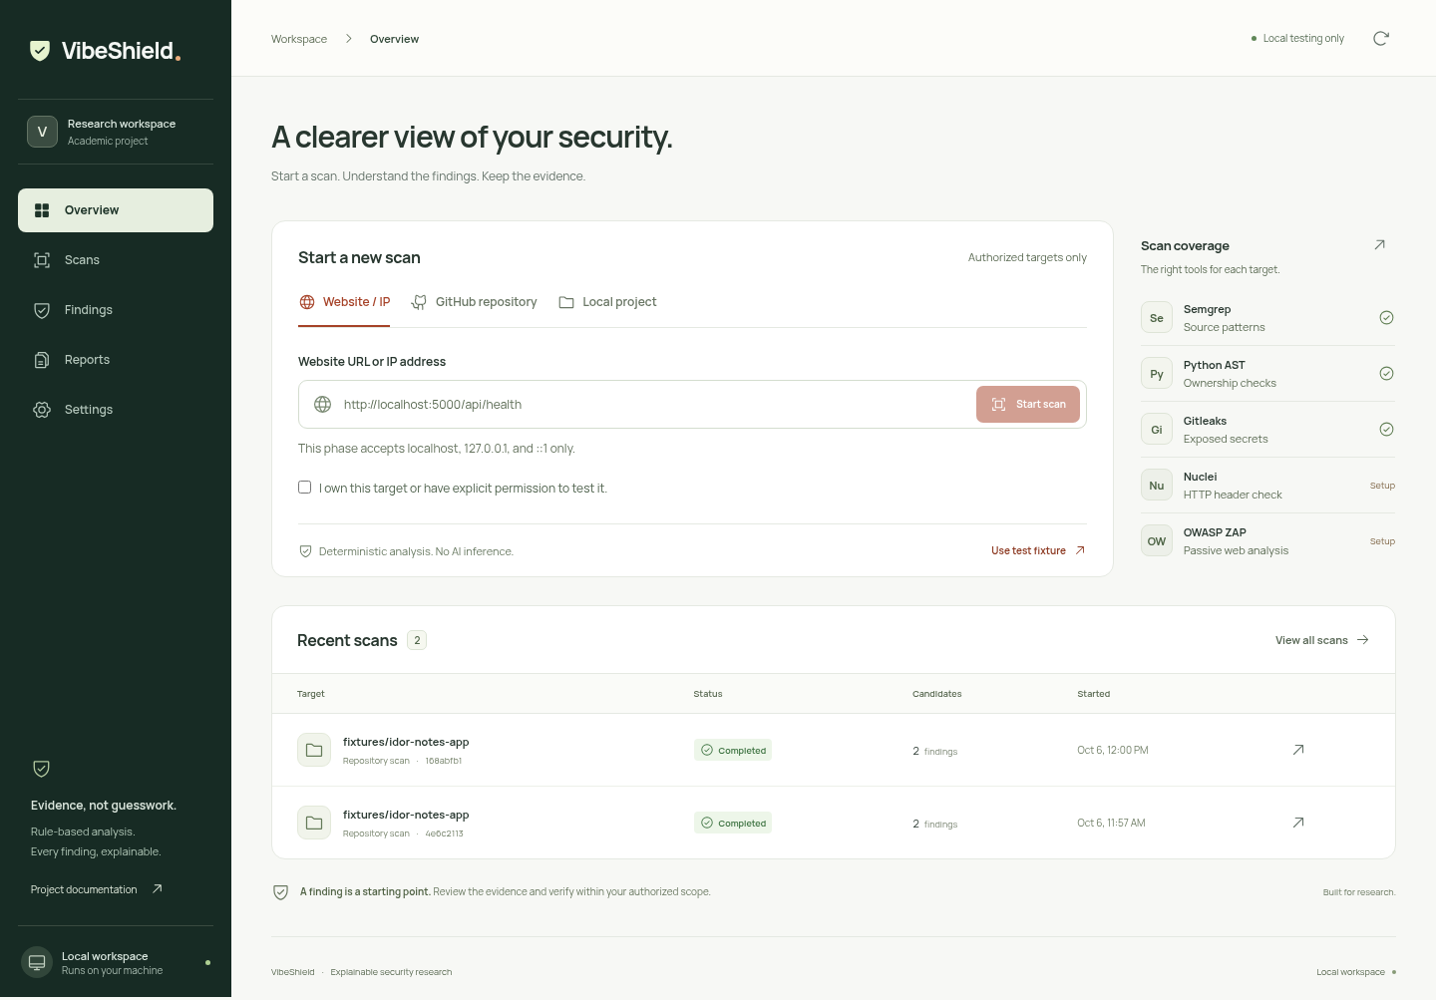
Figure 10.1: Desktop Overview with target form and recent scans

10.1.1 Overview Screen
The screen combines target selection, authorization, applicable scanner coverage and recent scan records. The fixture shortcut and local scope explanation appear near the form. The navigation rail links to Scans, Findings, Reports and Settings. Recorded results are candidate counts rather than confirmed vulnerability totals.

10.1.2 Findings Screen
The captured Findings view shows an actual recorded fixture assessment with separate Semgrep and AST candidates. The stage list exposes completed coverage, and the table separates native severity from confidence. The AST row is unrated because the heuristic does not assign a severity.
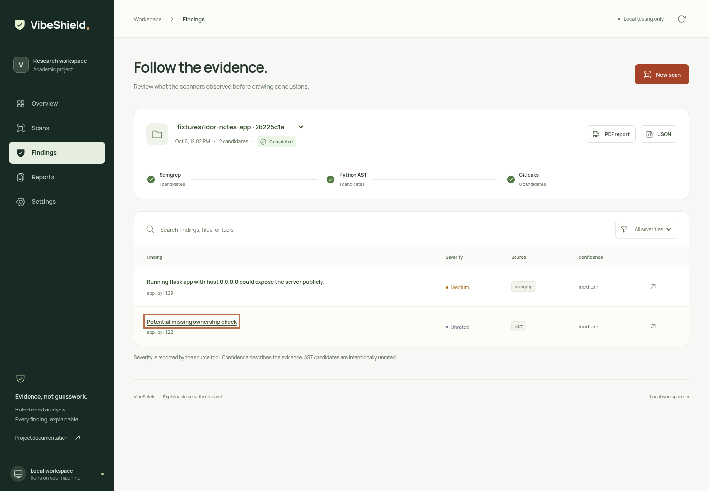
Figure 10.2: Findings view with Semgrep and AST fixture candidates
Opening a row shows the affected file and line, the observation, available source context and rule reference. The evidence dialog supports Escape and provides export controls for terminal scans. A Semgrep wildcard-bind observation needs deployment context; the interface does not convert it into confirmed public exposure.

10.1.3 Mobile Overview
The mobile capture demonstrates the compact application layout. Its content is the same implemented workflow, with navigation available through the menu control. Existing verification records cover overflow checks at several narrow widths; this screenshot alone is not a complete responsive or accessibility audit.
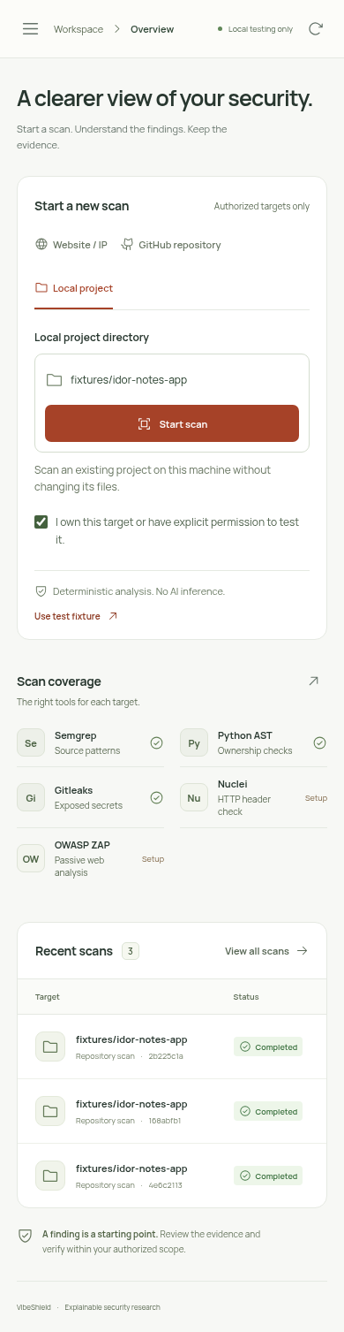
Figure 10.3: Mobile Overview with compact navigation
The screenshot is reproduced at its original aspect ratio. It is a historical project artifact and does not imply that the server or external scanners are currently running.

10.2 API Reference
The backend exposes a local JSON API and binary export routes. The same-origin Host/Origin checks apply to requests. Scan creation requires the session token from GET /api/status in the X-VibeShield-Token header. This token is not a user account credential.
Table 10.1: Implemented API endpoints
Method and path | Purpose | Normal response
GET /api/status | Tool discovery, scope, fixture shortcuts and token | 200 JSON
POST /api/scans | Create an authorized target job | 202 JSON
GET /api/scans | List persisted scan records | 200 JSON
GET /api/scans/{id} | Retrieve an individual job | 200 JSON
GET /api/scans/{id}/report.json | Download terminal assessment data | 200 JSON attachment
GET /api/scans/{id}/report.pdf | Download terminal assessment PDF | 200 PDF attachment
GET /api/documentation.pdf | Download existing project documentation PDF | 200 PDF attachment

10.2.1 Create-Scan Request
{
"target_type": "local",
"target": "fixtures/idor-notes-app",
"authorized": true
}
Target types are website, github and local. A created record returns its identifier and initial queued stages. Submission does not wait for assessment completion. The API does not implement user registration, authentication accounts, leave records or role-based approval routes from the source template.

10.2.2 Response and Error Behavior
Table 10.2: HTTP status codes used by the backend
Code | Meaning | Example
200 | Successful retrieval | Status, history, record or export
202 | Accepted job | Valid scan submitted to the worker
400 | Invalid request or target | Missing consent, invalid target or JSON
403 | Local-origin or session failure | Untrusted Host/Origin or wrong token
404 | Resource not found | Unknown job, route or missing project PDF
409 | Resource not ready | Report requested while scan is unfinished
413 | Request body outside permitted size | Missing/oversized scan payload
503 | Required rendering/assets unavailable | Missing ReportLab or frontend build

10.2.3 Export Fields
The JSON report contains schema_version, project, generated_at, scan_id, target, target_type, status, complete, created_at, finished_at, authorization, repository_commit, summary, stages, errors, findings and limitations. Each report finding retains the original candidate fields and adds display_severity, recommendation and limitation.

10.2.4 API Scope
Only the implemented local service is described here. There is no delete-scan, cancel-job, login, cloud-sync or administrative endpoint. Unknown API routes return not found. A report download operates on stored evidence and does not initiate another assessment. Consumers should inspect complete, stages and errors before interpreting the candidate list.

10.3 User Guide

10.3.1 Run a Local Repository Assessment
• Start the dashboard and open its printed loopback URL.
• Select Local project or use the fixture shortcut.
• Enter an owned or authorized directory and confirm the permission declaration.
• Start the scan and inspect each stage's actual outcome.
• Open Findings, select the scan and review candidate evidence and rule identifiers.
• Download PDF or JSON after the scan reaches a terminal state; retain any incomplete-coverage explanation.

10.3.2 Run a Local Website Assessment
• Start the owned fixture application separately and verify its health endpoint.
• Select Website / IP and enter the supported loopback URL.
• Confirm permission and submit. Nuclei and ZAP are the applicable stages.
• Review header and passive-analysis candidates in context. Missing tools or failed stages indicate incomplete coverage.

10.3.3 Review History and Reports
Use Scans to search target names or scan identifiers and filter lifecycle states. Select a row to inspect its evidence. Findings supports evidence search and severity filters. Reports provides exports for completed, partial, failed and interrupted records. Settings describes executable availability and environment configuration.

10.3.4 Stop and Resume Work
Stop the dashboard with Ctrl+C and keep the data directory. Start it again with the same data path to recover history. Unfinished jobs become interrupted and require a new scan. Stop a separately running fixture using its own terminal or named-container stop command. Save the source/commit, tool configuration and selected report together for academic reproducibility.

CHAPTER 11
REFERENCES / BIBLIOGRAPHY
The implementation descriptions and verification claims in this report are grounded in the following local project sources. External links identify the primary documentation for the tools and technologies used; they are reference destinations, not a claim that their current online contents were independently audited during report preparation.
[1] VibeShield. README.md. Project scope, setup, scanner operation and verification commands. Local checkout reviewed 5 November 2026.
[2] VibeShield. docs/VibeShield_Project_Documentation.md. Existing editable project description and implementation boundaries.
[3] VibeShield. dashboard/server.py; dashboard/web/src/main.jsx; dashboard/web/src/style.css. Local API, persistence, scheduling and interface implementation.
[4] VibeShield. pipeline/scan/common.py; run_scan.py; semgrep_runner.py; ast_heuristic_analyzer.py; secrets_runner.py; nuclei_runner.py; zap_runner.py. Scanner implementation and error handling.
[5] VibeShield. pipeline/report/report_builder.py. Deterministic finding guidance and PDF/JSON projection.
[6] VibeShield. pipeline/scan/VERIFICATION.md (5 October 2026) and dashboard/VERIFICATION.md (6 October 2026). Historical runtime and browser verification records.
[7] VibeShield. pipeline/scan/tests and dashboard/tests. Current regression suites: 37 and 6 tests passed on 5 November 2026.
[8] Python Software Foundation. Python documentation: ast, http.server, subprocess, dataclasses and concurrent.futures. https://docs.python.org/3/
[9] React. Official documentation. https://react.dev/
[10] Vite. Official documentation. https://vite.dev/guide/

11.1 Technical References (continued)
[11] Semgrep. Official documentation. https://semgrep.dev/docs/
[12] Gitleaks. Official project repository and usage documentation. https://github.com/gitleaks/gitleaks
[13] ProjectDiscovery. Nuclei documentation. https://docs.projectdiscovery.io/tools/nuclei/overview
[14] ZAP. Official documentation and Automation Framework guidance. https://www.zaproxy.org/docs/
[15] ReportLab. Official documentation. https://docs.reportlab.com/
[16] Playwright. Official testing documentation. https://playwright.dev/docs/intro
[17] Deque Systems. axe-core and axe-core Playwright integration. https://github.com/dequelabs/axe-core and https://github.com/dequelabs/axe-core-npm
[18] Pallets. Flask documentation, relevant to the deliberately vulnerable fixture and supported route shapes. https://flask.palletsprojects.com/
[19] Git. Official clone documentation, relevant to shallow public repository acquisition. https://git-scm.com/docs/git-clone
[20] Supplied Student Leave Management institutional documentation template (DOCX). Used for report organization, opening-page format, institutional artwork and bordered academic layout; its project content and student identifiers were replaced.

11.2 Documentation Provenance
Prepared for Daniel Hneturopui, roll number 25MCAC17. The report uses the project title VibeShield and follows the template's eleven-chapter organization. Hardware recommendations, explanatory diagrams and the abbreviated JSON example are identified as documentation aids. Recorded test results, earlier screenshots and historical scanner observations are distinguished from fresh live verification.
The application's existing downloadable documentation PDF is a separate repository artifact. This Word report is the requested academic DOCX submission and does not alter the running application's download route.

