
KRISTU JAYANTI INSTITUTE OF TECHNOLOGY
PROJECT REPORT ON
VIBESHIELD
Submitted in partial fulfillment of the requirements for Enterprise
Computing Project Lab for 3rd Semester
MASTER OF COMPUTER APPLICATION
Submitted By
Daniel Hneturopui
Reg no: 25MCAC17
Under the guidance of
Prof. Abinaya S
Assistant Professor
KRISTU JAYANTI (Deemed to be University)
Chagalahatti, Bengaluru, Karnataka 562149
Certificate
This is to certify that the project titled VibeShield has been satisfactorily completed by Daniel Hneturopui, Reg No 25MCAC17, in partial fulfillment of the requirements for Enterprise Computing Project with course code 25MCC7P231, for the 3rd Semester MCA course during the academic semester from July 2026 to November 2026 as prescribed by Kristu Jayanti University.
Faculty In-charge
Head of the Department
Valued by
Examiner 1:
Date:
Examiner 2:
Centre: Kristu Jayanti Institute of Technology
ACKNOWLEDGEMENT
First of all, I would like to thank God Almighty for all the blessings he has showered on me. This support gave me the strength and motivation to complete this project.
I would like to thank Rev. Fr. Dr. Augustine George, our Vice Chancellor, for his constant guidance and support. I would also like to thank Rev. Fr. Dr. Lijo P Thomas, our Pro Vice-Chancellor, for providing us with the best facilities.
I am extremely thankful to Dr. R. Kumar, Dean, Kristu Jayanti Institute of Technology, for his valuable guidance and encouragement. I also express my sincere gratitude to Dr. Muruganantham A, Head, Kristu Jayanti Institute of Technology, and Dr. Velmurugan R, Coordinator, for their support, guidance, and provision of the necessary project hours and software resources.
I extend my heartfelt thanks to Prof. Abinaya S, my project guide, for providing the necessary details related to project development and process identification, enabling me to complete VibeShield within the stipulated time.
I thank all other faculty members who helped me in completing this project.
I thank my classmates for their feedback, corrections and guidance, and everyone who supported the completion of this project.
Daniel Hneturopui (25MCAC17)

TABLE OF CONTENTS
Section | Title | Page
— | ABSTRACT | 1
1 | INTRODUCTION | 2–3
2 | SYSTEM STUDY | 4–7
3 | SYSTEM CONFIGURATION | 8
4 | SOFTWARE DESCRIPTION | 9–10
5 | SYSTEM DESIGN | 11–14
6 | SOURCE CODE | 15–57
7 | SYSTEM TESTING | 58–59
8 | SYSTEM IMPLEMENTATION /  DEPLOYMENT | 60–61
9 | CONCLUSION AND FUTURE  ENHANCEMENT | 62–63
10 | APPENDICES | 64–66
11 | REFERENCES / BIBLIOGRAPHY | 67
12 | TECHNICAL SUPPLEMENT —  IMPLEMENTATION DETAILS | 68–78

ABSTRACT
VibeShield is a deterministic cybersecurity coursework application that combines source-code assessment and controlled local website checks in one evidence-oriented workflow. Separate security tools produce different formats and may fail independently. VibeShield addresses this fragmentation by preserving candidate findings alongside the scanner stages, diagnostic information and assessment completeness.
The application uses a React dashboard and a local Python HTTP backend. Static repository assessment combines Semgrep, a Python abstract syntax tree heuristic for potentially missing ownership checks in Flask routes, and Gitleaks. Website assessment combines one bundled Nuclei header template with passive OWASP ZAP analysis. The researcher can inspect findings, search scan history and export PDF or JSON reports. Job records are persisted as local JSON files rather than in a hosted database.
Authorized local directories and public GitHub repositories are accepted for static inspection. Website targets are restricted to loopback addresses. Detection, classification and report guidance use fixed rules and heuristics without LLM inference. Findings remain candidates requiring contextual review; an incomplete scan or empty result is not a certification of security. The current regression suites passed during report preparation on 6 November 2026: 37 scanner tests and 6 dashboard backend tests. Earlier live-scanner and browser verification records are identified separately.

INTRODUCTION

1.1 Problem Statement
Security assessment in coursework often involves running separate source scanners, secret detectors and website tools. Their outputs use different field names and severity labels. The researcher must manually connect each observation to a file or endpoint, track tool failures and prepare a consistent report. This work becomes especially unreliable when missing executables, timeouts or parsing diagnostics are mistaken for clean results.
A scan may contain valid findings even when coverage is incomplete. Discarding those findings loses useful evidence, while hiding the failure misrepresents the assessment. VibeShield therefore treats the result as an evidence record containing both candidate observations and the outcome of every requested stage.

1.2 Project Description (includes Module Description)
VibeShield is a single-user application for authorized defensive cybersecurity research. A browser submits an approved target to a Python server on 127.0.0.1:8787. The server validates the request, creates a persistent job and queues scanner stages. A React interface displays actual progress, evidence and report downloads. Repository code is inspected statically rather than executed.

Modules
• Target validation: accepts supported local directories, public GitHub repository locations and loopback website URLs after a permission declaration.
• Static assessment: combines Semgrep rules, a built-in Flask AST ownership heuristic and Gitleaks secret-pattern detection.
• Dynamic assessment: runs the bundled Nuclei missing-nosniff header template and passive ZAP analysis on owned local endpoints.
• Job manager: maintains stage states, candidate counts, errors, timestamps and restart interruption in private local JSON records.
• Dashboard: provides Overview, Scans, Findings, Reports and Settings views with searchable evidence and an inspection dialog.
• Report builder: exports stored evidence, coverage and deterministic review guidance as PDF or JSON.

1.3 Objectives and Scope
The project aims to make candidate detection explainable and assessment coverage visible. It preserves native rule references, separates confidence from severity and keeps overlapping findings from different tools. It does not perform exploit verification, calculate CVSS values or generate numeric risk scores. Private GitHub access, authenticated website workflows, cloud hosting and multi-user accounts are outside the current implementation.

CHAPTER 2 — SYSTEM STUDY

2.1 Existing System
The baseline workflow uses the individual scanners directly. This gives access to their native capabilities but leaves target validation, format conversion, progress tracking and report preparation to the researcher. Tool-specific JSON, JSONL and alert structures are difficult to compare without knowing which stages completed and which observations require additional context.
The main limitations are fragmented evidence, repeated configuration, manual collation and ambiguity about partial results. These are integration problems rather than a claim that every other security tool lacks dashboards or reporting.

2.2 Proposed System
VibeShield provides a consistent local workflow around the scanner components. It validates a target, selects applicable stages, invokes adapters, consolidates candidate evidence and records errors. The dashboard and exports present this record without converting observations into confirmed vulnerabilities. The narrow AST heuristic adds an explainable check for unsupported or missing inline object-ownership protection in Flask handlers.
Aspect | Separate tools | VibeShield
Target selection | Repeated command configuration | Validated target request and permission declaration
Evidence | Different native schemas | Common candidate fields with native details retained
Failures | Researcher tracks each process | Stage errors preserved with valid findings
Reporting | Manual assembly | PDF / JSON generated from stored evidence

Feasibility and Constraints
Python subprocess integration, standard-library AST parsing and local file storage support technical feasibility. Open-source tools avoid an AI inference subscription, although setup and maintenance still require effort. Operational scope stays deliberately local. A single worker and a five-unfinished-job limit simplify execution, while external tools and their runtime requirements remain prerequisites.

2.3 Use Case Diagram
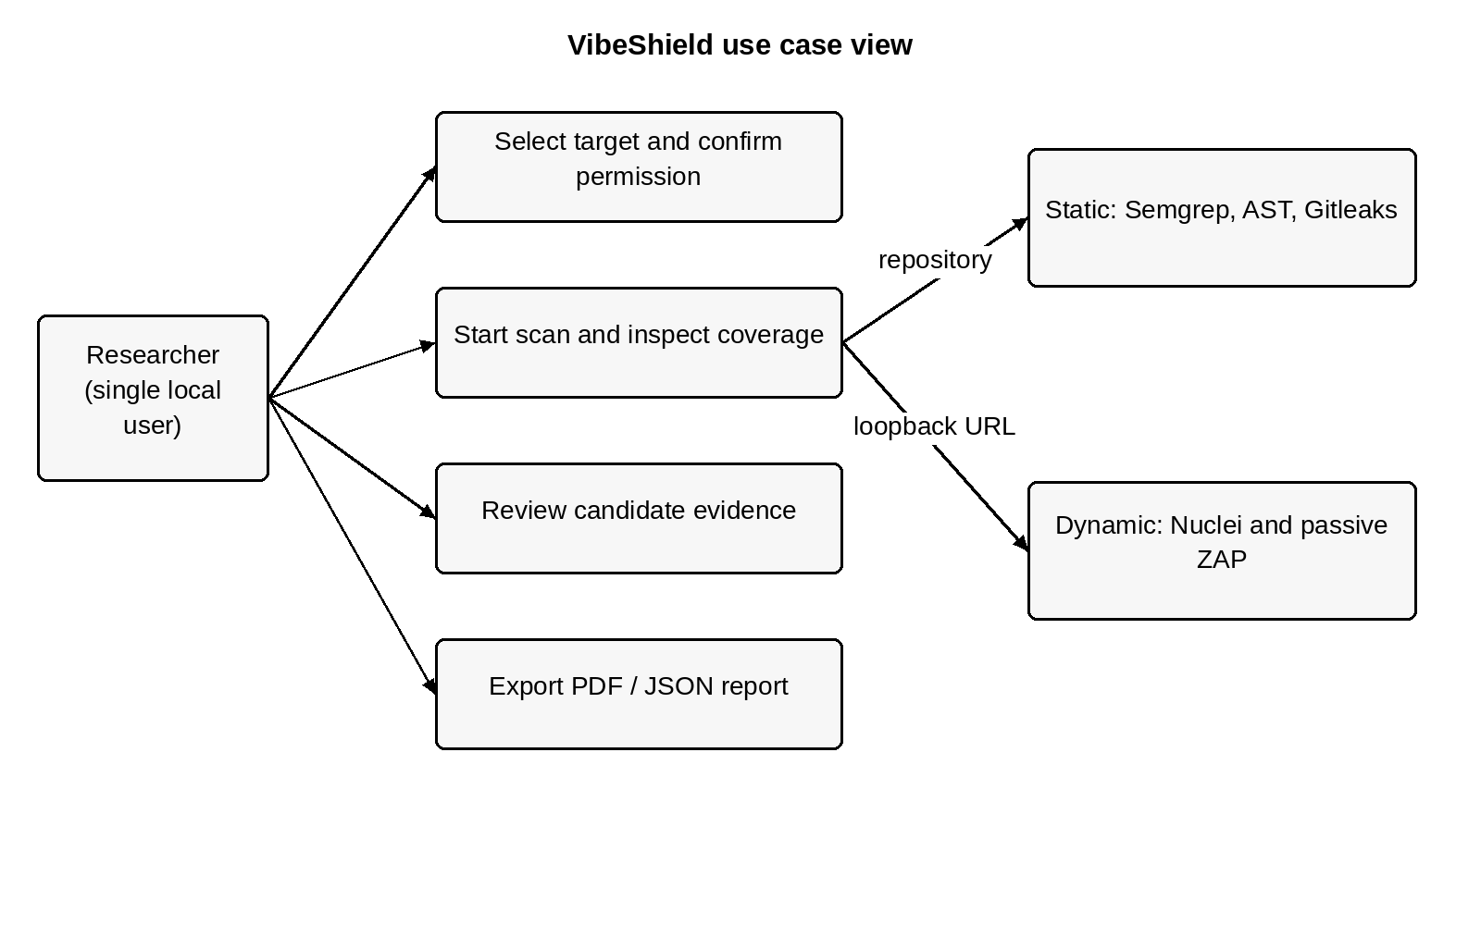
Figure 2.1: Use case diagram of the authorized assessment workflow.
The operational actor is the local researcher. The actor selects a target, confirms permission, starts a scan, reviews candidate evidence and exports a terminal report. A guide or examiner can review the exported material without being a separate account role in the application. Scanner processes are supporting components rather than human actors.

2.4 Sequential Diagram
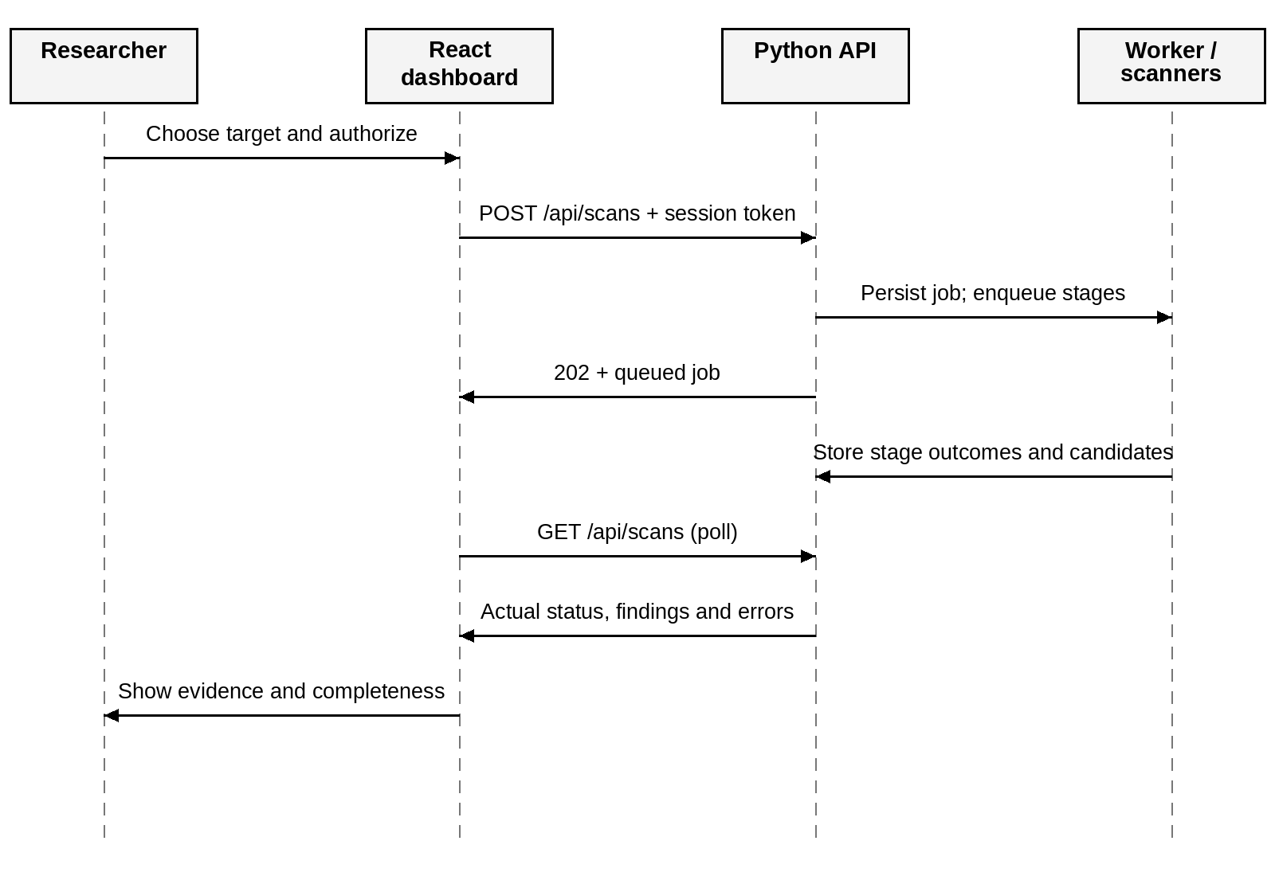
Figure 2.2: Sequence of target submission, worker execution and evidence retrieval.
The browser obtains the session token from the status endpoint and includes it in the scan request. The API persists the queued record before scheduling work. The worker writes actual stage outcomes; polling retrieves those changes. A diagnostic may coexist with valid findings, so evidence is retained even when a stage fails.

2.5 Activity Diagram
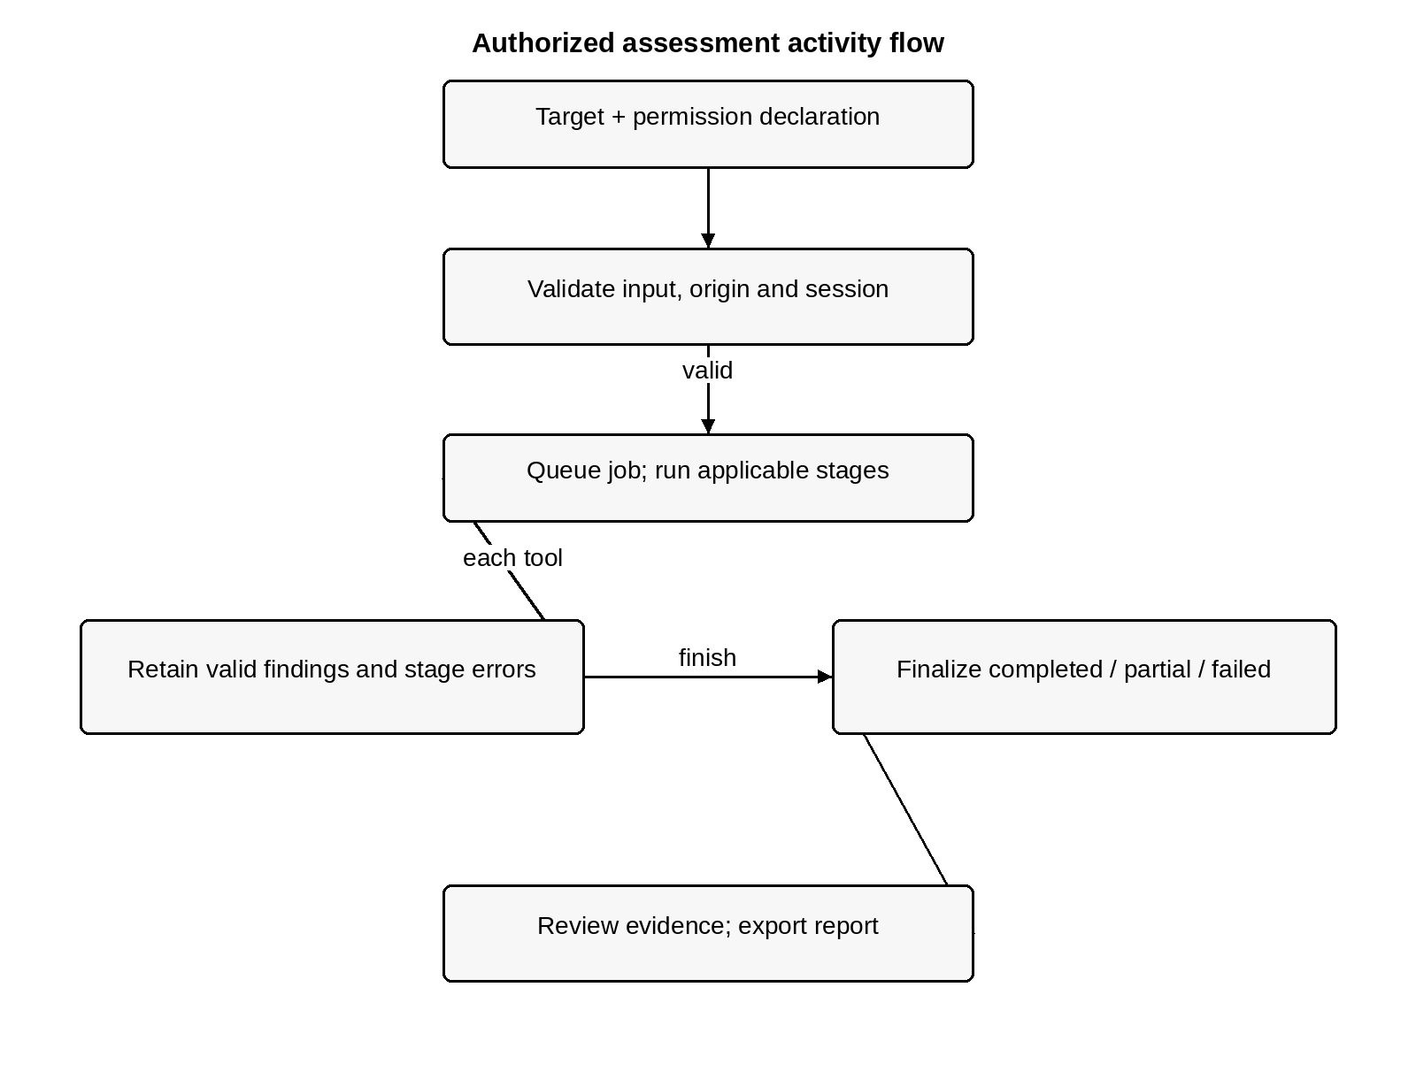
Figure 2.3: Activity flow from permission declaration to assessment export.
The normal lifecycle is queued, running and completed. Stage errors can produce partial or failed coverage, while unfinished jobs become interrupted after restart. A terminal job can be exported with its errors and limitations. None of these lifecycle states represents proof of exploitation or proof of security.

CHAPTER 3 — SYSTEM CONFIGURATION

3.1 Hardware Configuration
The project is operated locally on Linux. Processor, memory and storage specifications for the development machine are not established by the supplied source and are therefore not invented. Resource demand depends mainly on repository size, Semgrep and the Java-based ZAP runtime. The Python API itself is a small local service.
Component | Configuration / requirement
Development platform | Local Linux environment; exact machine specifications not recorded
Processor and memory | Sufficient for the selected external tools, browser and Python process
Storage | Space for dependencies, temporary checkouts, scan records and reports
Network | Needed for downloads, public GitHub acquisition and Semgrep auto rules
Display | Desktop or laptop display for reviewing source evidence

3.2 Software Configuration
Component | Purpose / requirement
Python 3.10+ | Backend, AST heuristic, adapters and CLI
React / Vite / Node.js / npm | Frontend and production asset build; use a compatible Node runtime
Semgrep / Gitleaks | Static source patterns and working-tree secret candidates
Nuclei / OWASP ZAP | Bundled header template and passive website analysis
ReportLab | PDF exports; pinned in dashboard/requirements.txt
Git / Java / Docker | Public checkouts; compatible Java for native ZAP; daemon/image for fallback

Native Windows execution has not been verified; the shared subprocess helper uses POSIX process-group handling. Package manifests, the frontend lockfile and recorded tool versions are the authority for dependency details.

CHAPTER 4 — SOFTWARE DESCRIPTION

4.1 Overview of Front End
The React application in dashboard/web/src/main.jsx renders five main views. Overview presents target type, target text, authorization, applicable tools and recent scans. Scans supports history search and lifecycle filters. Findings supports scan selection, severity filters, evidence search and a modal details view. Reports provides terminal-job downloads. Settings explains executable availability and configuration paths.
The browser fetches status and scan history every two seconds while visible. Loading, connection errors, submission progress and downloads have explicit states. Candidate rows show affected location, source, confidence and native display severity. The AST heuristic does not assign a severity, so its candidates are intentionally unrated.
Vite builds static frontend assets that the Python server serves from the same origin as the API. Manrope and icons belong to the application interface; this academic report retains the Times New Roman typography of the supplied template. Responsive navigation, keyboard focus, Escape handling for dialogs and reduced-motion support are implemented.

4.2 Overview of Back End
The backend uses ThreadingHTTPServer on 127.0.0.1 and a ScanStore that owns persistence, an in-memory index, a lock and one background worker. POST /api/scans validates consent and target scope, stores a queued record and selects static or dynamic stages. A GitHub job first performs a shallow temporary checkout and records its commit. Repository application code and package install scripts are not executed.

4.3 Scanner Technologies and Algorithms
Semgrep runs the auto configuration plus the bundled Flask rule and parses native JSON. Gitleaks runs against working-tree files and redacts secret values. The built-in AST analyzer recognizes supported Flask routes, ID-like parameters, storage lookups and inline rejecting or ownership guards. It emits IDOR-AST-01 when a recognized lookup lacks recognized protection. This is a heuristic and not a general authorization proof.
Nuclei uses one bundled missing X-Content-Type-Options: nosniff template. ZAP supports native passive analysis and compatible baseline/Docker paths. Nuclei and ZAP can report the same header observation; both source records are retained. A local URL allowlist restricts submitted targets but is not complete external-process network isolation.

4.4 Consolidation, Errors and Reporting
A candidate contains file_or_endpoint, vulnerability_type, confidence, source_tool and details. Native rule context remains in details with a CANDIDATE status. Semgrep diagnostics may carry valid concurrent findings through ScanError.findings. Missing tools, malformed output and timeouts are errors rather than clean empty assessments.
The report builder derives display severity from the native tool label, adds fixed review guidance and preserves stages, errors and limitations. Confidence and severity remain separate. PDF text is escaped before rendering. A terminal partial, failed or interrupted record can still be exported, with complete set to false.

CHAPTER 5 — SYSTEM DESIGN

5.1 Architectural Design
The architecture separates presentation, request validation, assessment processing and storage/reporting. The frontend never invokes a scanner directly. The API validates and persists a job; a worker calls adapters; the report builder projects stored evidence without making new detection decisions.
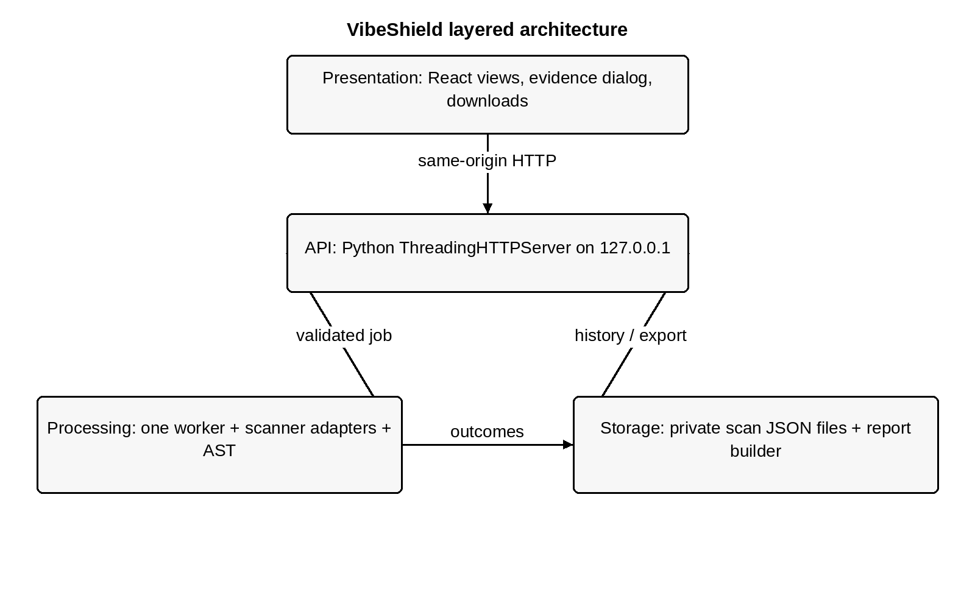
Figure 5.1: Current layered architecture of VibeShield.
Scanner adapters contain tool-specific parsing and subprocess options. Shared records support both the CLI and the dashboard. A sequential worker limits concurrent scanner demand. Local JSON storage suits the current single-user scope without introducing an external database service.

5.2 Data Flow Design
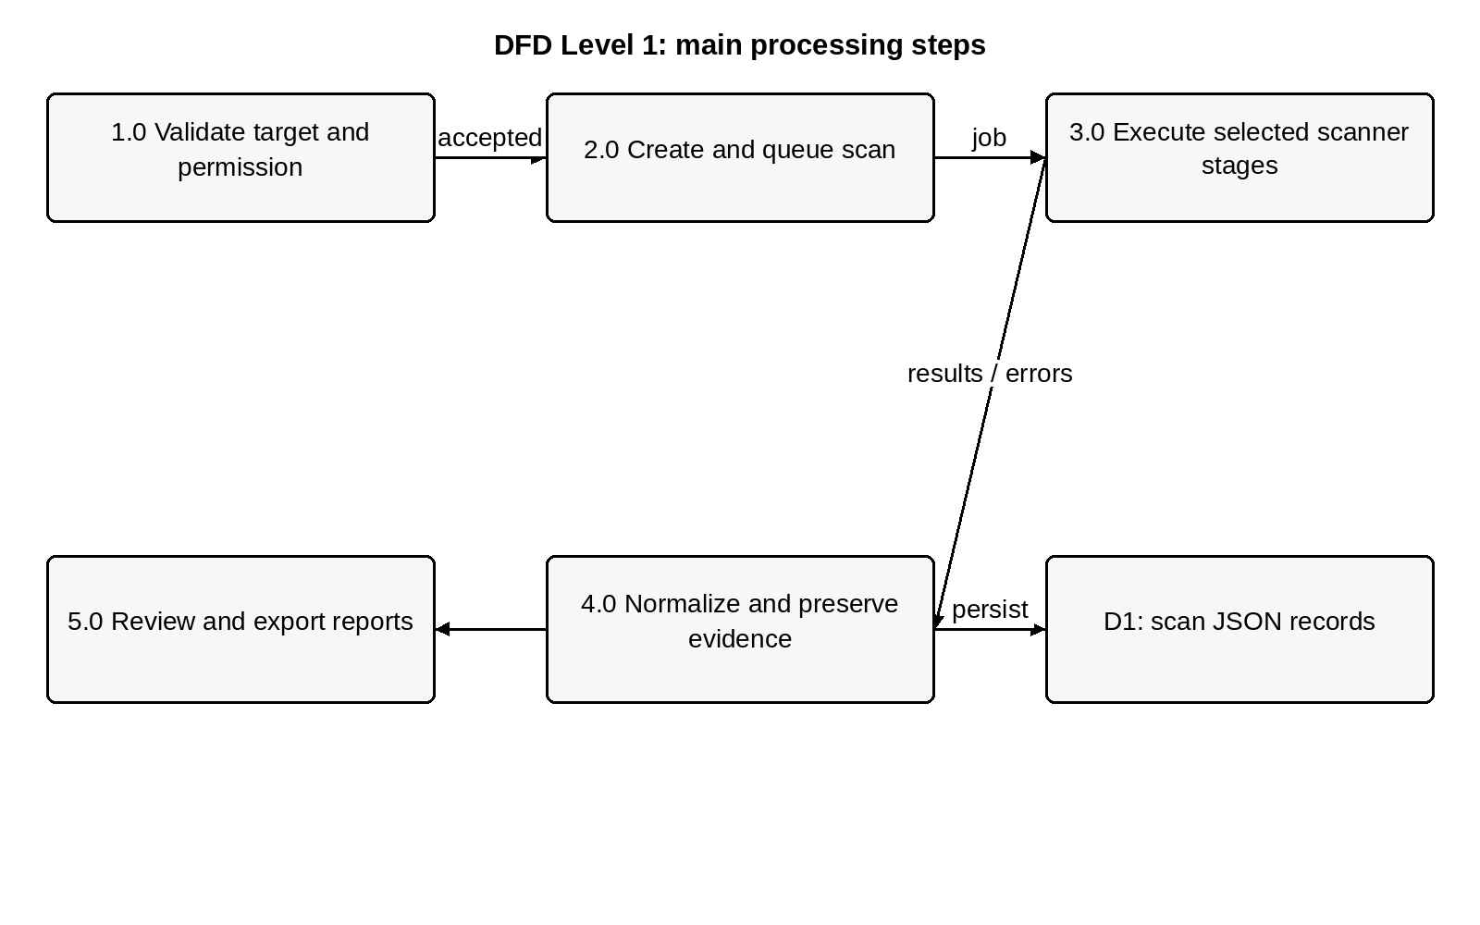
Figure 5.2: Main assessment processes and the persistent scan-record store.
A request becomes a normalized target and a persistent queued job. Applicable stages contribute candidate records and diagnostics. Atomic replacement updates each JSON file under the store lock. The browser and report endpoints read the same stored evidence. Failures remain part of the result instead of being discarded during consolidation.

5.3 Input and Output Design
Input comprises target_type, target and authorized. Target text must be nonempty and at most 2,048 characters. Website URLs accept only HTTP(S) on localhost, 127.0.0.1 or ::1, without credentials or fragments. Public GitHub input accepts an owner/repository URL, not branch paths or private credentials. Local paths must resolve to existing directories. Scan creation also checks the local Host/Origin and session token.
Outputs comprise live stage states, searchable findings, persisted job records and PDF/JSON reports. Reports describe coverage, source evidence and review limitations. A zero-candidate result is meaningful only alongside the stages and errors.

5.4 Database / Persistence Design
VibeShield uses file-based JSON persistence, not a relational application database. The default directory is .vibeshield/scans and is created with private directory permissions. A scan contains embedded stages, findings and errors, along with authorization, target metadata, timestamps and a repository commit when applicable.
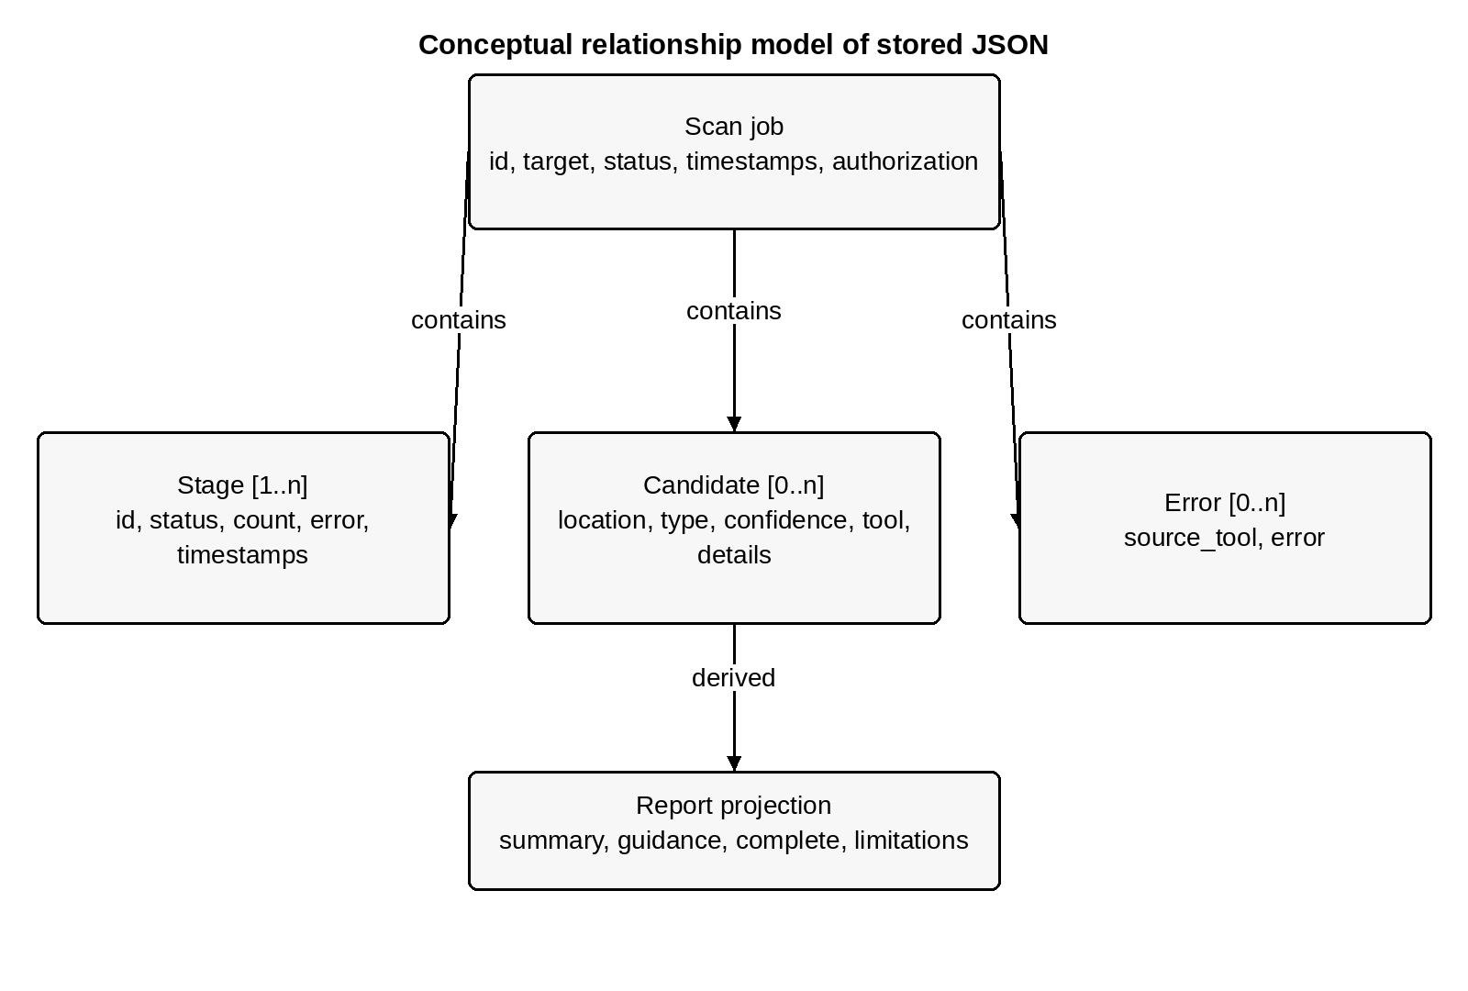
Figure 5.3: Conceptual relationships in the stored JSON assessment model.
Record | Important fields
Scan | id, target, target_type, status, timestamps, authorization, repository_commit
Stage | id, name, status, finding_count, timestamps and optional error
Candidate | file_or_endpoint, vulnerability_type, confidence, source_tool, details
Report projection | complete, summary, display_severity, recommendation and limitations

5.5 Security and Recovery Design
The server is local and single-user. Same-origin checks and X-VibeShield-Token verification protect scan submission, and responses include no-store, nosniff, frame and referrer restrictions. Static file paths are resolved within the frontend root. The request-body limit is 8,192 bytes. GitHub checkout disables prompts, hooks and credential helpers; a 200 MiB limit is checked after cloning, which does not bound download volume.
On startup, unfinished stored jobs become interrupted and receive a recovery explanation. The application does not silently resume them. Per-user access control, cancellation, retention management and a production sandbox are future work. Secret-pattern candidates are redacted, but other source context may still appear in exported reports.

CHAPTER 6 — SOURCE CODE
The following listings contain the current project implementation. They are taken from the local checkout, rather than recreated examples. The numbering, monospaced code layout and code-section spacing follow the supplied template. Long lines are wrapped for the page; this changes presentation only. The repository files remain authoritative for executable source.

6.1 Source Organisation
Area | Source files
Entry points | run_scan.py; run_dashboard.py
Scanner pipeline | pipeline/scan/common.py, run_scan.py and individual adapters
Heuristic | pipeline/scan/ast_heuristic_analyzer.py
Dashboard | dashboard/server.py; dashboard/web/src/main.jsx; src/style.css
Reporting | pipeline/report/report_builder.py
Verification | pipeline/scan/tests; dashboard/tests; dashboard/web/tests

6.2 Shared Evidence Model and Orchestration
common.py defines the raw finding and ScanError with retained findings, validates local targets and executes bounded subprocesses. run_scan.py consolidates scanner records into candidates and emits errors separately from CLI standard output.

Listing 6.1 — Shared records, scope validation and subprocess handling
Source: pipeline/scan/common.py. Line numbers refer to the current checkout; wrapped continuation lines have no repeated number.
0001 """Shared scanner records and subprocess/CLI error handling (standard library
only)."""
0002
0003 import argparse
0004 from dataclasses import asdict, dataclass
0005 import json
0006 import os
0007 from pathlib import Path
0008 import signal
0009 import subprocess
0010 import sys
0011 from urllib.parse import urlsplit
0012
0013
0014 @dataclass(frozen=True)
0015 class RawFinding:
0016 file: str
0017 line: int
0018 rule_id: str
0019 message: str
0020 severity: str
0021 source_snippet: str
0022 source: str
0023
0024
0025 class ScanError(Exception):
0026 """An incomplete scan may still carry valid findings from completed work."""
0027
0028 def __init__(self, message, findings=()):
0029 super().__init__(message)
0030 self.findings = tuple(findings)
0031
0032
0033 def run_command(command, timeout=180, cwd=None, env=None, accepted=(0,)):
0034 try:
0035 process = subprocess.Popen(command, stdout=subprocess.PIPE,
stderr=subprocess.PIPE,
0036 text=True, cwd=cwd, env=env,
start_new_session=True)
0037 try:
0038 stdout, stderr = process.communicate(timeout=timeout)
0039 except BaseException:
0040 # Kill the process group too: shell launchers may leave a Java child
behind.
0041 try:
0042 os.killpg(process.pid, signal.SIGKILL)
0043 except ProcessLookupError:
0044 pass
0045 process.communicate()
0046 raise
0047 result = subprocess.CompletedProcess(command, process.returncode, stdout,
stderr)
0048 except FileNotFoundError as exc:
0049 raise ScanError(f"Missing tool: {command[0]}. Install it or set its binary
path.") from exc
0050 except subprocess.TimeoutExpired as exc:
0051 raise ScanError(f"{command[0]} timed out after {timeout} seconds; scan
incomplete.") from exc
0052 except OSError as exc:
0053 raise ScanError(f"Cannot run {command[0]}: {exc}") from exc
0054 if result.returncode not in accepted:
0055 # Avoid echoing scanner diagnostics that may contain discovered
credentials.
0056 raise ScanError(f"{command[0]} exited with status {result.returncode};
scan incomplete.")
0057 return result
0058
0059
0060 def read_json(value, source):
0061 try:
0062 return json.loads(value)
0063 except (ValueError, TypeError) as exc:
0064 raise ScanError(f"Invalid JSON from {source}; scan incomplete.") from exc
0065
0066
0067 def repo_directory(value):
0068 path = Path(value).resolve()
0069 if not path.is_dir():
0070 raise ScanError(f"Repository directory does not exist: {path}")
0071 return path
0072
0073
0074 def local_url(value):
0075 """Development scope check, not network isolation or a redirect sandbox."""
0076 try:
0077 url = urlsplit(value)
0078 url.port # Validate a supplied port without resolving the host.
0079 except ValueError as exc:
0080 raise ScanError(f"Invalid target URL: {exc}") from exc
0081 if (url.scheme not in {"http", "https"} or
0082 url.hostname not in {"localhost", "127.0.0.1", "::1"} or
0083 url.username or url.password or url.fragment):
0084 raise ScanError("This phase accepts only http(s) localhost/127.0.0.1/[::1]
URLs without credentials or fragments.")
0085 return value
0086
0087
0088 def tool_environment():
0089 env = os.environ.copy()
0090 # No cloud credentials are needed by these local scanner processes.
0091 for key in list(env):
0092 if key.startswith(("OPENAI_", "ANTHROPIC_", "SEMGREP_APP_", "PDCP_")):
0093 env.pop(key)
0094 return env
0095
0096
0097 def run_cli(description, scan, kind="repo", default_timeout=180):
0098 parser = argparse.ArgumentParser(description=description)
0099 parser.add_argument("--repo-path" if kind == "repo" else "--url",
required=True)
0100 parser.add_argument("--timeout", type=int, default=default_timeout)
0101 args = parser.parse_args()
0102 if args.timeout <= 0:
0103 parser.error("--timeout must be positive")
0104 try:
0105 target = args.repo_path if kind == "repo" else args.url
0106 findings = scan(target, timeout=args.timeout)
0107 except (ScanError, OSError) as exc:
0108 print(json.dumps([asdict(item) for item in getattr(exc, "findings", ())],
indent=2))
0109 print(json.dumps({"error": str(exc)}), file=sys.stderr)
0110 return 2
0111 print(json.dumps([asdict(item) for item in findings], indent=2))
0112 return 0

Listing 6.2 — Candidate consolidation and command-line orchestration
Source: pipeline/scan/run_scan.py. Line numbers refer to the current checkout; wrapped continuation lines have no repeated number.
0001 """Consolidate deterministic static and local dynamic vulnerability candidates."""
0002
0003 import argparse
0004 from dataclasses import asdict, dataclass
0005 import json
0006 import sys
0007
0008 try:
0009 from . import ast_heuristic_analyzer, nuclei_runner, secrets_runner,
semgrep_runner, zap_runner
0010 from .common import ScanError
0011 except ImportError:
0012 import ast_heuristic_analyzer
0013 import nuclei_runner
0014 import secrets_runner
0015 import semgrep_runner
0016 import zap_runner
0017 from common import ScanError
0018
0019
0020 @dataclass(frozen=True)
0021 class CandidateFinding:
0022 file_or_endpoint: str
0023 vulnerability_type: str
0024 confidence: str
0025 source_tool: str
0026 details: dict
0027
0028
0029 def consolidate(finding):
0030 details = asdict(finding)
0031 details['status'] = 'CANDIDATE'
0032 if isinstance(finding, ast_heuristic_analyzer.HeuristicFinding):
0033 return CandidateFinding(finding.file, 'IDOR', finding.confidence, 'ast',
details)
0034 # Confidence describes evidence specificity, not severity or exploitability.
0035 confidence = 'HIGH' if finding.source == 'gitleaks' else 'MEDIUM'
0036 if finding.severity.upper() in {'INFO', 'INFORMATIONAL'}:
0037 confidence = 'LOW'
0038 vulnerability = 'SECRET_EXPOSURE' if finding.source == 'gitleaks' else
finding.rule_id
0039 return CandidateFinding(finding.file, vulnerability, confidence,
finding.source, details)
0040
0041
0042 def scan(repo_path=None, url=None, timeout=300):
0043 jobs = []
0044 if repo_path is not None:
0045 jobs.extend([('semgrep', semgrep_runner.scan, repo_path),
0046 ('ast', ast_heuristic_analyzer.scan, repo_path),
0047 ('gitleaks', secrets_runner.scan, repo_path)])
0048 if url is not None:
0049 jobs.extend([('nuclei', nuclei_runner.scan, url), ('zap', zap_runner.scan,
url)])
0050 findings, errors = [], []
0051 for source, runner, target in jobs:
0052 try:
0053 findings.extend(consolidate(item) for item in runner(target,
timeout=timeout))
0054 except (ScanError, OSError) as exc:
0055 findings.extend(consolidate(item) for item in getattr(exc, 'findings',
()))
0056 errors.append({'source_tool': source, 'error': str(exc)})
0057 findings.sort(key=lambda f: (f.source_tool, f.file_or_endpoint,
f.vulnerability_type,
0058 f.details.get('line', 0), json.dumps(f.details,
sort_keys=True)))
0059 return findings, errors
0060
0061
0062 def main(argv=None):
0063 parser = argparse.ArgumentParser(description=__doc__)
0064 parser.add_argument('--repo-path', help='Local checkout of an owned/authorized
GitHub repository')
0065 parser.add_argument('--url', help='Local fixture URL, e.g.
http://localhost:5000/api/health')
0066 parser.add_argument('--timeout', type=int, default=300, help='Per-tool timeout
in seconds')
0067 args = parser.parse_args(argv)
0068 if not args.repo_path and not args.url:
0069 parser.error('provide --repo-path, --url, or both')
0070 if args.timeout <= 0:
0071 parser.error('--timeout must be positive')
0072 findings, errors = scan(args.repo_path, args.url, args.timeout)
0073 print(json.dumps([asdict(item) for item in findings], indent=2))
0074 if errors:
0075 print(json.dumps({'complete': False, 'errors': errors}), file=sys.stderr)
0076 return 2
0077 return 0
0078
0079
0080 if __name__ == '__main__':
0081 raise SystemExit(main())

Listing 6.3 — Flask AST ownership heuristic
Source: pipeline/scan/ast_heuristic_analyzer.py. Line numbers refer to the current checkout; wrapped continuation lines have no repeated number.
0001 """Narrow Flask IDOR candidate discovery, not an authorization proof.
0002
0003 Recognizes literal @app/@blueprint .route/.get/.post/.put/.patch/.delete rules,
0004 ID-like path parameters used directly (or in an expression) in get/query/execute/
0005 filter/filter_by calls, including dictionary get used by the local fixture.
0006 Recognizes inline deny guards comparing that ID, or a fetched resource's owner,
0007 with common identity names, session/current_user/g.user, or token-derived aliases.
0008 A fetched-resource guard must precede further use of that resource. A bare
compare,
0009 logging-only branch, nested helper, or guard after a response is not sufficient.
0010
0011 No type inference, interprocedural analysis, SQL parsing, general control-flow
0012 proof, alias analysis for resource IDs, or support for other frameworks.
Decorator,
0013 middleware, helper-based checks, query-scoped ownership, complex branch/loop
guards,
0014 and unconventional identity/owner names can produce false positives. Name-based
0015 identity and storage recognition can be wrong. Public resources may be flagged.
0016 Only simple straight-line handlers and top-level deny guards are recognized.
0017 """
0018
0019 import ast
0020 from dataclasses import dataclass
0021 from pathlib import Path
0022 import re
0023 import tokenize
0024
0025 try:
0026 from .common import ScanError, repo_directory, run_cli
0027 except ImportError:
0028 from common import ScanError, repo_directory, run_cli
0029
0030
0031 @dataclass(frozen=True)
0032 class HeuristicFinding:
0033 file: str
0034 line: int
0035 function_name: str
0036 heuristic_id: str
0037 confidence: str
0038 reason: str
0039
0040
0041 ROUTES = {"route", "get", "post", "put", "patch", "delete", "head", "options"}
0042 LOOKUPS = {"execute", "executemany", "query", "get", "get_or_404", "filter",
"filter_by"}
0043 IDENTITIES = {"current_user", "user_id", "authenticated_user",
"authenticated_user_id", "auth_user", "uid"}
0044 OWNERS = {"owner", "owner_id", "user_id", "created_by", "author_id"}
0045 SKIP_DIRS = {".git", ".venv", "venv", "node_modules", "__pycache__"}
0046
0047
0048 def walk_local(node):
0049 """Walk an expression/statement without treating nested function bodies as
inline."""
0050 yield node
0051 for child in ast.iter_child_nodes(node):
0052 if not isinstance(child, (ast.FunctionDef, ast.AsyncFunctionDef,
ast.ClassDef, ast.Lambda)):
0053 yield from walk_local(child)
0054
0055
0056 def uses(node, names):
0057 return any(isinstance(n, ast.Name) and n.id in names for n in
walk_local(node))
0058
0059
0060 def authenticated(node, aliases, route_ids):
0061 for n in walk_local(node):
0062 if isinstance(n, ast.Name) and n.id in (IDENTITIES | aliases) - route_ids:
0063 return True
0064 if isinstance(n, ast.Subscript) and isinstance(n.value, ast.Name) and
n.value.id == "session":
0065 return True
0066 if isinstance(n, ast.Attribute):
0067 text = ast.unparse(n)
0068 if text in {"g.user", "request.authorization"} or
text.startswith(("g.user.", "request.authorization.")):
0069 return True
0070 if isinstance(n, ast.Call) and isinstance(n.func, ast.Attribute):
0071 if ast.unparse(n.func) in {"session.get", "request.headers.get"}:
0072 keys = [a.value.lower() for a in n.args if isinstance(a,
ast.Constant) and isinstance(a.value, str)]
0073 if any(k in {"authorization", "user_id", "uid", "user",
"x-auth-token"} for k in keys):
0074 return True
0075 return False
0076
0077
0078 def route_parameters(function):
0079 params = set()
0080 arguments = {a.arg for a in function.args.posonlyargs + function.args.args +
function.args.kwonlyargs}
0081 for decorator in function.decorator_list:
0082 if not (isinstance(decorator, ast.Call) and isinstance(decorator.func,
ast.Attribute)
0083 and decorator.func.attr in ROUTES):
0084 continue
0085 paths = list(decorator.args[:1]) + [k.value for k in decorator.keywords if
k.arg == "rule"]
0086 for path in paths:
0087 if isinstance(path, ast.Constant) and isinstance(path.value, str):
0088 for name in re.findall(r"<(?:[^<>:]+:)?([A-Za-z_]\w*)>",
path.value):
0089 if name in arguments and (name.lower() in {"id", "pk", "uuid"}
or
0090 name.lower().endswith(("_id", "_pk",
"_uuid"))):
0091 params.add(name)
0092 return params
0093
0094
0095 def owner_of(node, resources):
0096 if isinstance(node, ast.Attribute):
0097 return node.attr in OWNERS and uses(node.value, resources)
0098 if isinstance(node, ast.Subscript):
0099 return (isinstance(node.slice, ast.Constant) and node.slice.value in
OWNERS
0100 and uses(node.value, resources))
0101 if isinstance(node, ast.Call) and isinstance(node.func, ast.Attribute) and
node.func.attr == "get":
0102 return (uses(node.func.value, resources) and bool(node.args) and
0103 isinstance(node.args[0], ast.Constant) and node.args[0].value in
OWNERS)
0104 return False
0105
0106
0107 def rejects(body):
0108 # Require an unconditional first-statement rejection. Arbitrary returns may
leak data.
0109 if not body:
0110 return False
0111 first = body[0]
0112 if isinstance(first, ast.Raise):
0113 return True
0114 if isinstance(first, ast.Expr) and isinstance(first.value, ast.Call):
0115 call = first.value
0116 return (ast.unparse(call.func) in {"abort", "flask.abort"} and
bool(call.args)
0117 and isinstance(call.args[0], ast.Constant) and call.args[0].value
in {401, 403, 404})
0118 if isinstance(first, ast.Return) and isinstance(first.value, ast.Tuple):
0119 values = first.value.elts
0120 payload = values[0] if values else None
0121 if isinstance(payload, ast.Call) and ast.unparse(payload.func) in
{'jsonify', 'flask.jsonify'}:
0122 payload = payload.args[0] if len(payload.args) == 1 and not
payload.keywords else None
0123 try:
0124 ast.literal_eval(payload)
0125 static_payload = True
0126 except (ValueError, TypeError):
0127 static_payload = False
0128 return (len(values) >= 2 and static_payload
0129 and isinstance(values[1], ast.Constant) and values[1].value in
{401, 403, 404})
0130 return False
0131
0132
0133 def assigned_lookup(value, call):
0134 while isinstance(value, ast.Call) and isinstance(value.func, ast.Attribute):
0135 if value is call:
0136 return True
0137 if value.func.attr not in {'fetchone', 'first', 'one', 'one_or_none'}:
0138 break
0139 value = value.func.value
0140 return False
0141
0142
0143 def ownership_guard(statement, ids, resources, aliases, route_ids):
0144 if not isinstance(statement, ast.If) or not isinstance(statement.test,
ast.Compare):
0145 return False
0146 test = statement.test
0147 if len(test.ops) != 1:
0148 return False
0149 left, right = test.left, test.comparators[0]
0150 related = lambda n: (isinstance(n, ast.Name) and n.id in ids) or owner_of(n,
resources)
0151 pair = ((related(left) and authenticated(right, aliases, route_ids)) or
0152 (related(right) and authenticated(left, aliases, route_ids)))
0153 if not pair:
0154 return False
0155 return ((isinstance(test.ops[0], ast.NotEq) and rejects(statement.body)) or
0156 (isinstance(test.ops[0], ast.Eq) and rejects(statement.orelse)))
0157
0158
0159 def analyze_function(function, filename):
0160 route_ids = route_parameters(function)
0161 if not route_ids:
0162 return []
0163 aliases = set()
0164 prechecked = set()
0165 pending = []
0166 for statement in function.body:
0167 # Only guards seen in straight-line order before lookup/use can suppress a
candidate.
0168 for parameter in route_ids:
0169 if ownership_guard(statement, {parameter}, set(), aliases, route_ids):
0170 prechecked.add(parameter)
0171 for entry in pending:
0172 if not entry["used"] and ownership_guard(statement, set(),
entry["resources"], aliases, route_ids):
0173 entry["guarded"] = True
0174 if uses(statement, entry["resources"]):
0175 # Missing-resource checks are allowed between a fetch and its
ownership check.
0176 none_test = (isinstance(statement, ast.If) and
isinstance(statement.test, ast.Compare) and
0177 len(statement.test.ops) == 1 and
0178 isinstance(statement.test.ops[0], ast.Is) and
0179 isinstance(statement.test.comparators[0],
ast.Constant) and
0180 statement.test.comparators[0].value is None)
0181 falsey_test = (isinstance(statement, ast.If) and
isinstance(statement.test, ast.UnaryOp)
0182 and isinstance(statement.test.op, ast.Not)
0183 and isinstance(statement.test.operand, ast.Name)
0184 and statement.test.operand.id in
entry['resources'])
0185 missing_check = ((none_test or falsey_test) and
rejects(statement.body) and not statement.orelse)
0186 if not missing_check:
0187 entry["used"] = True
0188 calls = [n for n in walk_local(statement) if isinstance(n, ast.Call)
0189 and isinstance(n.func, ast.Attribute) and n.func.attr in LOOKUPS]
0190 for call in calls:
0191 arguments = call.args + [k.value for k in call.keywords]
0192 for parameter in sorted(route_ids):
0193 if not any(uses(arg, {parameter}) for arg in arguments) or
parameter in prechecked:
0194 continue
0195 resources = set()
0196 if isinstance(statement, (ast.Assign, ast.AnnAssign)) and
assigned_lookup(statement.value, call):
0197 targets = statement.targets if isinstance(statement,
ast.Assign) else [statement.target]
0198 resources = {t.id for t in targets if isinstance(t, ast.Name)}
0199 pending.append({"parameter": parameter, "call": call, "resources":
resources,
0200 "guarded": False, "used": False})
0201 if isinstance(statement, (ast.Assign, ast.AnnAssign)) and statement.value
is not None:
0202 targets = statement.targets if isinstance(statement, ast.Assign) else
[statement.target]
0203 for target in targets:
0204 if isinstance(target, ast.Name):
0205 if authenticated(statement.value, aliases, route_ids):
0206 aliases.add(target.id)
0207 else:
0208 aliases.discard(target.id)
0209 prechecked.discard(target.id)
0210 # Comparisons inside branching/loops aren't promoted to globally valid
guards.
0211 if isinstance(statement, (ast.If, ast.For, ast.While, ast.Try, ast.With,
ast.Match)):
0212 assigned = {n.id for n in walk_local(statement) if isinstance(n,
ast.Name) and isinstance(n.ctx, ast.Store)}
0213 prechecked.difference_update(assigned)
0214 if isinstance(statement, (ast.Return, ast.Raise)):
0215 break
0216 return [HeuristicFinding(filename, item["call"].lineno, function.name,
"IDOR-AST-01", "MEDIUM",
0217 f"Flask route parameter '{item['parameter']}' reaches
{ast.unparse(item['call'].func)}() "
0218 f"at line {item['call'].lineno}. No recognized inline
ownership deny guard compares "
0219 "the parameter with an authenticated identity before
lookup, or the fetched resource's "
0220 "owner with that identity before further use.
Authentication alone does not establish "
0221 "ownership. This is a static candidate, not a
confirmed IDOR.")
0222 for item in pending if not item["guarded"]]
0223
0224
0225 def scan(repo_path, timeout=180):
0226 repo = repo_directory(repo_path)
0227 findings = []
0228 for path in sorted(repo.rglob("*.py")):
0229 relative = path.relative_to(repo)
0230 if any(part in SKIP_DIRS for part in relative.parts) or path.is_symlink():
0231 continue
0232 try:
0233 with tokenize.open(path) as handle:
0234 tree = ast.parse(handle.read(), filename=str(relative))
0235 except (SyntaxError, UnicodeError, OSError) as exc:
0236 raise ScanError(f"Cannot parse {relative}: {exc}") from exc
0237 for node in ast.walk(tree):
0238 if isinstance(node, (ast.FunctionDef, ast.AsyncFunctionDef)):
0239 findings.extend(analyze_function(node, str(relative)))
0240 return findings
0241
0242
0243 if __name__ == "__main__":
0244 raise SystemExit(run_cli(__doc__, scan))

Listing 6.4 — Semgrep adapter and partial diagnostic handling
Source: pipeline/scan/semgrep_runner.py. Line numbers refer to the current checkout; wrapped continuation lines have no repeated number.
0001 """Run Semgrep OSS rules; missing ownership checks belong to the AST analyzer."""
0002
0003 import os
0004 import re
0005 from pathlib import Path
0006 import tempfile
0007
0008 try:
0009 from .common import RawFinding, ScanError, read_json, repo_directory, run_cli,
run_command, tool_environment
0010 except ImportError:
0011 from common import RawFinding, ScanError, read_json, repo_directory, run_cli,
run_command, tool_environment
0012
0013
0014 RULES = Path(__file__).with_name("rules") / "flask.yaml"
0015
0016
0017 def error_summary(errors, repo):
0018 """Expose diagnostic metadata, never messages/snippets that may contain
secrets."""
0019 if not isinstance(errors, list):
0020 return "Semgrep returned malformed error metadata; scan incomplete."
0021 summaries = []
0022 kinds = set()
0023 for error in errors[:5]:
0024 if not isinstance(error, dict):
0025 summaries.append("Unspecified scanner error")
0026 continue
0027 kind = error.get("type", "Unspecified scanner error")
0028 # Payload-bearing variants serialize as [tag, payload], e.g.
PartialParsing.
0029 if isinstance(kind, list) and kind:
0030 kind = kind[0]
0031 if not isinstance(kind, str) or not re.fullmatch(r"[A-Za-z][A-Za-z0-9
_-]{0,79}", kind):
0032 kind = "Unspecified scanner error"
0033 kinds.add(kind.lower())
0034 spans = error.get("spans")
0035 span = spans[0] if isinstance(spans, list) and spans and
isinstance(spans[0], dict) else {}
0036 path = error.get("path") or span.get("file")
0037 location = ""
0038 if isinstance(path, str):
0039 # Only show paths belonging to the scanned checkout.
0040 resolved = (repo / path).resolve()
0041 if resolved.is_relative_to(repo.resolve()):
0042 location = " in " + re.sub(r"[\x00-\x1f\x7f]", "?",
str(resolved.relative_to(repo.resolve())))[:240]
0043 start = span.get("start") or error.get("start")
0044 if location and isinstance(start, dict) and type(start.get("line")) is
int:
0045 location += f":{start['line']}"
0046 summaries.append(kind + location)
0047 extra = f"; {len(errors) - 5} more errors" if len(errors) > 5 else ""
0048 hint = "Review the affected file/rule with Semgrep locally."
0049 if any("pars" in kind or "syntax" in kind for kind in kinds):
0050 hint = "Some source regions could not be parsed. HTML containing template
syntax may not be fully supported; this does not by itself mean the application
syntax is invalid. Exclude a file only if it is intentionally outside scan scope."
0051 elif any("timeout" in kind for kind in kinds):
0052 hint = "A rule/file exceeded Semgrep's internal timeout; review that rule
or its timeout setting."
0053 return f"Semgrep reported {len(errors)} diagnostic(s): {';
'.join(summaries)}{extra}. Scan incomplete. {hint}"
0054
0055
0056 def parse_output(output, repo):
0057 report = read_json(output, "Semgrep")
0058 if not isinstance(report, dict) or not isinstance(report.get("results"),
list):
0059 raise ScanError("Semgrep report has no results list.")
0060 findings = []
0061 try:
0062 for item in report["results"]:
0063 extra = item["extra"]
0064 line = int(item["start"]["line"])
0065 filename = item["path"]
0066 snippet = extra.get("lines", "")
0067 if not snippet or snippet == "requires login":
0068 source = (repo / filename).resolve()
0069 snippet = ""
0070 if source.is_relative_to(repo):
0071 lines = source.read_text(errors="replace").splitlines()
0072 if 0 < line <= len(lines):
0073 snippet = lines[line - 1]
0074 findings.append(RawFinding(filename, line, item["check_id"],
0075 extra["message"], extra["severity"],
snippet, "semgrep"))
0076 except (KeyError, TypeError, ValueError, AttributeError, OSError) as exc:
0077 raise ScanError("Malformed Semgrep finding or unreadable source.") from
exc
0078 if report.get("errors"):
0079 raise ScanError(error_summary(report["errors"], repo), findings=findings)
0080 return findings
0081
0082
0083 def scan(repo_path, timeout=180, configs=None):
0084 repo = repo_directory(repo_path)
0085 selected_configs = configs if configs is not None else ["auto", str(RULES)]
0086 # Semgrep's auto resolver requires metrics; pinned local rules can disable
them.
0087 metrics = "auto" if "auto" in selected_configs else "off"
0088 command = [os.environ.get("SEMGREP_BIN", "semgrep"), "scan", "--json",
0089 f"--metrics={metrics}", "--disable-version-check", "--jobs", "1"]
0090 for config in selected_configs:
0091 command.extend(["--config", str(config)])
0092 command.append(str(repo))
0093 with tempfile.TemporaryDirectory(prefix="vibeshield-semgrep-") as directory:
0094 env = tool_environment()
0095 env.update(SEMGREP_SETTINGS_FILE=str(Path(directory) / "settings.yml"),
0096 SEMGREP_LOG_FILE=str(Path(directory) / "semgrep.log"),
0097 SEMGREP_SEND_METRICS=metrics, SEMGREP_ENABLE_VERSION_CHECK="0")
0098 result = run_command(command, timeout, cwd=repo, env=env)
0099 return parse_output(result.stdout, repo)
0100
0101
0102 if __name__ == "__main__":
0103 raise SystemExit(run_cli(__doc__, scan))

Listing 6.5 — Gitleaks adapter and redacted secret candidates
Source: pipeline/scan/secrets_runner.py. Line numbers refer to the current checkout; wrapped continuation lines have no repeated number.
0001 """Scan working-tree files with Gitleaks; report redacted secret candidates."""
0002
0003 import os
0004 from pathlib import Path
0005 import tempfile
0006
0007 try:
0008 from .common import RawFinding, ScanError, read_json, repo_directory, run_cli,
run_command, tool_environment
0009 except ImportError:
0010 from common import RawFinding, ScanError, read_json, repo_directory, run_cli,
run_command, tool_environment
0011
0012
0013 def parse_output(output):
0014 report = read_json(output, 'Gitleaks')
0015 if not isinstance(report, list):
0016 raise ScanError('Gitleaks report must be a list.')
0017 try:
0018 return [RawFinding(item['File'], int(item['StartLine']), item['RuleID'],
0019 item['Description'], 'HIGH', '[REDACTED]', 'gitleaks')
for item in report]
0020 except (KeyError, TypeError, ValueError) as exc:
0021 raise ScanError('Malformed Gitleaks finding.') from exc
0022
0023
0024 def scan(repo_path, timeout=180):
0025 repo = repo_directory(repo_path)
0026 with tempfile.TemporaryDirectory(prefix='vibeshield-gitleaks-') as directory:
0027 report = Path(directory) / 'report.json'
0028 result = run_command([os.environ.get('GITLEAKS_BIN', 'gitleaks'), 'dir',
str(repo),
0029 '--report-format', 'json', '--report-path',
str(report),
0030 '--redact=100', '--no-banner', '--exit-code', '10'],
0031 timeout, cwd=directory, env=tool_environment(),
accepted=(0, 10))
0032 if not report.is_file():
0033 raise ScanError('Gitleaks did not write its report; scan incomplete.')
0034 findings = parse_output(report.read_text())
0035 if (result.returncode == 10) != bool(findings):
0036 raise ScanError('Gitleaks exit status and report disagree; scan
incomplete.')
0037 return findings
0038
0039
0040 if __name__ == '__main__':
0041 raise SystemExit(run_cli(__doc__, scan))

Listing 6.6 — Nuclei local-template adapter
Source: pipeline/scan/nuclei_runner.py. Line numbers refer to the current checkout; wrapped continuation lines have no repeated number.
0001 """Run deterministic local HTTP templates. Nuclei and ZAP results may overlap."""
0002
0003 import os
0004 from pathlib import Path
0005 import tempfile
0006
0007 try:
0008 from .common import RawFinding, ScanError, local_url, read_json, run_cli,
run_command, tool_environment
0009 except ImportError:
0010 from common import RawFinding, ScanError, local_url, read_json, run_cli,
run_command, tool_environment
0011
0012
0013 TEMPLATES = Path(__file__).with_name('templates')
0014
0015
0016 def parse_output(output):
0017 findings = []
0018 for number, line in enumerate(output.splitlines(), 1):
0019 if not line.strip():
0020 continue
0021 item = read_json(line, f'Nuclei line {number}')
0022 try:
0023 info = item['info']
0024 findings.append(RawFinding(item['matched-at'], 0, item['template-id'],
0025 info['name'], info['severity'].upper(), '',
'nuclei'))
0026 except (KeyError, TypeError, AttributeError) as exc:
0027 raise ScanError(f'Malformed Nuclei finding on line {number}.') from
exc
0028 return findings
0029
0030
0031 def scan(url, timeout=180):
0032 target = local_url(url)
0033 with tempfile.TemporaryDirectory(prefix='vibeshield-nuclei-') as directory:
0034 config = Path(directory) / 'config.yaml'
0035 config.write_text('{}\n')
0036 env = tool_environment()
0037 for kind in ('CONFIG', 'CACHE', 'DATA'):
0038 state = Path(directory) / kind.lower()
0039 state.mkdir()
0040 env[f'XDG_{kind}_HOME'] = str(state)
0041 # Use only the reviewed, bundled HTTP templates. No AI generation, cloud
upload,
0042 # template download, out-of-band callbacks, or cross-host redirects.
0043 for provider in ('PUBLIC', 'GITHUB', 'GITLAB', 'AWS', 'AZURE'):
0044 env[f'DISABLE_NUCLEI_TEMPLATES_{provider}_DOWNLOAD'] = 'true'
0045 command = [os.environ.get('NUCLEI_BIN', 'nuclei'), '-u', target, '-jsonl',
0046 '-silent', '-no-color', '-omit-raw', '-duc', '-ni', '-dr',
0047 '-config', str(config), '-t', str(TEMPLATES), '-rl', '5', '-c',
'1']
0048 result = run_command(command, timeout, cwd=directory, env=env)
0049 return parse_output(result.stdout)
0050
0051
0052 if __name__ == '__main__':
0053 raise SystemExit(run_cli(__doc__, scan, kind='url'))

Listing 6.7 — Passive ZAP integration and fallback modes
Source: pipeline/scan/zap_runner.py. Line numbers refer to the current checkout; wrapped continuation lines have no repeated number.
0001 """Run a local ZAP passive baseline. Findings may overlap Nuclei; no
deduplication."""
0002
0003 import json
0004 import os
0005 from pathlib import Path
0006 import shutil
0007 import tempfile
0008 import uuid
0009
0010 try:
0011 from .common import RawFinding, ScanError, local_url, read_json, run_cli,
run_command, tool_environment
0012 except ImportError:
0013 from common import RawFinding, ScanError, local_url, read_json, run_cli,
run_command, tool_environment
0014
0015
0016 DEFAULT_IMAGE = 'ghcr.io/zaproxy/zaproxy:stable'
0017 SEVERITIES = {'0': 'INFO', '1': 'LOW', '2': 'MEDIUM', '3': 'HIGH'}
0018
0019
0020 def parse_output(output):
0021 report = read_json(output, 'ZAP')
0022 if not isinstance(report, dict) or not isinstance(report.get('site'), list) or
not report['site']:
0023 raise ScanError('ZAP report has no scanned site; scan incomplete.')
0024 findings = []
0025 try:
0026 for site in report['site']:
0027 if not isinstance(site['alerts'], list):
0028 raise TypeError('alerts must be a list')
0029 for alert in site['alerts']:
0030 instances = alert.get('instances') or [{'uri': site['@name']}]
0031 for instance in instances:
0032 findings.append(RawFinding(instance['uri'], 0,
str(alert['pluginid']),
0033 alert.get('name') or
alert['alert'],
0034 SEVERITIES[str(alert['riskcode'])],
'', 'zap'))
0035 except (KeyError, TypeError) as exc:
0036 raise ScanError('Malformed ZAP finding.') from exc
0037 return findings
0038
0039
0040 def scan_native(target, binary, directory, timeout):
0041 """Equivalent passive baseline via ZAP's official Automation Framework CLI."""
0042 report = Path(directory) / 'report.json'
0043 plan = {
0044 'env': {
0045 'contexts': [{'name': 'local-fixture', 'urls': [target]}],
0046 'parameters': {'failOnError': True, 'failOnWarning': True,
'progressToStdout': False},
0047 },
0048 'jobs': [
0049 {'type': 'passiveScan-config', 'parameters': {'scanOnlyInScope':
True}},
0050 {'type': 'spider', 'parameters': {'context': 'local-fixture', 'url':
target, 'maxDuration': 1}},
0051 {'type': 'passiveScan-wait', 'parameters': {'maxDuration': 2}},
0052 {'type': 'report', 'parameters': {'template': 'traditional-json',
'reportDir': directory,
0053 'reportFile': 'report.json',
'reportTitle': 'Local fixture baseline'}},
0054 ],
0055 }
0056 plan_file = Path(directory) / 'baseline.yaml'
0057 # JSON is a YAML subset: the wrapper needs no YAML dependency.
0058 plan_file.write_text(json.dumps(plan))
0059 command = [binary, '-cmd', '-silent', '-host', '127.0.0.1', '-dir',
str(Path(directory) / 'state'),
0060 '-autorun', str(plan_file), '-config',
'autoupdate.checkOnStart=false',
0061 '-config', 'autoupdate.downloadNewRelease=false']
0062 # AF statuses 1/2 mean plan errors/warnings, unlike packaged-baseline
statuses.
0063 run_command(command, timeout, cwd=directory, env=tool_environment())
0064 if not report.is_file():
0065 raise ScanError('ZAP CLI did not write its JSON report; scan incomplete.')
0066 return parse_output(report.read_text())
0067
0068
0069 def scan(url, timeout=300, mode='auto', image=None):
0070 target = local_url(url)
0071 if mode not in {'auto', 'cli', 'docker', 'native'}:
0072 raise ScanError('ZAP mode must be auto, cli, native, or docker.')
0073 baseline = os.environ.get('ZAP_BIN') or shutil.which('zap-baseline.py')
0074 native = os.environ.get('ZAP_CLI_BIN') or shutil.which('zap.sh')
0075 use_docker = mode == 'docker' or (mode == 'auto' and not baseline)
0076 with tempfile.TemporaryDirectory(prefix='vibeshield-zap-') as directory:
0077 if mode == 'native' or (mode == 'auto' and native and not baseline):
0078 return scan_native(target, native or 'zap.sh', directory, timeout)
0079 report = Path(directory) / 'report.json'
0080 container_name = 'vibeshield-zap-' + uuid.uuid4().hex[:12]
0081 arguments = ['-t', target, '-J', 'report.json' if use_docker else
str(report),
0082 '-m', '1', '-T', '2', '-z',
0083 '-silent -host 127.0.0.1 -config
api.addrs.addr.name=127.0.0.1 '
0084 '-config api.addrs.addr.regex=false -config
autoupdate.checkOnStart=false '
0085 '-config autoupdate.downloadNewRelease=false']
0086 if use_docker:
0087 # Linux host networking makes loopback refer to the local fixture
host.
0088 command = [os.environ.get('DOCKER_BIN', 'docker'), 'run', '--rm',
'--name', container_name,
0089 '--network', 'host', '--user',
f'{os.getuid()}:{os.getgid()}',
0090 '--mount', f'type=bind,source={directory},target=/zap/wrk',
0091 os.environ.get('ZAP_IMAGE', image or DEFAULT_IMAGE),
'zap-baseline.py', *arguments]
0092 else:
0093 command = [baseline or 'zap-baseline.py', *arguments]
0094 try:
0095 run_command(command, timeout, cwd=directory, env=tool_environment(),
accepted=(0, 1, 2))
0096 if not report.is_file():
0097 raise ScanError('ZAP did not write its JSON report; scan
incomplete.')
0098 return parse_output(report.read_text())
0099 finally:
0100 if use_docker:
0101 # A timed-out Docker client can leave its container running.
0102 try:
0103 run_command([command[0], 'rm', '-f', container_name],
timeout=15, accepted=(0, 1))
0104 except ScanError:
0105 pass
0106
0107
0108 if __name__ == '__main__':
0109 raise SystemExit(run_cli(__doc__, scan, kind='url', default_timeout=300))

Listing 6.8 — Dashboard API, validation, persistence and worker
Source: dashboard/server.py. Line numbers refer to the current checkout; wrapped continuation lines have no repeated number.
0001 """Local-only dashboard API and background scanner jobs. No LLM integration."""
0002 import argparse
0003 from concurrent.futures import ThreadPoolExecutor
0004 from copy import deepcopy
0005 from dataclasses import asdict
0006 from datetime import datetime, timezone
0007 from http.server import BaseHTTPRequestHandler, ThreadingHTTPServer
0008 import ipaddress
0009 import json
0010 import mimetypes
0011 import os
0012 from pathlib import Path
0013 import re
0014 import secrets
0015 import shutil
0016 import subprocess
0017 import sys
0018 import tempfile
0019 from threading import Lock
0020 from urllib.parse import urlsplit, unquote
0021 import uuid
0022
0023 ROOT = Path(__file__).resolve().parents[1]
0024 sys.path.insert(0, str(ROOT))
0025 from pipeline.scan import ast_heuristic_analyzer, nuclei_runner, secrets_runner,
semgrep_runner, zap_runner
0026 from pipeline.scan.common import ScanError, local_url, repo_directory,
run_command, tool_environment
0027 from pipeline.scan.run_scan import consolidate
0028 from pipeline.report.report_builder import json_report, pdf_report
0029
0030 TOOLS = [('semgrep', 'Semgrep', semgrep_runner.scan), ('ast', 'Python AST',
ast_heuristic_analyzer.scan),
0031 ('gitleaks', 'Gitleaks', secrets_runner.scan), ('nuclei', 'Nuclei',
nuclei_runner.scan), ('zap', 'OWASP ZAP', zap_runner.scan)]
0032 TERMINAL = {'completed', 'partial', 'failed', 'interrupted'}
0033
0034
0035 def now():
0036 return datetime.now(timezone.utc).isoformat()
0037
0038
0039 def available_tools():
0040 def exists(variable, binary):
0041 path = os.environ.get(variable, binary)
0042 return bool(shutil.which(path))
0043 readiness = {'ast': True, 'semgrep': exists('SEMGREP_BIN','semgrep'),
0044 'gitleaks': exists('GITLEAKS_BIN','gitleaks'), 'nuclei':
exists('NUCLEI_BIN','nuclei'),
0045 'zap': exists('ZAP_BIN','zap-baseline.py') or
exists('ZAP_CLI_BIN','zap.sh')}
0046 docker = exists('DOCKER_BIN','docker')
0047 return [{'id': key, 'name': name, 'available': readiness[key],
0048 'note': ('Docker fallback requires a running daemon and ZAP image' if
key == 'zap' and not readiness[key] and docker else
0049 'Ready' if readiness[key] else 'Executable not found'),
0050 'mode': 'static' if key in {'semgrep','ast','gitleaks'} else
'dynamic'} for key,name,_ in TOOLS]
0051
0052
0053 def validate_target(kind, target):
0054 if not isinstance(target, str) or not target.strip() or len(target) > 2048:
0055 raise ScanError('Enter a target of at most 2,048 characters.')
0056 target = target.strip()
0057 if kind == 'website':
0058 if '://' not in target:
0059 if target == '::1': target = '[::1]'
0060 target = 'http://' + target
0061 return local_url(target)
0062 if kind == 'github':
0063 match = re.fullmatch(r'(?:https://)?github\.com/([A-Za-z0-9][A-Za-z0-9-]*)
/([A-Za-z0-9_.-]+)/?', target)
0064 if not match:
0065 raise ScanError('Use a public GitHub repository URL:
https://github.com/owner/repository. Branch URLs and credentials are not
supported.')
0066 owner, repo = match.groups()
0067 if repo.endswith('.git'): repo = repo[:-4]
0068 if not repo or repo in {'.','..'}:
0069 raise ScanError('Enter a valid GitHub repository name.')
0070 return f'https://github.com/{owner}/{repo}.git'
0071 if kind == 'local':
0072 path = Path(target).expanduser()
0073 return str(repo_directory(path if path.is_absolute() else ROOT / path))
0074 raise ScanError('Choose Website / IP, GitHub repository, or Local project.')
0075
0076
0077 class ScanStore:
0078 def __init__(self, directory):
0079 self.directory = Path(directory)
0080 self.directory.mkdir(parents=True, exist_ok=True)
0081 self.directory.chmod(0o700)
0082 self.lock = Lock()
0083 self.jobs = {}
0084 self.executor = ThreadPoolExecutor(max_workers=1,
thread_name_prefix='vibeshield')
0085 for path in self.directory.glob('*.json'):
0086 try:
0087 job = json.loads(path.read_text())
0088 if job['status'] not in TERMINAL:
0089 job['status'] = 'interrupted'; job['finished_at'] = now()
0090
job['errors'].append({'source_tool':'orchestrator','error':'The dashboard stopped
before this scan completed. Run a new scan.'})
0091 for stage in job['stages']:
0092 if stage['status'] in {'queued','running'}:
stage['status'] = 'interrupted'
0093 self.persist(job)
0094 self.jobs[job['id']] = job
0095 except (ValueError, KeyError, OSError):
0096 continue
0097
0098 def persist(self, job):
0099 dest = self.directory / (job['id'] + '.json')
0100 temp = dest.with_suffix('.tmp')
0101 temp.write_text(json.dumps(job, ensure_ascii=False, indent=2));
temp.replace(dest)
0102
0103 def get(self, job_id):
0104 with self.lock:
0105 return deepcopy(self.jobs.get(job_id))
0106
0107 def list(self):
0108 with self.lock:
0109 return [deepcopy(j) for j in sorted(self.jobs.values(),key=lambda
j:j['created_at'],reverse=True)]
0110
0111 def change(self, job_id, update):
0112 with self.lock:
0113 update(self.jobs[job_id]); self.persist(self.jobs[job_id])
0114
0115 def create(self, body):
0116 if body.get('authorized') is not True:
0117 raise ScanError('Confirm that you own the target or have permission to
test it.')
0118 kind = body.get('target_type')
0119 target = validate_target(kind, body.get('target'))
0120 selected = TOOLS[3:] if kind == 'website' else TOOLS[:3]
0121 stages = [{'id':key,'name':name,'status':'queued','finding_count':0} for
key,name,_ in selected]
0122 if kind == 'github': stages.insert(0, {'id':'checkout','name':'GitHub
checkout','status':'queued','finding_count':0})
0123 job = {'id':uuid.uuid4().hex[:12], 'target':target, 'target_type':kind,
0124 'status':'queued', 'created_at':now(), 'started_at':None,
'finished_at':None,
0125
'authorization':{'confirmed':True,'confirmed_at':now(),'scope':'local website or
authorized static repository'},
0126 'stages':stages,'findings':[],'errors':[],
'repository_commit':None}
0127 with self.lock:
0128 if sum(j['status'] not in TERMINAL for j in self.jobs.values()) >= 5:
0129 raise ScanError('Five scans are already queued or running. Wait
for one to finish.')
0130 self.jobs[job['id']] = job; self.persist(job)
0131 self.executor.submit(self.execute, job['id'])
0132 return self.get(job['id'])
0133
0134 def stage(self, job_id, key, **values):
0135 def update(job):
0136 next(s for s in job['stages'] if s['id']==key).update(values)
0137 self.change(job_id, update)
0138
0139 def execute(self, job_id):
0140 job = self.get(job_id)
0141 self.change(job_id, lambda j:j.update(status='running', started_at=now()))
0142 temp = None
0143 try:
0144 target = job['target']
0145 if job['target_type'] == 'github':
0146 self.stage(job_id,'checkout',status='running',started_at=now())
0147 temp = tempfile.TemporaryDirectory(prefix='vibeshield-repo-')
0148 checkout = Path(temp.name) / 'repository'
0149 env = tool_environment(); env['GIT_TERMINAL_PROMPT']='0';
env['GIT_CONFIG_NOSYSTEM']='1'
0150 # Do not use user Git configuration, credential helpers, hooks, or
submodules.
0151 env['GIT_CONFIG_GLOBAL']=os.devnull
0152 git = os.environ.get('GIT_BIN','git')
0153
run_command([git,'-c','core.hooksPath='+os.devnull,'-c','credential.helper=',
0154 '-c','protocol.file.allow=never','clone','--depth','1
','--no-tags','--single-branch',target,str(checkout)],120,env=env)
0155 size = sum(p.stat().st_size for p in checkout.rglob('*') if
p.is_file() and not p.is_symlink())
0156 if size > 200 * 1024 * 1024:
0157 raise ScanError('Checkout exceeds the 200 MiB analysis
limit.')
0158 commit =
run_command([git,'-C',str(checkout),'rev-parse','HEAD'],15,env=env).stdout.strip()
0159 self.change(job_id,lambda j:j.update(repository_commit=commit))
0160 self.stage(job_id,'checkout',status='completed',finished_at=now())
0161 target = str(checkout)
0162 selected = TOOLS[3:] if job['target_type']=='website' else TOOLS[:3]
0163 for key,name,runner in selected:
0164 self.stage(job_id,key,status='running',started_at=now())
0165 try:
0166 diagnostic = None
0167 try:
0168 raw = runner(target, timeout=300)
0169 except ScanError as exc:
0170 raw = exc.findings
0171 diagnostic = exc
0172 findings = [asdict(consolidate(f)) for f in raw]
0173 for item in findings:
0174 if job['target_type'] != 'website':
0175 for container,field in
[(item,'file_or_endpoint'),(item['details'],'file')]:
0176 value = container.get(field,'')
0177 try: container[field] =
str(Path(value).relative_to(target))
0178 except ValueError: pass
0179 def update(j):
0180 j['findings'].extend(findings)
0181 self.change(job_id,update)
0182 self.stage(job_id,key,status='completed',finding_count=len(fin
dings),finished_at=now())
0183 if diagnostic is not None:
0184 raise diagnostic
0185 except (ScanError, OSError) as exc:
0186 message = str(exc)
0187
self.stage(job_id,key,status='failed',error=message,finished_at=now())
0188 self.change(job_id,lambda
j:j['errors'].append({'source_tool':key,'error':message}))
0189 current = self.get(job_id)
0190 completed = [s for s in current['stages'] if s['status']=='completed'
and s['id']!='checkout']
0191 status = 'completed' if not current['errors'] else 'partial' if
completed else 'failed'
0192 self.change(job_id,lambda j:j.update(status=status,finished_at=now()))
0193 except Exception as exc:
0194 # Unexpected exceptions are a failure, never a completed empty scan.
0195 message = str(exc) if isinstance(exc,(ScanError,OSError)) else
'Unexpected scanner error. Check the local server log.'
0196 if not isinstance(exc,(ScanError,OSError)):
0197 print(f'Scan {job_id}: {type(exc).__name__}', file=sys.stderr)
0198 def fail(j):
0199 j.update(status='failed',finished_at=now())
0200 j['errors'].append({'source_tool':'orchestrator','error':message})
0201 for stage in j['stages']:
0202 if stage['status']=='running':
stage.update(status='failed',error=message)
0203 elif stage['status']=='queued': stage['status']='skipped'
0204 self.change(job_id,fail)
0205 finally:
0206 if temp: temp.cleanup()
0207
0208
0209 class DashboardServer(ThreadingHTTPServer):
0210 daemon_threads = True
0211 def __init__(self, address, store, web_root):
0212 self.store=store; self.web_root=Path(web_root).resolve();
self.csrf=secrets.token_urlsafe(32)
0213 super().__init__(address, Handler)
0214
0215
0216 class Handler(BaseHTTPRequestHandler):
0217 server_version = 'VibeShield/1.0'
0218 def log_message(self, fmt, *args):
0219 if '/api/' not in self.path: super().log_message(fmt,*args)
0220
0221 def trusted(self):
0222 host = self.headers.get('Host','')
0223 allowed =
{f'localhost:{self.server.server_port}',f'127.0.0.1:{self.server.server_port}'}
0224 if host not in allowed: return False
0225 origin = self.headers.get('Origin')
0226 return not origin or origin in {'http://'+h for h in allowed}
0227
0228 def send(self, status, data, content_type='application/json', filename=None):
0229 if not isinstance(data, bytes): data=json.dumps(data).encode()
0230 self.send_response(status)
0231 self.send_header('Content-Type',content_type);
self.send_header('Content-Length',str(len(data)))
0232 self.send_header('Cache-Control','no-store');
self.send_header('X-Content-Type-Options','nosniff')
0233 self.send_header('Referrer-Policy','no-referrer');
self.send_header('X-Frame-Options','DENY')
0234 self.send_header('Content-Security-Policy',"default-src 'self'; script-src
'self'; style-src 'self' 'unsafe-inline'; font-src 'self'; img-src 'self' data:;
connect-src 'self'; frame-ancestors 'none'; base-uri 'none'")
0235 if filename: self.send_header('Content-Disposition',f'attachment;
filename="{filename}"')
0236 self.end_headers(); self.wfile.write(data)
0237
0238 def do_GET(self):
0239 if not self.trusted(): return self.send(403,{'error':'Only same-origin
localhost access is allowed.'})
0240 path = urlsplit(self.path).path
0241 if path == '/api/status':
0242 return self.send(200,{'tools':available_tools(),'csrf_token':self.serv
er.csrf,'scope':'local-only',
0243 'fixture_path':'fixtures/idor-notes-app','fixtur
e_url':'http://127.0.0.1:5000/api/health',
0244
'git_available':bool(shutil.which(os.environ.get('GIT_BIN','git'))),
0245 'pdf_available':__import__('importlib.util',from
list=['util']).find_spec('reportlab') is not None})
0246 if path == '/api/documentation.pdf':
0247 document = ROOT / 'docs' / 'VibeShield_Project_Documentation.pdf'
0248 if not document.is_file(): return self.send(404, {'error': 'Project
documentation has not been generated.'})
0249 return self.send(200, document.read_bytes(), 'application/pdf',
document.name)
0250 if path == '/api/scans': return
self.send(200,{'scans':self.server.store.list()})
0251 match =
re.fullmatch(r'/api/scans/([a-f0-9]{12})(?:/report\.(pdf|json))?',path)
0252 if match:
0253 job = self.server.store.get(match[1])
0254 if not job: return self.send(404,{'error':'Scan not found.'})
0255 if match[2]:
0256 if job['status'] not in TERMINAL: return
self.send(409,{'error':'The scan is still running. Reports are available when it
finishes.'})
0257 try: content = pdf_report(job) if match[2]=='pdf' else
json_report(job)
0258 except ImportError: return self.send(503,{'error':'PDF rendering
is unavailable. Install dashboard/requirements.txt or download JSON.'})
0259 return self.send(200,content,'application/pdf' if match[2]=='pdf'
else 'application/json',f'vibeshield-{job["id"]}.{match[2]}')
0260 return self.send(200,job)
0261 if path.startswith('/api/'): return self.send(404,{'error':'API route not
found.'})
0262 relative = unquote(path).lstrip('/') or 'index.html'
0263 file = (self.server.web_root / relative).resolve()
0264 if not file.is_relative_to(self.server.web_root): return
self.send(404,{'error':'Not found.'})
0265 if not file.is_file():
0266 if '.' in Path(relative).name: return self.send(404,{'error':'Not
found.'})
0267 file = self.server.web_root/'index.html'
0268 if not file.is_file(): return self.send(503,{'error':'Build the dashboard
first: cd dashboard/web && npm run build'})
0269 self.send(200,file.read_bytes(),mimetypes.guess_type(file.name)[0] or
'application/octet-stream')
0270
0271 def do_POST(self):
0272 if not self.trusted() or not secrets.compare_digest(self.headers.get('X-Vi
beShield-Token',''),self.server.csrf):
0273 return self.send(403,{'error':'Session verification failed. Refresh
the page and try again.'})
0274 if self.path != '/api/scans': return self.send(404,{'error':'API route not
found.'})
0275 try:
0276 length = int(self.headers.get('Content-Length','0'))
0277 if length < 1 or length > 8192: return self.send(413,{'error':'Request
must contain a small JSON scan target.'})
0278 body = json.loads(self.rfile.read(length))
0279 if not isinstance(body,dict): raise ValueError()
0280 return self.send(202,self.server.store.create(body))
0281 except (ValueError, UnicodeError): return self.send(400,{'error':'Invalid
JSON request.'})
0282 except ScanError as exc: return self.send(400,{'error':str(exc)})
0283
0284
0285 def main():
0286 parser=argparse.ArgumentParser(description=__doc__)
0287 parser.add_argument('--port',type=int,default=8787)
0288 parser.add_argument('--data-dir',default=str(ROOT/'.vibeshield'/'scans'))
0289 args=parser.parse_args()
0290 server=DashboardServer(('127.0.0.1',args.port),ScanStore(args.data_dir),ROOT/'
dashboard'/'web'/'dist')
0291 print(f'VibeShield dashboard: http://127.0.0.1:{args.port}',flush=True)
0292 try: server.serve_forever()
0293 except KeyboardInterrupt: pass
0294 finally: server.server_close();
server.store.executor.shutdown(wait=False,cancel_futures=True)
0295
0296
0297 if __name__=='__main__': main()

Listing 6.9 — Deterministic assessment report generation
Source: pipeline/report/report_builder.py. Line numbers refer to the current checkout; wrapped continuation lines have no repeated number.
0001 """Deterministic, evidence-based exports for completed or incomplete scans."""
0002 from collections import Counter
0003 from datetime import datetime, timezone
0004 from html import escape
0005 from io import BytesIO
0006 import json
0007 import re
0008
0009 REMEDIATIONS = {
0010 'IDOR': ('Review object ownership before returning data. Compare the resource
owner with the authenticated principal, or constrain the lookup to authorized
objects. Verify a correction using two owned test accounts.', 'The AST rule
identifies missing-check patterns; it does not prove an authorization bypass.'),
0011 'SECRET_EXPOSURE': ('Review the redacted match locally. If it is a real
credential, revoke or rotate it and remove it from source and relevant history. Do
not include the secret in shared reports.', 'A pattern match does not prove that
a credential is active.'),
0012 'vibeshield-missing-nosniff': ('Consider returning X-Content-Type-Options:
nosniff and correct Content-Type headers. Recheck the same endpoint after the
change.', 'A missing header alone does not establish exploitability.'),
0013 '10021': ('Consider returning X-Content-Type-Options: nosniff and correct
Content-Type headers. Recheck the same endpoint after the change.', 'A missing
header alone does not establish exploitability.'),
0014 '10036': ('Review whether the Server response header needs to disclose
software versions. Configure the application or reverse proxy to reduce
unnecessary version disclosure.', 'Version disclosure does not prove the software
is vulnerable.'),
0015 }
0016
0017
0018 def finding_guidance(finding):
0019 kind = finding['vulnerability_type']
0020 if kind in REMEDIATIONS:
0021 action, limitation = REMEDIATIONS[kind]
0022 elif 'avoid_app_run_with_bad_host' in kind:
0023 action = 'Review the bind address and port publishing. For this fixture,
bind Docker host ports to 127.0.0.1; a container-internal 0.0.0.0 bind is not
proof of public exposure.'
0024 limitation = 'Review deployment context before classifying this
configuration as a vulnerability.'
0025 elif 'flask-debug-enabled' in kind:
0026 action, limitation = 'Disable Flask debug mode outside controlled local
development.', 'Confirm the actual deployed configuration.'
0027 else:
0028 action, limitation = 'Review the source rule, affected location, and
application context. Reproduce only within the authorized scope before choosing a
fix.', 'No rule-specific remediation is implemented for this finding.'
0029 return {'recommendation': action, 'limitation': limitation}
0030
0031
0032 def severity(finding):
0033 value = finding.get('details', {}).get('severity', '').upper()
0034 return {'WARNING': 'MEDIUM', 'ERROR': 'HIGH', 'INFORMATIONAL': 'INFO', '':
'UNRATED'}.get(value, value)
0035
0036
0037 def report_data(scan):
0038 findings = [{**item, 'display_severity': severity(item),
**finding_guidance(item)} for item in scan['findings']]
0039 return {
0040 'schema_version': '1.0', 'project': 'VibeShield', 'generated_at':
datetime.now(timezone.utc).isoformat(),
0041 'scan_id': scan['id'], 'target': scan['target'], 'target_type':
scan['target_type'],
0042 'status': scan['status'], 'complete': scan['status'] == 'completed',
0043 'created_at': scan['created_at'], 'finished_at': scan.get('finished_at'),
0044 'authorization': scan.get('authorization', {}), 'repository_commit':
scan.get('repository_commit'),
0045 'summary': {'candidate_count': len(findings), 'by_severity':
dict(Counter(item['display_severity'] for item in findings))},
0046 'stages': scan['stages'], 'errors': scan['errors'], 'findings': findings,
0047 'limitations': [
0048 'All findings are candidates. No exploit verification, numeric risk
score, or LLM analysis was performed.',
0049 'Tool severity and evidence confidence are different. AST IDOR
candidates have no assigned severity.',
0050 'Overlapping findings from different scanners are preserved.',
0051 'An incomplete scan or empty result does not establish safety.',
0052 'Nuclei currently uses one bundled missing-nosniff header template.
ZAP performs passive analysis.',
0053 ],
0054 }
0055
0056
0057 def json_report(scan):
0058 return json.dumps(report_data(scan), indent=2,
ensure_ascii=False).encode('utf-8')
0059
0060
0061 def pdf_report(scan):
0062 from reportlab.lib import colors
0063 from reportlab.lib.styles import getSampleStyleSheet, ParagraphStyle
0064 from reportlab.lib.enums import TA_LEFT
0065 from reportlab.platypus import SimpleDocTemplate, Paragraph, Spacer, Table,
TableStyle, KeepTogether
0066 data = report_data(scan)
0067 output = BytesIO()
0068 styles = getSampleStyleSheet()
0069 styles.add(ParagraphStyle('BodyV', fontName='Helvetica', fontSize=9.5,
leading=14, textColor=colors.HexColor('#26352e'), spaceAfter=9))
0070 styles.add(ParagraphStyle('SmallV', parent=styles['BodyV'], fontSize=8,
leading=11))
0071 def p(text, style='BodyV'):
0072 # Report content is untrusted scanner/target text, never ReportLab markup.
0073 value = re.sub(r'[\x00-\x08\x0b\x0c\x0e-\x1f]', '', str(text))
0074 return Paragraph(escape(value).replace('\n', '<br/>'), styles[style])
0075 story = [p('VibeShield / Security assessment', 'Title'), Spacer(1, 10),
p(data['target'], 'Heading2'),
0076 p(f"Scan {data['scan_id']} | {data['status'].upper()} |
{len(data['findings'])} candidate findings"),
0077 p(f"Started: {data['created_at']} | Finished: {data['finished_at'] or
'not recorded'}", 'SmallV'),
0078 p('This report records deterministic scanner observations. It is not
an exploit-verification report or a certification of safety.')]
0079 if data['repository_commit']:
0080 story.append(p('Repository commit: ' + data['repository_commit'],
'SmallV'))
0081 story.append(p('Scan coverage', 'Heading2'))
0082 rows = [[p('Tool'), p('Result'), p('Findings')]]
0083 for stage in data['stages']:
0084 rows.append([p(stage['name']), p(stage['status']),
p(stage.get('finding_count', '—'))])
0085 table = Table(rows, colWidths=[160, 210, 105], repeatRows=1, hAlign='LEFT')
0086 table.setStyle(TableStyle([('BACKGROUND',
(0,0),(-1,0),colors.HexColor('#eeeae4')),
('LINEBELOW',(0,0),(-1,0),0.6,colors.HexColor('#b7beb8')),
('VALIGN',(0,0),(-1,-1),'TOP'), ('BOTTOMPADDING',(0,0),(-1,-1),8)]))
0087 story.extend([table, Spacer(1, 12)])
0088 if data['errors']:
0089 story.append(p('Incomplete coverage', 'Heading2'))
0090 for error in data['errors']:
0091 story.append(p(f"{error['source_tool']}: {error['error']}"))
0092 story.append(p('Candidate findings', 'Heading2'))
0093 if not data['findings']:
0094 story.append(p('No candidates were emitted by the completed scanner
stages. Review coverage and errors before interpreting this result.'))
0095 for index, finding in enumerate(data['findings'], 1):
0096 details = finding['details']
0097 title = details.get('message') or finding['vulnerability_type']
0098 story.append(KeepTogether([p(f'{index}. {title}', 'Heading3'),
p(f"{finding['source_tool']} | Severity: {finding['display_severity']} |
Confidence: {finding['confidence']}", 'SmallV')]))
0099 story.append(p(f"Location: {finding['file_or_endpoint']}" +
(f":{details['line']}" if details.get('line') else ''), 'SmallV'))
0100 story.append(p('Evidence: ' + (details.get('reason') or
details.get('message') or 'See native rule identifier.')))
0101 if details.get('source_snippet'):
0102 story.append(p('Source: ' + details['source_snippet'], 'SmallV'))
0103 story.extend([p('Suggested review: ' + finding['recommendation']),
p(finding['limitation'], 'SmallV')])
0104 story.append(p('Method and limitations', 'Heading2'))
0105 story.extend(p(item) for item in data['limitations'])
0106 story.append(p('Authorized coursework only. Test only systems you own or have
explicit permission to assess.'))
0107 def footer(canvas, doc):
0108 canvas.saveState(); canvas.setFont('Helvetica', 8);
canvas.setFillColor(colors.HexColor('#59685e'))
0109 canvas.drawString(42, 27, 'VibeShield · Deterministic research report')
0110 canvas.drawRightString(553, 27, str(doc.page)); canvas.restoreState()
0111 SimpleDocTemplate(output, title='VibeShield security assessment',
author='VibeShield',
0112 leftMargin=42, rightMargin=42, topMargin=42,
bottomMargin=45).build(story, onFirstPage=footer, onLaterPages=footer)
0113 return output.getvalue()

Listing 6.10 — React dashboard, evidence inspection and downloads
Source: dashboard/web/src/main.jsx. Line numbers refer to the current checkout; wrapped continuation lines have no repeated number.
0001 import React, { useEffect, useRef, useState } from 'react';
0002 import { createRoot } from 'react-dom/client';
0003 import { ShieldCheck, SquaresFour, Scan, Files, GearSix, ArrowUpRight, ArrowRight,
CheckCircle, WarningCircle, XCircle, X, Globe, GithubLogo, FolderSimple,
ArrowClockwise, DownloadSimple, FilePdf, FileCode, Pulse, List, CircleNotch,
Clock, MagnifyingGlass, Funnel, Info, Desktop, CaretRight, ArrowLeft } from
'@phosphor-icons/react';
0004 import '@fontsource-variable/manrope';
0005 import './style.css';
0006
0007 const terminal = new Set(['completed','partial','failed','interrupted']);
0008 const nav = [['overview','Overview',SquaresFour],['scans','Scans',Scan],['findings
','Findings',ShieldCheck],['reports','Reports',Files],['settings','Settings',GearS
ix]];
0009 const toolDescriptions = {semgrep:'Source patterns',ast:'Ownership
checks',gitleaks:'Exposed secrets',nuclei:'HTTP header check',zap:'Passive web
analysis'};
0010 const label = {completed:'Completed',partial:'Incomplete',failed:'Failed',interrup
ted:'Interrupted',running:'Running',queued:'Queued',skipped:'Skipped'};
0011 const severity = f => ({WARNING:'MEDIUM',ERROR:'HIGH',INFORMATIONAL:'INFO','':'UNR
ATED'}[f.details?.severity?.toUpperCase() || ''] ||
f.details.severity.toUpperCase());
0012 const title = f => f.source_tool === 'ast' ? 'Potential missing ownership check' :
f.details.message || f.vulnerability_type;
0013 const targetName = job => job.target_type === 'local' ?
job.target.split('/').filter(Boolean).slice(-2).join('/') :
job.target.replace(/^https?:\/\//,'').replace(/\.git$/,'');
0014 const TargetIcon = ({kind,...props}) => {const Icon =
kind==='github'?GithubLogo:kind==='local'?FolderSimple:Globe;return <Icon
{...props}/>};
0015 const timestamp = t => t ? new Intl.DateTimeFormat(undefined,{month:'short',day:'n
umeric',hour:'2-digit',minute:'2-digit'}).format(new Date(t)) : '—';
0016 function State({value}) {const Icon=value==='completed'?CheckCircle:value==='faile
d'?XCircle:value==='running'?CircleNotch:value==='partial'||value==='interrupted'?
WarningCircle:Clock;return <span className={`state state-${value}`}><Icon
size={14} className={value==='running'?'spin':''}/>{label[value]||value}</span>}
0017 function Severity({finding}) {const value=severity(finding);return <span
className={`severity severity-${value.toLowerCase()}`}><i/>{value==='UNRATED'?'Unr
ated':value[0]+value.slice(1).toLowerCase()}</span>}
0018 async function api(path,opts={}) {const res=await fetch(path,opts);const
data=await res.json();if(!res.ok)throw new Error(data.error||'The request could
not be completed.');return data}
0019
0020 function App(){
0021 const [view,setView]=useState('overview'); const [menu,setMenu]=useState(false);
0022 const [status,setStatus]=useState(null);const [scans,setScans]=useState([]);const
[loading,setLoading]=useState(true);const
[connectionError,setConnectionError]=useState('');
0023 const [kind,setKind]=useState('website');const
[target,setTarget]=useState('');const
[authorized,setAuthorized]=useState(false);const
[submitting,setSubmitting]=useState(false);const
[formError,setFormError]=useState('');
0024 const [selectedId,setSelectedId]=useState(null);const
[finding,setFinding]=useState(null);const [search,setSearch]=useState('');const
[filter,setFilter]=useState('all');const [toast,setToast]=useState('');const
[downloading,setDownloading]=useState('');
0025 const menuButton=useRef(null);const sidebar=useRef(null);const
input=useRef(null);const dialog=useRef(null); const
selected=scans.find(s=>s.id===selectedId)||scans[0];
0026 const running=scans.filter(s=>!terminal.has(s.status));const
completed=scans.filter(s=>terminal.has(s.status));
0027 async function refresh(){try{const [health,data]=await Promise.all([api('/api/sta
tus'),api('/api/scans')]);setStatus(health);setScans(data.scans);setConnectionErro
r('')}catch(e){setConnectionError('Cannot reach the local dashboard server. Check
that it is running, then retry.')}finally{setLoading(false)}}
0028 useEffect(()=>{refresh();const id=setInterval(()=>{if(!document.hidden)refresh()}
,2000);return()=>clearInterval(id)},[]);
0029 useEffect(()=>{if(!toast)return;const
t=setTimeout(()=>setToast(''),4500);return()=>clearTimeout(t)},[toast]);
0030 useEffect(()=>{if(finding&&!dialog.current.open)dialog.current.showModal();else
if(!finding&&dialog.current?.open)dialog.current.close()},[finding]);
0031 useEffect(()=>{const handler=e=>{if((e.metaKey||e.ctrlKey)&&e.key==='k'){e.preven
tDefault();newScan()}};window.addEventListener('keydown',handler);return()=>window
.removeEventListener('keydown',handler)},[]);
0032 useEffect(()=>{if(!menu)return;sidebar.current?.querySelector('button')?.focus();
const close=e=>{if(e.key==='Escape'){setMenu(false);menuButton.current?.focus()}};
window.addEventListener('keydown',close);return()=>window.removeEventListener('key
down',close)},[menu]);
0033 function navigate(next){setView(next);setSearch('');setFilter('all');setMenu(fals
e);if(menu)menuButton.current?.focus();window.scrollTo({top:0,behavior:'instant'})
}
0034 function
newScan(){navigate('overview');setTimeout(()=>input.current?.focus(),30)}
0035 function preset(){setKind('local');setTarget(status?.fixture_path||'fixtures/idor
-notes-app');setFormError('');navigate('overview');setTimeout(()=>input.current?.f
ocus(),30)}
0036 async function
submit(e){e.preventDefault();setFormError('');setSubmitting(true);try{const
job=await api('/api/scans',{method:'POST',headers:{'Content-Type':'application/jso
n','X-VibeShield-Token':status.csrf_token},body:JSON.stringify({target_type:kind,t
arget,authorized})});setSelectedId(job.id);setScans(old=>[job,...old]);setToast('S
can queued. Results will appear as each tool finishes.');await
refresh()}catch(e){setFormError(e.message)}finally{setSubmitting(false)}}
0037 async function download(job,type){setDownloading(`${job.id}-${type}`);try{const
res=await fetch(`/api/scans/${job.id}/report.${type}`);if(!res.ok){const
data=await res.json();throw new Error(data.error)}const blob=await
res.blob();const url=URL.createObjectURL(blob);const a=document.createElement('a')
;a.href=url;a.download=`vibeshield-${job.id}.${type}`;a.click();setTimeout(()=>URL
.revokeObjectURL(url),1000);setToast(`${type.toUpperCase()} report
downloaded.`)}catch(e){setToast(e.message||'Download failed. Please try
again.')}finally{setDownloading('')}}
0038 function reportButtons(job,compact=false){return <div
className="report-actions"><button className={compact?'icon-button':'button
secondary'} aria-label={`Download PDF report for ${targetName(job)}`}
disabled={!status?.pdf_available||!!downloading}
onClick={()=>download(job,'pdf')}>{downloading===`${job.id}-pdf`?<CircleNotch
className="spin" size={17}/>:<FilePdf size={17}/>} {!compact&&'PDF
report'}</button><button className={compact?'icon-button':'button secondary'}
aria-label={`Download JSON report for ${targetName(job)}`}
disabled={!!downloading} onClick={()=>download(job,'json')}><FileCode
size={17}/>{!compact&&'JSON'}</button></div>}
0039 const
visibleScans=scans.filter(s=>(filter==='all'||s.status===filter)&&(targetName(s)+'
'+s.id).toLowerCase().includes(search.toLowerCase()));
0040 const visibleFindings=(selected?.findings||[]).filter(f=>(filter==='all'||severit
y(f)===filter)&&(title(f)+' '+f.file_or_endpoint+'
'+f.source_tool).toLowerCase().includes(search.toLowerCase()));
0041 function findingsTable(items){return <div className="table-scroll"><table classNa
me="findings-table"><thead><tr><th>Finding</th><th>Severity</th><th>Source</th><th
>Confidence</th><th><span
className="sr-only">Inspect</span></th></tr></thead><tbody>{items.map((f,i)=><tr
key={`${f.source_tool}-${f.vulnerability_type}-${i}`}><td><button
className="finding-link" onClick={()=>setFinding(f)}>{title(f)}</button><span clas
sName="location">{f.file_or_endpoint}{f.details.line?`:${f.details.line}`:''}</spa
n></td><td><Severity finding={f}/></td><td><span
className="source-tag">{f.source_tool==='ast'?'AST':f.source_tool}</span></td><td
className="muted">{f.confidence.toLowerCase()}</td><td><button
className="icon-button" aria-label={`Inspect ${title(f)}`}
onClick={()=>setFinding(f)}><ArrowUpRight
size={17}/></button></td></tr>)}</tbody></table></div>}
0042 function empty(titleText,body,action=true){return <div className="empty"><div
className="empty-mark"><Scan size={29}
weight="light"/></div><h3>{titleText}</h3><p>{body}</p>{action&&<button
className="text-button" onClick={preset}>Try the local fixture <ArrowRight
size={16}/></button>}</div>}
0043 function scanTable(items){return items.length?<div className="table-scroll"><tabl
e><thead><tr><th>Target</th><th>Status</th><th>Candidates</th><th>Started</th><th>
<span className="sr-only">Open
scan</span></th></tr></thead><tbody>{items.map(job=><tr key={job.id}><td><button
className="target-cell"
onClick={()=>{setSelectedId(job.id);navigate('findings')}}><span
className="target-icon"><TargetIcon kind={job.target_type}
size={20}/></span><span><strong title={job.target}>{targetName(job)}</strong><smal
l>{job.target_type==='website'?'Website scan':'Repository scan'} <span>·</span>
{job.id.slice(0,8)}</small></span></button></td><td><State
value={job.status}/></td><td className="tabular">{job.findings.length}<span
className="count-label"> findings</span></td><td
className="table-date">{timestamp(job.created_at)}</td><td><button
className="icon-button" aria-label={`Open scan for ${targetName(job)}`}
onClick={()=>{setSelectedId(job.id);navigate('findings')}}><ArrowUpRight size={18}
/></button></td></tr>)}</tbody></table></div>:empty((search||filter!=='all')?'No
scans match your filters':'Your first scan starts
here',(search||filter!=='all')?'Try a different target or status filter.':'Every
scan becomes a traceable record of what was checked, what was found, and what
needs a closer look.',!search&&filter==='all')}
0044 return <div className="app-shell">
0045 {menu&&<button className="nav-backdrop" aria-label="Close navigation"
onClick={()=>setMenu(false)}/>}
0046 <aside id="workspace-navigation" ref={sidebar} className={`sidebar
${menu?'is-open':''}`}>
0047 <a className="brand" href="#"
onClick={e=>{e.preventDefault();navigate('overview')}} aria-label="VibeShield
home"><span className="brand-symbol"><ShieldCheck size={26}
weight="fill"/></span>VibeShield<span className="brand-dot"/></a>
0048 <div className="workspace-switch"><span
className="workspace-avatar">V</span><span>Research workspace<small>Academic
project</small></span></div>
0049 <nav aria-label="Main navigation">{nav.map(([id,text,Icon])=><button key={id}
onClick={()=>navigate(id)} className={`nav-item ${view===id?'active':''}`}
aria-current={view===id?'page':undefined}><Icon size={20} weight={view===id?'fill'
:'regular'}/><span>{text}</span>{id==='scans'&&running.length>0&&<span
className="nav-count">{running.length}</span>}</button>)}</nav>
0050 <div className="sidebar-note"><ShieldCheck size={21}/><h3>Evidence, not
guesswork.</h3><p>Rule-based analysis.<br/>Every finding, explainable.</p><a
href="/api/documentation.pdf" className="sidebar-link">Project documentation
<ArrowUpRight size={15}/></a></div>
0051 <div className="sidebar-bottom"><span className="local-avatar"><Desktop
size={20}/></span><span>Local workspace<small>Runs on your
machine</small></span><span className="online-dot"/></div>
0052 </aside>
0053 <div className="main-shell"><header className="topbar"><div
className="breadcrumb"><button className="icon-button menu-button"
ref={menuButton} aria-label="Open navigation" aria-expanded={menu}
aria-controls="workspace-navigation" onClick={()=>setMenu(!menu)}><List
size={23}/></button><span>Workspace</span><CaretRight
size={13}/><strong>{nav.find(n=>n[0]===view)?.[1]}</strong></div><div
className="topbar-actions"><span className="scope-badge"><span/>Local testing
only</span><button className="icon-button" aria-label="Refresh scans and tool
status" onClick={refresh}><ArrowClockwise size={19}/></button></div></header>
0054 <main>
0055 {connectionError&&<div className="notice error" role="alert"><WarningCircle
size={21}/><p>{connectionError}</p><button className="text-button"
onClick={refresh}>Retry</button></div>}
0056 <div className="page-heading"><div><h1>{view==='overview'?'A clearer view of
your security.':view==='scans'?'Your scan history.':view==='findings'?'Follow the
evidence.':view==='reports'?'Findings, ready to share.':'Your scanning
toolkit.'}</h1><p>{view==='overview'?'Start a scan. Understand the findings. Keep
the evidence.':view==='scans'?'Every target, every run, and the coverage behind
the result.':view==='findings'?'Review what the scanners observed before drawing
conclusions.':view==='reports'?'Export real findings, coverage, and practical
review guidance.':'See what is ready and what needs to be
installed.'}</p></div>{view!=='overview'&&<button className="button primary"
onClick={newScan}><Scan size={18}/>New scan</button>}</div>
0057 {view==='overview'&&<>
0058 <div className="composer-layout"><section className="panel composer"><div
className="section-title"><h2>Start a new scan</h2><span
className="quiet-label">Authorized targets only</span></div>
0059 <div className="target-tabs" role="group" aria-label="Target
type">{[['website','Website / IP',Globe],['github','GitHub
repository',GithubLogo],['local','Local
project',FolderSimple]].map(([id,text,Icon])=><button key={id}
aria-pressed={kind===id} className={kind===id?'selected':''}
onClick={()=>{setKind(id);setTarget('');setFormError('')}}><Icon
size={18}/>{text}</button>)}</div>
0060 <form onSubmit={submit}><label className="input-label"
htmlFor="target">{kind==='website'?'Website URL or IP
address':kind==='github'?'Public GitHub repository URL':'Local project
directory'}</label><div className={`target-input-row
${formError?'invalid':''}`}><TargetIcon kind={kind} size={21}/><input ref={input}
id="target" value={target}
onChange={e=>{setTarget(e.target.value);setFormError('')}} placeholder={kind==='we
bsite'?'http://localhost:5000/api/health':kind==='github'?'https://github.com/owne
r/repository':'fixtures/idor-notes-app'} spellCheck="false" autoComplete="off"
aria-describedby="target-hint" aria-invalid={!!formError}/><button type="submit"
className="button primary" disabled={!target.trim()||!authorized||submitting||!sta
tus||!!connectionError}>{submitting?<CircleNotch className="spin"
size={17}/>:<Scan size={17}/>}<span>{submitting?'Queuing…':'Start
scan'}</span></button></div>
0061 <p className="input-hint" id="target-hint">{kind==='website'?'This phase
accepts localhost, 127.0.0.1, and ::1 only.':kind==='github'?'Static analysis of a
public repository. No application code is executed.':'Scan an existing project on
this machine without changing its files.'}</p>
0062 <label className="authorization"><input type="checkbox" checked={authorized}
onChange={e=>setAuthorized(e.target.checked)}/><span>I own this target or have
explicit permission to test it.</span></label>{formError&&<div
className="form-error" role="alert"><WarningCircle
size={16}/>{formError}</div>}</form>
0063 <div className="composer-foot"><span><ShieldCheck size={15}/>Deterministic
analysis. No AI inference.</span><button className="text-button"
onClick={preset}>Use test fixture <ArrowUpRight size={14}/></button></div>
0064 </section><section className="toolbox"><div className="section-title"><h2>Scan
coverage</h2><button className="icon-button" aria-label="View scanner settings"
onClick={()=>navigate('settings')}><ArrowUpRight size={17}/></button></div><p
className="toolbox-intro">The right tools for each target.</p><div>{(status?.tools
||[{id:'semgrep',name:'Semgrep'},{id:'ast',name:'Python AST'},{id:'gitleaks',name:
'Gitleaks'},{id:'nuclei',name:'Nuclei'},{id:'zap',name:'OWASP
ZAP'}]).map(tool=><div className={`tool-row
${kind==='website'?tool.mode==='static'?'dim':'':tool.mode==='dynamic'?'dim':''}`}
key={tool.id}><span className="tool-monogram">{tool.id==='ast'?'Py':tool.name.sli
ce(0,2)}</span><span><strong>{tool.name}</strong><small>{toolDescriptions[tool.id]
}</small></span><span className={`tool-status ${tool.available?'ready':''}`}
title={tool.note||'Checking
availability'}>{loading?'…':tool.available?<CheckCircle
size={17}/>:<span>Setup</span>}</span></div>)}</div></section></div>
0065 {selected&&!terminal.has(selected.status)&&<section className="panel
live-panel" aria-live="polite"><div className="section-title"><div><h2>Scan in
progress</h2><p className="muted
live-target">{targetName(selected)}</p></div><State
value={selected.status}/></div><StageList scan={selected}/><button
className="text-button" onClick={()=>navigate('findings')}>View live results
<ArrowRight size={16}/></button></section>}
0066 <section className="panel ledger"><div className="section-title
ledger-title"><div className="heading-inline"><h2>Recent scans</h2><span
className="number-badge">{scans.length}</span></div><button className="text-button
muted-button" onClick={()=>navigate('scans')}>View all scans <ArrowRight
size={15}/></button></div>{loading?<div className="skeleton-block"
aria-label="Loading scan
history"><i/><i/><i/></div>:scanTable(scans.slice(0,5))}</section>
0067 <div className="principle-line"><ShieldCheck size={19}/><p><strong>A finding
is a starting point.</strong> Review the evidence and verify within your
authorized scope.</p><span>Built for research.</span></div>
0068 </>}
0069 {view==='scans'&&<section className="panel ledger"><div
className="filterbar"><Search value={search} set={setSearch} placeholder="Search
targets or scan IDs"/><label className="select-filter"><Funnel size={16}/><span
className="sr-only">Filter scan status</span><select value={filter}
onChange={e=>setFilter(e.target.value)}><option value="all">All statuses</option>{
['completed','partial','running','queued','failed','interrupted'].map(s=><option
value={s} key={s}>{label[s]}</option>)}</select></label></div>{scanTable(visibleSc
ans)}</section>}
0070 {view==='findings'&&(!selected?<section className="panel">{empty('Evidence
follows a scan','Run your first scan to inspect locations, rule IDs, and the
reasoning behind each candidate.')}</section>:<>
0071 <section className="panel scan-summary"><div className="selected-target"><span
className="large-target-icon"><TargetIcon kind={selected.target_type}
size={25}/></span><div><label className="sr-only" htmlFor="scan-select">Select
scan</label><select className="scan-picker" id="scan-select" value={selected.id} o
nChange={e=>{setSelectedId(e.target.value);setSearch('');setFilter('all')}}>{scans
.map(s=><option key={s.id} value={s.id}>{targetName(s)} ·
{s.id.slice(0,8)}</option>)}</select><p>{timestamp(selected.created_at)}
<span>·</span> {selected.findings.length} candidates <span>·</span> <State value={
selected.status}/></p></div></div>{terminal.has(selected.status)&&reportButtons(se
lected)}<StageList scan={selected}/></section>
0072 {selected.errors.length>0&&<div className="notice warning"
role="status"><WarningCircle size={23}/><div><strong>This scan has incomplete
coverage.</strong><p>Some tools did not finish. Available findings are shown
below; missing results do not mean the target is safe.</p><details><summary>View
{selected.errors.length} scanner {selected.errors.length===1?'error':'errors'}</su
mmary>{selected.errors.map((err,i)=><p className="error-detail"
key={i}><b>{err.source_tool}:</b> {err.error}</p>)}</details></div></div>}
0073 <section className="panel ledger"><div className="filterbar"><Search
value={search} set={setSearch} placeholder="Search findings, files, or
tools"/><label className="select-filter"><Funnel size={16}/><span
className="sr-only">Filter severity</span><select value={filter}
onChange={e=>setFilter(e.target.value)}><option value="all">All severities</option
>{['CRITICAL','HIGH','MEDIUM','LOW','INFO','UNRATED'].map(s=><option key={s} value
={s}>{s[0]+s.slice(1).toLowerCase()}</option>)}</select></label></div>{visibleFind
ings.length?findingsTable(visibleFindings):empty(terminal.has(selected.status)?'No
matching candidates':'Waiting for scanner
results',terminal.has(selected.status)?'Check your filters and scan coverage. An
empty result is not a guarantee of safety.':'Findings will appear here as each
scanner completes.',false)}</section><p className="fineprint">Severity is reported
by the source tool. Confidence describes the evidence. AST candidates are
intentionally unrated.</p>
0074 </>)}
0075 {view==='reports'&&<section className="panel ledger"><div
className="section-title ledger-title"><h2>Assessment reports</h2><span
className="quiet-label">PDF & JSON</span></div>{completed.length?<div className="t
able-scroll"><table><thead><tr><th>Assessment</th><th>Coverage</th><th>Findings</t
h><th>Download</th></tr></thead><tbody>{completed.map(job=><tr
key={job.id}><td><div className="target-cell"><span
className="target-icon"><TargetIcon kind={job.target_type} size={21}/></span><span
><strong>{targetName(job)}</strong><small>{timestamp(job.finished_at)}</small></sp
an></div></td><td><State value={job.status}/></td><td>{job.findings.length} candid
ates</td><td>{reportButtons(job)}</td></tr>)}</tbody></table></div>:empty('Your
reports will live here','Completed and incomplete scans both produce an honest
record of findings and coverage.')}</section>}
0076 {view==='settings'&&<div className="settings-layout"><section className="panel
settings-panel"><h2>Scanner readiness</h2><p>Availability checks confirm an
executable is present. A scan records whether it actually
succeeds.</p>{status?.tools.map(tool=><div className="settings-tool"
key={tool.id}><span className="tool-monogram">{tool.id==='ast'?'Py':tool.name.slic
e(0,2)}</span><div><strong>{tool.name}</strong><p>{tool.note}</p></div><span
className={`state ${tool.available?'state-completed':'state-partial'}`}>{tool.avai
lable?'Available':'Needs setup'}</span></div>)}<button className="button
secondary" onClick={refresh}><ArrowClockwise size={17}/>Check
again</button></section><section className="panel settings-panel"><h2>Workspace
boundaries</h2><dl className="settings-facts"><dt>Website targets</dt><dd>Loopback
addresses only</dd><dt>Repository access</dt><dd>Public GitHub & local
directories</dd><dt>Classification</dt><dd>Deterministic rules and
heuristics</dd><dt>Exploit verification</dt><dd>Not performed by this
dashboard</dd><dt>PDF reports</dt><dd>{status?.pdf_available?'Available':'Install
dashboard/requirements.txt'}</dd></dl><details
className="configuration"><summary>Configure scanner paths</summary><p>Set these
environment variables before starting the Python server. Use executable paths, not
commands with
arguments.</p><code>SEMGREP_BIN<br/>GITLEAKS_BIN<br/>NUCLEI_BIN<br/>ZAP_CLI_BIN or
ZAP_BIN<br/>JAVA_HOME (native ZAP)</code><p>The AST analyzer needs no external
executable. PDF rendering uses ReportLab.</p></details></section></div>}
0077 <footer className="page-footer"><span>VibeShield <span>·</span> Explainable
security research</span><span>Local workspace <i/></span></footer>
0078 </main></div>
0079 <dialog ref={dialog} className="finding-dialog" aria-labelledby="finding-title"
onCancel={()=>setFinding(null)}
onClick={e=>{if(e.target===dialog.current)setFinding(null)}}>{finding&&<div
className="drawer-content"><div className="drawer-top"><span>Finding
details</span><button className="icon-button" aria-label="Close finding details"
onClick={()=>setFinding(null)}><X size={23}/></button></div><div
className="drawer-title"><div className="finding-badges"><Severity
finding={finding}/><span className="source-tag">Candidate</span></div><h2
id="finding-title">{title(finding)}</h2><p>{finding.source_tool.toUpperCase()}
<span>·</span> {finding.confidence.toLowerCase()}
confidence</p></div><section><h3>Affected location</h3><code className="code-block
">{finding.file_or_endpoint}{finding.details.line?`:${finding.details.line}`:''}</
code></section><section><h3>What was observed</h3><p>{finding.details.reason||find
ing.details.message}</p></section>{finding.details.source_snippet&&<section><h3>So
urce evidence</h3><pre className="code-block">{finding.details.source_snippet}</pr
e></section>}<section><h3>Rule reference</h3><code className="code-block">{finding
.details.heuristic_id||finding.details.rule_id||finding.vulnerability_type}</code>
</section><div className="notice neutral"><Info size={22}/><p>This is a candidate,
not a confirmed exploit. The PDF report includes review guidance and known
limitations.</p></div>{selected&&terminal.has(selected.status)&&<div
className="drawer-download">{reportButtons(selected)}</div>}</div>}</dialog>
0080 {toast&&<div className="toast" role="status"><CheckCircle
size={19}/><span>{toast}</span><button className="icon-button" aria-label="Dismiss
notification" onClick={()=>setToast('')}><X size={17}/></button></div>}
0081 </div>
0082 }
0083 function Search({value,set,placeholder}){return <label
className="search-field"><MagnifyingGlass size={18}/><span
className="sr-only">{placeholder}</span><input value={value}
onChange={e=>set(e.target.value)} placeholder={placeholder}/>{value&&<button
className="icon-button" aria-label="Clear search" onClick={()=>set('')}><X
size={14}/></button>}</label>}
0084 function StageList({scan}){return <div
className="stage-list">{scan.stages.map((stage,i)=><div className={`stage
stage-${stage.status}`} key={stage.id}><span
className="stage-marker">{stage.status==='completed'?<CheckCircle size={19}
weight="fill"/>:stage.status==='running'?<CircleNotch size={19}
className="spin"/>:stage.status==='failed'?<WarningCircle size={19}/>:<span classN
ame="stage-dot"/>}</span><span><strong>{stage.name}</strong><small>{stage.status==
='completed'?`${stage.finding_count} candidates`:label[stage.status]||stage.status
}</small></span>{i<scan.stages.length-1&&<div
className="stage-connector"/>}</div>)}</div>}
0085
0086 createRoot(document.getElementById('root')).render(<App/>);

6.3 Local Nuclei Template
The bundled template checks one response-header condition. It does not represent the full Nuclei community collection, and absence of the header alone does not prove exploitability.
0001 id: vibeshield-missing-nosniff
0002 info:
0003 name: Missing X-Content-Type-Options nosniff header (hardening review)
0004 author: vibeshield
0005 severity: info
0006 description: A deterministic header check; absence alone is not proof of an
exploitable vulnerability.
0007 tags: headers,local,hardening
0008 http:
0009 - method: GET
0010 path:
0011 - "{{BaseURL}}"
0012 redirects: false
0013 matchers:
0014 - type: dsl
0015 dsl:
0016 - "!contains(tolower(header), 'x-content-type-options: nosniff')"

CHAPTER 7 — SYSTEM TESTING

7.1 Testcase
Verification distinguishes regression tests from real external-tool and browser execution. On 6 November 2026, the current scanner suite passed 37 tests and the dashboard backend suite passed 6 tests. These commands were executed during report preparation. They do not establish that every external tool, Java runtime, Docker daemon or public repository checkout is currently available.
.venv/bin/python -m unittest discover -s pipeline/scan/tests -q
Ran 37 tests — OK

.venv/bin/python -m unittest discover -s dashboard/tests -q
Ran 6 tests — OK
Test ID | Scenario | Expected / observed outcome
T01 | Owned vulnerable Flask fixture | IDOR-AST-01 candidate; passing AST regression
T02 | Supported inline ownership rejection | No missing-guard candidate; passing regression
T03 | Logging-only comparison or late guard | Not treated as protecting authorization
T04 | Missing tool / malformed JSON / timeout | Explicit incomplete-scan error
T05 | Semgrep finding plus tagged diagnostic | Finding preserved and coverage marked incomplete
T06 | External, LAN or deceptive website URL | Rejected by local target validation
T07 | Absent permission declaration | Rejected before scan creation
T08 | Partial job with real AST evidence | Persist findings; export complete false
T09 | Server restart with unfinished job | Record and affected stages become interrupted
T10 | Secret-pattern result | Sensitive value redacted before display

7.2 Historical Browser and Scanner Verification
The dashboard record dated 6 October 2026 documents a Chromium fixture workflow: submission, real static results, evidence inspection, Escape handling, PDF download and mobile navigation. It records width checks at 320, 390 and 768 pixels and zero automated axe violations on the populated findings view. These are scoped historical observations, not a new browser run or a complete accessibility certification.
The scanner record dated 5 October 2026 documents two static candidates and three dynamic candidates on the owned fixture. Nuclei observed missing nosniff; passive ZAP observed missing nosniff and server-version disclosure. Overlap was retained. The record does not verify Docker-mode ZAP, public-target testing or exploitation.

7.3 Defects and Verification Boundaries
A notable corrected failure assumed Semgrep error.type was always a string. The formatter now supports tagged list forms such as PartialParsing, limits displayed metadata and retains concurrent valid findings. A parse diagnostic indicates incomplete coverage; it does not automatically mean application syntax is invalid. Regression tests protect both evidence retention and error visibility.
For reproducible assessment, record source or commit, endpoint, tool versions, rule set, configuration and date alongside the exported report. Semgrep auto rules are mutable. A passing test or completed stage alone cannot establish comprehensive vulnerability coverage.

CHAPTER 8 — SYSTEM IMPLEMENTATION / DEPLOYMENT

8.1 Prerequisites and Setup
Use Python 3.10 or later, a Node.js version compatible with the installed Vite toolchain, npm and a modern browser. Install external scanner executables separately. Git is needed for public repository acquisition, native ZAP needs compatible Java, and Docker fallback needs an accessible daemon and image. No SQL schema or database service is required.
python3 -m venv .venv
.venv/bin/pip install -r dashboard/requirements.txt
npm install --prefix dashboard/web
npm run build --prefix dashboard/web
.venv/bin/python run_dashboard.py
Open http://127.0.0.1:8787. The backend serves the production React assets and the API from one local origin. Use --port to select another port and --data-dir to select a private history location. Stop the dashboard with Ctrl+C; stored scan history is preserved. A later start marks unfinished jobs interrupted rather than silently completing them.

8.2 Scanner Configuration
Set SEMGREP_BIN, GITLEAKS_BIN, NUCLEI_BIN, ZAP_BIN or ZAP_CLI_BIN as needed. DOCKER_BIN and GIT_BIN select supporting executables. JAVA_HOME may be required for native ZAP. Values are executable paths, not shell commands with arguments. Settings checks discoverability; actual stage outcomes establish whether a run succeeded.

8.3 Assessment Workflow
Choose a target type, enter an authorized location and confirm permission. The fixture shortcut selects fixtures/idor-notes-app without granting consent automatically. Inspect the running stages and then open candidate evidence. Terminal jobs, including incomplete ones, support PDF and JSON exports. Check coverage and errors before interpreting a zero-result scan.
python3 run_scan.py --repo-path fixtures/idor-notes-app
python3 run_scan.py --url http://127.0.0.1:5000/api/health

8.4 Controlled Fixture and Troubleshooting
The fixture is deliberately vulnerable and must remain an owned local test target. The preserved image, when present, can be launched with loopback-only publishing. This checkout does not provide an original Compose file or image-build recipe.
docker run --rm --name vibeshield-scan-fixture \
-p 127.0.0.1:5000:5000 vibeshield-idor-notes-app:latest

# Stop a separately running fixture:
docker stop vibeshield-scan-fixture
The health endpoint is /api/health, not the fixture root page. --rm makes that fixture container temporary. It does not remove dashboard scan history. Missing frontend assets require a production build; missing ReportLab affects PDF export; stale session errors require refreshing the local page. A discovered scanner can still fail because of rules, permissions or runtime dependencies. Such failures must remain in the assessment record.

CHAPTER 9 — CONCLUSION AND FUTURE ENHANCEMENT

9.1 Present Status and Conclusion
VibeShield implements an end-to-end local workflow for target validation, scanner execution, evidence consolidation, history review and report export. It combines source-pattern analysis, a narrow Flask ownership heuristic, working-tree secret detection and controlled local website checks. The current scanner and backend suites passed during report preparation.
The main contribution is connecting candidate observations to the coverage record. A researcher can inspect which tools ran, what evidence they emitted and why a scan is incomplete. Deterministic guidance supports review without inventing scores or claiming confirmed exploitation. Partial evidence remains useful, while empty results do not certify security.

9.2 Limitations
The AST heuristic can miss helper, middleware, alias and policy structures outside supported patterns, and may flag legitimate public-resource handlers. Semgrep results depend on rule and parser support. Nuclei uses one bundled header template and ZAP performs passive analysis. These modes are not comprehensive vulnerability coverage. There is no authentication account system, multi-user separation, hosted database, job cancellation or production sandbox.
Public GitHub acquisition is shallow and not complete historical analysis. A post-clone size check does not limit transferred bytes. The website allowlist is not a full egress firewall. Reports may contain source context even after secret-value redaction. Earlier references to a separate idor_prober.py are not implemented in this checkout; the dashboard does not perform that exploit-confirmation workflow.

9.3 Future Enhancements
Priorities include cancellable jobs, stronger process and network isolation, reproducibility manifests, pinned rule bundles, storage recovery and retention controls. Detection could expand through explicitly tested framework and authorization patterns, additional reviewed local templates and authenticated fixture workflows. Each expansion needs its own clean controls, false-positive boundaries and runtime verification.
An optional researcher-review state could annotate candidates while preserving their original evidence. Any future exploit-verification component would require a separate authorized scope and evidence model. These are proposed improvements rather than completed features.

CHAPTER 10 — APPENDICES
The following are existing VibeShield verification screenshots from 6 October 2026. Their tool indicators, job timestamps and counts describe that capture, not a fresh live scan on the report date.
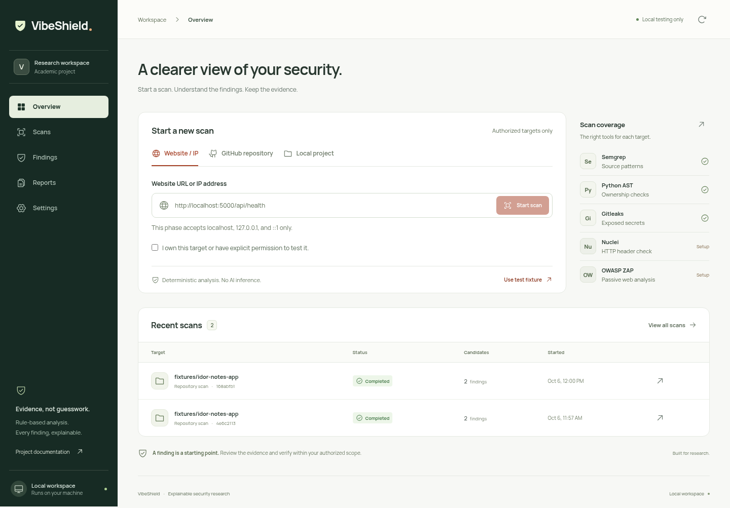
Screenshot 10.1: Overview with target selection, authorization and recent scans.
The form presents website, GitHub and local project targets. The coverage panel describes executable availability, and recent rows open meaningful assessment records. Candidate counts are not confirmed vulnerability totals.

10.1 Findings and Evidence
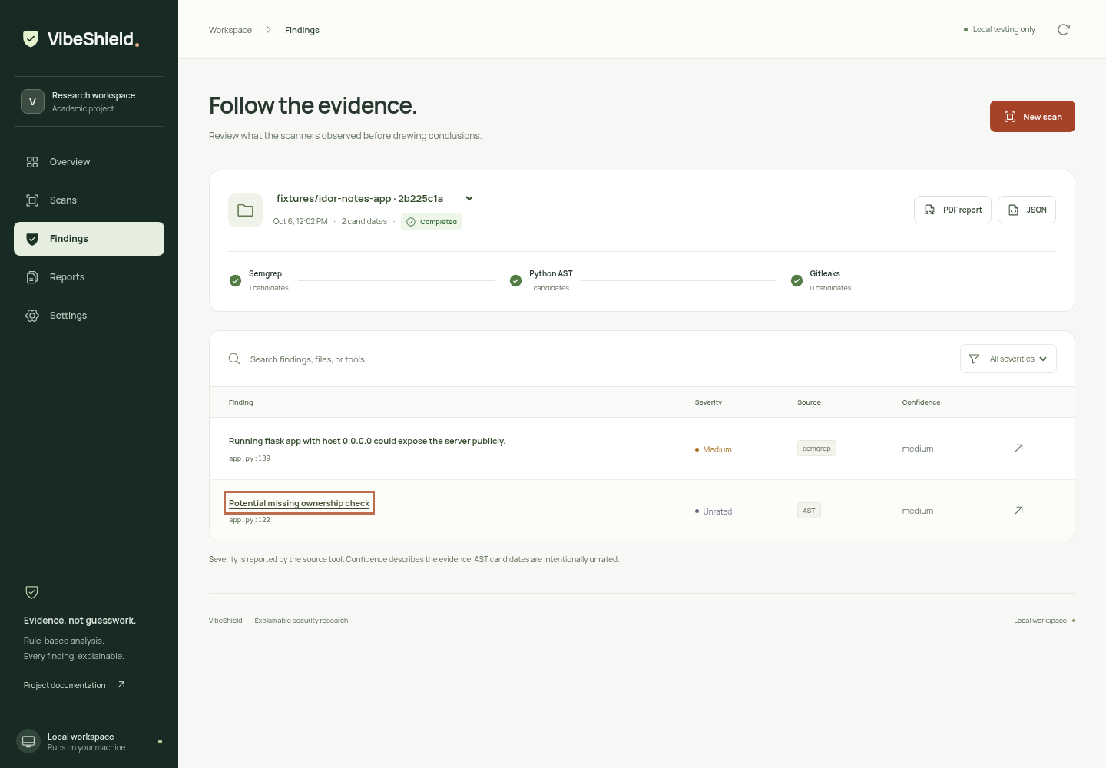
Screenshot 10.2: Findings view of the recorded static fixture assessment.
The captured run contains separate Semgrep and AST observations. The stage list shows coverage, and the AST candidate is intentionally unrated. Selecting a finding opens its affected location, reason, rule reference and available source context. Deployment context is required for the wildcard-bind observation.

10.2 Compact Interface
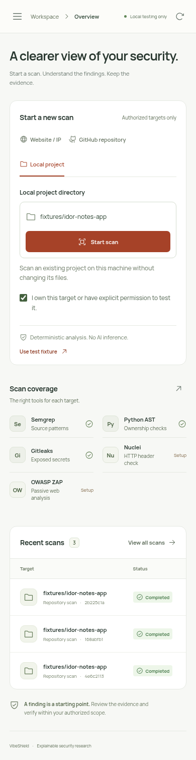
Screenshot 10.3: Mobile Overview with compact navigation.
The mobile interface exposes the same workflow through compact navigation. The existing verification record describes narrow-width overflow checks and a scoped automated accessibility audit. This image alone is not a complete responsiveness or accessibility test.

CHAPTER 11 — REFERENCES / BIBLIOGRAPHY
Project descriptions and verification claims are grounded in the current local source and recorded evidence. External links below identify primary technology documentation; they are reference destinations rather than a claim of a current online documentation audit.
[1] VibeShield. README.md, PRODUCT.md and DESIGN.md. Local project scope and design.
[2] VibeShield. dashboard/, pipeline/scan/ and pipeline/report/. Current implementation.
[3] VibeShield. Scanner and dashboard VERIFICATION.md records, 5–6 October 2026. Regression suites rerun 6 November 2026: 37 scanner and 6 backend tests passed.
[4] Python Software Foundation. https://docs.python.org/3/
[5] React and Vite. https://react.dev/ ; https://vite.dev/guide/
[6] Semgrep. https://semgrep.dev/docs/
[7] Gitleaks. https://github.com/gitleaks/gitleaks
[8] ProjectDiscovery Nuclei. https://docs.projectdiscovery.io/tools/nuclei/overview
[9] ZAP. https://www.zaproxy.org/docs/
[10] ReportLab. https://docs.reportlab.com/
[11] Playwright. https://playwright.dev/docs/intro
[12] Pallets Flask. https://flask.palletsprojects.com/
[13] Supplied ECP final-report PDF template. Used for format and institutional artwork; student identifiers and project content replaced.

12.TECHNICAL SUPPLEMENT — IMPLEMENTATION DETAILS
This supplement expands implementation details for viva, review and handover. It documents the existing scanner and dashboard behavior, separates current verification from historical records and identifies proposed controls explicitly. The source listings in Chapter 6 remain authoritative. No database, authentication account, cloud service or exploitation capability is implied by these explanations.

S1. Evidence model: observation to candidate
Tool-native findings and AST heuristic records have different shapes. RawFinding carries file, line, rule_id, message, severity, source_snippet and source. HeuristicFinding instead carries the function, heuristic identifier, confidence and reason. consolidate converts either into a CandidateFinding while keeping native fields inside details. The CANDIDATE marker is added during this conversion.
The common candidate fields are file_or_endpoint, vulnerability_type, confidence, source_tool and details. AST uses the type IDOR and source ast. Gitleaks uses SECRET_EXPOSURE. Other sources retain the native rule identifier. A source file and endpoint therefore share one display field without discarding tool identity. Reports add display severity and guidance as a projection rather than modifying the original stored finding.

S1.1 Confidence and Severity
Confidence describes evidence specificity. The AST rule supplies MEDIUM confidence, Gitleaks maps to HIGH, and other native informational results map to LOW. Display severity separately maps WARNING to MEDIUM, ERROR to HIGH and INFORMATIONAL to INFO; an absent severity becomes UNRATED. These conventions are deterministic presentation rules, not calculated exploitability or validated CVSS values.

S2. Static orchestration and partial-result semantics
For repository assessment, the selected order is Semgrep, AST and Gitleaks. For a URL, the selected stages are Nuclei and ZAP. The CLI can request both kinds. It collects findings and errors separately and sorts consolidated records by stable fields. Standard output stays a JSON list; errors are written to standard error and a partial failure returns a nonzero status.
A scanner may raise ScanError with findings. The orchestrator preserves those findings before appending the error. The dashboard follows the same principle, records the retained candidate count and marks the diagnostic stage failed. With other completed scanner stages, the terminal job is partial. If no scanner stage completed, the dashboard may mark it failed while still retaining any valid findings.
Case | Evidence treatment | Coverage interpretation
Tool succeeds with no results | Store zero candidates | Stage completed; not proof of security
Tool emits results and diagnostics | Preserve results and error | Incomplete coverage
Executable missing or invalid output | Record explicit stage error | No clean result inferred
Unexpected orchestration failure | Preserve existing job evidence | Job failed; unstarted stages skipped

S2.1 Parsing Diagnostics
Semgrep tagged errors such as PartialParsing carry metadata rather than a plain string type. The formatter extracts a bounded tag, checkout-relative file and line where available. It avoids copying arbitrary message text that may contain source or credentials. A template parser limitation can leave valid findings elsewhere; the report must describe incomplete coverage instead of deleting the diagnostic.

S3. Flask ownership heuristic and control flow
The AST analyzer parses Python without executing the target. It identifies supported route decorators and ID-like parameters that reach recognized lookup calls. Supported identity shapes include common principal names, session access, current_user, g.user and selected token-derived aliases. Recognized owner fields include owner_id, user_id, created_by and author_id. These sets constrain the algorithm and can be wrong for unfamiliar application conventions.
A relevant comparison must protect the lookup or fetched object through a supported rejecting branch. A bare comparison, a logging-only branch, an unrelated identity check, a nested helper definition or a guard after disclosure does not establish protection. The analyzer walks local statements without treating nested function bodies as inline authorization logic.

S3.1 The Owned Fixture Example
get_note authenticates a user, queries a note by note_id and returns note fields. The lookup at app.py:122 does not compare the fetched owner against the authenticated user before disclosure. Parameterizing the SQL query addresses a different concern; it does not add object ownership. The heuristic emits a candidate explaining this missing recognized relationship.
Manual review must consider whether authorization exists elsewhere, whether the resource is intentionally public and whether the recognized identity/storage names describe the real program. Interprocedural policy analysis, complex alias inference and general control-flow proofs are outside the rule. Supported clean cases limit overbroad matching but do not eliminate false positives or false negatives.

S4. Secret detection and controlled dynamic checks
Gitleaks runs dir mode against working-tree files. It writes a JSON report with full redaction and uses an explicit finding exit status. The adapter checks that the report exists, validates its structure and verifies that the exit status agrees with whether findings are present. Displayed evidence contains [REDACTED], not the discovered credential. A match does not establish that a credential is live, and the mode does not establish complete Git-history coverage.
Nuclei receives a validated local URL, a temporary configuration and the bundled template directory. Its invocation disables several external template/update behaviors and redirects, limits request rate and omits raw HTTP material. The one bundled template observes the absence of X-Content-Type-Options: nosniff. This narrow observation needs application context.
ZAP native automation is configured for passive analysis. Compatible baseline and Docker paths are also supported by the adapter. Native mode requires suitable Java; Docker mode additionally requires a daemon and image. Earlier records establish native fixture execution, not live Docker readiness. Overlapping Nuclei and ZAP header observations remain separate to preserve their source evidence.

S4.1 Target Scope Is Not Full Isolation
The shared URL validator accepts only exact loopback hostnames, supported schemes and no credentials or fragments. It does not implement a complete network or privilege sandbox for every subprocess. Tool behavior, redirects, rule acquisition and host permissions must be considered independently. Use the controlled fixture and retain the scope statement in reports.

S5. Request validation and job lifecycle
POST /api/scans requires a JSON object containing target_type, target and authorized true. Target text is bounded to 2,048 characters and request bytes to 8,192. The local Host and Origin checks and the session token limit cross-origin scan creation. The token is generated for the running server and is not a user-account login.
The store checks the unfinished-job limit, creates a 12-character identifier, initializes stages and persists the queued job. The single worker sets started_at, runs the selected stages and writes each outcome. Unexpected failures do not become a completed empty scan. Stage errors, timestamps and candidate counts remain part of the record.
State | Meaning | Recovery / next action
queued | Accepted and waiting for worker | Wait or retain as interrupted after restart
running | Worker executing stages | Inspect stage states
completed | Requested stages finished without recorded errors | Review candidates and export
partial | Some scanner coverage completed and errors remain | Review evidence and failed stages
failed | No completed scanner stage or orchestration failure | Review errors; correct setup and rerun
interrupted | Previously unfinished when server restarted | Start a new scan; retain old history

S5.1 Readiness Versus Runtime
Settings uses executable discovery for tool availability. That is useful setup information, but a discovered command can still fail because of runtime, permissions, registry access or configuration. A Docker executable alone does not prove daemon readiness. The stage record is the authority for a particular assessment.

S6. Persistence, public checkout and recovery
The scan directory is private and stores one JSON file per job. ScanStore keeps an in-memory copy and uses a lock for updates. persist writes a temporary sibling and atomically replaces the destination. This protects an individual file update; it does not supply database transactions, a backup policy or a comprehensive corruption-recovery service.
Startup reloads records and marks unfinished ones interrupted, with an error describing the stopped assessment. Queued and running stages become interrupted. Corrupt or structurally invalid records are skipped by the loader. A recovery interface, retention policy and supported deletion workflow are not implemented.
Public GitHub input normalizes an owner/repository URL. Acquisition disables prompts, user Git configuration, credential helpers and hooks and performs a shallow clone. A successful checkout records its commit. The code is inspected without running dependency installation or the repository application. The temporary directory is removed after the job. Credentials, private repositories and branch/tree URLs are unsupported.

S6.1 Resource Boundaries
A post-clone 200 MiB check prevents analysis of an oversized checkout but does not bound download volume. Scanner stages receive bounded timeouts. The subprocess helper uses a new process session and kills the process group on timeout, including launcher children. Repository-size budgets during transfer, cancellable jobs and stronger process isolation remain improvements.

S7. Report generation and API contract
The report projection combines stored metadata, candidates, stage outcomes and errors. complete is true only for completed jobs. Fixed guidance covers recognized findings, and unknown rules receive generic contextual-review advice. PDF content is escaped before it enters ReportLab markup. Secret-pattern redaction happens upstream, but other source snippets can still be present and should be reviewed before sharing.
Method and endpoint | Purpose
GET /api/status | Readiness, local scope, fixture shortcuts and session token
POST /api/scans | Validate and queue an authorized request
GET /api/scans | List stored scan records
GET /api/scans/{id} | Retrieve a single assessment
GET /api/scans/{id}/report.pdf | Download terminal PDF evidence report
GET /api/scans/{id}/report.json | Download terminal structured report
GET /api/documentation.pdf | Existing downloadable project PDF artifact

S7.1 Response Semantics
Normal retrieval returns 200 and accepted scan creation returns 202. Invalid target or JSON returns 400; local-origin or session failure returns 403; unknown records or routes return 404. An unfinished-report request returns 409. Request-size violations return 413, and unavailable PDF rendering or missing frontend assets can return 503. No login, delete-scan, cancel-job or cloud-sync endpoint is implemented.

S8. Browser interaction and evidence review
The browser stores navigation, target input, selected scan, filters, submission state and evidence-dialog state in React. refresh requests status and history together. An effect repeats it every two seconds while the page is visible and reports connection failure with a retry action. The UI does not manufacture a percentage or synthetic findings when a scanner is unavailable.
Search and filters operate on the actual selected records. A finding row opens a modal dialog with location, reason, rule reference and available source evidence. Escape closes it. Mobile navigation exposes the same destinations with focus handling. Terminal report controls fetch binary or JSON bytes for the selected job, create a temporary browser download URL and revoke it afterward.

S8.1 Empty and Incomplete States
An empty history invites an owned fixture scan. An empty findings view reminds the researcher to inspect coverage. A partial or failed scan stays reviewable. Tool-readiness notes explain setup and remain distinct from actual outcomes. Source confidence, native severity and candidate status are shown separately so they are not mistaken for a security score.

S8.2 Accessibility Evidence
The recorded browser workflow checked a populated findings view with axe, keyboard Escape and compact navigation, plus overflow at several widths. It reported zero automated violations for that view. This is useful scoped evidence; it does not cover every assistive technology, every state or a complete accessibility certification. New UI changes should be checked against the same concrete workflow.

S9. Verification matrix and reproducibility
Layer | Evidence | Boundary
Scanner regression | 37 tests passed on 6 Nov 2026 | Controlled AST, parser, timeout and orchestration cases
Backend regression | 6 tests passed on 6 Nov 2026 | Validation, consent, real AST, persistence and exports
Browser workflow | Recorded pass on 6 Oct 2026 | Historical owned-fixture Chromium workflow
Live dynamic scanners | Recorded native pass on 5 Oct 2026 | Historical Nuclei / ZAP local endpoint
Public GitHub cloning | URL validation tests | No new live checkout verification for this report
Docker ZAP / exploit confirmation | Not established | No runtime or exploitation claim

The fixture source is preserved. Current tests use controlled external-tool responses where appropriate and real AST evidence for the partial-report path. This makes regression behavior testable without implying fresh live scanner execution. The earlier screenshot and runtime records retain their original dates and environment limits.

S9.1 Reproducibility Checklist
• Retain the exact source or repository commit and the full authorized input endpoint.
• Record scanner versions, rule configuration, template files and execution date.
• Export the selected job with stages and errors, not only a candidate count.
• Distinguish current tests from historical runtime evidence and proposed work.
Tool rules, temporary runtimes, registry access and environment variables can change. Detection is deterministic under the same supported code, rules and conditions, but report timestamps and identifiers vary. Reproducibility is therefore more specific than expecting every export byte to be identical.

S10. Limitations and improvement priorities
The present product is a local coursework scanner. It does not supply multi-user identity, per-user storage, complete historical secret scanning, authenticated website journeys or a production egress sandbox. The AST heuristic is deliberately limited, and scanner configuration observations require deployment context. Numeric scoring and automatic exploitation are not implemented.
Improvement | Reason | Required validation
Cancellable jobs and resource controls | Bound operator and process impact | Interrupt running and queued work without losing evidence
Pinned rule bundles and manifest | Improve repeatability | Compare target, rule and tool provenance across runs
Storage recovery and retention | Maintain long-term history | Handle corruption and deletion without accidental loss
Broader reviewed detection | Expand useful coverage | Positive and clean controls; document false classifications
Researcher review annotations | Track contextual decisions | Retain original evidence and explicit reviewer state

S11. Authorized operation and report sharing
The permission checkbox records a declaration; it is not independent proof of authorization. Use owned local fixtures and authorized repositories. Keep the deliberately vulnerable fixture loopback-published. Review reports for source context before academic sharing, and rotate genuine exposed credentials through the appropriate owner workflow rather than placing secret values in the report.

S12. Local setup and deployment readiness
A repeatable local setup needs the Python environment, frontend build and separately installed scanners. The backend serves only its existing compiled assets and API on loopback. The startup URL, tool-path settings and actual fixture outcomes should be verified after migration. Native Windows compatibility is not established by the current POSIX subprocess helper.

S13. User acceptance procedure
• Start the server, open the printed local URL and inspect Settings.
• Select the owned local fixture, confirm permission and start assessment.
• Inspect actual stage outcomes and open the AST rule evidence.
• Download PDF and JSON; confirm the target, stage errors and complete flag.
• Check keyboard navigation, narrow layout, empty states and connection errors.
• Stop with Ctrl+C, restart with the same data path and check preserved history.

S14. Handover evidence
Keep the checkout, dependency manifests, relevant rule files, fixture provenance, test commands and selected exports together. Preserve the distinction between scanner output and reviewed conclusions. This report is a separate DOCX submission based on the supplied PDF format; it does not replace the application’s existing documentation-download route.

S15. Developer notes for a future maintainer
Before changing an adapter, inspect the native output and its failure modes, then verify both useful-result parsing and incomplete coverage. Before changing the AST heuristic, add a relevant vulnerable case and clean protection case. Before changing report rendering, exercise untrusted text and partial jobs. Before changing job states or persistence, verify restart behavior and preservation of earlier evidence. Browser checks should then confirm that the same underlying record is understandable in the interface and exports.

