**SPUN SEDIMENT FILTERS**

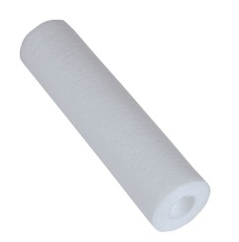

**Water Purification Supplies** cartridges are constructed with multi-layers depth filter cartridges and manufacture by meltblown process. The meltblown cartridges feature graded density construction, which captures particles throughout the entire cross section of the cartridge and reduces surface blinding, which can occur in string wound cartridges.

**Water Purification Supplies** cartridges combine quality and cost effectiveness to provide excellent filtration value.

**Features & Benefits:**

Certificated by NSF 42 standard

FDA Compliant V

ISO 9001 certified

Pure Polypropylene construction

Highly Price Competitive

**Operation conditions:**

Maximum operating temperature: 52 ℃

Maximum operating pressure @20 ℃: 3.2 kg/cm2

Recommended replaceable pressure drop: 1.5 kg/cm2

**Applications of product:**

Removal of Sediment from water in residential and light commercial applications

**Product specifications:**

Micron ratings: nominal 1, 5, 10, 20, and 50 microns

Materials of construction: 100% Polypropylene

Length: 9 7/8”, 10”, 20”, 30”, and 40”

Inside diameter: 1”

Outside diameter: 2.5” or 4.5”