**How to use Project Boundary Template in Regeneration Assessment Program**

In order to automate post-survey data processing, a feature class describing the exact boundary of the project/block is required.

The automation uses the geometric information as well as some attributes (such as “ProjectID”) of the feature class for analysis and reporting. Therefore it is necessary to have not only the boundaries correct, but also the attribute names must be consistence. For this reason, I highly recommend using the Project Boundary Template (RAP_TEMPLATE feature class) when populating project boundary descriptions.

**Here is how we recommend you to use the template:**

We are going to assume that you already picked the projects/blocks that your district will be surveying this year and have them in a shapefile or a feature class. For this example, we will call your layer “Timmins_RAP2020_projects”

1. On ArcMap, load both the template (RAP_TEMPLATE) feature class and the “Timmins_RAP2020_projects” layer that your district chose for this year’s survey.  
   Make sure that all two layers are turned on (check-box checked) on table of contents.  
   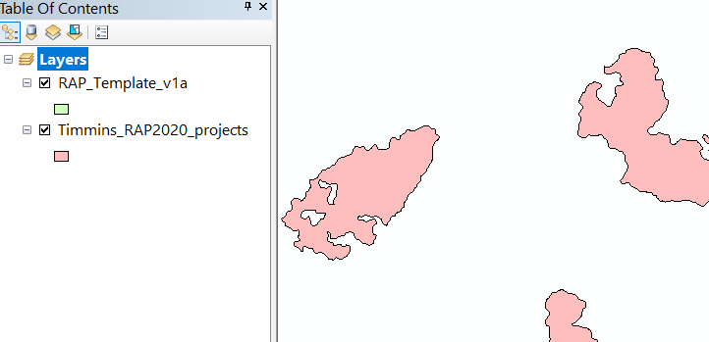
2. Right click on the RAP_TEMPLATE layer and Edit Features – Start Editing  
   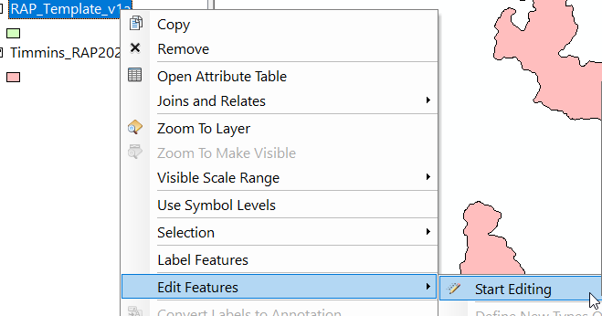
3. Select all the features from “Timmins_RAP2020_projects”.  
   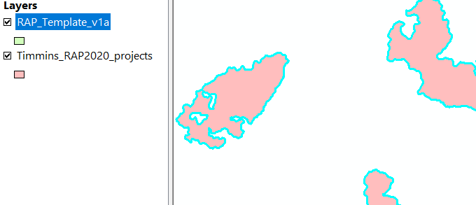
4. Go to Edit – Copy.  
   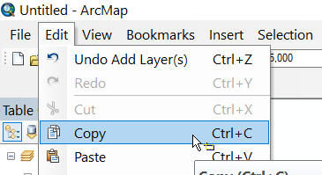
5. Go to Edit – Paste.
6. A window will pop up asking where to paste those selected shapes to. Pick RAP_TEMPLATE. Click OK.  
   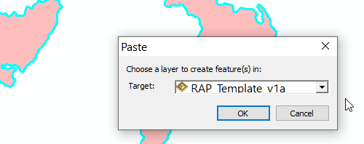
7. Open the attribute table of the RAP_TEMPLATE. Note that first 3 records are there as an example.  
   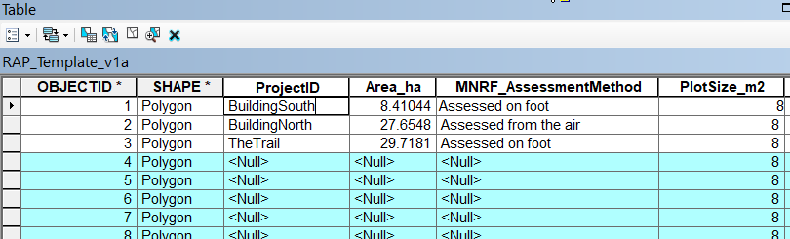
8. Manually populate the ProjectID. You MUST populate ProjectID and there shouldn’t be any duplicate ProjectIDs (i.e. no two records should have the same ProjectID).
9. Populate other attributes if you have the information available. (Don’t worry about Area_Ha)
10. Make sure to Save edits when you are done!  
    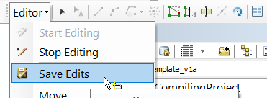
11. Once you are done, close the ArcMap. Zip up the geodatabase you’ve just edited and send it Daniel Kim ([Daniel.kim2@ontario.ca](mailto:Daniel.kim2@ontario.ca)).

Below is the description of each attribute. Please fill in as much information as possible, but you can always add more information later on as they become available:

*Project ID: MANDATORY FIELD! A unique id of the project or the block. Every record's Project ID must be unique.

*Number of Clusters: Number of cluster points in this project/block.

Area_ha: Area in hectare.

MNRF_AssessmentMethod: Assessment done via Aerial or Ground

MNRF Assessment Year: Year assessed by the MNRF

*PlotSize_m2: for all boreal forests in 2020, the value of this field should be 8.

YRDEP: Year of last depletion.

DepletionFU: Forest Unit before it was depleted

TargetFU: intended future Forest Unit

SILVSYS: Silvicultural Systems

SGR: Silvicultural Ground Rule codes

*FMU: Forest Management Unit

*District: MNR District

SFL_SPCOMP: Species composition assessment result by the SFL.

SFL_SO: Site Occupancy result by the SFL. should range from 0 to 1. It's the ratio of occupied plot over all surveyed plots.

SFL_FU: Forest Unit result by the SFL.

SFL_EffDens: Effective density calculated by the SFL (if available). should range from 0 to 3000.

SFL_AssessmentMethod: Assessment done via Aerial or Ground

SFL_Name: Name of the SFL company that conducted the survey.

SFL Assessment Year: Year assessed by the SFL.