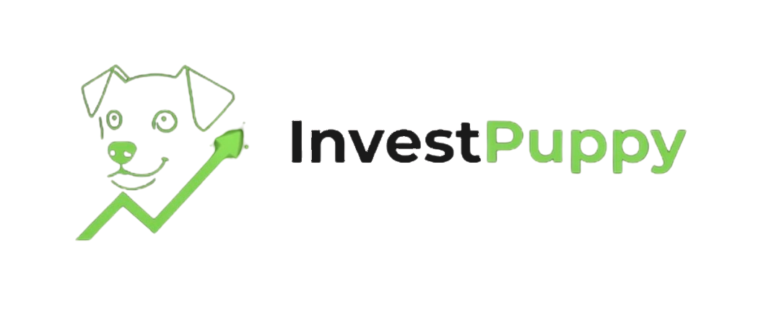
Founder Story
For NDA recipients only · Not for external distribution

This document is shared under mutual NDA as the second document in the InvestPuppy due diligence sequence — delivered immediately after NDA execution.

On stealth and the seed round.
The founding team is currently in stealth. Neither founder’s name appears in public materials at this stage. The institutional world in which both founders have built their careers is small enough that employer names, platform names, and specific project context make people identifiable by implication. The sections below describe what the founders know and what they have built — not where.
InvestPuppy is in the process of completing a seed funding round. Completion of that round is the trigger for full public disclosure — names, employer histories, verifiable references — and from that point InvestPuppy is the complete professional focus of both founders. That is a commercial process with a defined timeline.
At the point of first commercial commitment — Proof Partner term sheet or equivalent — both founders will provide full professional backgrounds under whatever legal protection the counterparty requires. If that trigger needs to come earlier, tell us.

The Question Everyone Asks
When people who know us well — people who have no stake in the answer, who have nothing to sell and nothing to gain — heard what we were building, they asked the same question independently. Not together. Separately. Without comparison.

“Why this? Why now? Why you?”

Why this: because both of us spent years inside the institutional infrastructure that boutique wealth managers cannot access, watching the same gap from the inside. Not a gap in capability — the tools that exist are sophisticated. A gap in accessibility. Every systematic portfolio construction workflow we worked on, every compliance-grade audit trail we built or operated, was available only to teams with institutional budgets, institutional headcount, and institutional procurement processes. The boutique DPM running thirty mandates on a Bloomberg terminal and an Excel model was not an underserved niche. It was the majority of the market. We could not find a reason that should be true. So we stopped looking for one.

Why now: because three things converged that were not true two years ago. The regulatory environment in Singapore, Switzerland, and the UK is moving toward requiring systematic, documented investment processes from licensed managers — which means the compliance case for Vektor is becoming mandatory rather than optional. The OpenWealth standard has reached institutional adoption that makes custodian API integration genuinely tractable rather than aspirational. And the founding team’s combined experience now includes production implementation of that API layer on one of the market’s leading PMS platforms — which means the institutional channel is credible from the first conversation in a way it could not have been earlier.

Why us: because neither of us could have built this alone, and both of us knew it. The platform required someone who understood what a portfolio manager needed at every step of the workflow — not theoretically, but from years of operating inside that workflow. And it required someone who could translate that understanding into production architecture that would satisfy an institutional compliance team. Those are not the same person. They are, in this case, two people who have worked together for over a decade and built the specific complementarity the platform required. That is not a coincidence. It is the answer.

The CEO
The eleven-step workflow in this platform is the CEO’s operational knowledge in executable form. The three-role separation — Stock Analyst, Portfolio Manager, Operations — is not an interface design choice. It reflects the compliance architecture that a licensed discretionary manager operates under, and the specific points at which a human sign-off is not optional.

The allocation step fetching live prices at execution rather than using the prior close is not a technical feature. It is the answer to a recurring operational problem. The 99.94% capital allocation efficiency figure is not a marketing claim — it is the result of lot-size rounding logic built by someone who has watched what happens when residual cash sits uninvested across a book of mandates. These decisions are in the platform because they are the solution to things that went wrong in practice, repeatedly, in the absence of a systematic process.

The platform is the evidence.

The CTO
The technical architecture of Vektor is the testimony. The schema design separates the instrument master from portfolio positions with independent audit trails because a compliance team reviewing a trade six months later needs to reconstruct the exact data state at the moment of allocation — not a summary. The service ownership model isolates the signal generation layer from the order creation layer because conflating them creates an untraceable failure mode. The audit trail is append-only because a mutable audit trail is not an audit trail.

Readers with technical backgrounds who have reviewed WP-07 will recognise these decisions and understand what they reflect. They are not decisions a generalist engineer makes. They are decisions made by someone who has seen what happens when they are made the other way.

Where the CEO understood what a portfolio manager needed in order to approve a trade, the CTO understood how to build a system where that approval was structurally required and technically impossible to bypass. Where the CEO knew what a compliance team would ask for twelve months after execution, the CTO knew how to design a schema that would answer that question from its structure rather than from a manual query. Neither works without the other.

The platform is the evidence.

The Decade Between Them
The CEO and CTO have worked together for over ten years. Not as colleagues in the background of the same organisation. As the people in the room, on the projects that mattered, under the pressure that tests whether a professional relationship holds or fractures.

They have disagreed. They have resolved disagreements. They have been wrong and told each other so. They have been right under difficult circumstances and backed each other. Ten years of that is the governance structure that no shareholder agreement can fully replicate.

The equal ownership and equal voice between them is not a compromise structure and it was not negotiated. It is the accurate description of how they already operated. In a structure where neither party has final authority over the other, every disagreement has to be resolved on its merits rather than overridden by seniority. That only works between two people who are more interested in the right answer than in being right — and whose expertise is genuinely equal in weight, not equal in name only. The CTO does not defer to the CEO on architecture. The CEO does not defer to the CTO on commercial strategy. Each holds their domain. Each is persuadable by a better argument. The governance follows the relationship. It is not prior to it.

The Pre-Launch Team
Three practitioners complete the founding team. None were recruited. Each approached the founders independently after learning what was being built. Five people from the same institutional environment, working separately over the same years, arrived at the same diagnosis of the same problem and joined the same founding team. That convergence is itself the validation.

Not assembled for credentials. Formed in practice over careers. All five arrived at the same conviction independently.

Why Now
The gap Vektor is built to close has existed for years. The question of why now has a specific answer.

- The regulatory environment in Singapore, Switzerland, and the UK is moving toward requiring systematic, documented investment processes from licensed managers. The compliance demand for what Vektor provides is acute and growing.
- The OpenWealth standard has reached a level of institutional adoption that makes API-based integration with custodian bank infrastructure genuinely tractable. Two years ago this was an aspiration. Today it is a project.
- The founding team’s combined experience now includes production implementation of the OpenWealth API layer on one of the market’s leading PMS platforms. The institutional channel is technically credible from the first conversation in a way it could not have been without that specific credential.
- The two of us, with the pre-launch team, are at a moment in our careers where we have the knowledge, the network, and the capacity to build this — and where the cost of not building it is too high to accept.
- The boutique wealth management segment is undergoing a structural shift. Practitioners who built their businesses on Excel and manual process face a credibility gap as clients and regulators become more specific about process. The window — before a large incumbent addresses it, and before the regulatory requirement becomes a compliance crisis rather than a competitive advantage — is open now.

That is the co-founder relationship. It is also the product thesis. And it is the founding team.

We are available to answer any question this document raises. The same offer that runs throughout the InvestPuppy documentation suite — ask us, we will tell you — applies here. This is the team behind that suite.

Built from mistakes, not textbooks.
InvestPuppy · investpuppy.com · contact@investpuppy.com

