24/25 MECH3465 Robotics and Machine Intelligence

 | School of Mechanical Engineering  MECH3465 - Robotics and Machine Intelligence

Mark
Assignment:

Coursework 1: Aircraft Recognition CNN

Name | Student ID | Signature
Louie Burns | 201588498
Dan Nehushtan | 201594650

Section 1: Mode and Optimisation
A detailed rational for the choice of your mode and optimisation processes of fine tuning your model (max 200 words).
Convolutional Neural Networks (CNNs) are ideal for image classification as they are specifically designed to process images through convolutional operations. They automatically learn hierarchical features directly from raw image data, making them highly adaptable and scalable for complex datasets.
A key aim was to improve the F1 score, which depends on the accuracy of training and test data; thus, prioritising accuracy enhancements was essential. The Simple CNN architecture was improved by increasing image resolution and adding layers. These changes enable the model to capture finer details and extract higher-order features, essential for accurate classification. Batch normalisation stabilises training by normalising inputs to each layer, accelerating convergence, and reducing sensitivity to weight initialisation. A dynamic learning rate schedule, halving every five epochs, ensures steady convergence by preventing oscillations near minima and balancing exploration and refinement.
Increasing the number of epochs provided more opportunities for the model to learn data patterns, while data augmentations (horizontal flips, random rotations, and normalisation) improved generalisation by simulating real-world variations and mitigating overfitting risks. Selecting the categories with the highest image counts ensured balanced class representation, maximising training data and improving performance.
These changes collectively contributed to improving the F1 score and the model’s accuracy/ performance.
Section 2: Improved Model Comparison
A section comparing your model to your optimised model, accompanied by evaluation metrics in the form of tables or graphs and draw conclusions (max 200 words).

The improved model implemented several upgrades:
- Increased Image Resolution: From 64x64 to 128x128 (Figure 1 vs Figure 2), capturing finer details for better feature extraction.
- Increased Epochs: Training iterations were raised from 15 to 40 (Figure 3 vs Figure 4).
- Dynamic Learning Rate: Learning rate halved every 9 epochs (Figure 6), rather than staying fixed
- Expanded Architecture: Additional neural network layers improved capacity, supported by batch normalisation
- Data Augmentation: Techniques like horizontal flips, random rotations, and normalisation reduced overfitting risks.
- Optimised Training Data: Selected categories with the highest image counts increased training data, though risks of overfitting persisted.
The simplified model plateaued with a maximum test accuracy of 46.44% and an F1 score of 33.26% (Figure 5), while training accuracy stopped at 47.72%. Loss values showed a gap (Figure 1), indicating underfitting.
The improved model reached a test accuracy of 53.51% and an F1 score of 52.42%. Training accuracy peaked at 99.94%, though overfitting became evident after epoch 30, as reflected in Figure 4. While dynamic learning rates and batch normalisation stabilised training, test accuracy fluctuated around 50% (Figures 2, 4).
These enhancements demonstrate improved generalisation and accuracy, with room for further refinement.

Training & Test Loss:
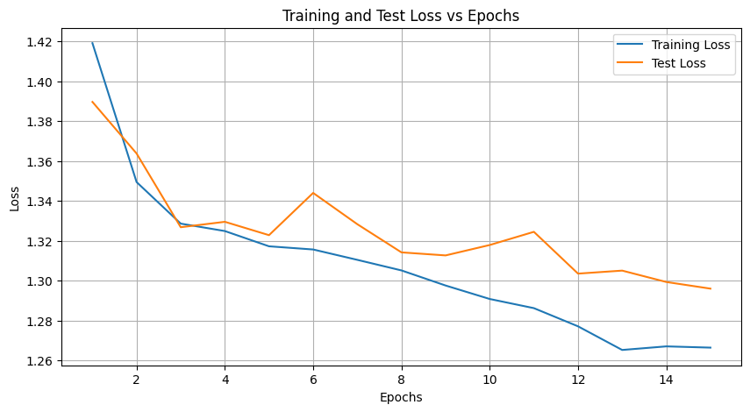
Figure 1: Training and Test Loss vs Epoch for the simple model
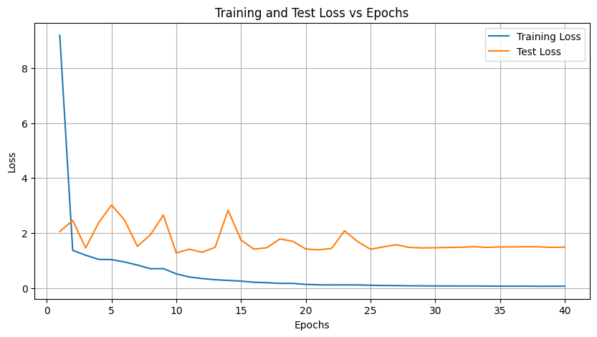
Figure 2: Training and Test Loss vs Epoch for the improved model

Training & Test Accuracy:

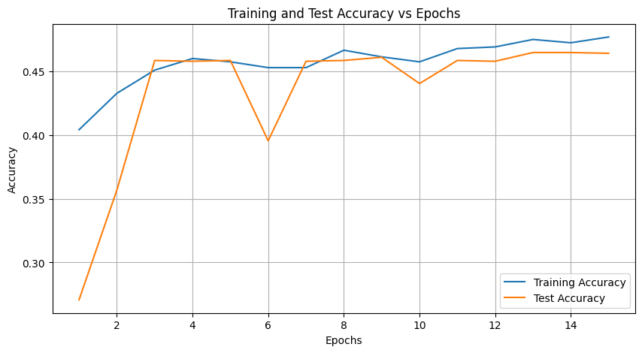
Figure 3: Training and Test Accuracy vs Epoch for the simple model
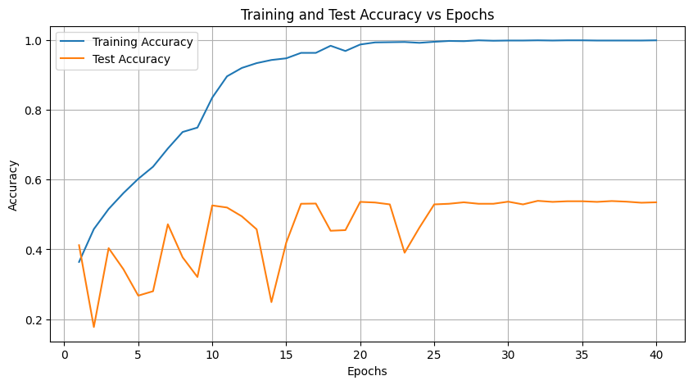
Figure 4: Training and Test Accuracy vs Epoch for the improved model

F1 Score:
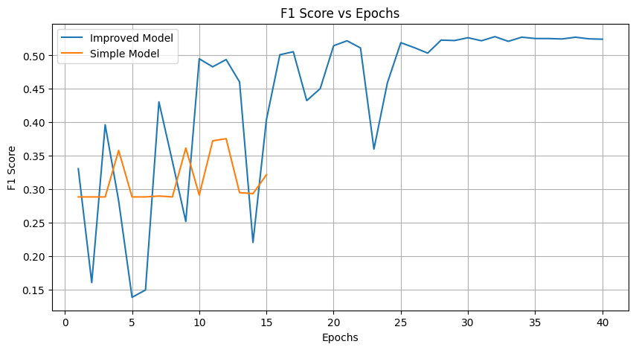
Figure 5: F1 Score vs Epoch for the simple and complex model

Learning Rate Values:
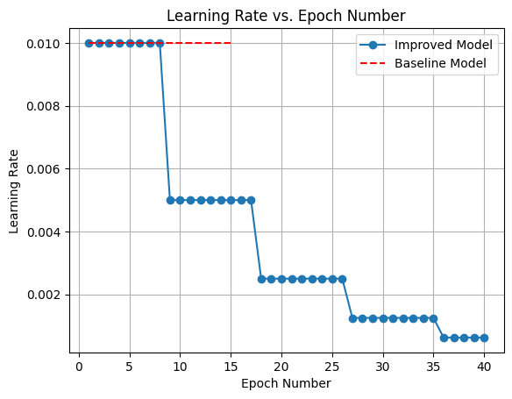
Figure 6: The learning rate per epoch for the simple and improved CNN models

Simplified Model Results:

Epoch | Train Loss | Test Loss | Train Acc | Test Acc | F1 Score
1/15 | 1.4191 | 1.3897 | 0.4043 | 0.2706 | 0.1153
2/15 | 1.3495 | 1.3638 | 0.4329 | 0.3569 | 0.3084
3/15 | 1.3286 | 1.3268 | 0.4512 | 0.4587 | 0.2885
4/15 | 1.3249 | 1.3296 | 0.4603 | 0.4581 | 0.3114
5/15 | 1.3173 | 1.3229 | 0.4577 | 0.4587 | 0.2885
6/15 | 1.3157 | 1.344 | 0.4531 | 0.3956 | 0.3386
7/15 | 1.3105 | 1.3284 | 0.4531 | 0.4581 | 0.3102
8/15 | 1.3052 | 1.3142 | 0.4668 | 0.4587 | 0.2885
9/15 | 1.2976 | 1.3127 | 0.4616 | 0.4612 | 0.3064
10/15 | 1.2908 | 1.3179 | 0.4577 | 0.4406 | 0.3516
11/15 | 1.2863 | 1.3245 | 0.4681 | 0.4587 | 0.2885
12/15 | 1.2771 | 1.3036 | 0.4694 | 0.4581 | 0.2927
13/15 | 1.2653 | 1.3051 | 0.4753 | 0.465 | 0.3271
14/15 | 1.2671 | 1.2994 | 0.4727 | 0.465 | 0.3252
15/15 | 1.2665 | 1.296 | 0.4772 | 0.4644 | 0.3326
Table 1: The results of each epoch calculation for the simplified CNN model
The learning rate for this model was kept constant at 0.01

Improved Model Results:

Epoch | Train Loss | Test Loss | Train Acc | Test Acc | F1 Score | Learning Rate
1 | 9.1959 | 2.0513 | 0.3641 | 0.4121 | 0.3307 | 0.01
2 | 1.3687 | 2.4558 | 0.4583 | 0.1776 | 0.1606 | 0.01
3 | 1.1897 | 1.4528 | 0.5159 | 0.4037 | 0.3963 | 0.01
4 | 1.0382 | 2.3682 | 0.5615 | 0.3431 | 0.2831 | 0.01
5 | 1.0304 | 3.0175 | 0.6023 | 0.2675 | 0.1386 | 0.01
6 | 0.9436 | 2.4723 | 0.6371 | 0.2801 | 0.1495 | 0.01
7 | 0.8308 | 1.5123 | 0.6893 | 0.4721 | 0.4305 | 0.01
8 | 0.6985 | 1.9315 | 0.7367 | 0.3773 | 0.3419 | 0.01
9 | 0.7009 | 2.6508 | 0.7493 | 0.3209 | 0.2518 | 0.005
10 | 0.5131 | 1.2718 | 0.835 | 0.5261 | 0.495 | 0.005
11 | 0.3976 | 1.4083 | 0.8962 | 0.5201 | 0.483 | 0.005
12 | 0.3389 | 1.2983 | 0.9202 | 0.4949 | 0.4939 | 0.005
13 | 0.297 | 1.4776 | 0.934 | 0.4577 | 0.4604 | 0.005
14 | 0.2716 | 2.8273 | 0.943 | 0.249 | 0.2206 | 0.005
15 | 0.2471 | 1.7417 | 0.9478 | 0.4193 | 0.404 | 0.005
16 | 0.2048 | 1.4096 | 0.9634 | 0.5309 | 0.501 | 0.005
17 | 0.1898 | 1.4626 | 0.9634 | 0.5315 | 0.5055 | 0.005
18 | 0.1639 | 1.7807 | 0.9838 | 0.4535 | 0.4325 | 0.0025
19 | 0.1641 | 1.6966 | 0.9688 | 0.4553 | 0.4503 | 0.0025
20 | 0.1268 | 1.4149 | 0.9874 | 0.5363 | 0.5145 | 0.0025
21 | 0.1127 | 1.3864 | 0.9934 | 0.5345 | 0.5219 | 0.0025
22 | 0.1078 | 1.4369 | 0.994 | 0.5291 | 0.5112 | 0.0025
23 | 0.1104 | 2.0805 | 0.9946 | 0.3905 | 0.3601 | 0.0025
24 | 0.108 | 1.6883 | 0.9922 | 0.4625 | 0.4589 | 0.0025
25 | 0.0953 | 1.4062 | 0.9952 | 0.5291 | 0.519 | 0.0025
26 | 0.0866 | 1.4943 | 0.9976 | 0.5309 | 0.5117 | 0.0025
27 | 0.0838 | 1.57 | 0.997 | 0.5351 | 0.5034 | 0.00125
28 | 0.0766 | 1.4738 | 0.9994 | 0.5309 | 0.5229 | 0.00125
29 | 0.0743 | 1.4553 | 0.9982 | 0.5309 | 0.5222 | 0.00125
30 | 0.0713 | 1.4617 | 0.9988 | 0.5369 | 0.5265 | 0.00125
31 | 0.0709 | 1.4722 | 0.9988 | 0.5291 | 0.5219 | 0.00125
32 | 0.0688 | 1.4783 | 0.9994 | 0.5393 | 0.528 | 0.00125
33 | 0.0683 | 1.4998 | 0.9988 | 0.5363 | 0.5211 | 0.00125
34 | 0.0662 | 1.4726 | 0.9994 | 0.5381 | 0.5273 | 0.00125
35 | 0.0636 | 1.4906 | 0.9994 | 0.5381 | 0.5253 | 0.00125
36 | 0.0624 | 1.4922 | 0.9988 | 0.5363 | 0.5252 | 0.000625
37 | 0.0645 | 1.4988 | 0.9988 | 0.5387 | 0.5246 | 0.000625
38 | 0.0596 | 1.4951 | 0.9988 | 0.5369 | 0.5272 | 0.000625
39 | 0.0606 | 1.4727 | 0.9988 | 0.5339 | 0.5248 | 0.000625
40 | 0.0615 | 1.4848 | 0.9994 | 0.5351 | 0.5242 | 0.000625
Table 2: The results of each epoch calculation for the improved CNN model

Section 3: Evaluation
A critical evaluation and reflection on the results, discussing potential improvements and acknowledging any limitations of your approach (max 200 words).

The results indicate that the model improvements, though beneficial, were still limited in their overall impact on performance. Attempts to increase image resolution to 512x512, add more epochs, incorporate colour jitter during preprocessing, use bounding boxes to crop images, and introduce early dropout did not yield significant improvements. This suggests that while these techniques could be effective in different contexts or with more abundant datasets, they were not impactful here due to the constrained data and computational resources.
A major limitation is the low number of training data, which hindered the model’s ability to generalise effectively. Despite data augmentation techniques, the model still faced overfitting, as seen in the widening gap between training and test accuracy. Furthermore, the long compute times due to the local computing power restricted experimentation, limiting the ability to explore complex architectures, longer training periods, or additional hyperparameter tuning.
Using pretrained models or using external datasets could provide a more robust foundation for learning. Pretrained models offers knowledge that could be transferred to this task, addressing the data constraints. Improved computational resources would also allow testing with more advanced models and longer training. These adjustments could lead to more improvements in the model’s generalisation and accuracy.

Section 4: Ethics
A statement on ethical and societal implications of the booming usage of artificial neural networks in engineering (max 200 words).
A significant issue for artificial neural networks (ANN) is bias and fairness, as ANNs heavily rely on training data. If the data is biased, models risk perpetuating societal inequalities, particularly in engineering applications like resource allocation or urban planning, where outcomes can disproportionately affect certain groups.
Additionally, the lack of transparency and explainability in ANNs poses challenges in safety-critical fields like healthcare and aerospace engineering, where accountability and trust are essential. Data and privacy concerns are also paramount, as ANNs often require vast amounts of sensitive data, raising risks of misuse, inadequate data protection, and breaches that could have far-reaching consequences.
The environmental impact of training large-scale ANNs is another concern, as their computational demands significantly contribute to carbon emissions, highlighting the need for energy-efficient approaches. Furthermore, job displacement caused by automation driven by ANNs raises societal concerns, particularly in industries reliant on repetitive tasks, necessitating reskilling initiatives to minimise unemployment.
Misuse and security risks also emerge as ANNs can be exploited for malicious purposes, such as cybersecurity attacks or infrastructure vulnerabilities. To address these concerns, it is vital to develop ethical, sustainable, and inclusive AI systems that prioritise fairness, transparency, privacy, and equitable access while mitigating risks.

Baseline Model and Simple Model are used interchangeably. They both relate to the model without any improvements added

