# Costs:

## Crowdsourcing Campaign: DMO

The idea of crowdsourcing Project PAM was brought up during the spring; however, it was decided to be too much of a commitment for the team members at that time. As the semester continued and the estimated cost of building the prototype became apparent crowdsourcing was again looked at. The decision was made at the beginning of the fall to move forward with a crowdsourcing campaign.

The first step of this process was to pick a crowdsourcing platform. Originally Kickstarter was chosen; however, after during the process of trying to create the campaign it was determined Kickstarter did not meet the needs of the project. Because of this Indiegogo was chosen as the crowdsourcing platform for Project PAM.

One of GitHub’s feature called GitHub Pages, which hosts simple static HTML websites as part of the GitHub repo for free, was used to develop a website for Project PAM [GitHub Pages]. There are

Both project pages and organization page

<https://pages.github.com/>

### Indiegogo

$741 Raised

29.64 % Funded

11 Contributions

Visits: 1,253

Referrals: 146

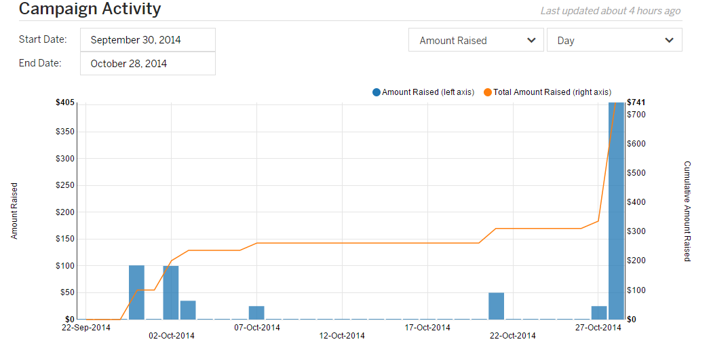

Crowdsourcing campaign activity

### Social Media

In addition to the GitHub origination for Project PAM and the Gmail account for email social media accounts/pages were created as part of the crowdsourcing campaign. Twitter (@ProjectPAM), Facebook, Google+, YouTube. Mailing list and GitHub Issue tracking

Twitter:

Tweets: 59

Followers: 17

Facebook:

Likes: 40

YouTube:

Project PAM Promo: 891 Views

Project PAM: First Render: 171 Views

### Media Coverage

3DPrint.com: [Project PAM – College Students Look to Create an Entirely Open Source DLP 3D Printer](http://3dprint.com/17504/project-pam/)

3DPrintingIndustry.com: [Help The Open Sourced DLP 3D Printer called Project Pam on Indiegogo?](http://3dprintingindustry.com/2014/10/02/help-open-sourced-dlp-3d-printer-called-project-pam-indiegogo/)

WSIU: [SIU Engineering Students Use Crowdfunding for 3D Printer](http://news.wsiu.org/post/siu-engineering-students-use-crowdfunding-3d-printer)

Make Magazine: Cool Crowdfunding: October 26, 2014 <http://makezine.com/2014/10/26/cool-crowdfunding-october-26-2014/>

## Prototype Costs: DMO

Cost of subsystems

|  |  |
| --- | --- |
| Subsystem | Price |
| Motion control | $113.61 |
| Chassis | $315.99 |
| Hardware software interface | $25.97 |
| Motors/motor control | $82.83 |
| MakerJuice G+ resin | $45.00 |
| Total | $602.17 |

## Implementation Costs: DMO

Under $1000

# Schedules:

## Proposed Schedule: DMO

## Reworked Schedule: DMO

Addition of Nate

Procurement Problems

Jig

# Subsystem Descriptions

## Printer Control Software: DMO

### Process of Design

Proposal from last semester

Wait for B9 Creator update and associated licensing

Problems with B9Creator

Problems with OSS CAM

Start from scratch

Define own platform

Define own user interface

Lots of work and mediocre results

Python

UI Requirements

Ribbon Interface

Toolboxes that act like wizards

### development Process

KDevelop and KDevPlatform/KDE Frameworks 5

Pre Alpha Stage

Release next year

Qt 5

Ot 5 Open GL

<http://doc-snapshot.qt-project.org/qt5-5.4/qopenglwidget.html>

<http://qt-project.org/doc/qt-5/qtopengl-index.html>

<http://qt-project.org/wiki/New-Features-in-Qt-5.4>

### development SCHEDULE

LibreCAM

Ver. 0.1.0:

Ver. 1.0.0:

Ver. 2.0.0:

LibrePAM

Ver. 0.1.0:

Ver. 1.0.0

Ver. 2.0.0

### Health and Safety Issues

Stuff that is made

### Recommendations

<https://www.kdevelop.org/frameworks/kdevelop-master-now-depends-kde-frameworks-5>

<https://www.kdevelop.org/news/kdevelop-470-released>

<http://qt-project.org/doc/qt-4.8/qtopengl.html#details>

<http://qt-project.org/doc/qt-5/qtgui-index.html#opengl-and-opengl-es-integration>

<https://github.com/ktechlab/ktechlab>