# Nathaniel Benjamin Tyler

While adhering to ISO standards, part files were dimensioned in drawing files. In short, ISO, is an international standard-setting body composed of representatives from various national standards organizations.

The ISO standard for dimensioning parts is GD&T (Geometric Dimensioning and Tolerance). In short, this system is useful when communicating engineering tolerances. This form of dimensioning follows a symbolic language that allows engineering drawings within a computer three-dimensionally. In other words, one can virtually fabricate solid models that explicitly describes nominal geometry and its allowable variation.

It is important to clarify that GD&T is not synonymous for Basic Dimensioning. In short, basic dimensioning represent an ideal case and consequently lacks the necessary tolerances to appropriately design parts. Thankfully, GD&T overcomes this fabrication hurdle and provide the machinist both the necessary dimensions tolerances to produce high quality parts. In technical drawings, a basic dimension is a theoretically exact dimension, given from a datum to a feature of interest. Basic dimensions only communicate a designs critical dimensions and consequently lack tolerance. To facilitate manufacturability, a feature control frame is often used to assign a dimensional tolerance to the feature that is referenced in by the basic dimension. It is important to note that a set of chained basic dimensions do not create tolerance stack up. Furthermore, proper tolerance must be inferred by Datum’s referenced in the feature control frame, and not by dimension arrows or start points. In summary, a numerical value used to describe the theoretically exact size, profile, orientation or location of either a feather or datum target is the basis from which permissible variations are established by tolerances on other dimensions, in notes, or in feature control frames. In conclusion, basic dimension are denoted by enclosing the number of the dimension in a rectangle.

The 3D-printer is comprised of many parts which must be appropriately dimensioned. To produce a high quality design one should GD&T the hardware component; i.e.) the ribbed vat, carriage, lead screw(s), coupler, and etcetera.

SolidWorks was the program used to create parts, technical drawings, assemblies, & preform simulations on subsystem assemblies; I.E.) The ribbed vat.

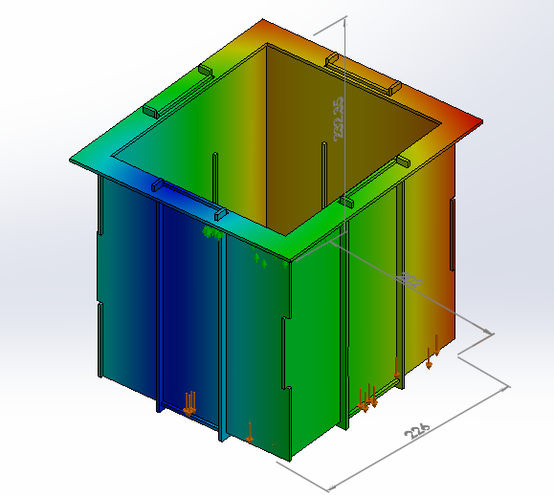

Figure 2 - Ribbed Vat undergoing an FEA Simulation - Displacement diagram

The point of the placing the Ribbed Vat under an FEA Simulation was to determine the theoretical motion of the assembled subsystem when holding the resin in a static environment. The goal of this simulation was to reduce all areas of motion to values less than zero. Due to bonding issues experienced in SolidWorks the simulation above is incorrect. At the end of the FEA Simulation, SolidWorks was able to generate a Report in Microsoft words which summarized all of its findings in the FEA analysis.

In total there were three subassemblies prior to the final printer assembly; the chassis, build table, & ribbed vat. Furthermore, the final assembly included the projector. The purpose of the three subassemblies was to simplify the overall/final assembly, and to assist the end user. Exploded assemblies were created to help the client gain a visual understanding of all the components comprised within the 3D Printer assembly. These visuals assisted in the instructions for piecing the subassemblies and final design.

The Printer assembly was comprised of the Chassis Assembly, the Motion Control Assembly, the Projector and the Ribbed Vat Assembly. The Chassis Assembly served as the main body of the 3D Printer and held all the other components. The Motion Control Assembly moves up and down the chassis. The movement of this subassembly is controlled by the Stepper Motors. The Projector projects UV Light in order to cure the resin in the vat and solidify the liquid. The Ribbed Vat Assembly servers as the container for the resin. The Motion Control Assembly is submerged and raised out of the Ribbed Vat during the systems printing phase.

The Chassis Assembly is currently comprised of 10 unique parts; a Base Plate, a Top Plate, Side Plate Enclosures, Screws, 12mm Rods, Stepper Motors, a Bracket Plate for the Projector, Mounting Plates for the Projector, Lead Screws, & Bearing Lead Screws. The Base Plate & Top Plate sever as fixtures which hold together the main components which make up the Chassis. Furthermore, the Side Plate Enclosures serve as both a stabilizer and light shield which blocks out external light which may over cure the resin. The Screws simply keep the chassis from falling apart. The 12mm Rods act as the stands of the Chassis and vertical sliders of the Motion Control Assembly. The Stepper Motors control the vertical movement of the Motion Control Assembly which greatly affects the quality of the 3D Print. The Bracket Plate’s job is to hold up the Projector(s). The current design allows for a maximum of two Projectors. The Mounting Plates serve as supports for the Bracket Plate holding the Projector(s). The Lead Screws are turned by the Stepper Motors and consequently affect the vertical position of the Motion Control Assembly. The Bearing Lead Screws are found at the Base Plate, and hold the bottom ends of each Lead Screw.

The Motion Control Assembly is currently comprised of 5 different types of parts; a Carriage, a Build Table, 4mm rods, Linear Bearings, & Nuts for the Lead Screws. The Carriage serves as the core component of the Motion Control Assembly, and in turn houses most of the subassembly’s components. The Build Table is the area which is submerged within the Resin and holds the part which is being printed. The 4mm Rods connect the carriage to the Build Table. The Linear Bearings allow the subassembly to slide up and down the 12mm Rods on the Chassis. The Nuts connect the subassembly to the Lead Screws.

The Ribbed Vat Assembly is currently comprised of 6 different types of parts; a Vat Base Plate, Wall X, Wall Y, a Lip, Rib Y and Rib X. The Vat Base Plate is the floor plate of the subassembly. The Wall X & Wall Y are wall components of the subassembly. The Lip is the part which rests atop the Bottom Plate of the Chassis. Both Rib Y and Rib X are fixtures within the subassembly that brace together the subassembly.

Furthermore, it was necessary to create a title block in SolidWorks that would meet our team’s needs while adhering to both ISO standards and the needs of the Open Source Hardware Community. This title block serves as a template for technical drawings.

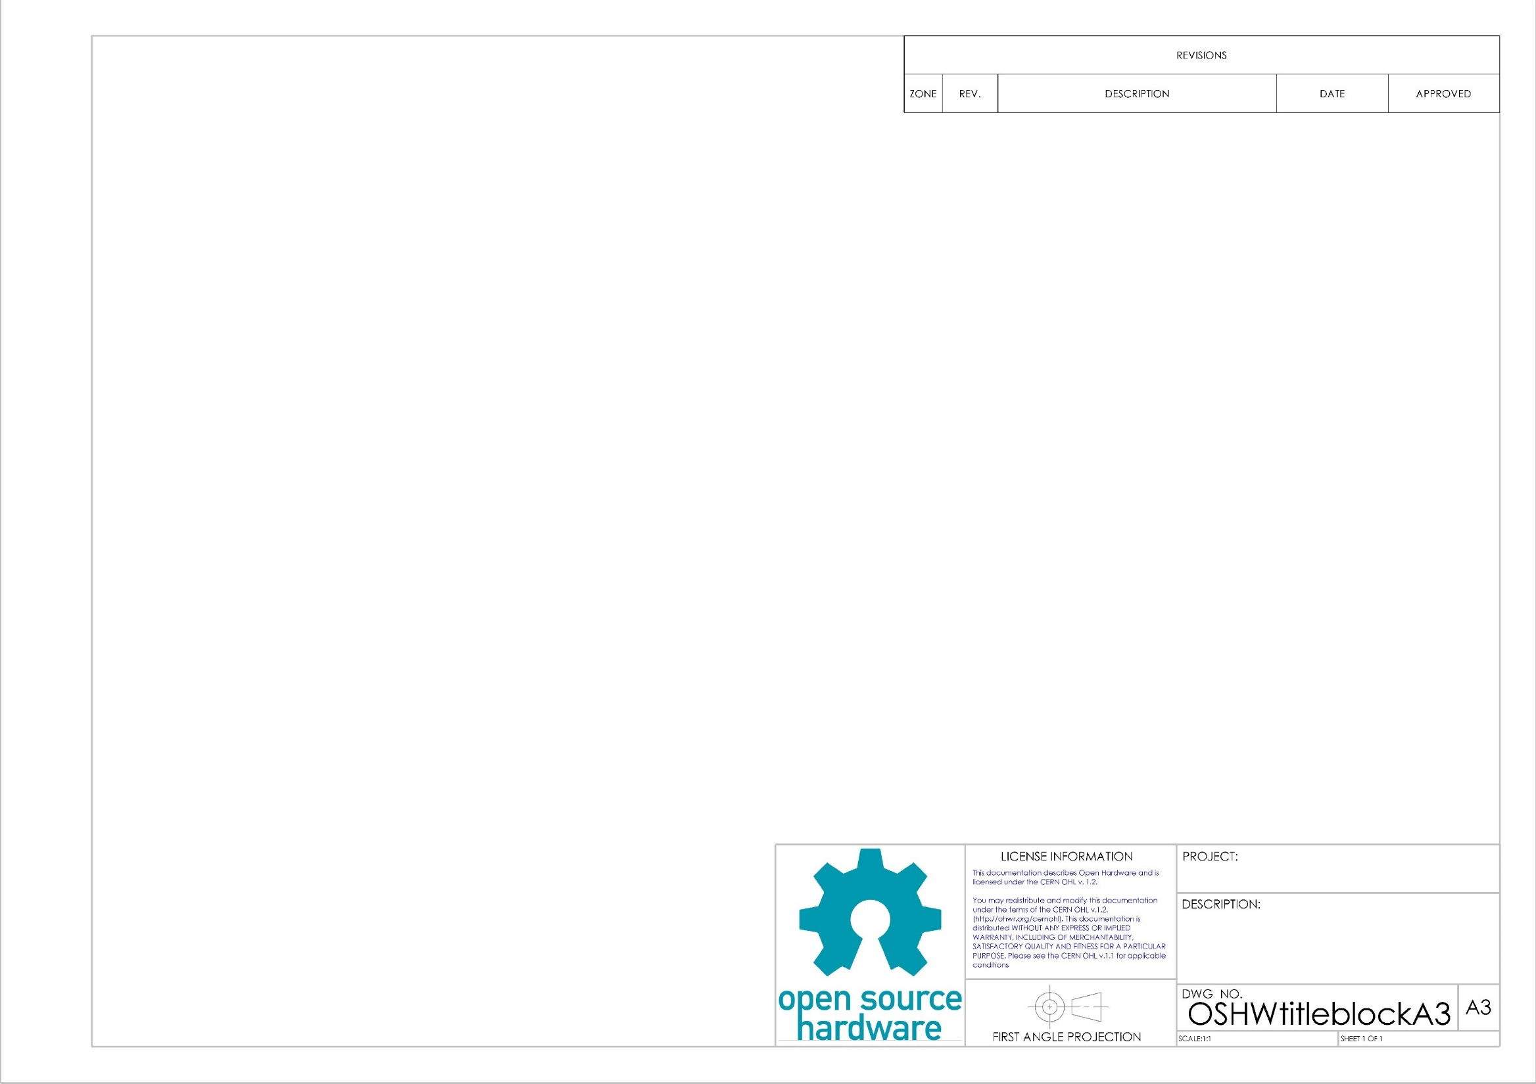

Figure 3 - Generic Title block

In order to provide the Open Source Hardware Community with standard paper sizes several title block & block templates were created: ‘A0’, ‘A1’, ‘A2’, & ‘A3.’ These templates adhered to the ISO standards for the ‘Open Source Hardware Community’ which are licensed under the creative license Share-Alike 3.0. <http://opensourceecology.org/wiki/CAD_Standards>

While the ISO standards were adhered to the CERN license was implemented into the title Block. <http://www.ohwr.org/projects/cernohl/wiki>

In total three files were saved under the folder OSHWtitleblocks; SLDDRW, DRWDOT, & slddrt. SLDDRW files are part files, DRWDOT files drawing template files, & slddrt files are format. When creating a new drawing in SolidWorks the user is asked to choose a format prior to importing and dimensioning a part. In order to use formats ‘A0’, ‘A1’, ‘A2’, or ‘A3’ the respective ‘slddrt’ files should be placed in the “sheetformat” folder.

The open source hardware Logo experienced pixilation issues when imported as a jpeg file. Therefore the logo was imported as a psd file which took SolidWorks a full minute.

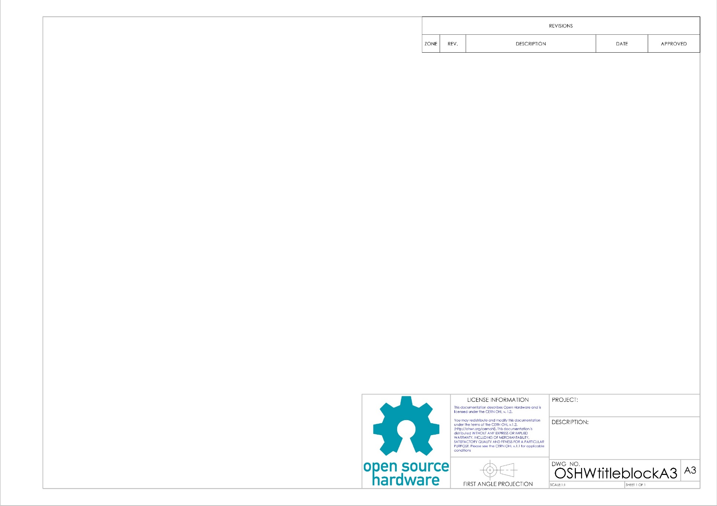

Figure 4 – Open Source Hardware Logo

The psd file corrected the pixilation problem and provided the title block with a professional appearance. In short, a psd file is a layer image file used in Adobe PhotoShop. PSD, which stands for Photoshop Document, is the default format that Photoshop uses for saving data. PSD is a proprietary file that allow the user to work with the images’ individual layers even after the file has been saved.