# Nathaniel Benjamin Tyler

During this semester my main task was to dimension parts while adhering to ISO standards. In short, ISO, is an international standard-setting body composed of representatives from various national standards organizations. The map below is useful in understanding how many nations adhere to ISO standards.

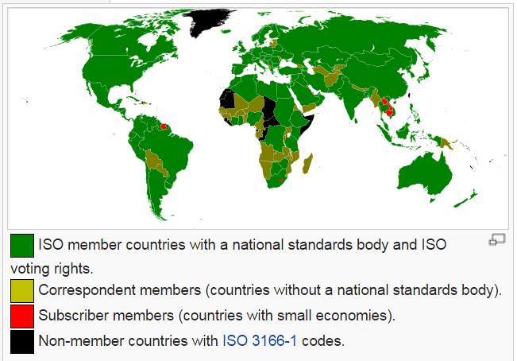

Figure 1 – [Map](http://en.wikipedia.org/wiki/International_Organization_for_Standardization)

The ISO standard for dimensioning parts is GD&T (Geometric Dimensioning and Tolerance). In short, this system is useful when communicating engineering tolerances. This form of dimensioning follows a symbolic language that allows engineering drawings within a computer three-dimensionally. In other words, one can virtually fabricate solid models that explicitly describes nominal geometry and its allowable variation.

It is important to clarify that GD&T is not synonymous for Basic Dimensioning. In short, basic dimensioning represent an ideal case and consequently lacks the necessary tolerances to appropriately design parts. Thankfully, GD&T overcomes this fabrication hurdle and provide the machinist both the necessary dimensions tolerances to produce high quality parts. In technical drawings, a basic dimension is a theoretically exact dimension, given from a datum to a feature of interest. Basic dimensions only communicate a designs critical dimensions and consequently lack tolerance. To facilitate manufacturability, a feature control frame is often used to assign a dimensional tolerance to the feature that is referenced in by the basic dimension. It is important to note that a set of chained basic dimensions do not create tolerance stack up. Furthermore, proper tolerance must be inferred by Datum’s referenced in the feature control frame, and not by dimension arrows or start points. In summary, a numerical value used to describe the theoretically exact size, profile, orientation or location of either a feather or datum target is the basis from which permissible variations are established by tolerances on other dimensions, in notes, or in feature control frames. In conclusion, basic dimension are denoted by enclosing the number of the dimension in a rectangle.

The 3D-printer is comprised of many parts which must be appropriately dimensioned. Parts needing to be fabricated in the machine shop were GD&T prior to construction; ribbed vat, carriage, lead screw(s), coupler, and etcetera.

A program called SolidWorks allowed Jeff and I to create parts, technical drawings, assemblies, & preform simulations on subsystem assemblies with the overall Printer system. I.E.) The ribbed vat

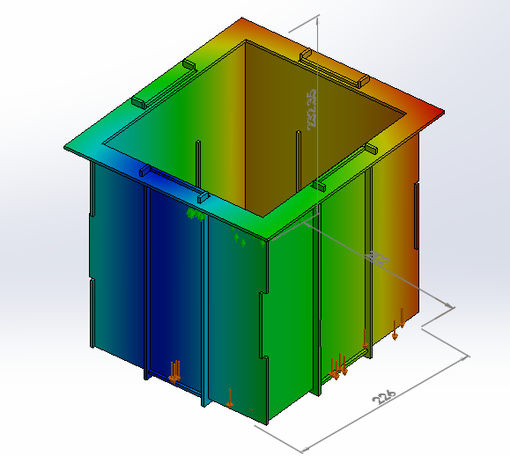

Figure 2 - Ribbed Vat undergoing an FEA Simulation - Displacement diagram

The point of the placing the Ribbed Vat under an FEA Simulation was to determine the theoretical motion of the assembled subsystem when holding the resin in a static environment. The goal of this simulation was to reduce all areas of motion to values less than zero. Due to bonding issues experienced in SolidWorks the simulation above is incorrect. At the end of the FEA Simulation SolidWorks was able to generate a Report in Microsoft words which summarized all of its findings in the FEA analysis.

Furthermore, it was necessary to create a title block in SolidWorks that would meet our team’s needs while adhering to both ISO standards and the needs of having a technical drawing template for the Open Source Hardware Community.

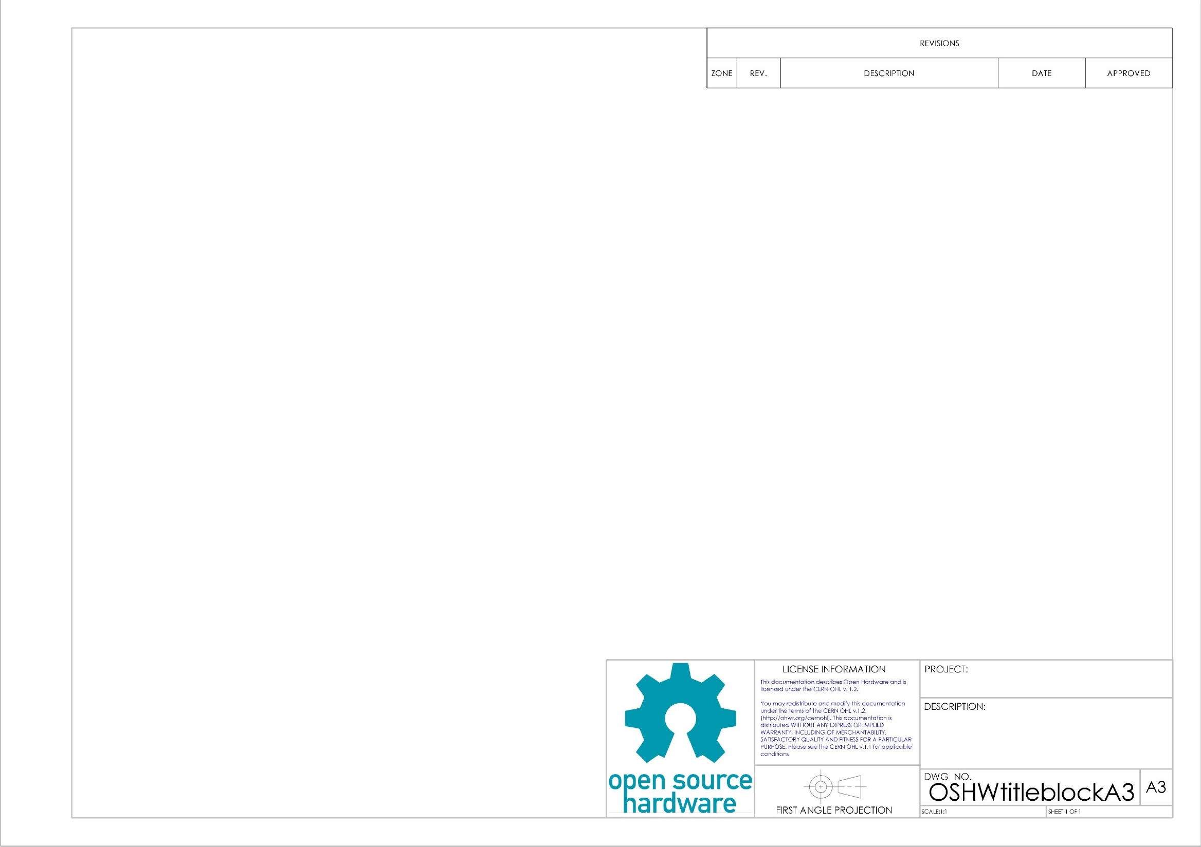

Figure 3 - Generic Title block

In order to provide the Open Source Hardware Community with standard paper sizes several title block & block templates were created: ‘A0’, ‘A1’, ‘A2’, & ‘A3.’ These templates adhere to the ISO standards for the ‘Open Source Hardware Community’ which are licensed under the creative license Share-Alike 3.0.

In total three files were saved under the folder OSHWtitleblocks; SLDDRW, DRWDOT, & slddrt. SLDDRW files are part files, DRWDOT files drawing template files, & slddrt files are format. When creating a new drawing SolidWorks asks the user to choose a format before importing and GD&T a part. In order to use formats ‘A0’, ‘A1’, ‘A2’, or ‘A3’ the respective ‘slddrt’ files were placed in the “sheetformat” folder.

The open source hardware Logo experienced pixilation issues when imported as a jpeg file. Therefore the logo was imported as a psd file which took SolidWorks a full minute.

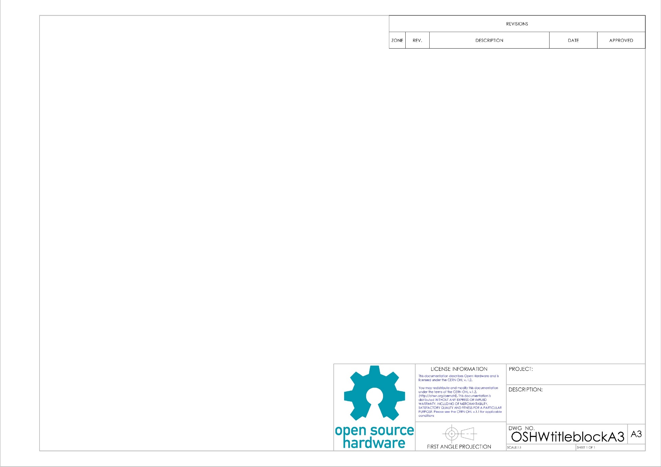

Figure 4 – Open Source Hardware Logo

The psd file corrected the pixilation problem and provided the title block with a professional appearance. In short, a psd file is a layer image file used in Adobe PhotoShop. PSD, which stands for Photoshop Document, is the default format that Photoshop uses for saving data. PSD is a proprietary file that allow the user to work with the images’ individual layers even after the file has been saved.