**Project PAM: Photoresin Additive Manufacturing**

**House of Quality:**



Standards:

* ISO 262 - metric screw thread dimensions
* DIN 103 - Trapezoidal lead screw dimensions
* ANSI/NEMA MG 1-2011 - Stepper motor mounting dimensions
* ISO 6983 - G-Code
* ISO 10303-21 - STEP file
* STL file format ( ungoverned )
* ISO/ASTM 52915:2013 - Additive manufacturing file format
* W3C XML 1.1 - Extensible Markup Language file format
* ISO/IEC 14882:2011 / 2011 - C++ programming language

Drawings:

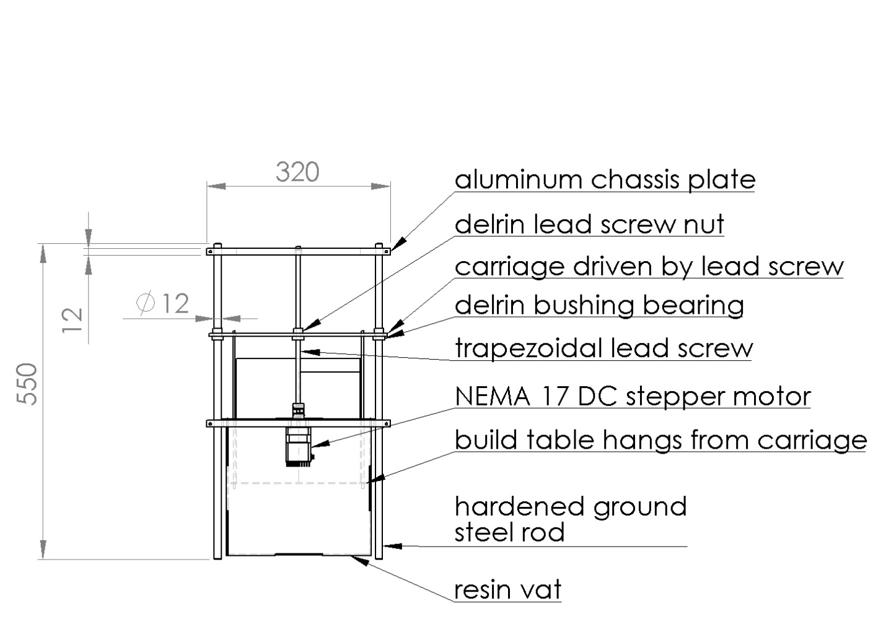

Questions:

1. Would the use of two lead screws be more appropriate?
2. What would be the most effective and elegant projector mounting system?
3. How to optics?