[1]

Stepper Motors and Their Use in 3D Printing

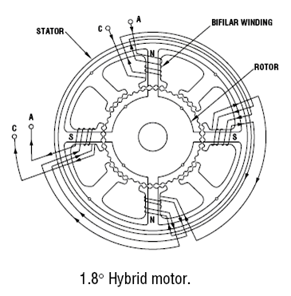

Casey Spencer

*Abstract*— *Stepper motors provide an inexpensive solution to machining and manufacturing techniques which call for high precision and reaptability. Today, they have become a standard in the world of consumer-level 3D printing and fabrication. Consumers now have the luxury of choosing from many different types and models of motors to fit their individual needs and desires.*

# INTRODUCTION

**A**

stepper motor (or step motor) is a brushless electric motor commonly used manufacturing and robotics. “The rotary motion of a stepper motor can be converted to linear motion using a lead screw/worm gear drive system [Omega].” This linear motion (whether it be one, two, or three degrees of freedom) is what allows the printers to “print” in 3-Space. What makes a step motor ideal for manufacturing processes such as 3D Printing is the motors ability to rotate a set distance and then hold that position with great accuracy (this corresponds to precision in a given axis). They accomplish this rotation by sending a pulse to a toothed electromagnetic stator, which will turn a gear-shaped rotor until it aligns with the corresponding teeth on the electromagnet. This set rotation from a single pulse is known as a ‘step’.

Fig. 1. Bipolar Step Motor Diagram [Omega]

# Discussion

## Motor Design Characteristics

Stepper motors for consumer 3D manufacturing can be separated into two major categories: bipolar and unipolar. These categories refer to the internal winding configuration of the motors.

Bipolar motors have two coils and operate by energizing and reversing the current through a coil winding to achieve stepping. The advantage of this configuration is that it utilizes the entire coil for every step. This enables the motor to produce more torque for a given size[Wale]. The drawback to this type of configuration is that it requires more complicated drive circuitry [Condit].

Unipolar motors also implement two coils. However, in this configuration the operator has access to a “center tap” on each coil [Wale]. This essentially divides each coil in two. Unipolar motors achieve stepping by energizing each section of windings one at a time. The advantage of this configuration is that current direction does not need to be reversed in order to turn the rotor; this allows for simple drive circuitry. The major disadvantage is that, since only half of the coil has current flowing through it at a given time, a unipolar motor cannot produce as much torque as a bipolar motor of the same size [REPRAP].

## Step Motor Properties

Three important motor properties for 3D printer design are ***step angle***, ***holding torque***, and ***pullout torque***.

Step angle is *the angle by which the rotor will turn when one pulse is applied to the winding coil* [Subrahmanyam]. Or, more simply, the angle between full steps. This angle is determined by the number of poles and the corresponding number of teeth on the rotor and stator. This rotation then translates to linear motion through the drive system, which means the smaller the step angle, the more precision one has available in the printer itself.

Step angle can also be thought of in terms of the number of steps it takes the motor to turn through 360°, or one full rotation of the rotor. This is often referred to as the step number. For example, a motor with step angle of 3.6° will take 100 steps to complete one full rotation. Either of these parameters may be used when classifying step motors.

A step motor will always have a set number of steps. However, it is possible to realize even greater precision through practices known as ‘half-stepping’ and ‘micro-stepping.’ Both of these methods take advantage of the drive software to attain rotation positions that fall between a full step of the motor. Though, this increase in precision does come at the expense of a decrease in torque; since, once again, there will be less current moving through each coil winding.

Holding torque, according to [Drury], is “…after step angle – the most important single parameter which is looked for in selecting a motor.” This torque parameter is defined by [Gieras] as “The torque required to deflect the motor from its stable position…” when the motor is at rest and rated current is applied to the windings.

Pullout torque refers to the maximum torque a motor can supply at a given speed. This inherent characteristic is defined over a wide range of motor speeds and is essentially a limiting factor in performance. When operating at higher speeds the motor can supply less torque to the drive system. This suggests that for a given torque the motor has a limit on how fast it can rotate. Attempting to operate outside of these parameters can cause the motor to misstep and even stall [SolarBotic].

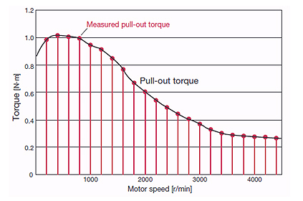

Fig. 2. Speed-Torque Curve [Oriental]

# Conclusion

# Acknowledgment

# References

1. Hybrid Stepping Motors and Drives, Wale and Pollock
2. Stepping Motors Fundamentals, Condit
3. REP RAP wiki.
4. <http://www.omega.com/prodinfo/stepper_motors.html>
5. Subrahmanyam, Electric Drives: Concepts & Appl, 2/E,
6. Hughes, Drury, Electric Motors and Drives: Fundamentals, Types and Applications
7. Gieras, Permanent Magnet Motor Technology: Design and Applications, Second Edition
8. <http://www.solarbotics.net/library/pdflib/pdf/motorbas.pdf>
9. http://www.orientalmotor.com/technology/articles/article-speed-torque-curves-for-step-motors.html

1. Manuscript prepared February 28, 2014.

   The author is with the Saluki Engineering Company, Southern Illinois University at Carbondale, IL 62901 USA (phone: 618-453-7053; fax: 618-453-7972; email: cspence182@siu.edu).