[1]

# Discussion of Stepper Motors and their use in 3D Printing

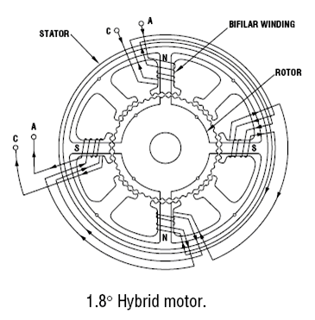

A stepper motor (or step motor) is a brushless electric motor commonly used manufacturing and robotics. “The rotary motion of a stepper motor can be converted to linear motion using a lead screw/worm gear drive system [1]." This linear motion (whether it be one, two, or three degrees of freedom) is what allows the printers to “print” in 3-Space. The motor's ability to rotate a set distance and then hold that position with great accuracy makes a step motor ideal for manufacturing processes such as 3D Printing (this corresponds to precision in a given axis). The rotation is accomplished by sending a pulse to a toothed electromagnetic stator, which will turn a gear-shaped rotor until it aligns with the corresponding teeth on the electromagnet. This set rotation from a single pulse is known as a ‘step’.

## Motor Design Characteristics

Stepper motors for consumer 3D manufacturing can be separated into two major categories: bipolar and unipolar. These categories refer to the internal winding configuration of the motors.

Fig. . Bipolar Step Motor Diagram

Bipolar motors have two coils and operate by energizing and reversing the current through a coil winding to achieve stepping. The advantage of this configuration is that it utilizes the entire coil for every step. This enables the motor to produce more torque for a given size . The drawback to this type of configuration is that it requires more complicated drive circuitry.

Unipolar motors also implement two coils. However, in this configuration the operator has access to a “center tap” on each coil . This essentially divides each coil in two. Unipolar motors achieve stepping by energizing each section of windings one at a time. The advantage of this configuration is that current direction does not need to be reversed in order to turn the rotor; this allows for simple drive circuitry. The major disadvantage is that, since only half of the coil has current flowing through it at a given time, a unipolar motor cannot produce as much torque as a bipolar motor of the same size.

## Step Motor Properties

The three most important motor properties for 3D printer design are ***step angle***, ***holding torque***, and ***pullout torque***.

Step angle is *the angle by which the rotor turns when one pulse is applied to the winding coil* . Or, more simply, the angle between full steps. This angle is determined by the number of poles and the corresponding number of teeth on the rotor and stator. This rotation then translates to linear motion through the drive system, which means the smaller the step angle, the more precision one has available in the printer itself.

Step angle can also be thought of in terms of the number of steps it takes the motor to turn through 360°, or one full rotation of the rotor. This is often referred to as the step number. For example, a motor with step angle of 3.6° will take 100 steps to complete one full rotation. Either of these parameters may be used to classify step motors.

A step motor will always have a set number of steps. However, it is possible to realize even greater precision through practices known as ‘half-stepping’ and ‘micro-stepping.’ Both methods take advantage of the drive software to attain rotation positions that fall between a full step of the motor. Though, this increase in precision does come at the expense of a decrease in torque; since, once again, there will be less current moving through each coil winding.

Holding torque, according to , is “…after step angle – the most important single parameter which is looked for in selecting a motor.” This torque parameter is defined by as “The torque required to deflect the motor from its stable position…” when the motor is at rest and rated current is applied to the windings.

In contrast, pullout torque refers to the maximum torque a motor can supply at a given speed. This inherent characteristic is defined over a wide range of motor speeds and is essentially a limiting factor in performance. When operating at higher speeds the motor can supply less torque to the drive system. This suggests that for a given torque the motor has a limit on how fast it can rotate. Attempting to operate outside of these parameters can cause the motor to misstep and even stall.

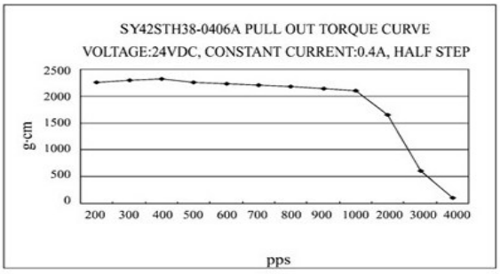

Fig. . Speed-Torque Curve

## Conclusion Drawn

Figure 2 shows a graph of pullout torque vs. pulses per second for half-step operation of the step motor project PAM will be implementing. It is a NEMA 17 sized unipolar motor. Speed-torque characteristics are the most important parameters for stepping motors and it is essential to study these characteristics carefully when selecting a motor.

Since the Project PAM printer design will not require stepping through long distances of z-travel, the speed of the motor will not be as critical to the performance of the machine. While the speed may vary slightly depending on specific needs for a particular print the motor should never exceed more than 500 pulses per second. Based on the provided data our printer will be within tolerable ranges for the motors operation.

# Works Cited

|  |  |
| --- | --- |
| [1] | O. E. Co, "Introduction to Stepper Motors," Omega, [Online]. Available: http://www.omega.com/prodinfo/stepper_motors.html. [Accessed 26 February 2014]. |
| [2] | J. D. Wale and C. Pollock, "Hybrid Stepping Motors and Drives," *Power Engineering Journal,* pp. 5-12, 2001. |
| [3] | R. Condit and D. Jones, "Stepping Motors Fundamentals," [Online]. Available: http://www.bristolwatch.com/pdf/stepper.pdf. [Accessed 27 February 2014]. |
| [4] | "Rep RAp Wiki," Rep Rap, [Online]. Available: http://reprap.org/wiki/Stepper_motor. [Accessed 25 February 2014]. |
| [5] | Subrahmanyam, Electronic Drives: Concepts and Applications, Tata McGraw-Hill, 2011. |
| [6] | A. Hughes, Electronic Mortors and Drives: Fundamentals, Types, and Applications, Waltham: Elsevier Ltd., 2013. |
| [7] | J. F. Gieras, Permanent Magnet Motor Technology: Design and Applications, Marcel Dekker, Inc, 2002. |
| [8] | "Products: Stepper Motors," Oriental Motors, [Online]. Available: http://www.orientalmotor.com/technology/articles/article-speed-torque-curves-for-step-motors.html. [Accessed 28 February 2014]. |
| [9] | "Robot Shop," [Online]. Available: file:///C:/Users/Casey/Documents/ECE%20495/rb-soy-03-unipolar-stepper-motor-specs.pdf. [Accessed 11 March 2014]. |
| [10] | "Industrial Circuits Application Note, Stepper Motor Basics," [Online]. Available: http://www.solarbotics.net/library/pdflib/pdf/motorbas.pdf. [Accessed February 2014]. |



Fig. 3. Wiring Diagram for Step Motor and Drive

1.