[1]

|  |  |  |  |
| --- | --- | --- | --- |
|  | B9 Creator | MiiCraft | Creation Workshop |
| Language | C++ [4] | Python [7] | C# [10] |
| Cross-platform | ✓ [2] | ✗ [6] | ✓ [9] |
| Slicing Software | Custom [4] | Skeinforge [7] | Slic3r [10] |
| G-Code Support | ✗ [4] | ✓ [7] | ✓ [10] |
| CAD File Input | STL [2] | STL [6] | STL, OBJ, 3DS [9] |
| Able to Add Supports | ✓ [2] | ✗ [6] | ✓ [9] |
| Image Output | SLC [4] | SVG [4] | SVG [4] |

Table 1. Comparison chart of three open-source computer control software for DLP printer.

A Proposal for a Reference Design of a Photoresin Additive Manufacturing 3D Printer

Daniel M Olsen

*Abstract*—With the recent rise of digital light processing printing in the hobbyist market there is a need for a more consolidated form of printer control software. Current implantations are very printer specific. One exception to this is the Creation Workshop by Steve Hernandez.

***Index Terms*—Three Dimensional Printing, Digital Light Processing, Light-curing Resins**

# INTRODUCTION

**D**

IGITAL light processing fabrication or DLP printing works by using a DLP projector to display a *series of two-dimensional “slices”* of a CAD representation of the object to be printed *on the surface of a pool of light-curing resin* [1].

# Discussion of Control Software

## B9 Creator Software

The B9 Creator is a crowdsourced open-source DLP printer [2][3]. The B9 Creator’s printer control software is written in C++, using the Qt library for the user interface [4]. It supports STL CAD files as the model input [2], the standard for 3D printing [5]. *Support structure can be manually* added after the import of the STL file [2]. The slicing of each individual layer is done by a custom implementation and outputs SLC files, SLC files are CAD slice files [4]. However, because it uses a custom implantation for slicing there is no standard G-code support.

## MiiCraft Suite

The MiiCraft printer is a DLP printer that has closed-source hardware however it has open source printer control software [6]. The MiiCrat’s printer control software, or MiiCraft Suite as it has been dubbed, is written in Python, and uses Tkinter for the user interface [7]. Unlike the B9 Creator and the Creation Workshop the MiiCraft is not cross-platform and only supports Windows [6]. It supports STL CAD files as the model input. The software does not have the ability to add supports to the model before printing [6]. Skeinforge is the slicing software used by the MiiCraft [7], which supports the output of each layer as a scalable vector graphics (SVG) file through its Vectorwrite plugin [8].

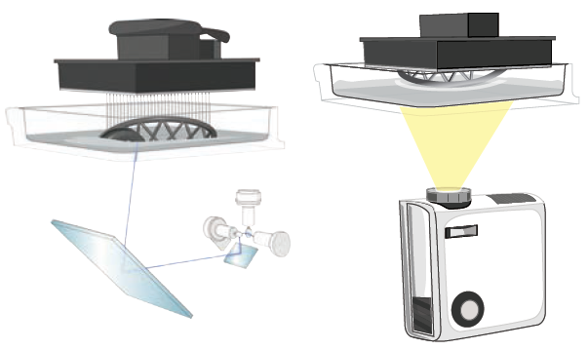

Fig. 1. Overview of operation of laser-based SLA printer (left) and projector-based DLP printer (right) [1].

## Creation Workshop

The Creation Workshop is an attempt to provide printer control software for any DLP printer, however it also supports FDM printers [9]. It is written in C#, using OpenTK, which is a C# wrapper for OpenGL, for the user interface [10][11]. Unlike the B9 Creator and the MiiCraft the Creation Workshop does not only support STL CAD files for the model import, it also supports OBJ and 3DS files [9]. The software does allow supports to be added after the CAD file is imported. The Creation Workshop uses Slic3r for the slicing software [10], which is written in Perl and supports outputting the layers as SVG files [12]. The Creation Workshop also supports G-code for DLP printers [9].

# Conclusion

The Creation Workshop printer control software is the most powerful and open printer control software on the market for DLP printers. The biggest reason for this is that it uses Slic3r as its slicing engine, which is *the most popular slicing engine* [13].

# Acknowledgment

# References

1. A. Ta, E. Chu and A. Kaziunas France, "Liquid Dreams," Make: Ultimate Guide to 3D Printing, p. 91.
2. E. Chu, "B9 Creator," Make: Ultimate Guide to 3D Printing, p. 93.
3. "B9 Creator," B9 Creations LLC, 2013. [Online]. Available: http://b9creator.com/. [Accessed 27 February 2014].
4. B9 Creations LLC, "B9 Creator GitHub," GitHub Inc, 2014. [Online]. Available: https://github.com/B9Creations/B9Creator. [Accessed 27 February 2014].
5. S. Ragan, "Software for 3D Printing," *Make: Ultimate Guide to 3D Printing,* pp. 34-35.
6. Rays Optics Inc, "MiiCraft User Guide," 2012. [Online]. Available: http://www.miicraft.com/web/assets/2012/11/MiiCraft-3D-printer-User-Guide.pdf. [Accessed 27 Febuary 2014].
7. MiiCraft, "MiiCraft Suite GitHub," GitHub Inc, 2014. [Online]. Available: https://github.com/miicraft/MiiCraftSuite. [Accessed 27 February 2014].
8. Fabmetheus, "Skeinforge Vectorwrite," Demozendium, 17 July 2012. [Online]. Available: http://fabmetheus.crsndoo.com/wiki/index.php/Skeinforge_Vectorwrite. [Accessed 27 February 2014].
9. S. Hernandez, "Creation Workshop - SLA / FDM Slicer and Controller," Makerbot Industries LLC, 8 January 2013. [Online]. Available: https://www.thingiverse.com/thing:40778. [Accessed 27 February 2014].
10. S. Hernandez, "Creation Workshop GitHUb," GitHub Inc, 2014. [Online]. Available: https://github.com/Pacmanfan/UVDLPSlicerController. [Accessed 27 February 2014].
11. S. Apostolopoulos, "OpenTK," Stefanos A. Icons, 2013. [Online]. Available: http://www.opentk.com/. [Accessed 27 February 2014].
12. A. Ranellucci, "Slic3r Manual," GitHub Inc, 2014. [Online]. Available: https://github.com/alexrj/Slic3r-Manual. [Accessed 27 Febuary 2014].
13. J. Abella, "Slicing and Control Software: Where it's going and where it's been," Make: Ultimate Guide to 3D Printing, p. 90.

1.