## **Dan Singer**

## HvZ Check-off

## Friday, November 3, 2017

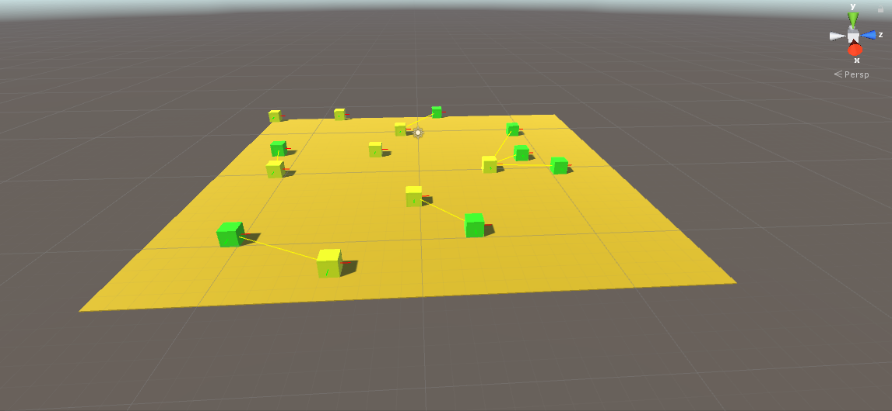

Zombies and humans are spawned on the floor in random locations, and debug lines are drawn for forward, right, and lines from zombie towards their human target.

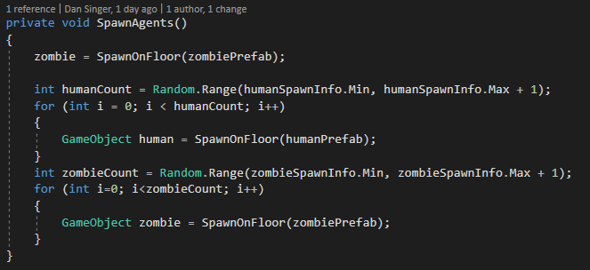

Method which spawns agents onto the floor.

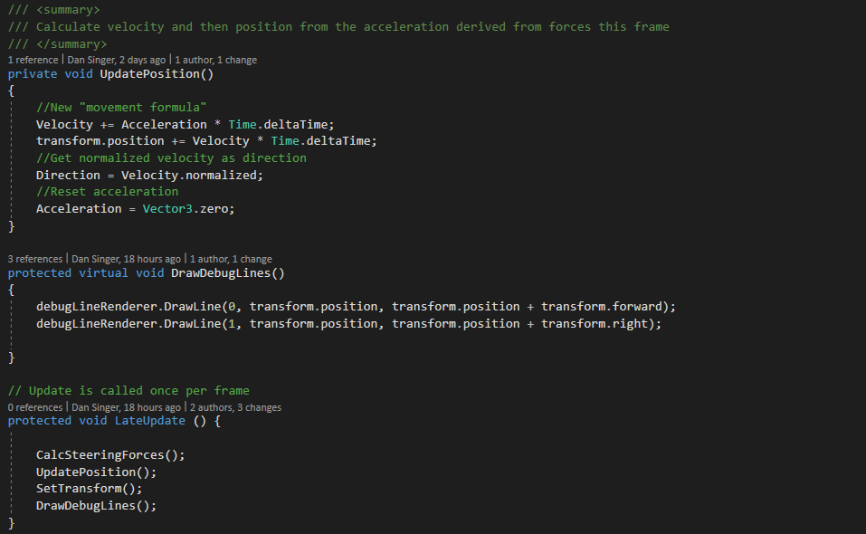

Code samples from the abstract Vehicle class.

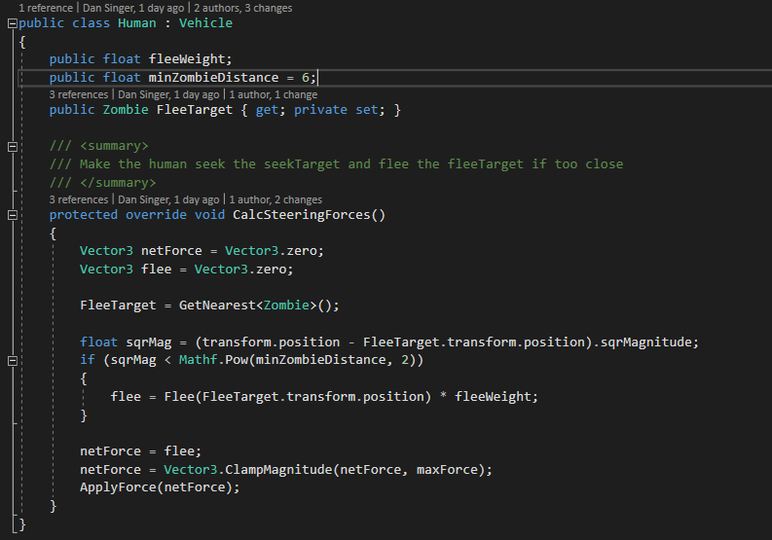

Human class, which is a child of Vehicle class.

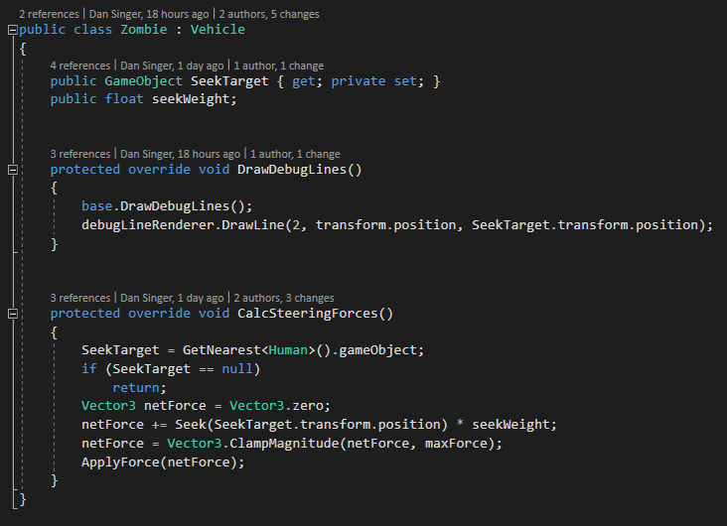

Zombie class, which is a child of Vehicle class.

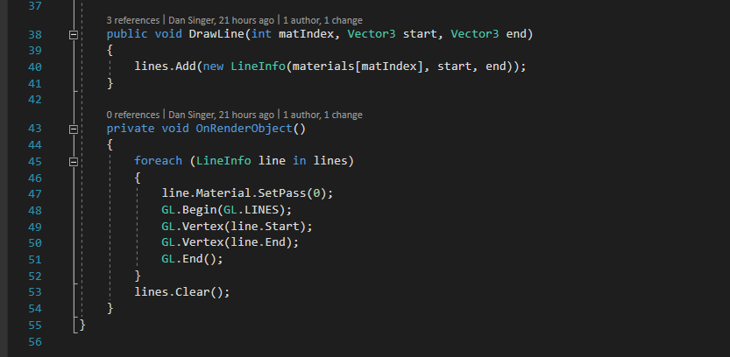

Sample of DebugLineRenderer component, which draws debug lines visible during gameplay.