Exercise 6A: Analyzing Websites with CRAP

Your Name: __Dan Singer_________________________________________________

# Overview

So, you've been web surfing for quite some time now, and you've undoubtedly found some pages that you like and others that you don't like. Sometimes, it's not so easy to really explain why. You now have a new vocabulary with which to describe your thoughts on the matter.

# Part 1: Group Evaluations

1. Follow this link using the browser of your choice.

**http://www.rochesterfirst.com/**

1. Examine this site… at least the first page and a couple of links to sub-pages (pages that are part of the same site).
2. Summarize your opinions and why you came to them here:
   1. Alignment:

Small details aligned to the narrower, right column, and more prominent details aligned to the wider, left column.

* 1. Proximity:

Things that are related to each other are close together, and vice versa. However, their displacements from each other are too extreme, as in either too close or too far.

* 1. Repetition:

There’s very little repetition, and the sections don’t seem very related. Thus, repetition could be better.

* 1. Contrast:

There is contrast, but likely too much.

* 1. Use of color

There is some consistency in the blue theme, but it’s not consistent enough and too varied.

* 1. Use of typography

This is good; the sans-serif fonts are readable and work well.

1. Now go into myCourses, into the **Design Principles** discussion, and tell the class your opinions on the design of **http:// rochesterhomepage.net/**.(HINT: You just wrote them in step 3). Each of you should post your thoughts individually – not as a group.
2. After you post your review, read the other student comments about this site. Choose one other student review and summarize below:
   1. Author of message you’re summarizing: __Kyle Fasanella_____________________
   2. Alignment:

The left column is larger than the right, and they’re centered on the page. The right column is not aligned perfectly.

* 1. Proximity:

The content should be spaced out more.

* 1. Repetition:

The right column and fonts are consistent.

* 1. Contrast:

The story thumbnails use contrasting colors, and the white text does not work with the blue background.

* 1. Use of color:

Not bad; there is a lot of blue, white, and red.

* 1. Typography

The font is sans-serif and easy to read.

1. Do you agree or disagree with this person about the design elements of the page in question (Why?)

I agree with this person because we had similar opinions about its design. We both feel that the site is not great overall, and could use better CRAP principles.

1. Reply to their post (politely) to discuss your agreements and disagreements.

# Part 2: Design Critiques

Pick a web site ***you don’t like*** (in terms of design), and a web site you ***do***, and describe/critique each using the forms attached to this handout. If you are having trouble finding a bad site, try using a random link generator such as:

http://www.uroulette.com/ or   
http://www.randomwebsite.com/

# Part 3: Individual Critiques

Pick a color scheme for your own class page and describe it below. (Describe your color scheme in terms of what color(s) you will use for each element.) Feel free to make these determinations as a team.

Body: #2E112D

H1, H2: #F0433A

Section: #820333

Nav: #540032

p: white  
  
  
Now, use the space below to sketch an improved layout for your page. Again, work with your neighbors to come up with something really great! A simple wireframe drawn up in the app of your choice, or a hand sketch either scanned or photographed with a phone would be fine.

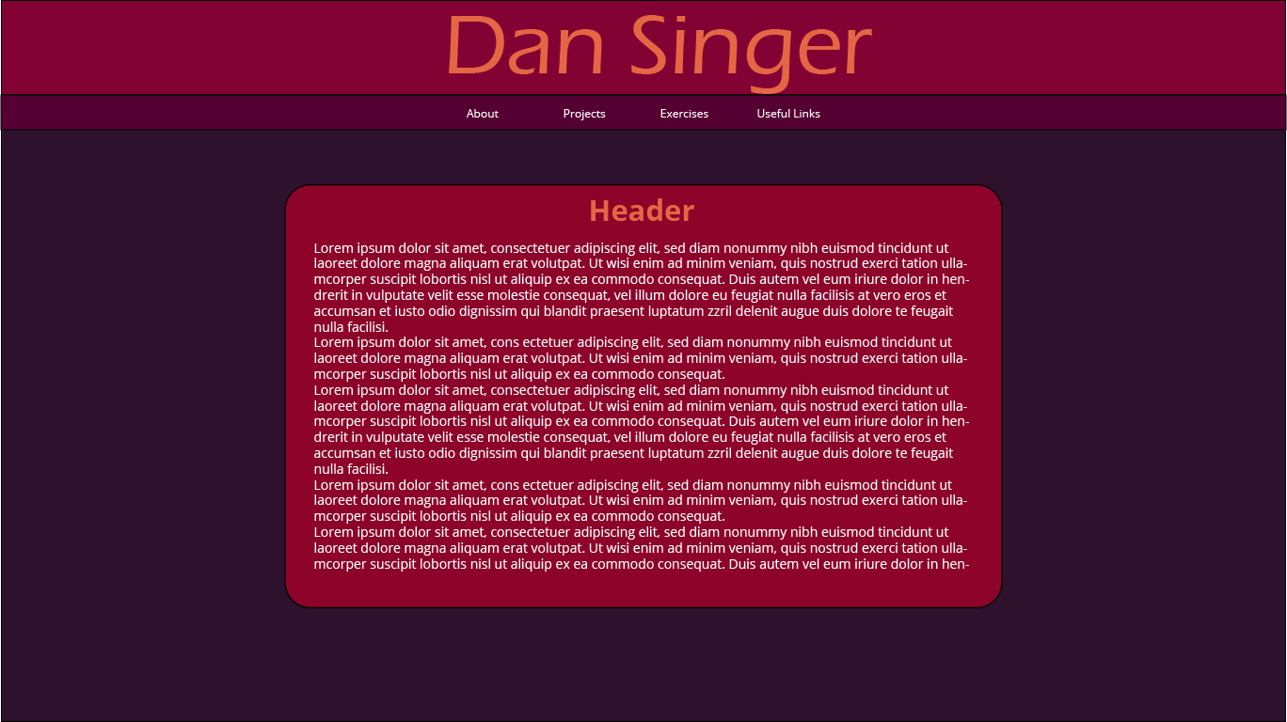

|  |
| --- |
| **bad site: http://www.suzannecollinsbooks.com/** |
| **Alignment:** How many different styles of alignment can you see on this page? Describe them:  I see four different alignment styles, which include left, right, center, and center left.  Where is the strongest alignment line on this page? Why?  Middle-left – aside from the center picture, most of the content is aligned to the middle left of the screen. |
| **Proximity:** Identify two elements of this site that, due to their proximity, appear to have a relationship.  The selected works header and the content below it appear to have a relationship.  Identify information at this site that "hangs" alone.  The center image on top hangs alone and doesn’t have much relationship with anything else on the site. |
| **Repetition:** Does the repetition on this page draw attention to anything particular? What?  The repetition of the selected works header style draws my attention to them.   Describe the repetitive element(s) used to the best advantage on this site.  Not much is repetitive on this site, but the consistent mid-left aligned images do work best, even though they sometimes are aligned to the middle. |
| **Contrast:**  Identify the strongest area of contrast at this site.  The selected works section.  Are there areas of this site that seem "muddy" or run together because of a   lack of contrast? What are they?  The majority of the site is like this; each of the books do not have clear divisions and thus run together. |
| **Color & Type:**  Does the use of color and type on this page enhance or detract from   the content? How?  There is a consistent color scheme, but I feel it detracts from the page because the orange and white do not look good together. Also, this color scheme makes the images feel out of place. |

**Additional Notes:**

|  |
| --- |
| **good site: https://www.theverge.com/** |
| **Alignment:** How many different styles of alignment can you see on this page? Describe them:  I see two main alignment styles: center left and far right.  Where is the strongest alignment line on this page? Why?  Center left – it takes up more space on the page than the smaller right section. |
| **Proximity:** Identify two elements of this site that, due to their proximity, appear to have a relationship.  The Tech and Science navbar items appear to have a relationship due to their proximity.   Identify information at this site that "hangs" alone.  I don’t believe anything hangs alone on this site. |
| **Repetition:** Does the repetition on this page draw attention to anything particular? What?  The repetitive jagged lines draw attention to important articles.  Describe the repetitive element(s) used to the best advantage on this site.  The repetitive color scheme, fonts, and occasional purple accents make the site feel consistent. |
| **Contrast:**  Identify the strongest area of contrast at this site.  The neon-colored borders.  Are there areas of this site that seem "muddy" or run together because of a   lack of contrast? What are they?  The smaller articles below the main ones run together due to lack of contrast. |
| **Color & Type:**  Does the use of color and type on this page enhance or detract from   the content?  The color enhances the content; it’s consistent and looks good. |

**Additional Notes:**

When you're all done, post this completed file, renamed **Exercise-CRAP-YOURNAME.docx**, to the appropriate dropbox before next class.