Lecture 5 – Inference for Numerical Data

**One-sample t-test**

t test has a thicker tail than the z test

The test statistic for inference on a small sample (n < 30) mean is the T statistic with df = n 􀀀 1:

Xbar (average) = point estimate

SE =

Confidence Intervals = point estimate ± ME, ME = t* x SE

Using the t table the t* value is at the intersection of the df row and two tail probability of .05

Summary

If σ is unknown and we do not have a reliable estimate, use the t-distribution with SE =

Conditions 1) Independence of observations 2) No extreme skew

**Paired t-test**

When two sets of observations have a special correspondence (not independent), they are said to be paired

To analyze paired data it is useful to look at the difference in outcomes of each pair of observations diff = x – y (difference in means)

Parameter of interest = average difference between population values µdiff

Point estimate = average difference between sampled values xbardiff

No different than before we just use the one sample which is the difference between the observations

**Two sample t-test**

Mean difference µgroup1- µgroup2

point estimate = (xbar1 – xbar2)

SE =

Confidence Intervals = point estimate ± ME, ME = t*df x SE

Conditions: 1) independence within groups (often verified by a random sample, if sampling without replacement, n<10% of population) and between groups 2) no extreme skew

**ANOVA (ANalysis Of VAriance)**

To compare means of 3+ groups, ANOVA is used to assess whether the mean of the outcome

variable is different for different levels of a categorical variable.

Use F statistic

H0 : The mean outcome is the same across all categories, µ1 = µ 2 = ….. = µk; where µ i represents the mean of the outcome for observations in category i.

HA : At least one mean is different than others.

Test Statistic: F =

Conditions: 1) observations should be independent within and between groups 2) Observations should be nearly normal 3) the variability across the groups should be about equal.

Large test statistics lead to small p-values.

Degrees of freedom: groups dfG = k – 1, where k is the number of groups, total dfT = n-1, where n is tht total sample size, error: dfE = dfT - dfG

Sum of squares between groups is SSG = SG1+SG2+…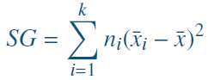

Total sum of squares, SST = 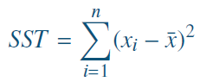

Sum of squares error, SSE = SST – SSG

Mean square error: MSG = SSG/df df=k-1, MSE=SSE/df df=n-1

F = MSG / MSE

Estimate any within-group standard deviation with , use the error degree of freedom n-k for t distributions

Difference in two means after a significant F-test 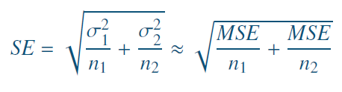

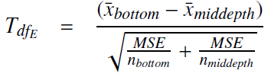

α*=α/k

**Lecture 6 Inference for Categorical Data**

**Single Proportion**

Parameter of interest: proportion of all - p(a population proportion)

Point estimate: proportion of sampled – phat(a sample proportion)

Confidence Intervals = point estimate ± ME

Standard error of a sample proportion is SE =

Central limit theorem for proportions: Under certain conditions sample proportions will be nearly normally distributed with mean equal to the population mean, p, and standard error equals to SE below

P(hat)~N(mean=p, SE=)

Conditions: 1) independent observations 2) at least observed 10 successes and 10 failures (large sample)

Parameters: Population Parameter: p, Point Estimate p(hat)

Confidence Interval

CI vs HT: CI at least 10 observed Successes and failures, HT at least 10 expected successes and failures calc using null value

H0: p = p0 HA: p ≠ p0

Test statistic

**Two Proportions**

Parameter of interest: Difference between the proportions of all group1 and all group2: p1-p2

Point estimate: Difference between the proportions of sampled1 and sampled2 phat1-phat2

Confidence Intervals = point estimate ± ME

Conditions 1) observations within groups are independent 2) observations between groups are independent 3) at least 10 observed successes and failures in each group

Confidence Interval:

For HT we don’t have a given H0 so we need to calculate an pooled estimate of a proportion

CI use observed sample (p1,p2) for HT use pooled estimate phat

Hypotheses: H0: p1 = p2 HA: p1 ≠ p2

Test statistic

Page 114