# Interface

Use the following packages, and ‘extend Remote’ for interface:

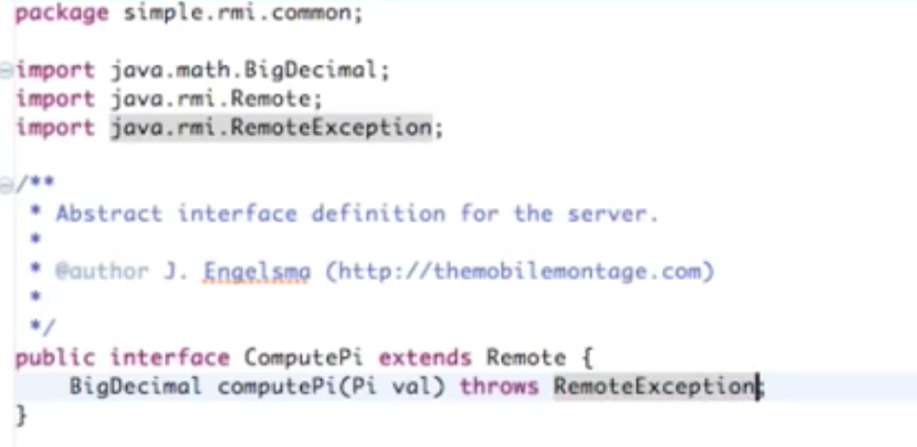

Any object that is passed as a parameter has to be serializable:

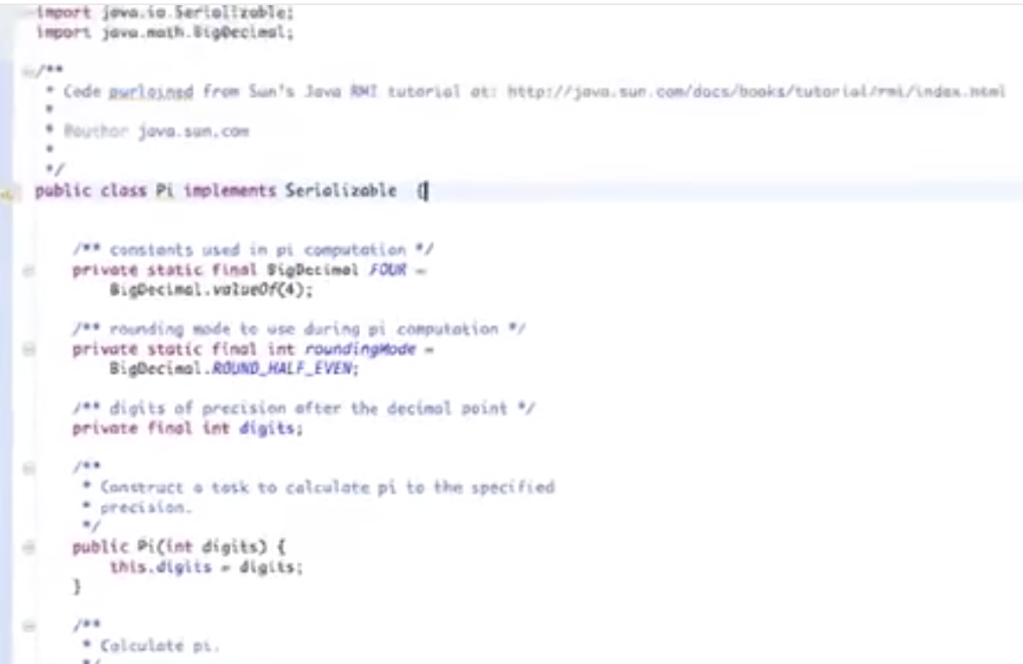

# Server

Initialise a constructor, which may throw an error. The UnicastRemoteObject is commonly used for servers, but something else may be required.

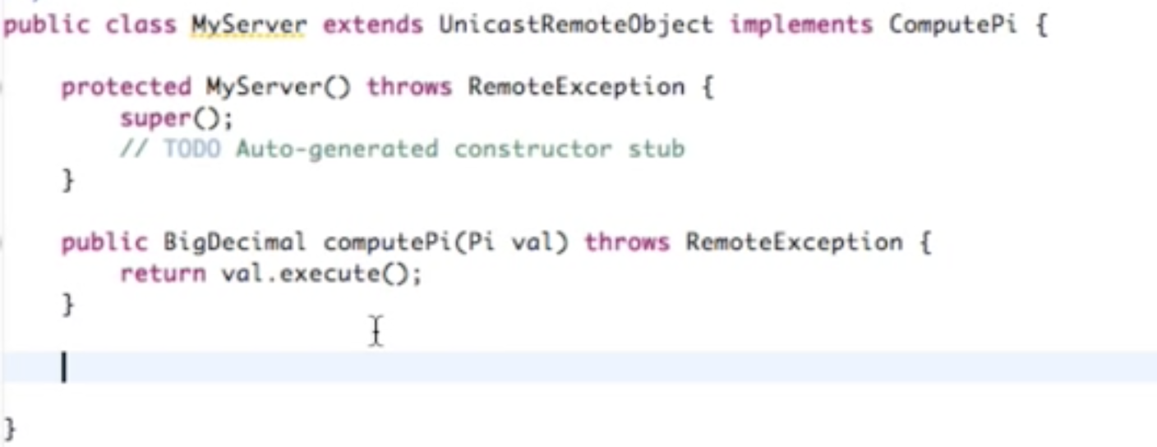

Create a Registry in the main, and bind a server name to the object constructor.

Also remember to have a catch exception.

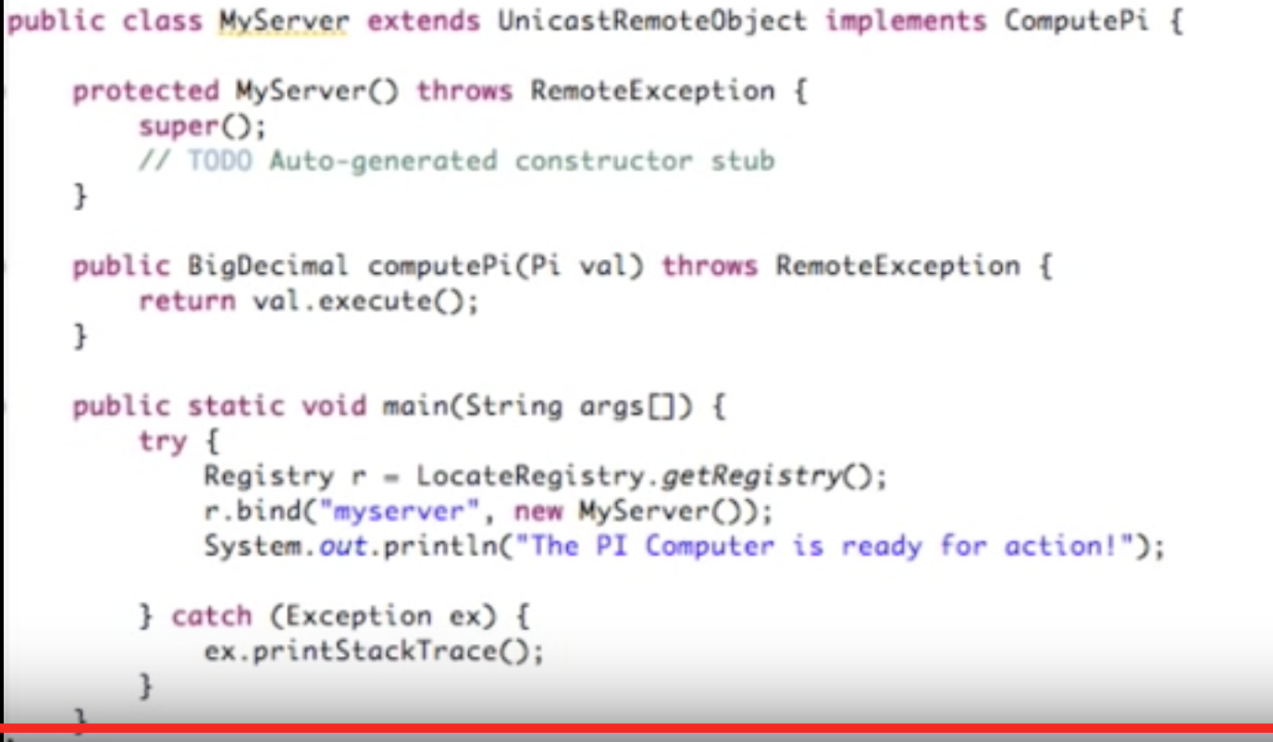

# Client

Set a security manager. Remember to cast correctly!

