Iyuehan Yang, 5300231

Daniyal Usman

**User Manual**

**Navigation  
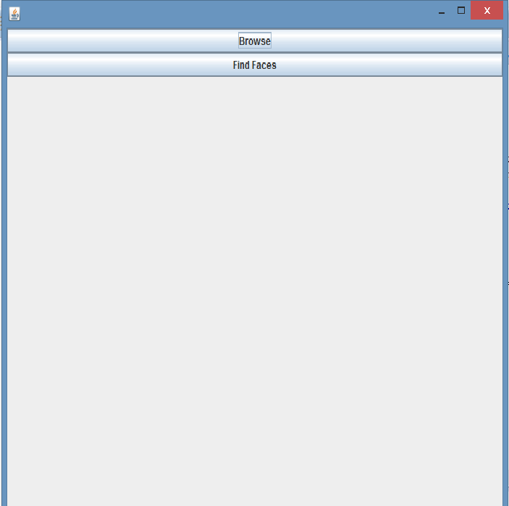**

Upon starting the program, a JFrame panel will appear. Which tells you to browse for an image.

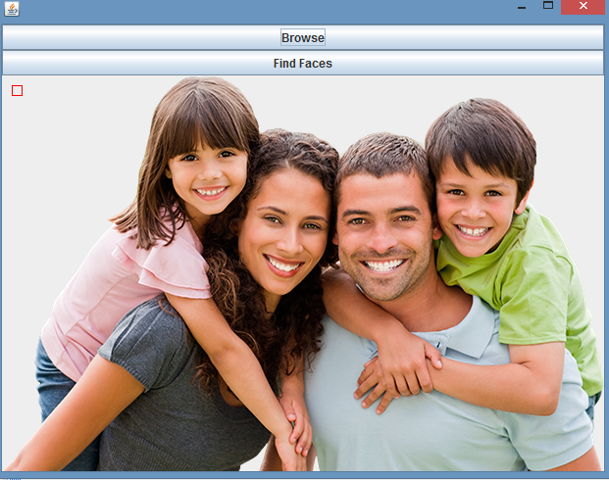

After choosing your image, it will show you the image you chose back on the JFrame.

After the image has loaded, by clicking Find Faces, it will run the algorithm to try to find all the faces on this image.