|  |  |
| --- | --- |
| OOP | Functional |
| * Imperative way of programming * How things are done * Variable are assigned * Variable value can change in the middle of the method body | * Declarative way of programming * What things are * Variables are defined * Variable values are constant |

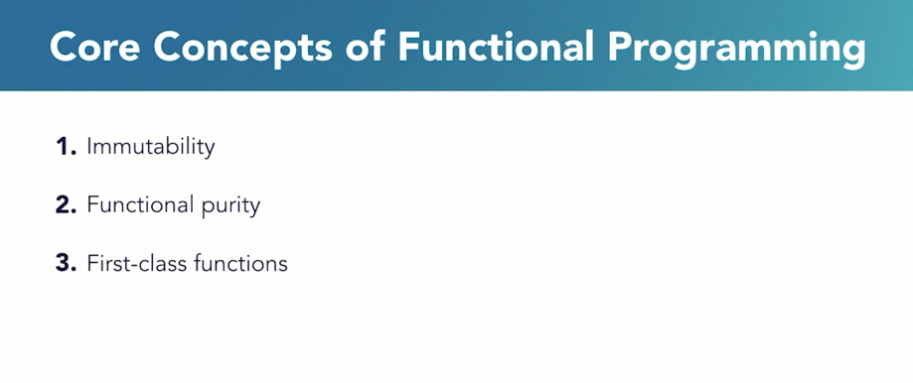

1. Immutability – Variables, parameters are constant, I.e. they do not change in the middle of the function body
2. Functional Purity – For a given set of inputs, the output remains the same
3. Fist-class functions – functions can be used as data, arguments or return values of another function