Taras Bulba and Other Tales

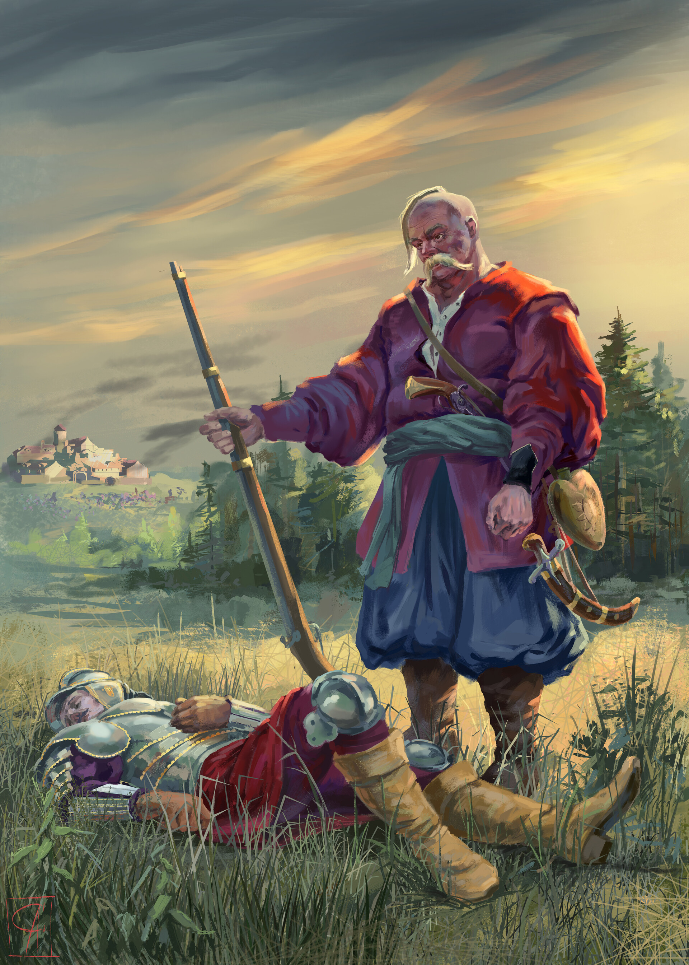

***Taras killed his son Andriy***

# Book author: Nikolai Vasilievich Gogol Report author: Danylo Vasylyshyn 256711

**Plot of distribution of lengths of paragraphs**

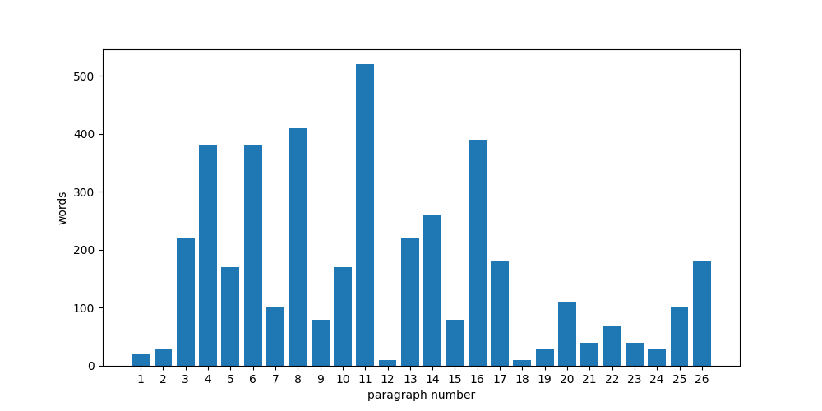

**Chapter 1 data about paragraphs:**Paragraphs (12, 18) all have the length of 10 words  
Paragraphs (2, 19, 24) all have the length of 30 words  
Paragraphs (21, 23) all have the length of 40 words  
Paragraphs (9, 15) all have the length of 80 words  
Paragraphs (7, 25) all have the length of 100 words  
Paragraphs (5, 10) all have the length of 170 words  
Paragraphs (17, 26) all have the length of 180 words  
Paragraphs (3, 13) all have the length of 220 words  
Paragraphs (4, 6) all have the length of 380 words  
  
Avaerage number of words in paragraphs of chapter 1: 162.7  
Maximum number of words is 520 in paragraph(s) (11,)  
Minimum number of words is 10 in paragraph(s) (12, 18)