**User experience Questionnaire**

By filling out the survey you are giving consent for your responses to be used in this research, and possibly be made public. Responses which include numerical values or likert values will be averaged with other responses. No individual responses will be provided to anyone not directly involved with the study. In the event an individual quote or feedback is made public, all personally identifiable information in any manner will be removed from any statements. Additionally, no feedback which could negatively reflect upon an individual or groups will be made public at any time. Whenever possible, responses will be combined and aggregated with all of the other survey responses.

1. Age (optional):
2. Gender:



1. Highest level of education (complete):

* High school/GED Degree
* Some college
* 4-year college
* Graduate degree or higher
* Prefer not to disclose

1. How long have you been using smartphone?

* Never
* One year – Three years
* More than three years
* Less than a year

1. How long have you been using an Android device?

* Never
* Less than a year
* One year – Three years
* More than three years

Enter User ID ________

This appears on the initial screen after installing the app

**NOW PLAY THE GAME!**

1. Check ALL the permissions the App asked for:

* Record Audio
* External Storage
* Access Location
* Record Audio
* Read SMS Messages
* Read Contacts
* Access Photographs
* Manage Phone Calls

1. How easy was it to recall what permissions you ***accepted***? (circle one)

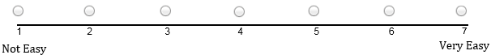

1. How easy was it to recall what permissions you ***rejected***? (circle one)



1. To what degree do you agree with the statement “I felt more secure using the application” (circle one)

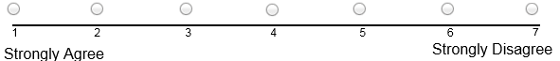

1. The overall rating I would give the app: (circle one)



1. The “**Location**” permission means the app can (check all that apply):

* Access your approximate location
* View local Wi-Fi connections
* Can access your home location
* Update your Google maps preferences
* Change network connectivity state

1. The “**Contacts**” permission means the app can (check all that apply):

* Read your list of contacts
* Add & remove users from your contact list
* Know when you communicate with one of your contacts
* Add the app to your list of contacts

1. The “**SMS**” permission means the app can (check all that apply):

* Send SMS messages
* Delete existing SMS messages
* Read SMS messages
* Disable the ability for the device to send SMS messages
* Share your phone number with 3rd parties

1. How frequently do you check an app’s permissions before deciding to install it (circle one):

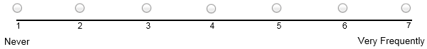

1. Is there anything else you want to share with us about your experience with the app?

|  |
| --- |
|  |
|  |
|  |