1. Clone the repository 🡪 <https://github.com/cps-sei/swim.git>

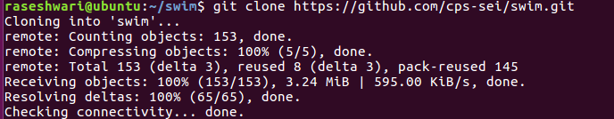

1. Unzip queueinglib.tgz 🡪 tar xzf swim/queueinglib.tgz
2. cd to queueinglib and added the omnet bin path temporarily to PATH🡪

export PATH=file:///home/raseshwari/omnetpp-5.2.1/bin:$PATH

1. run 'make'

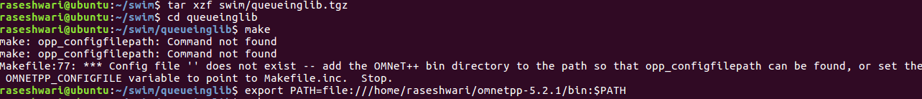

1. cd to swim/swim and run 'make'

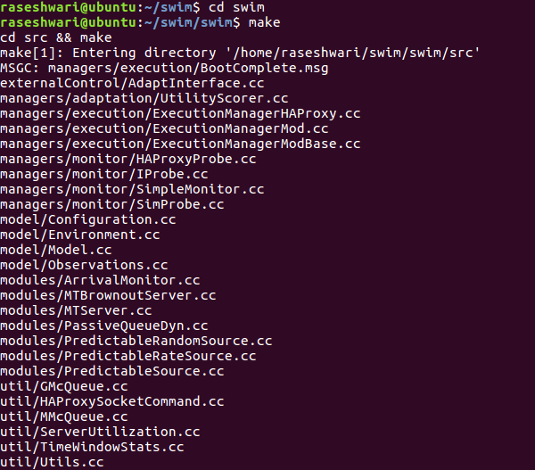



1. cd simulations/swim/ and run -->> ./runexp.sh sim 1



1. wait until the files are generated. Check in swim/results/SWIM (results folder created automatically).