**CloneInspection Usage Instructions**

The following paper describes how to conduct a clone analysis using the tool CloneInspection. The assumption is that the reviewer is already familiar with the concept of [code clones](http://www.cs.usask.ca/~croy/papers/2009/RCK_SCP_Clones.pdf). If not already familiar with clones, please read [this](http://www.cs.usask.ca/~croy/papers/2009/RCK_SCP_Clones.pdf) paper, specifically the background section in page 3 and the clone example on page 25.

CloneInspection is an application created to assist with the manual task of clone identification and classification.

1. **Download CloneInspection**

CloneInspection may be downloaded from: <https://code.google.com/p/dek-graphicdiff/>

or here: <http://www.se.rit.edu/~dkrutz/cloneoracle/cloneinspection/CloneDiff.zip>

1. **Run CloneInspection**
2. CloneInspection may be invoked by running the Main class in the GraphicDiff/src/graphicdiff directory.

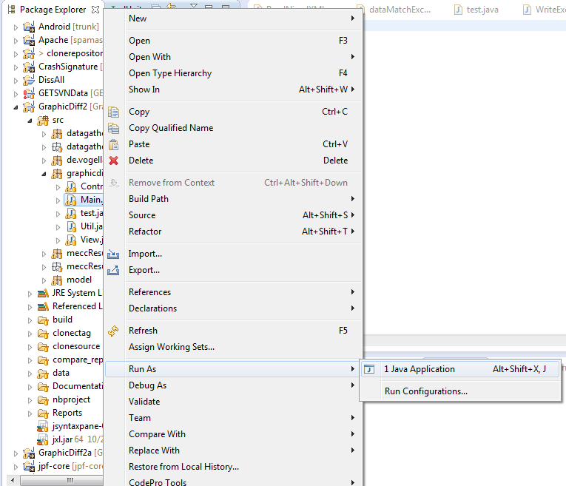

1. This should then bring up a small screen asking the user to browse for the input file. The user should select the input file for the name of the application which they wish to examine.

Note: that it may take up to a minute for the file to load.

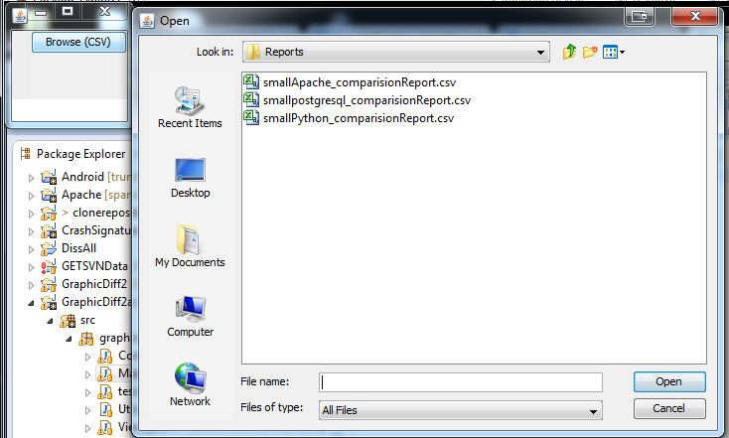

1. Once you have selected the input .csv, the initial comparison screen will be shown.

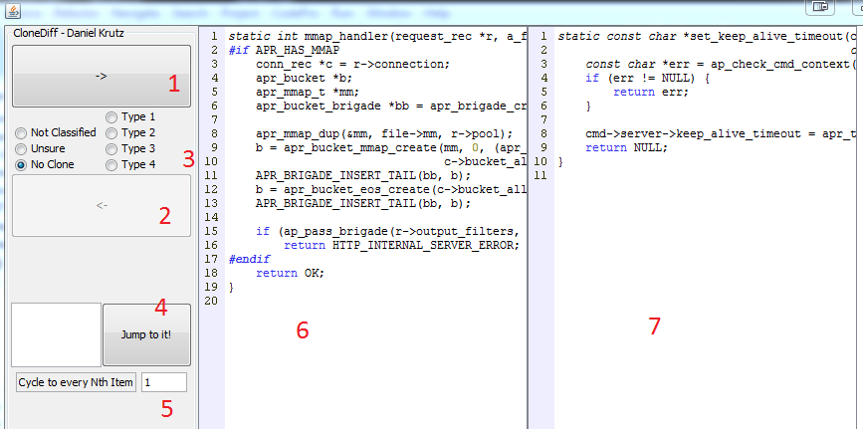

**The items on the screen are:**

* + 1. Show the next clone
    2. Show the previous clone
    3. Display the type of clone selected by user (No clone by default)
    4. Cycle to a specific clone in the list
    5. Input the Nth item in this textbox. For example, if the user inputs a 5 into this textbook, when they cycle to the next clone in the list, they will be shown every 5th possible comparison.
    6. Clone possibility #1
    7. Clone Possibility #2

1. Pressing the next button (item #1) will cycle to the next clone. The results are automatically saved.
2. Perform this until you reach the conclusion of your testing. If you decide to take a break and close the application, it is best to make note of the clone number you leave off at and jump to this comparison (item #4) when you reopen the application. The application will not automatically remember the point you leave off at.

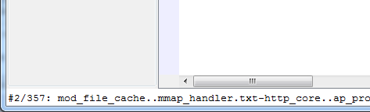

1. Once finished, your final results are located in the “reports” directory.

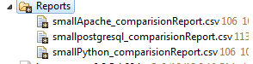

Complete results are saved in the analyzed .csv files.