Requirements Document

D & J Tech Solutions

Joel Hilley

Dan Hayworth

# Business Requirements

## Introduction

A local small business called *Flash-As Pies*, is in need of a management system for their staff and inventory. This business is in the food service industry. The business owner, Padre, reaches out to D & J Tech Solutions for a product that will help him run his business by managing his inventory and staff more efficiently.

## Statement of Problem or Need

The head chef at a pie shop called *Flash-As Pies,* is busy, distracted and without a proper inventory ordering/tracking structure. Admin work is not always done properly by busy chefs in small businesses. The head chef forgets when a staff member tells them they need something or forget to place an order during an especially busy time. This leads to not having the proper ingredients or products on hand when needed. A staff management system is also required to organize and update staff details. Having correct staff information helps to organize scheduling and have contact information available and updated for each employee. A singular system is needed to store and manipulate inventory and staff information effectively and easily. A management system will centralize and organize these important kitchen restaurant functions leading to a more well-run food service business.

## Business Requirements

### List of stakeholders

* Head Chef/Owner
* Employees
* Product Suppliers

### Client

Owner and Head Chef of Flash-As Pies

### List of business requirements

* Authorized access controls
* Place orders to supplier
* View / edit staff details

### Quality requirements

* Portable to any operating system
* Reliable

# Business Solution

## Options considered

* Excel spreadsheet
* Mobile Application
* Web Page

## Recommended Solution

### Solution statement

For chefs, kitchen hands and small business owners that want to more effectively maintain organization of their inventory and staff. Our kitchen inventory management system allows our customer to control important aspects of their business with an easy to use web application. This management system takes the hassle and time out of tracking, updating your inventory and placing orders over the phone or computer.

Chefs work long hours as it is, so being able to shorten a necessary process is a game-changer. An improved ordering system that combines staff management will increase overall efficiency, organization and prevent miscommunications between staff regarding needed supplies. Not only does it meet the needs of a head chef but by allowing all staff members to use the system and contribute to the inventory takes the weight and pressure off of one person. Rather than telling the head chef they need something; they can simply log in and add that item to the order.

As a business process management software, this technology will prevent headaches and ease inventory and staff management. Errors in the kitchen lead to missing product, inefficient spending and an unhappy workplace. Without our product you leave more opportunity for mistakes and human error. Tracking which user uses or orders which product allows for actions to be traceable. At the end of the day, using the kitchen inventory management system will be like having an administrator and dedicated inventory staff member all in one with the added benefit of being available at all times and having one fixed cost. The cost to begin using this system greatly outweighs the troubles and time loss it prevents. Combing a big task of inventory into a team task creates a more productive and cohesive team. Its ease of use and in combination with staff management, makes this product a must have for a well-run food service operation.

### Main Features

* Authorized Log-in to management or staff accounts
* Add quantity of item to order, place order
* View staff member information

### Unique value proposition / Justification

Our solution allows multiple authorized users to manage inventory levels and place orders. It takes away the responsibility from one person and allows others to assist in ordering supplies.

I recommend this solution as it is simple to use and addresses a key problem with the business.

# Solution Requirements

## Context Diagram

Management

Staff/Product Database

Staff info input

Place Order

Use product

User

Place order

Use product

**Kitchen Inventory**

**Management System**

Staff

Product Database

Product Orders

Supplier API

Supplier

## User Roles

* Management
* Staff

## Business Domain Model

Entity Relationship Diagram

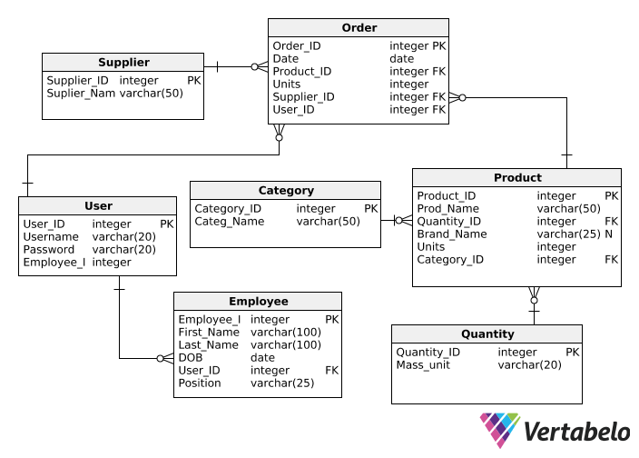

**Product:** The items available to view, use and place orders for

**Employee:** Staff members

**User:** Staff or Management access controls

**Category:** Category that a product can fit into

**Supplier:** Source where products are ordered from. 1 supplier to 0 or many orders

**Order:** The order of products to the supplier

**Quantity:** A measurement of how much of each product.

## User Stories

* Create database of Products (admin)
* Create database of Staff (admin)
* Log-in as staff/management
* Find an employee’s phone number to contact them by clicking their name
* View products by category “dry goods”
* View order/Submit order

## Non-Functional Requirements

### Security requirements

* Log-in Authorization. Management level, staff level
* Limited attack vectors

### Other quality requirements

* High ease of use
* Accurate Data

# Scope

Indicate which requirements you plan to include in the first two iterations. Note that this may change as you advance through the project.

## Iteration 1

* View individual staff member profiles
* View product list
* Add products to order
* Simple, easy to navigate design
* MVP

## Iteration 2

* Add colours and graphics
* Create Levels of authentication
* Place order via web application

## Backlog

List user stories

* Management – would like to see which staff member (user) placed an order for potatoes yesterday. (track usage of user actions)

List non-functional requirements

* Strong password enforcement