System Design Document

Kitchen Inventory Management System

D & J Tech Solutions

# Architecture

## Web Framework

The Django framework is designed around the model-template-view. It is designed to separate concerns and make less code do more with consistent quality.

The model layer is a class that represents the data structure. This allows the user to configure the models to the database and then Django allows us to manipulate our data structures by accessing them via the models.

The view layer handles requests with data from a model. Accessing a specific value of data from an entity is possible by the view layer which communicates with the model layer to access that value from an entity in the database.

The template is what allows us to see our database values by rendering them into HTML and displaying it as a consistent template. Each time new data is called it is turned into html and presented in the same manner as determined by the HTML structure of the template layer.

The URL dispatcher matches with a view by matching the requested URL pattern that represents a specific page in the website.

# Data Access Design

## Model Design (Data Model)

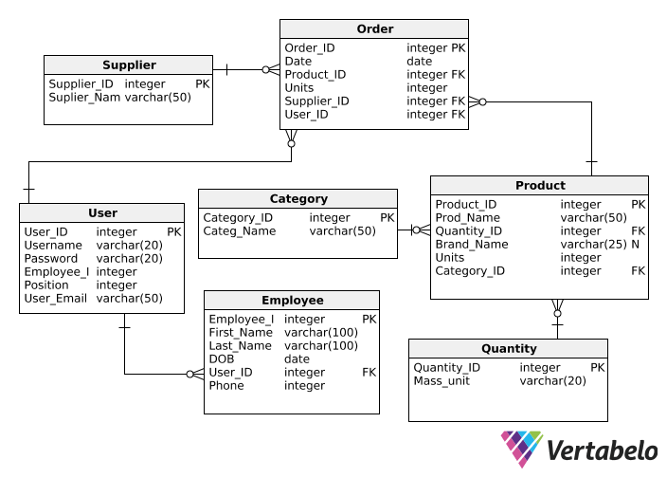

## Functional Decomposition

User Stories:

1. Look up employee by last name.

* Employee table must include first and last_name, as well as date of birth, contact details and position. This allows the employee to be found by the userID unique value PK.

1. View all products in category “dry goods”

* The entity Category can have several Products but each product can only have one category. This allows searching for a product to be done more quickly as you can have a large number of products.

1. User logs into account
   * User needs a username and password to access the web application

## Database Investigation

SQLite – We chose to use SQL as our database management system simply because this is a low traffic application that has minimal functionality. With there only being a as many users as there are staff in the restaurant, we do not require a more robust DBMS while still providing us with the functionality we need.

# Security Design

## Framework Security

Our code will be outside of the Web servers’ foot to ensure it cannot be viewed as plain text.

## Security Mechanisms

Access Control

* User authentication and Authorization – To log-in to the application. UserID and passwords are required. A user must be an Admin to access employee data. All users are able to access product data.

Application uses other access security principles such as separation of duties, limited attack vectors and least privilege.

## User Roles and Permissions

Admin – Head Chef and owner: Full authorization to use all functionality of the application including; view and edit product and staff database values. Can place orders/manage inventory and view employee page.

Strict admin – Sous-chef: Authorization to view and edit product database values. Can place orders. Not authorized to edit staff database. Can view Employee page.

User – Kitchen hands: Authorization to use inventory management functionality. Ca not modify products. Ca not access Employee page.

Strict user – Non kitchen staff, users that do not have an account: can view product list. Cannot log in to use ordering/inventory management functionality. Cannot view Employee page.

# User Interface Design

## View Design (UI List)

*Home*

*Order*

*Employees*

*Admin*

### User Story 1

The owner needs to look up a new employee’s birthday for payroll purposes. They log-in with their admin account which allows them to view staff.html. The owner can see all staff members and their private details.

### User Story 2

A Non kitchen employee wants to see if the restaurant has a specific item in stock. They are not able to log in as they do not have an account but they can see the product landing page which displays all of the products. They are unable to perform any function beyond seeing the product page. Staff page is unavailable to this view.

### User Story 3

Sous chef (strict admin) wants to add 15 kg of potatoes to the order. Sous chef is able to access order.html and add that product to the order.

### User Story 4

User wants to view products by the category “dry good”. User is able to access products and view all dry goods available.

## UI Design

High contrast, easy to read user interface

Obvious functionality

Bootstap used in HTML.

Black, White and Blue color scheme.

* Creates easy readability
* 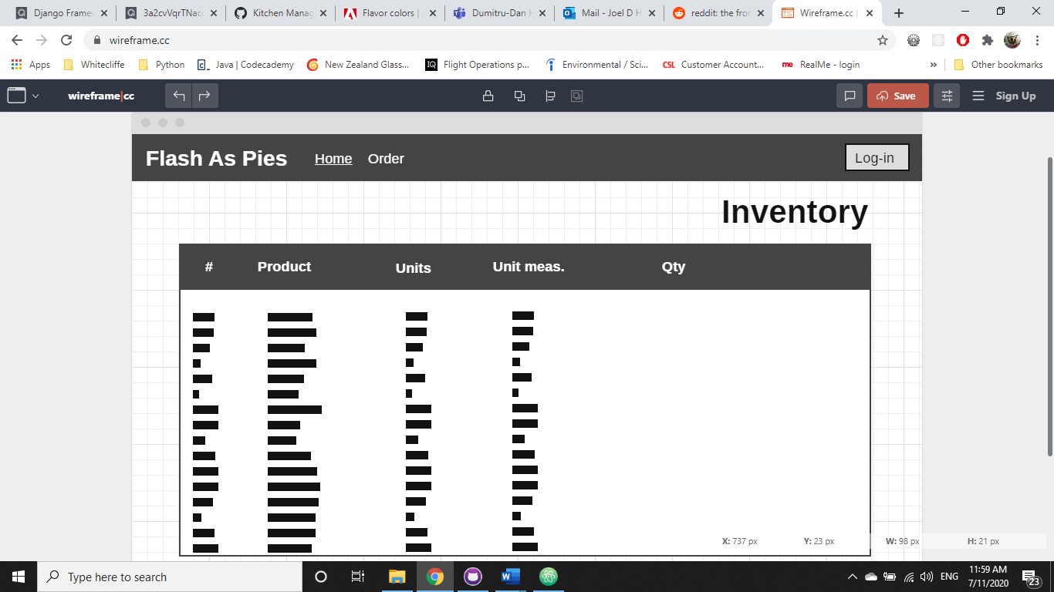Blue is commonly used for log-in buttons, creates familiar look and feel previous used web apps for users.

Landing page wireframe