RPE4: Personalized Advertising on the Web

Team A: Mark F., Dan R.

**Scenario:**

A group of online businessmen who feel that is important to mine information about potential customers from their browsing behaviour online, delivering customized advertisements to these customers, as part of their business partnerships with other organizations, leading to a win-win situation for the businesses and the customers, both.

Contents

Introduction 2

Benefits to Companies 3

Benefits to Consumers 5

Privacy Concerns of Tracking6

Tracking without Permission 8

Opt Out 8

Conclusion 9

References 10

# Introduction

More people are relying on the Internet to help them manage their daily lives. The average adult is spending twice as much time online today than they did ten years ago (Time spent online doubles in a decade, 2015) and the most substantial increase is in the 16-24 age bracket. These users spend hours consuming content on highly popular media sites such as Youtube, Reddit and Facebook and while these products are available to consumers for free, they remain highly profitable. Many of these companies have rejected a subscription-based pricing model and rely on advertising as their primary source of revenue. Google spent over 55 billion dollars in 2015 and approximately 90% of its revenue that year came from its use of efficient use of advertising (Advertising revenue of Google from 2001 to 2015 (in billion U.S. dollars), 2015).

In order to improve the effectiveness of our own advertisements, we plan to follow the strategy adopted by many companies already and use behavioral targeted advertising generated by data mining techniques on information collected from our users. By analyzing user browsing behaviour, we will be able to increase revenue by showing consumers the products and services that they are most likely to purchase. These custom advertisements also benefit our customers by providing them with useful information about the products that we believe are relevant to them. There are necessary security implications when interacting with user data and the concerns that have been made by groups advocating the privacy concerns of using targeted advertising must be addressed. Unfortunately, in order for the effort made by switching to targeted advertising to be worth the investment, it must be used by a large portion of users and because of this requirement, the ability for users to opt-out of this system is not currently under consideration. It is proposed that all members of our business network consider the use of this technology. The following assessment evaluates the projected increase to both our combined revenue and user satisfaction that is expected to result from the adoption of this advertisement strategy.

# Benefits to Companies

Targeted advertising is already in use by many online services and is shown to improve ad performance. In 2010, the Network Advising Initiative (NAI) examined data from 12 private advertising networks and found that advertisements based on user behaviour generated approximately 2.68 times as much revenue as non-targeted advertisements (Study Finds Behaviorlally Targetd Ads More Than Twice As Valuable, Twice As Effective As Non-targeted Online Ads, 2010). This data shows that a switch to targeted advertising will increase revenue, provided that enough users do not disapprove this approach based on its use of their user data and leave the ecosystem.

A 2014 poll conducted by the data analytics platform Qriously for the Wall Street Journal (WSJ) found that out of 4000 mobile users, 54 percent preferred “relevant ads” to “irrelevant ads”, while only 48 percent preferred the same advertising techniques when it was referred to as “targeted” versus “untargeted ads” (Marshall, 2014) This research suggests that there are a large number of users who view targeted ads positively, and that the majority of users will agree with this advertising technique if it is marketed correctly.

Using the revenue increase determined by the NAI’s study and assuming that all 54 percent of disapproving users reject the new behavioural-driven advertisement model, there remains a projected profit increase of over 20 percent. Since the time of the NAI study, targeted advertising has only become more advanced and it can be expected that there is an even greater value in using this approach today.

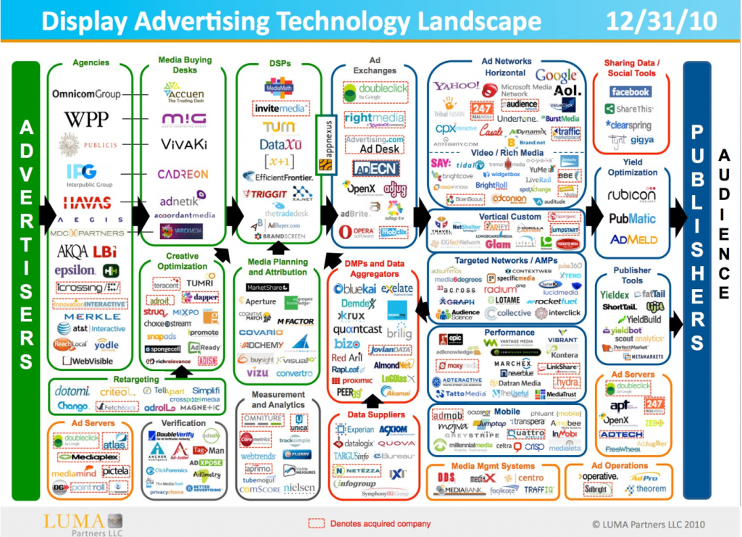

Figure 1 Many Services Already Use Behaviour Driven Advertising (Madrigal, 2012)

In addition to being profitable, the use of targeted advertising is becoming a necessity as more competitors adopt this technology. There are hundreds of services that already use advanced behaviour-driven advertising techniques to optimize the ads that they present to their audience. Companies like Amazon have taken behavioral targeting even further by using behavioral re-targeting to increase performance. Behavioral re-targeting is the process of showing targeted advertisements on different websites within the advertising network, such as in the case of recommended or past-viewed Amazon products being displayed on Facebook. It has been estimated by different studies that this form of re-targeting can outperform traditional advertising by 400 to 1000 percent (The Amazon Strategy - Using Dynamic Ads for Your Business, 2016). By analyzing our users browsing habits, we can develop a similar network of targeted advertisements that will keep our businesses competitive with other industry leaders.

# Benefits to Consumers

The majority of consumers are in favor of the use of online advertisements over subscription-based models. A 2016 poll organized by the Digital Advertising Alliance determined that 85 percent of Americans polled prefer ad-supported free content over paying for ad-free content and value the total amount that they have saved by using free ad-supported at approximately $1200 per year (Digital Advertising Alliance, 2016). Advertisements are saving users money by keeping services like weather apps and music streaming sites free and if these websites don’t keep users interested in their ads, they will need to start charging for them.

Targeted ads keep users engaged by using behavioural data to select ads that are relevant to what they are currently doing or generally enjoy. In 2014, the popular music streaming service Spotify announced that it was incorporating targeted advertisements, called “curated moments”, for free-tier listeners. This service promised to customize advertisements based on what Spotify determined the person is currently doing while listening, such as recommending post-gym meal deals at restaurants if a person is listening to their workout playlist (Atkinson, 2014). These ads are beneficial to both the consumer and the provider by keeping the service profitable and free while providing value to the user.

The most difficult step in this process is determining what sort of advertisements the user would prefer to see. This analysis can be improved by allowing the user to explicitly provide data on the ads that they care about. Google invites its users to control the type of ads that they see when using its services and provides a list of recommended interests that it has compiled from data on the user’s browsing history (Control your Google ads, n.d.). Google is combining the data that it has on the browsing behaviour of its users with direct user feedback, leading to even more effective advertisements. By collecting data on what our own users prefer and using this type of a feedback mechanism, we anticipate a similar increase in in customer engagement across our business network.

## Privacy Concerns of Tracking

The use of behavioral targeted ads has been called “creepy” in various pieces of scientific literature and many users believe that their privacy has been compromised by advertising companies. A 2014 Survey of Canadians by the Privacy Commission found that nearly two-thirds of those who could recall seeing targeted advertising felt that they had less privacy online (Phoenix Strategy Perspectives Inc., 2014). This problem can be mitigated by providing users with a public privacy policy and we plan to make one that will clearly indicate what information we collect and how it is collected, as well as how it is used.

We will use data mining, the process of determining meaningful information from the collection and analysis of large data sets, to generate important information about our users such as the duration of their visits and the specific advertisements and products that have engaged them in the past. Data mining will be focused on analyzing marketing segmentation, relating characteristics of users to products, and behavioral basket analysis to group products that a specific user would want to buy together. From this information we will generate unique profiles for users that will be saved in their browsers to anonymously identify them.

The Personal Information Protection and Electronic Documentation Act (PIPEDA) defines personal information as “information about an identifiable individual” and requires an individual’s knowledge and consent when performing collection or analysis (Privacy and Online Behavioural Advertising  , 2011). Our data collected will be anonymized and will not include personal information such as names or emails.

While we are dedicated to ensuring that we have mechanisms in place to ensure the privacy of our users, there are always security concerns that the policy may be violated by malicious groups. Internal security across our business network will be handled similarly to other large businesses such as Google, which uses physical mechanisms like alarms, biometrics, and constant surveillance to protect its data centers. Less than 1% of Google's employees even enter their data centers over the course of their employment (Google Security Model, n.d.) and we will also heavily restrict who has access to this data.

External breaches happen each year throughout the industry, and to protect the data of our users, we will investigate encrypting all collected information. PIPEDA further suggests that an “individual could be identified through the use of that information, alone or in combination with other available information” (Privacy and Online Behavioural Advertising  , 2011) and in order to prevent user identification through aggregate analysis of our data sets, we will use techniques such as k-anonymity and l-diversity to minimize the ability to infer personal information about users from anonymized entries (Goldberg, 2008). Through regulation of user privacy and enforcing high standards of data security, we will ensure that our collected data will be used to improve our advertisements while minimizing the privacy concerns of our users.

# Tracking without Permission

Privacy advocates often argue that the tracking is done without a user’s permission. This is not true. When a user accesses a website, they make a contract with the website. They receive access to the website, and in exchange they agree to a variety of terms about the website. One of these terms is that the user will be tracked. This form of contract isn’t unique to computers. When you call customer support and the call is recorded for quality assurance, that is the same idea. The same thing is true at a hiking trail where a sign indicates that by using the trail you waive your right to sue for any injury you sustain.

## Opt Out

Many privacy advocates including PIPEDA state that consumers should be able to opt out of tracking. One method that has been suggested is a Do Not Track Header (Do Not Track, n.d.) which would be included with all web requests and prevent a visitor's data from being used by advertisements or analytics services.

While being able to opt out of tracking allows users concerned about their privacy to determine when they want to be tracked, this approach can lead to problems for companies. The proposed solutions involve the user asking not to be tracked, and the company complying. The major issue is that there is no alternative way to compensate the company for its lost revenue. One example is the AdBlock Plus service that is widely used by users to remove ads from the sites they visit. AdBlock allows companies to whitelist their ads, but only in certain cases and some companies have criticized this service as amounting to racketeering. It is conservatively estimated that even with whitelisting, Google is losing a billion dollars in North America alone from lost revenue from AdBlock (Google Losing Billions in Adblocking Devil's Deal, 2015). Currently users pay the company for its services by being tracked and seeing ads. For an opt out system to be widely adopted by companies, it needs to have an alternate method for the user to pay for the service the site provides. As previously mentioned, users prefer to see ads than pay for a subscription fee for an add-free or opt out experience and without an alternative option to generate revenue, an opt out system is not currently in consideration.

# Conclusion

There are privacy concerns with using behavioral targeted advertising, but if privacy regulations are made clear to users and enforced properly, then the massive upsides from the access to free content and more meaningful results are worth the cost. Many sites on the Internet today cannot survive without the extra revenue made available by tracking users.

People are given a choice about whether or not they want to be tracked. If they don’t want to be tracked they can decide to not use services that track them. We’ve seen overwhelmingly that this is not the choice that many people make. Google has a huge amounts of users even though less invasive alternatives such as DuckDuckGo exist. These alternatives are not as successful, but that’s the result of having less money to spend on research and development as a result of using models that generate less revenue. This suggests that people may talk about wanting privacy, however, in reality it is is often the cheaper service that is preferred by the majority of users. The proposal for using behavioural targeting in our advertisements across our business network will not include an opt out option until an alternative revenue source for users that choose to opt out is determined to be a viable option.

# References

*Advertising revenue of Google from 2001 to 2015 (in billion U.S. dollars)*. (2015). Retrieved from Statista: http://www.statista.com/statistics/266249/advertising-revenue-of-google/

Atkinson, C. (2014, June 6). *Spotify ready to hyper-target ads to users*. Retrieved from Page Six: http://pagesix.com/2014/06/16/spotify-ready-to-hyper-target-ads-to-subscribers

*Control your Google ads*. (n.d.). Retrieved from Google: https://www.google.com/settings/u/0/ads/authenticated

Digital Advertising Alliance. (2016, May 11). *Zogby Poll: Americans Say Free, Ad-Supported Online Services Worth $1,200/Year; 85% Prefer Ad-Supported Internet to Paid*. Retrieved from PR Newswire: http://www.prnewswire.com/news-releases/zogby-poll--americans-say-free-ad-supported-online-services-worth-1200year-85-prefer-ad-supported-internet-to-paid-300266602.html

*Do Not Track*. (n.d.). Retrieved from Do Not Track: http://donottrack.us/

Goldberg, I. (2008). *F08 Lecture Slides*. Retrieved from CS 458/658: https://crysp.uwaterloo.ca/courses/cs458/F08-lectures/

*Google Security Model*. (n.d.). Retrieved from Google: https://cloud.google.com/security

*Google Losing Billions in Adblocking Devil's Deal.* (2015, June 8). Retrieved from PageFair: https://pagefair.com/blog/2015/google-losing-billions-adblock-devils-deal

Madrigal, A. C. (2012, February 29). *I'm Being Followed: How Google—and 104 Other Companies—Are Tracking Me on the Web*. Retrieved from The Atlantic: http://www.theatlantic.com/technology/archive/2012/02/im-being-followed-how-google-151-and-104-other-companies-151-are-tracking-me-on-the-web/253758/

Marshall, J. (2014, April 17). *Do Consumers Really Want Targeted Ads?* Retrieved from The Wall Street Journal: http://blogs.wsj.com/cmo/2014/04/17/do-consumers-really-want-targeted-ads/

Phoenix Strategy Perspectives Inc. (2014, December). *2014 Survey of Canadians on Privacy*. Retrieved from Office of the Privacy Commissioner of Canada: https://www.priv.gc.ca/information/por-rop/2015/por_2014_12_e.pdf

*Privacy and Online Behavioural Advertising*. (2011, December). Retrieved from World Wide Web Consortium: https://lists.w3.org/Archives/Public/public-tracking/2011Dec/att-0029/Stoddart_OBA_guidelines.pdf

*Study Finds Behaviorlally Targetd Ads More Than Twice As Valuable, Twice As Effective Aa Non-targeted Online Ads*. (2010, March 24). Retrieved from Network Advertising Initiative: https://www.networkadvertising.org/pdfs/NAI_Beales_Release.pdf

*The Amazon Strategy - Using Dynamic Ads for Your Business*. (2016, January 11). Retrieved from Dandelion: https://www.discoverdandelion.com/blog/the-amazon-strategy---using-dynamic-ads-for-your-business/

*Time spent online doubles in a decade*. (2015, May 11). Retrieved from Ofcom: http://media.ofcom.org.uk/news/2015/time-spent-online-doubles-in-a-decade/